Red Colored Part Detection Execution Process

- Open the code in any python code editor
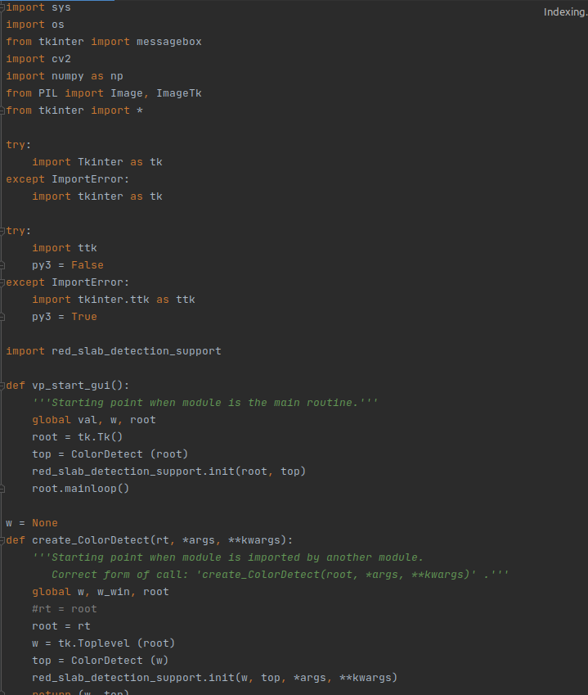
- Run the program and you will get a GUI window.
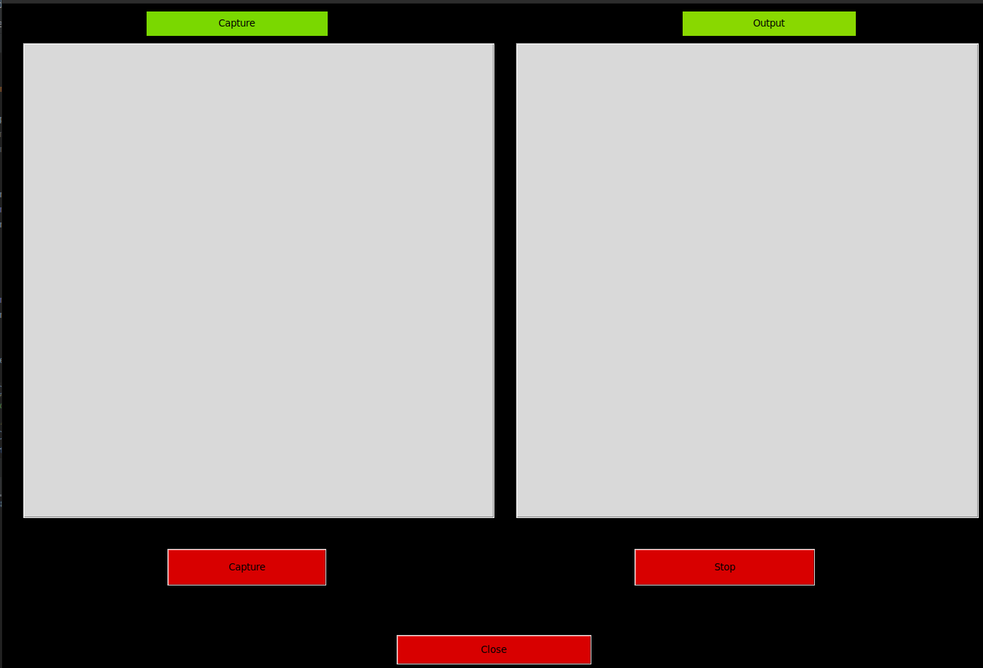

- Click on capture button and start capture and it will automatically stat detecting red colored part in the video.
