MongoDB

MongoDB is a NoSQL database.NoSQL batabases are different than relational databases like MySql. In relational database we need to create table, define schema,set the data typesof fields etc before inserting the data. In NoSQL we don't have to worry about that, we can insert,update data on the fly.

When to go for NoSQL

When we would want to choose NoSQL over relational database:

1)When we want to store and retrieve huge amount of data.
2)The relationship between the data is not important
3)The data is not structured and changing over time
4)Constraints and Joins support is not required at database level
5)The data is growing continuously and we need to scale the database regular to handle the data

Introduction to MongoDB

MongoDB is an open source, 'document' oriented database that stores data in form of documents(i.e), in key and value pairs.

What is document?
Documents are like rows in RDBMS. The attached image can very much make it clear
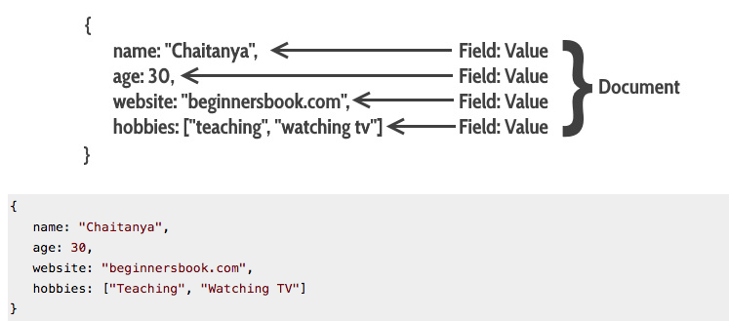
Features of MongoDB:-
1)High performance: Compared to DRBMS MongoDB are faster.
2)Auto Replication:This feature quickly allows us to recover in case of failure.
3)Horizontal Scaling:MongoDB supports horizontal scaling.
4)Load balancing:Horizontal scaling allows MongoDB to balance the load.
5)High Availability:Auto replication improves the availability of MongoDB database.
6)Indexing:Indexes are used to quickly locate data without having to earch every document in a MongoDB database. This improves the performance of operations performed on the MongoDB database.

Mapping RDBMS to MongoDB

Lets understand this using the below image:
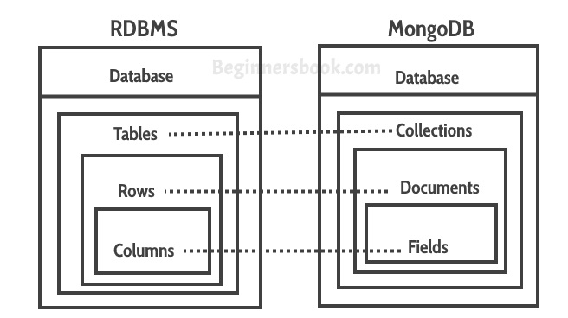

Collections in MongoDB is equivalent to the tables in RDBMS.
Documents in MongoDB is equavalent to the rows is RDBMS.
Fileds in MongoDB is equivalent to the columns is RDBMS.

The only difference between document and row is that documents are in JSON format.

Table vs Collection

In the image attached below, we can see how the data in RDBMS can be represented in MongoDB:
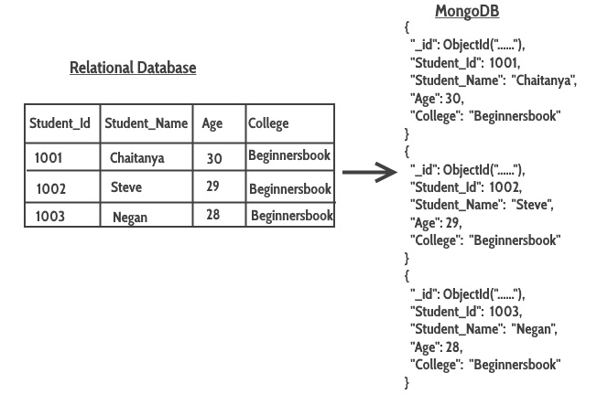
Getting Started with MongoDB

*Start the MongoDB by typing below command:

>net start MongoDB

*Lets navigate to bin directory of MongoDB
*Now we should be working in MongoDB shell, to run the shell we will use below given command:
>mongo
*Lets create the database by typing the below command
>use database_name
e.g. use demo
here, demo is the name of the database
*I order to check the currently used database we can type the below command
>db
*To list down all the batabases, use the below command
>show dbs

Dropping Database

Syntax: db.dropDatabase()

Below are the steps delete a database:-
a)See the list of databases using show dbs command
>show dbs
b)Switch to the database that needs to be dropped.
>use demo
here, demo is the database that i want to drop
c)Now, run the command db.dropDatabase()
>db.dropDatabase()

Creating Collection in MongoDB(1st way)

Syntax:db.collection_name.insert({key:value, key:value…})

e.g: We don't have a collection 'user' in the database 'demo'. The below given command will create the collection named 'user' and insert a document.
> use demo
switched to db demo

>db.user.insert({
name: "Sachin",
age: 42,
website: "abc.com"
})
We will see the command response as below:

WriteResult({ "nInserted" : 1 })

*To check whether the document is successfully inserted, type the following command
>db.collection_name.find()
*To check whether the collection is created successfully, type the following command
>show collections

Creating collection with options before inserting the documents

Syntax: db.createCollection(name, options)
here, name is the collection name
options is the optional field that we can use to specify certain parameters such as size, max number of documents etc in the collection.

*Lets see the command used for creating collection without any parameters:
>db.createCollection(“students”)

*Lets see the options that we can provide while creating a collection

capped: type: boolean.
This parameter takes only true and false. This specifies a cap on the max entries a collection can have. Once the collection reaches that limit, it starts overwriting old entries.
The point to note here is that when you set the capped option to true you also have to specify the size parameter.

size: type: number.
This specifies the max size of collection (capped collection) in bytes.

max: type: number.
This specifies the max number of documents a collection can hold.

autoIndexId: type: boolean
The default value of this parameter is false. If you set it true then it automatically creates index field _id for each document. We will learn about index in the MongoDB indexing tutorial.
e.g: related to capped collection:
>db.createCollection(“teachers”, {capped : true, size : 9232768}

Dropping Collection
Syntax:db.collection_name.drop()
e.g:
>use demo
we can check the existing collections in the database by using the command
>show collections
following command for dropping teachers collection
>db.teachers.drop()

Inserting Document
We can understand this by following example:
here, we are inserting document into the collection named 'user'. The field 'course' in the example below is an array that holds the sevral key-value pairs
e.g:
>db.user.insert(
{
name: "Sam",
age: 22,
email: "sam@abc.com",
course: [ { name: "MongoDB", duration: 5 }, { name: "Java", duration: 30 } ]
}
)
We can verify whether the document is successfully inserted or not by following command:
Syntax: db.collection_name.find()
>db.user.find()

