MICRO-SERVICES

Introduction

Problem with Monolithic Architecture and Solution
It is a architecture which contains all the services and components of an appication as a single package. Monolithic Architecture maintains all these services as a single package and stores them in same sever and database.

If we come across a situation where we need to make some changes in the application or some sort of migration is required. Any modification made to a small section of an application requires deploying entirely the new version in monotithic architecture where as in microservices architecture a single application is developed as a suite of small services, each running in its own process and communicating with lightweight mechanisms, a resource API. It is lightweight, scalable, easy to integrate with third party services, domain driven design, small and smart end points and better fault isolation.

Microservices is a variant of the service-oriented architecture(SOA) architectural style that structures an application as a collection of loosely coupled services. In a microservices architecture, services should be fine-grained and the protocolsshould be light-weight. The benefit of decomposing an application into different smaller services is that it improves modularity and makes the application easier to understand, develop and test. It also parallelizes development by enabling small sutonomous team to develop, deploy and scale their respecitve services independently. It also allows the architecture of an individual service to emerge through continuous refactoring. Microservices based architecture enable continuous delivery and deployement.

Service Registration and Discovery and its Implementstion in Spring Cloud

When we start a project, we usally have all the configurations in the properties file. As more and more services are developed and deployed, adding and modifying these properties become more complex. Some services might go down, while some the location might change. This manual changing of properties may create issues.
Eureka Service Registration and Discovery helps in such scenarios. As all services are registered to the Eureka server and lookup done by calling the Eureka Server, any change in service locations need not be handled and is taken care of.

Example:
Microservice Registration and Discovery with Spring Cloud using Netflix Eureka

=>We will be developing 2 Spring Boot microservices named as producer and consumer. Producer will expose REST API which will be consumed by the consumer.

1.Steps for creating Producer microservices:

a)Create a maven spring boot application by adding the below dependencies:

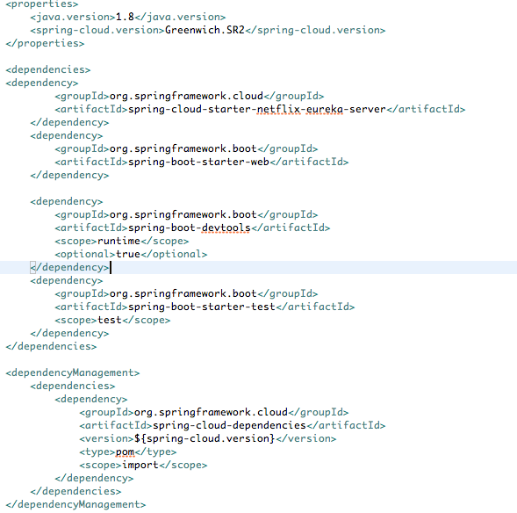
b)In the bootstrap class add the @EnableDiscoveryClient at the class level. Refer the attached image

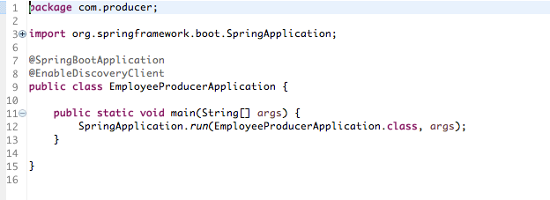
c)Functionality can be added by adding different layers like:model, controller,service, dao...here I have restricted the application till controller layer. I have added the screen-shot for reference:

Screen-shot of Controller:
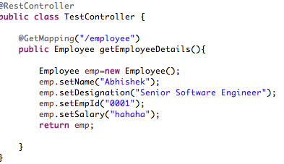
Screen-shot of Model class:
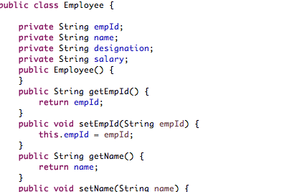

d)Specify the server port on which producer will run and Service Registry uri inside src/main/resource/application.properties ,refer the below screen-shot

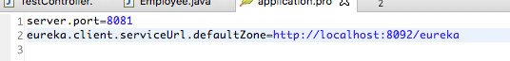
2.Steps for creating Consumer Microservices:

a)Create a Maven Spring boot application by adding dependencies shown in screen-shot

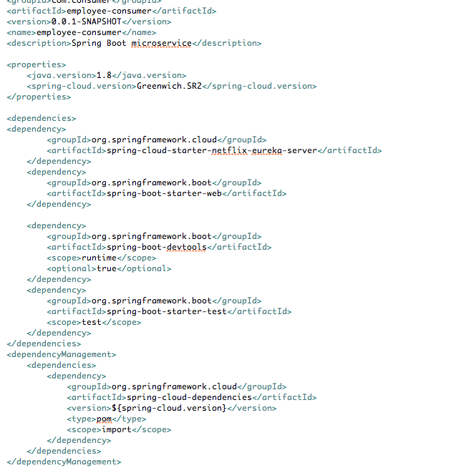
b)Create the boot-strap as shown in the scree-shot:
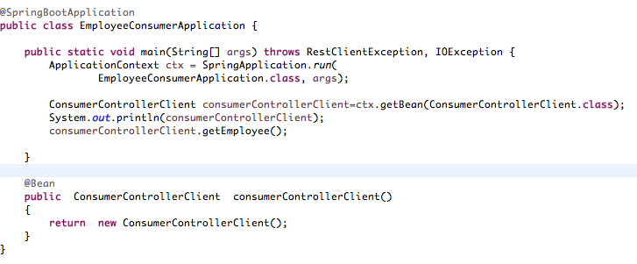
c) Write a rest controller class to consume the service. Please the screen-shot:

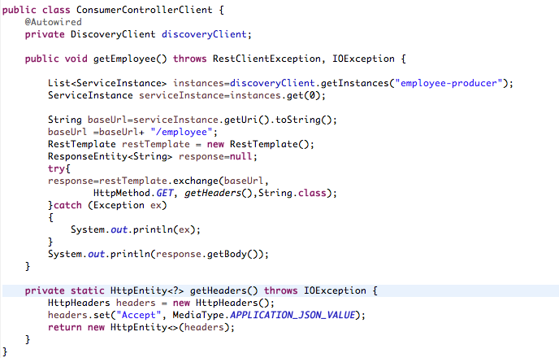
d)Configure application.properties as follows:
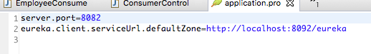

3)Steps for creating service-registry using Eureka Server
a)Create a maven Spring boot application by adding dependencies shown in the screen-shot:
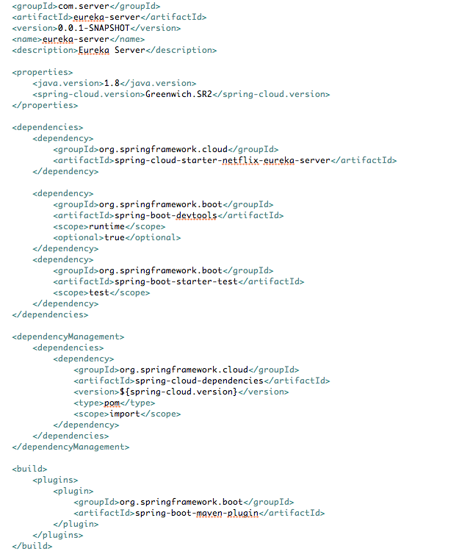
b)Add the annotation @EnableEurekaServer in the Bootstrap class.Refer the screen-shot
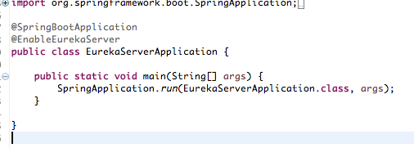
c)Mention the port on which we want we run the server as shown in attached screen-shot
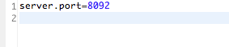
- Start the Eureka Server application and then start both producer and consumer application.
- Hit the url http://localhost:8092

We see both the consumer and producer application running in the Eureka as shown in the screen-shot attached below:

