Docker Compose

Docker compose is a tool defining and running multi containers docker
application. with compose, you use a yml file to configure your application services.
with a single command, you create and start all the services from your configuration.

The feature of compose that make it effective are
- Multiple isolated environment on a single host compare uses a project names so isolate environment from each other.
- Preserve volume data when container called compose preserve all volumes
used by your services. It ensures that any data you have created in volumes
init lost.
- Only recreate containers that have changes compose caches the configurations
used to create a containers meaning you can quickly make changes to your
environment.

How to check docker-compose version

cmd:- docker-compose -–version

please see docker-compose.yml in project directory
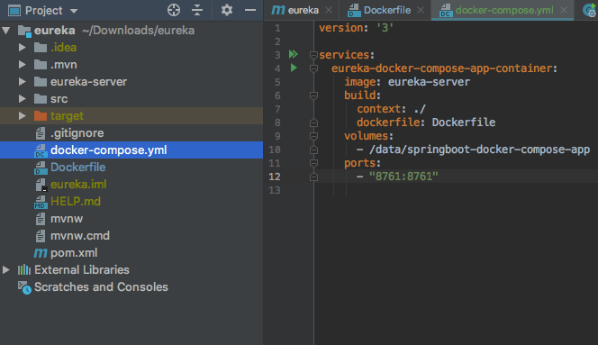

compose file defines one service eureka-docker-compose-app-container:

use an image that built from the docker-file in the current directory. Forwards the
Exposed port 8761 on the containers to port 8761 on the host machine.

Volumes key mounts the project directory on the host to /data/springboot-docker
-compose-app inside the container allowing you to modify the code on the fly without
having to rebuild the image. volume is analogous. to docker volume create.

Run command to create and start containers

cmd:- docker-compose up

cmd:- docker-compose -f <composefile-name>

cmd:- docker-compose up -d

you can avoid -f if your file name is docker-compose.yml. If you want to run.
Your services in the background.

You can pass the -d flag ( for detached mode)

compose builds an image for your code & story the services you defined.
In this case the code is statically copied into the images at build time.

If you started compose with -d stop your service once you have finished with them.

$ docker-compose stop

you can bring everything down & remove all container entirely with command
$ docker-compose down

The Benefits of Kubernetes

Kubernetes alleviates the burdens of manually managing your containers in a
large scale production environment. If set up properly, kubernetes can save
Developers time and money by automating infrastructure resource management.

Getting Started with Kubernetes

Before you can start creating clusters with kubernetes, you must download and
install serveral things.

- MiniKube:- a lightweight distribution that lets you run kubernetes clusters
locally
- A virtualization software like VirtualBox
- Kubectl:- the command line client for kubernetes.
- A container runtime like Docker

Run MiniKube

$ minikube start

Now, to confirm that your cluster is running enter:

$ kubectl get nodes

if done correctly, you should see some information about your cluster such as its status
and a version number.

Configuring Kubectl

if you followed the steps above and installed Minikube, then Kubectl should have
automatically configured itself to access the cluster you created.
You can confirm this with the following command:

$ kubectl cluster-info

The ~/.kube/config file defines which API endpoints and clusters kubectl can access.
Determining which cluster kubectl interacts with is referred to as “Setting the context”.

$ kubectl config use-context minikube

you can change the context using the KUBECONFIG variable. If everything was
correctly configured, you should be able to open the Kubernetes dashboard in a
browser with this command:

$ minikube dashboard

The Kubernetes Dashboard

The kubernetes dashboard tells you everything you need need to know about your
cluster. To determine if your dashboard is up and running, enter this command

$ kubectl get pods -n kube-system

Look for an entry that begins with kubernetes-dashboard. Before you can view your
Dashboard, you must run the following command to proxy to the API.

$ kubectl proxy

Now, the kubernetes API will be available at http://localhost:8081. To open your
dashboard in a browser, visit the following URL:

http://localhost:8001/api/v1/namespaces/kube-system/services/https:kubernetes- dashboard:/proxy/

Creating a Service

As mentioned earlier, pods are initially only accessible via their internal IP addresses within a cluster. To make your containers accessible outside of Kubernetes, pods
must be exposed as services. A Kubernetes service is basically an internal load
balancer that serves as an ambassador for pods. To expose a pod, use this kubectl command:

$ kubectl expose deployment hello-node --type=LoadBalancer

The --type=LoadBalancer flag lets Kubernetes know that you want to expose
the service to the public. Just replace hello-node with the name of your application’s container. You can view your newly created service with this command:

$ kubectl get services

If your cloud provider supports load balancers, you may be given an external IP
address to access the service. If you’re using Minikube,
the --type=LoadBalancerflag makes your service accessible via the minikube
service command.

Kubernetes

Kubernetes is a orchestration system.

What can kubernetes do for you?

With modern web services users expects applications to be available 24/7 &
developers expect to deploy new version of those applications several times a day.

Containerisation helps package software to serve these goals.

Enabling application to be release and updated in an easy & fast way without downtime.

Kubernetes helps you make sure those containezed applications run where and when
you want & helps them find the resources and tools they need to work.

