BUILDING DOCKER CONTAINER

Example:
Let's build a docker docker container with Ubuntu OS and install Apache server in it. Commit these changes to the containe. Run the Apache server inside the container inside the Ubuntu conatiner and push this container to Docker hub.

Step 1: Lets pull image(ubuntu) from the central docker repository.

$ docker pull ubuntu

Step 2: List out all the images installed on the system.

$ docker images

Step 3: Lets run container , from the image name available on the terminal

$ docker run -it -d <image-name>

'it' ==>make the terminal interactive
'-d'==>run the container as demon(in the back ground)

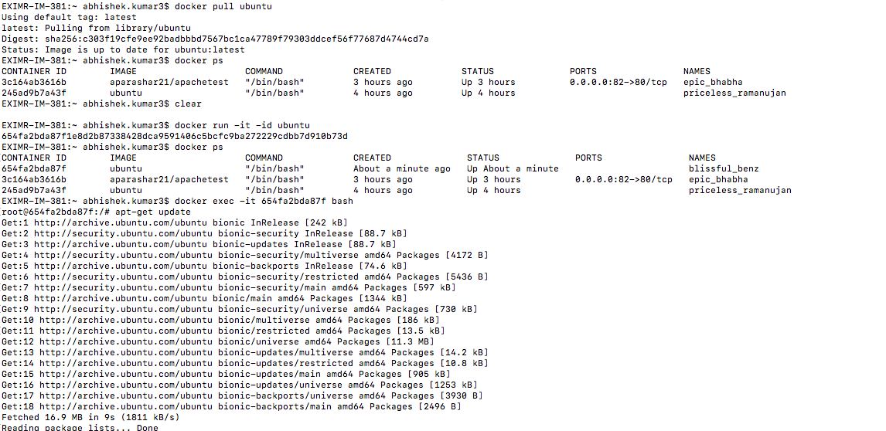

Step 4: Lets check the running containers running in the system.
(refer the attache image)
$ docker ps

Step 5: Lets login/access or get inside the running container
(refer the attached image)
$ docker exec -it <container-id> bash
'bash'==>i want to run this container in current terminal space where I am currently working

Step 6:Lets update the containe, as if it is a new OS running on a System.
$ apt-get update

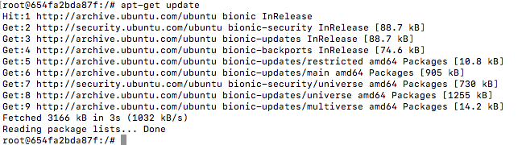
The minimum library which are required for a container to make it behave as a particular OS is only present inside the containe.

Step 7: Lets install apache2 inside this containe.
(refer the image attached below)
$ apt-get install apache2
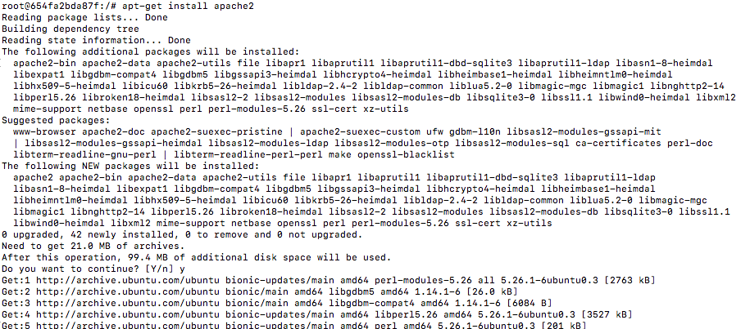
Step 8:Lets check whether apache2 is installed and running or not.
(refer the image attached below)
$ service apache2 status
Step 9: If Apache2 is not running, lets run it
(refer the image attached below)
$ service apache2 start
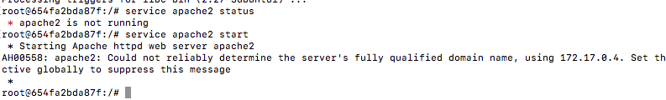
Step 10: Exit from the containers
$ exit

Step 11: List out the running containers
$ docker ps

Step 12:Commit the container by giving a image-name, image name should follow the standard which is 'DockerRepositoryName/theNameWhichWeWantForContainer'

$docker commit <container-id> <image-name>
e.g: $ docker commit 654fa2bda87f aparashar/apachetest2
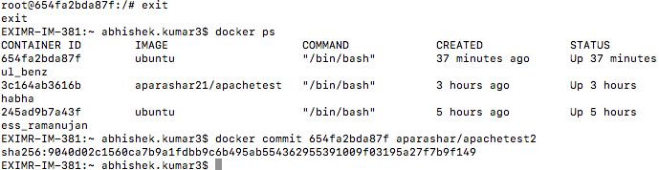

Step 13:Lets check the images inside out repository, we will find the new image here with name aparashar/apachetest2
$docker images
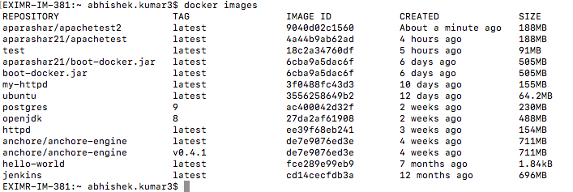

Step 14: Lets run the image
$docker run -it -p 82:80 -d aparashar/apachetest2
==> Here we are running port 80 of the container to the port 82 of Host system.

Step 15: Lets check container is running
$ docker ps

Step 16:Lets get inside the containe
$docker exec -it <container-id> bash

Step 17:Lets start apache2 inside ubuntu container
$service apache2 start

PUSHING THIS CONTAINER TO DOCKER HUB

Step 18: Log inside docker
$ sudo docker login

provide docker hub username and password

Step 19: Lets push this image to the Docker Hub
$ docker push <image-name>
e.g: docker push aparashar21/apachetest2

