Insurance Claims Analytics Dashboard
1. Introduction
The Insurance Claims Analytics Dashboard is a business intelligence project developed using Power BI to analyze insurance policy performance, claims activity, customer demographics, and feedback behavior.
Insurance companies generate large volumes of operational data related to policies, claims, premium payments, customer coverage, and service interactions. Converting this raw data into meaningful business insights is essential for better decision-making.
This dashboard was designed to provide a complete analytical view of insurance operations by using interactive visualizations, KPI cards, filters, DAX calculations, and business insight reporting.
The project helps stakeholders quickly understand premium generation, claim distribution, approval and rejection rates, active policy status, and customer sentiment.

2. Project Objective
The main objective of this project is to create an interactive dashboard that can monitor insurance business performance and support operational analysis.
The dashboard is designed to answer key business questions such as:
• Which insurance policy type generates the highest premium revenue
• What is the total claim amount across all policies
• What percentage of claims are approved or rejected
• Which customer age group contributes the highest claim value
• How many policies are active versus inactive
• What business insights can be derived from customer feedback

3. Tools and Technologies Used
The following tools and technologies were used in this project:
• Power BI for dashboard development
• DAX for KPI and business measure creation
• Data Modeling for relationships between tables
• Excel / CSV files as source datasets
• Power BI Service for cloud publishing
Power BI was used because it provides strong visualization capability, interactive filtering, and easy business reporting.
4. Dataset Description
The project uses structured insurance data containing policy information, claim records, customer details, and feedback data.
Main columns used in the dataset include:
• PolicyNumber
• CustomerID
• ClaimNumber
• Age
• Gender
• CoverageAmount
• PremiumAmount
• PolicyStartDate
• PolicyEndDate
• PolicyType
• ClaimStatus
• ClaimDate
• ClaimAmount
• Active / Inactive Status
A separate feedback dataset was also used for sentiment analysis, which contains customer comments and satisfaction indicators.

5. Data Preparation Process
Before creating the dashboard, the dataset was cleaned and prepared inside Power BI.
The preparation process included:
• checking null values
• correcting column data types
• formatting date fields
• removing duplicate records
• ensuring numerical consistency for premium and claim values
Data cleaning ensures that all calculations and visuals are accurate.
After cleaning, relationships were created between policy data and customer feedback tables using common identifiers.

6. Data Modeling and Relationships
A proper data model was created to connect multiple tables and enable efficient analysis.
Relationships were built using common keys such as CustomerID and PolicyNumber.
The data model helps Power BI aggregate information correctly across multiple visuals.
Star schema principles were followed where possible to maintain clean reporting logic.
The relationships enabled filtering between:
• policy records
• customer records
• claim records
• feedback records

7. DAX Measures Used
DAX measures were created to calculate key business indicators.
Important measures include:
Approval Rate
Rejection Rate
Active Policies Count
Logic:
Active Policies = CALCULATE(
COUNTROWS('InsuranceData'),
'InsuranceData'[Active/Inactive] = "Active")
Claim Approval Rate = DIVIDE(
CALCULATE(COUNTROWS('InsuranceData'), 'InsuranceData'[ClaimStatus] = "Settled"),
COUNTROWS('InsuranceData'))
Claim Rejection Rate = DIVIDE(
CALCULATE(COUNTROWS('InsuranceData'), 'InsuranceData'[ClaimStatus] = "Rejected"),
COUNTROWS('InsuranceData'))
8. Dashboard Design
The dashboard is divided into multiple analytical sections.
Top section contains KPI cards that summarize major business metrics.
Middle section contains category-based business analysis.
Bottom section includes trend analysis and business insights.
Separate pages were created for:
Overview Page
Table View
Feedback Analysis Page
This page separation improves readability and user navigation.

9. Overview Dashboard Explanation
The Overview page provides the main business summary.
KPI cards display:
• Premium Amount
• Coverage Amount
• Claim Amount
• Approval Rate
• Rejection Rate
• Active Policies
Visual charts show:
• Premium Amount by Policy Type
• Active vs Inactive Policies
• Claim Amount by Age Group
• Monthly Claim Status Trend
A business insight box was added to highlight major findings directly.
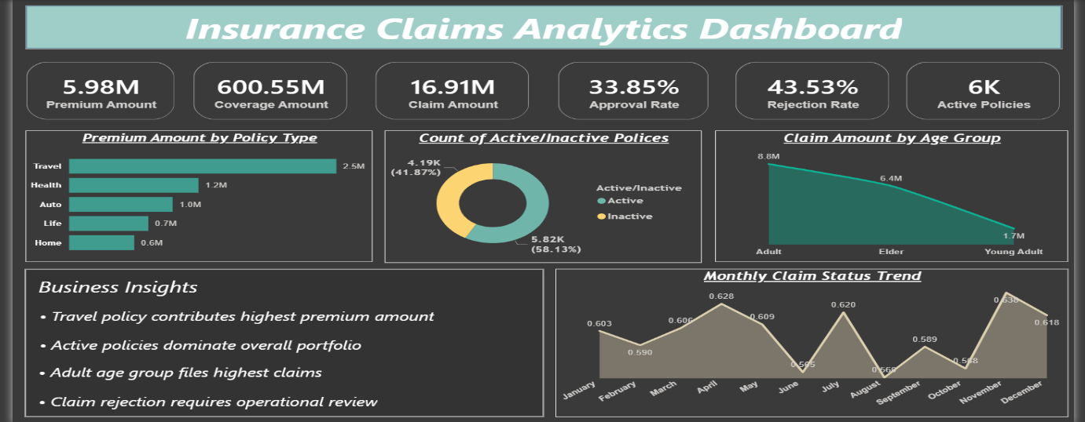
10. Table View Explanation
The Table View page provides row-level transaction data.
Users can view detailed records for each policy.
Displayed fields include:
• Policy Number
• Customer ID
• Claim Number
• Age
• Gender
• Coverage Amount
• Premium Amount
• Claim Status
• Claim Amount
This page helps in detailed operational review.
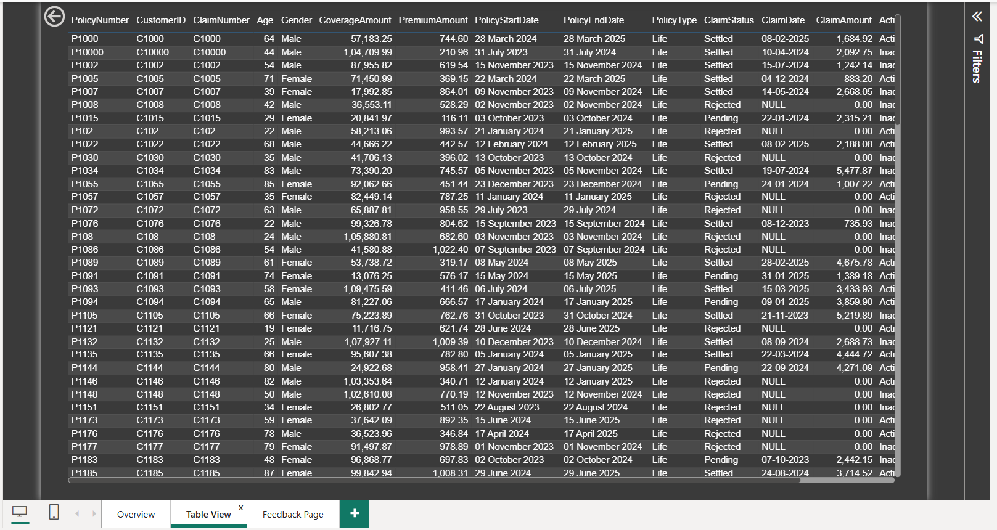

11. Feedback Analysis PageThe Feedback page analyzes customer service feedback.
A word cloud was used to identify common customer expressions.
A sentiment score was calculated to classify feedback quality.
A count chart was added to compare excellent and good feedback responses.
This section adds customer-centric analysis to the insurance project.
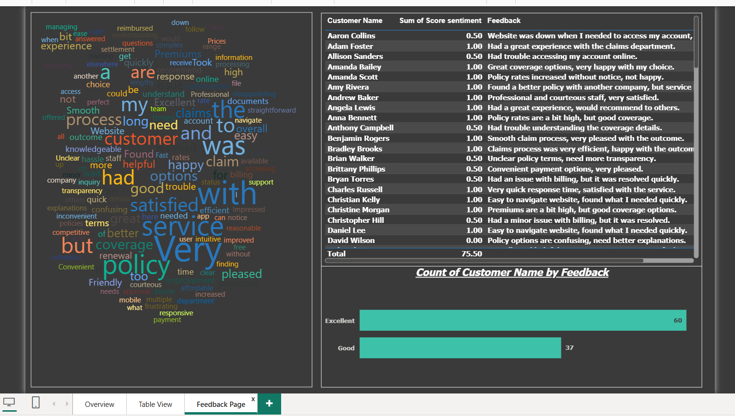

12. Business Insights Generated
Major insights from the dashboard include:
• Travel policy contributes highest premium revenue
• Active policies dominate the overall insurance portfolio
• Adult customers generate the highest claim amount
• Claim rejection remains significant and requires operational review
These insights help management identify focus areas.

13. Power BI Service Deployment
After development, the dashboard was published to Power BI Service.
This allows cloud-based access, sharing, and online reporting.
Power BI Service makes the dashboard available for remote viewing and business presentation.

14. Conclusion
This project demonstrates practical business intelligence skills using Power BI.
It covers data cleaning, data modeling, DAX calculations, KPI reporting, dashboard design, and business interpretation.
The project can be extended further by integrating SQL databases, Python automation, or cloud data pipelines.

