Sales Analytics Dashboard using Power BI
Submitted By
Abhishek Kumar
Project Type
Business Intelligence / Sales Analytics Dashboard
Tools Used
- Power BI Desktop
- Power BI Service
- DAX (Data Analysis Expressions)
- Data Modeling

1. Introduction
The Sales Analytics Dashboard is an interactive business intelligence project developed using Power BI to analyze sales performance and generate decision-support insights. The dashboard transforms raw sales data into visual reports that help understand product performance, profitability, promotion effectiveness, sales trends, and regional sales distribution.
The project was developed in Power BI Desktop and later published to Power BI Service for cloud-based accessibility and report sharing.

2. Project Objective
The main objectives of this project are:
- To identify top-performing and low-performing products
- To analyze sales trends across time periods
- To compare sales, profit, and quantity across selected periods
- To study discount and promotion impact
- To monitor city-wise sales performance
- To provide transaction-level business reporting

3. Problem Statement
Businesses often generate large volumes of sales data but face difficulty in extracting actionable insights quickly.
This dashboard solves that problem by providing an interactive reporting solution where business users can analyze:
- Which products perform best
- Which products generate low profit
- Which promotions are effective
- Which cities contribute most to revenue

4. Dataset Description
The dataset contains transactional sales information.
Main Fields Used
- Order ID
- Customer ID
- Product ID
- Product Name
- Sales
- Profit
- Quantity
- Discount
- Promotion Category
- City
- Order Date

5. Data Model
The project follows a star schema data model.
Tables Used
- Fact Table
- Customer Dimension Table
- Product Dimension Table
- Promotion Dimension Table
- Date Table 1
- Date Table 2
- Measure Table
Relationship Design
The fact table stores transactional records, while dimension tables provide descriptive attributes used for filtering and analysis.

6. Measures Created Using DAX
Several analytical measures were created using DAX.
Sample Measures –
Quantity Sold = CALCULATE(SUM('Fact Table'[Units Sold]),ALL('Date Table 1'), USERELATIONSHIP('Date Table 2'[Date],'Fact Table'[Date (dd/mm/yyyy)]))

Sum of Net Sales = CALCULATE(SUM('Fact Table'[Net Sales]),ALL('Date Table 1'), USERELATIONSHIP('Date Table 2'[Date],'Fact Table'[Date (dd/mm/yyyy)]))

Total Profit = CALCULATE(SUM('Fact Table'[Profit]), ALL('Date Table 1') , USERELATIONSHIP('Date Table 2'[Date] , 'Fact Table'[Date (dd/mm/yyyy)]))
These measures were used to calculate KPI cards and visual analysis.

7. Dashboard Pages
Page 1: Top and Bottom 5 Analysis
This page shows:
- Top 5 products by sales
- Bottom 5 products by sales
- Top 5 products by quantity
- Bottom 5 products by quantity
- Top 5 products by profit
- Bottom 5 products by profit

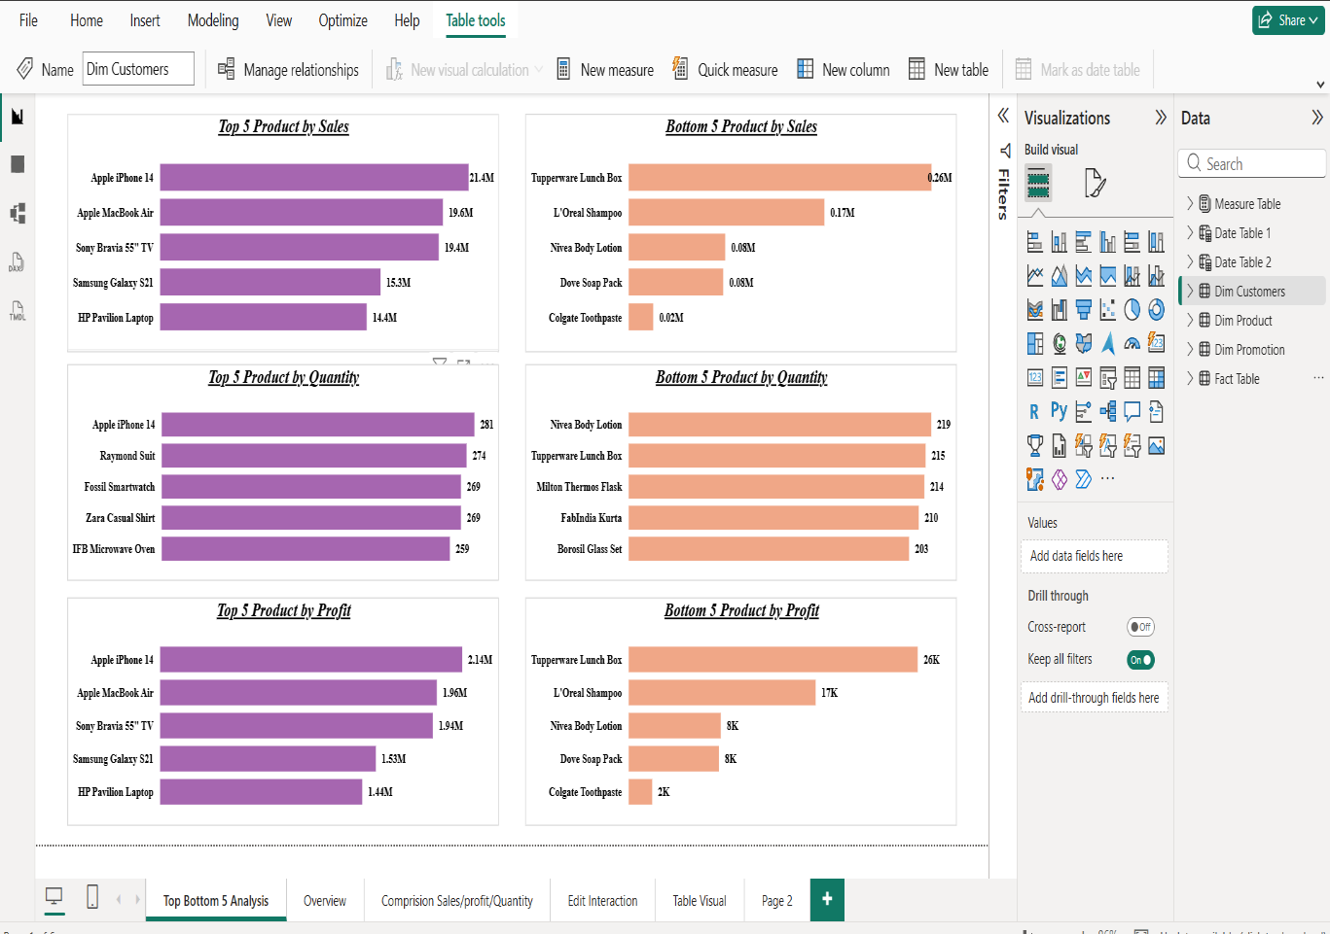

Page 2: Overview Dashboard
This page contains:
- Sales by city
- Total order count
- Promotion category discount analysis
- Sales vs profit scatter plot
- Sales trend over time

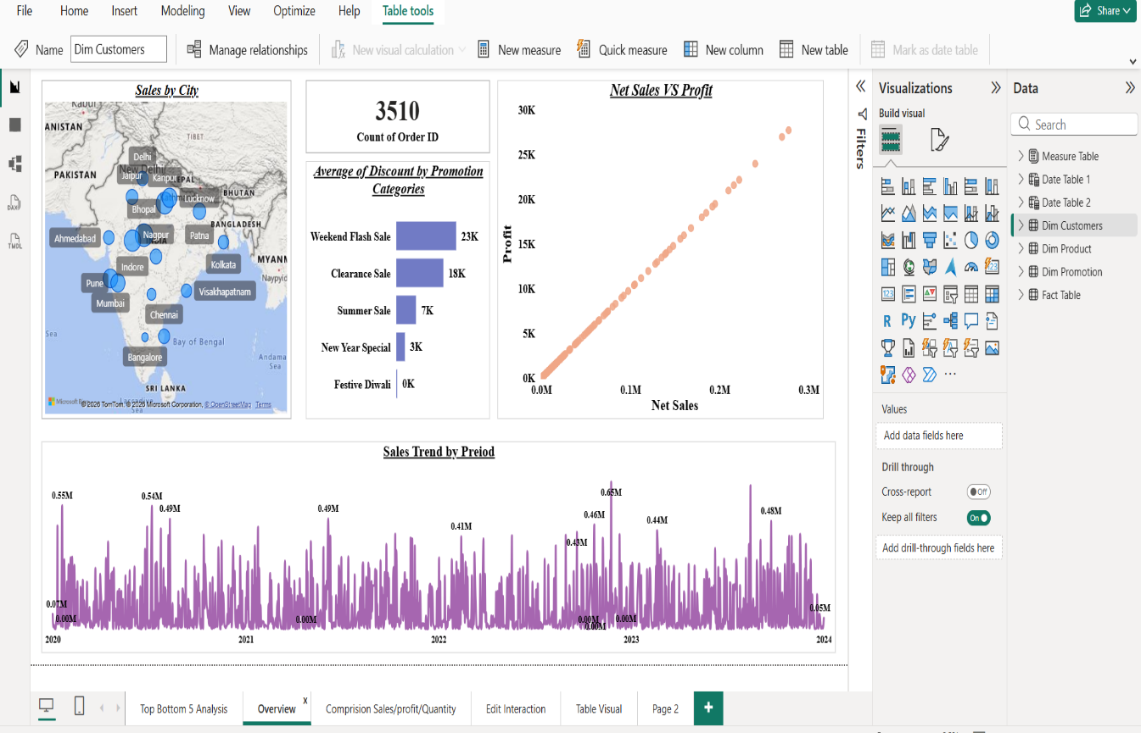

Page 3: Comparison Dashboard
This page compares:
- Sales between two selected periods
- Profit between two selected periods
- Quantity between two selected periods
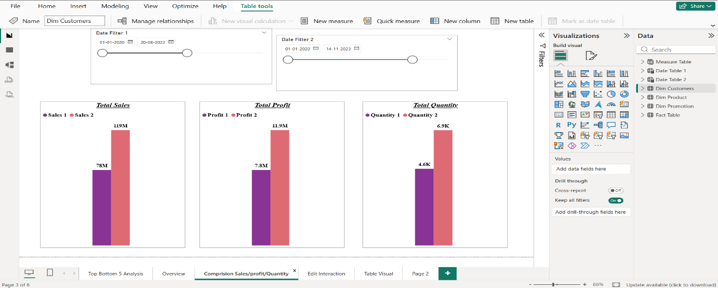

Page 4: Interactive Analysis
Interactive slicers allow filtering by:
- Date
- Product
- Customer
- Promotion
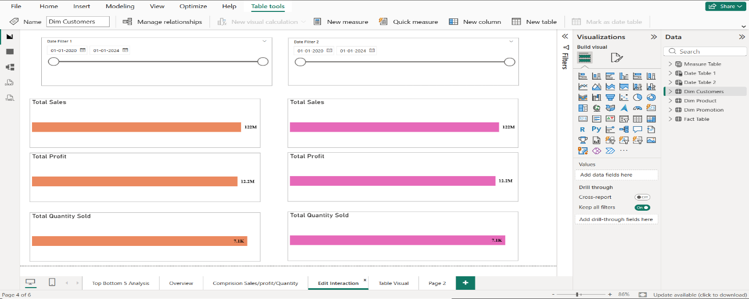

Page 5: Transaction Table View
This page provides detailed transaction records including:
- Order ID
- Date
- Sales
- Profit
- Discount
- Quantity
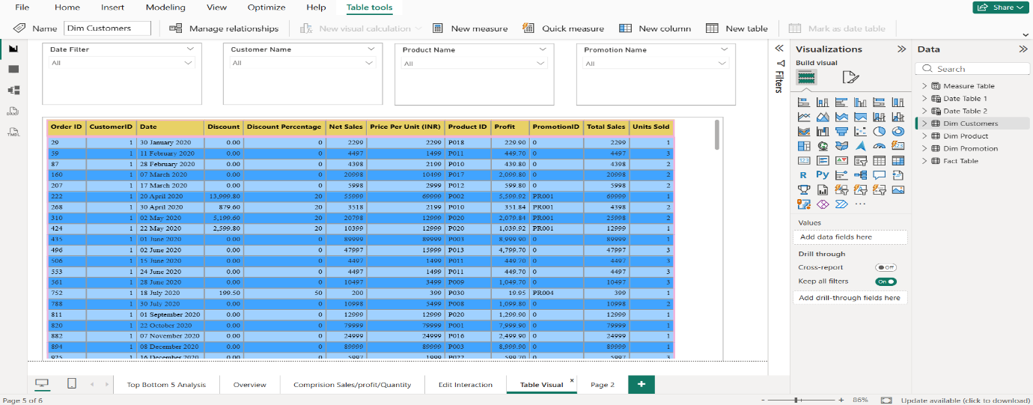

Page 6: Filter Analysis Page
Additional filters help users focus on specific business segments.
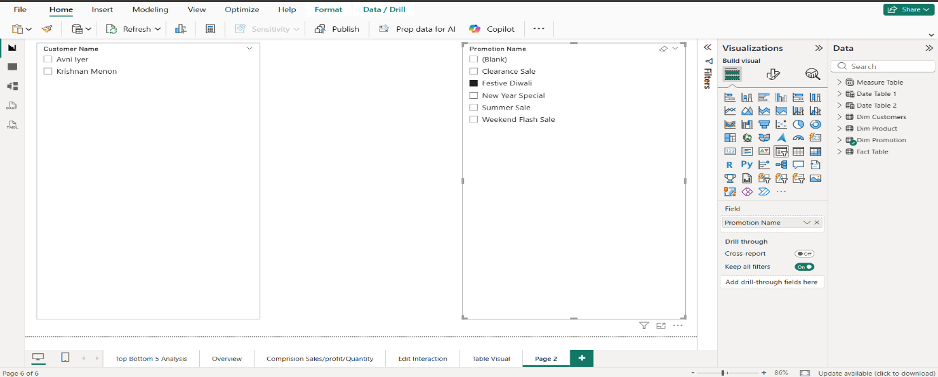

8. Key Insights Generated
The dashboard produced the following business insights:
- Apple iPhone 14 generated highest sales and profit
- Tupperware Lunch Box showed lowest performance
- Weekend Flash Sale had highest average discount
- Metro cities contributed highest revenue
- Sales and profit showed positive correlation

9. Dashboard Output
The dashboard helps decision makers to:
- Identify profitable products
- Detect weak-performing products
- Optimize promotions
- Monitor regional sales
- Support inventory planning

10. Publishing to Power BI Service
After dashboard development, the project was published to Power BI Service.
Benefits of Publishing
- Cloud-based access
- Online report sharing
- Dashboard accessibility from browser
- Future scheduling support for refresh
This enables the dashboard to be accessed online for demonstration and reporting.

11. Business Value
This dashboard provides a business-ready reporting solution that supports data-driven decision making.
It helps managers understand sales behavior quickly and improve business strategy.

12. Future Improvements
Future enhancements can include:
- Forecasting
- Dynamic KPI indicators
- Drill-through reports
- Advanced DAX calculations
- Scheduled refresh integration

13. Conclusion
The Sales Analytics Dashboard successfully converts raw sales data into meaningful visual insights using Power BI.
It demonstrates practical skills in data modeling, DAX calculations, visualization design, and cloud publishing using Power BI Service.

