**PROJECT-1_INFO-5709**

For this project, we took all_stocks csv formatted dataset, which contains a total 7 attributes, they are date, open, high, low, close, volume and name. It contains all the details of stock prices of some named companies such as apple.

So, to display the visualizations for data understanding purposes, I have used PowerBI. It is interactive software used for data visualizations, which is developed by Microsoft by focusing on business intelligence. This tool is used to display the various kinds of visualizations, which will be helpful for decision making.

As the first step for this project, I have installed powerBI and signed up with help of my university mail to create an account.

Then for processing the visualizations of the data, I have used the get_data option and chosen the extract csv data, and then loaded the data.

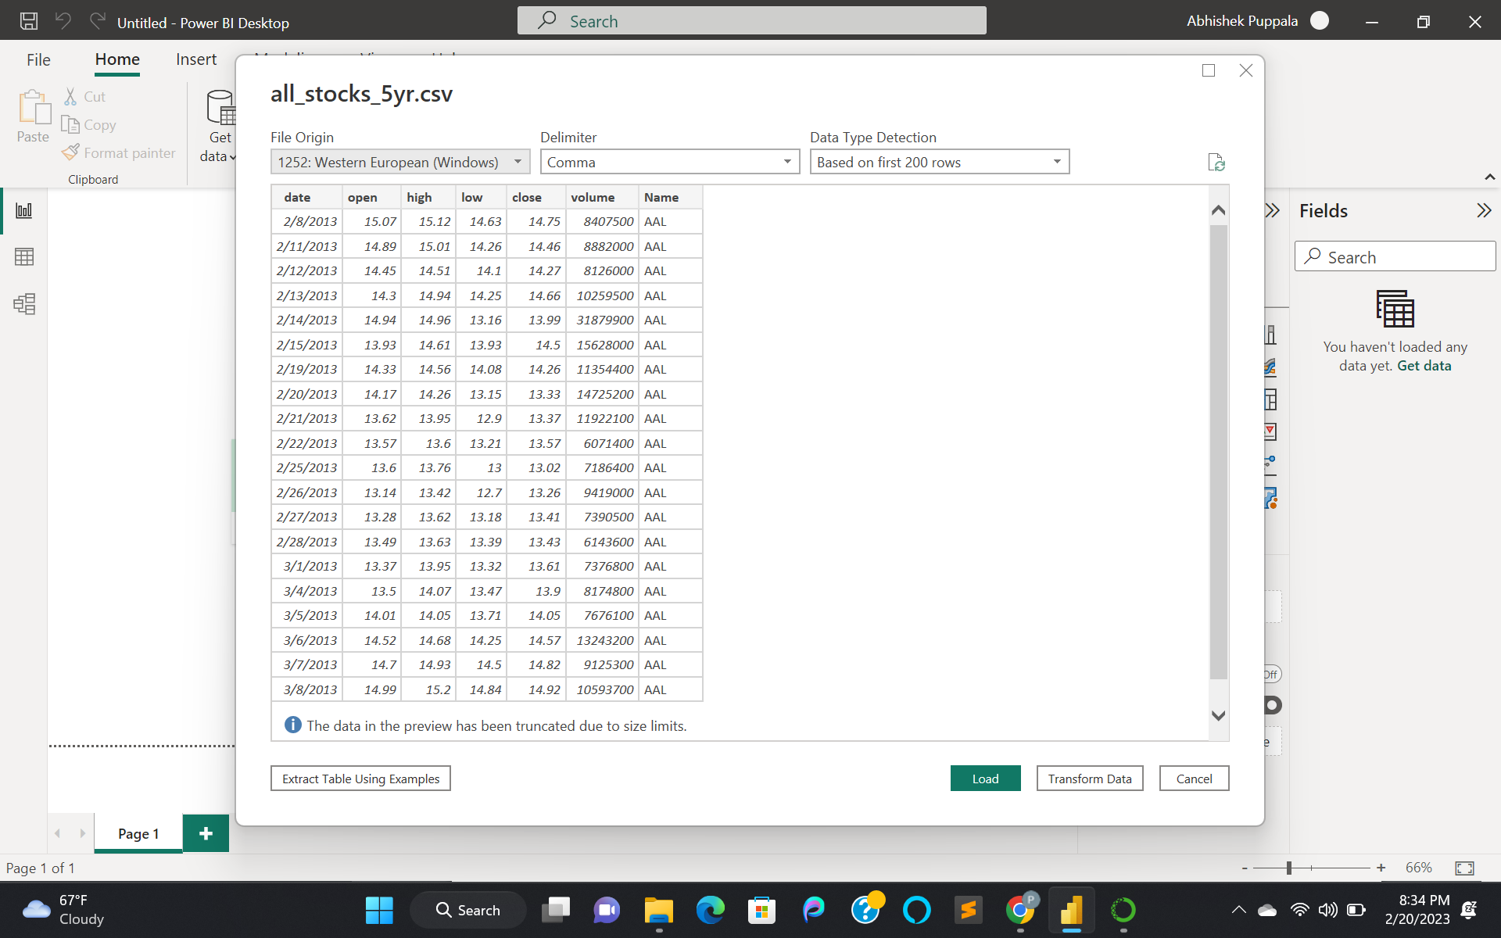

Here, we have decided the datatype for each attribute to be chosen based on the first 200 rows, data type detection.

After loading the data, we get our data in the data-section and visualizations can be found under reports.

Now, for each attribute, the data type can be, Nominal(N), Ordinal(O), Quantitative(Q).

| Attribute/ column | Datatype | N, O, Q |
| --- | --- | --- |
| Date | date | Quantitative (Interval) |
| Open | Decimal number | Quantitative |
| High | Decimal number | Quantitative |
| Low | Decimal number | Quantitative |
| Close | Decimal number | Quantitative |
| Volume | Whole number | Quantitative |
| Name | Text | Nominal |

**Visualization-1:**

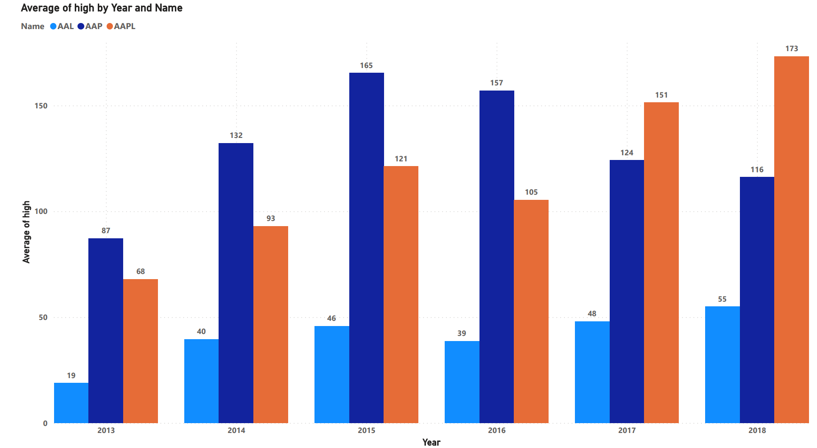

In the above clustered column chart, we took the average of highest stock price per each year of AAL, AAP and AAPL. We took, year as x-axis on the scale of 2013 to 2018(Q) and average of high as y-axis on the scale of 0 to 150 price(Q), which is auto generated and legend labels as 3 names with colors: AAP as dark blue, AAPL as orange and AAL as sky blue. The size is 709 height and 1252 width.

We can see that, in the year 2013, AAP has the highest average stock price, which is 87. For 2014, again it's AAP with 132. Followed by 2015 and 2016, AAP has the highest average stock price with 165 and 157. For 2017 and 2018, it’s AAPL with 151 and 173. From above data, over all the years, 2018 has the highest average stock of high with AAPL of 173.

**Visualization-2:**

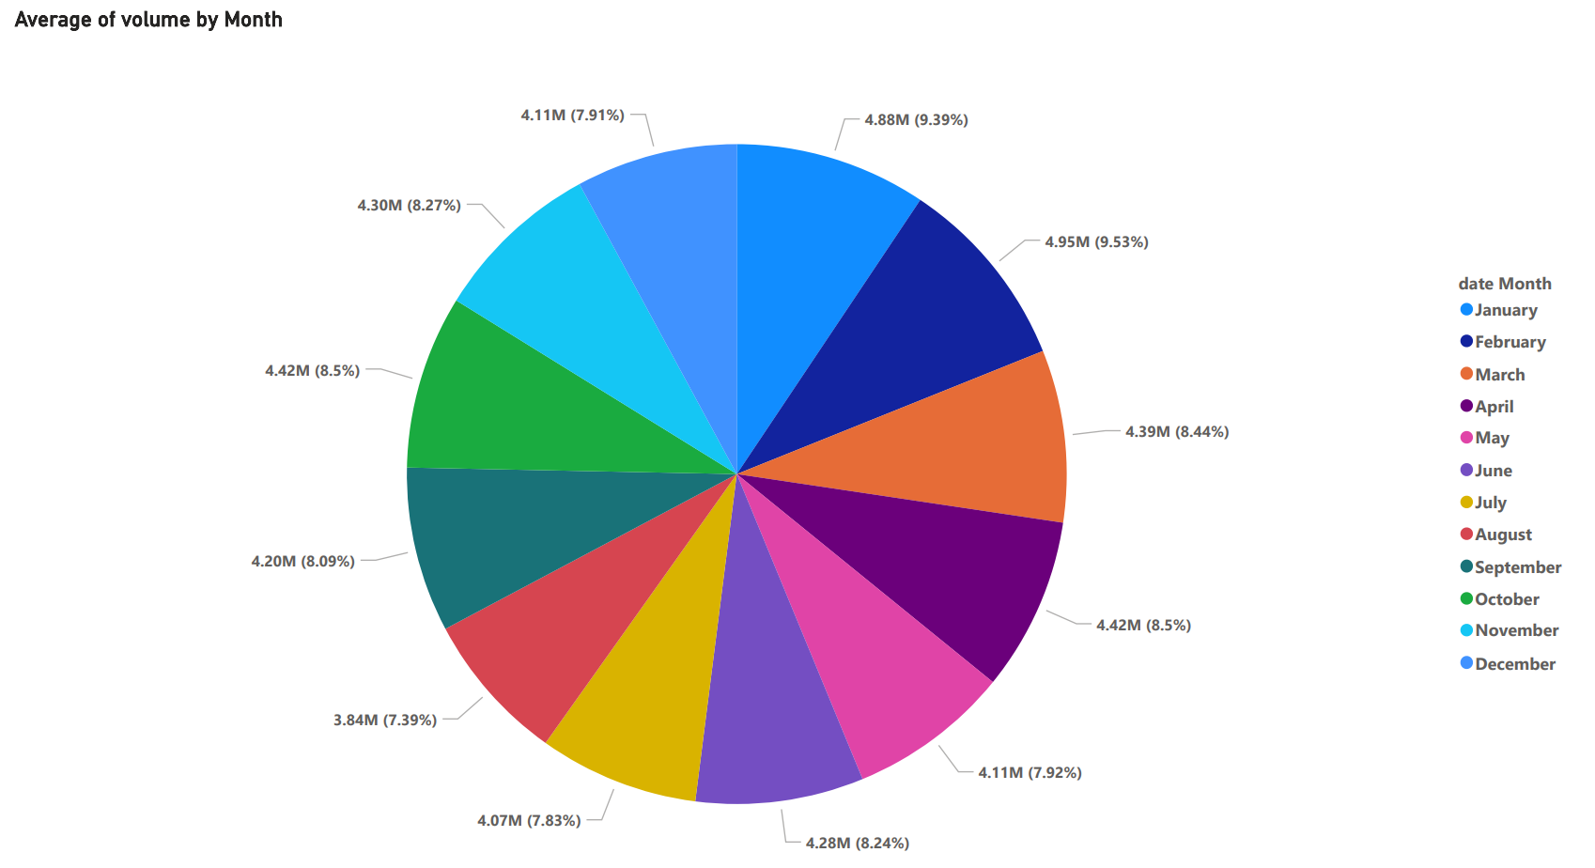

In the above pie chart with rotation of 0 degree, we took legend as various colors each month(N), they are January with dark sky blue, February with dark blue, March with orange, April with dark purple, May with pink, June with purple, July with yellow, August with light red, September with dark green, October with light green, November with sky blue and December with blue, on scale of average of volume values for each month and in terms of percentage(Q). The size is 719 height and 1245 width.

It is the average of volume per each month for all the stocks. Here the volume is, how much share has been traded. As we can see, In february, it got the highest average of all stocks that have been traded with 9.53%. The second one is, in January with 9.39% and then in April and October, with 8.5% has been traded and in march, 8.44% of stock has been traded and 8.27% stock has been traded in November. In June, 8.24% of stock was traded and in September, 8.09% of stock was traded. 7.92% of stock was traded in May and 7.91% stock was traded in December. And lastly, in July and August, 7.83%, 7.39% of stock has been traded.

Before proceeding to the next one, I have created a new column called volume_category with 3 categories such as small, medium, large. By using volume column and adding condition as

volume_category = if([volume]<10000000, "small", if([volume]<100000000, "medium", if([volume]>100000000, "large")))

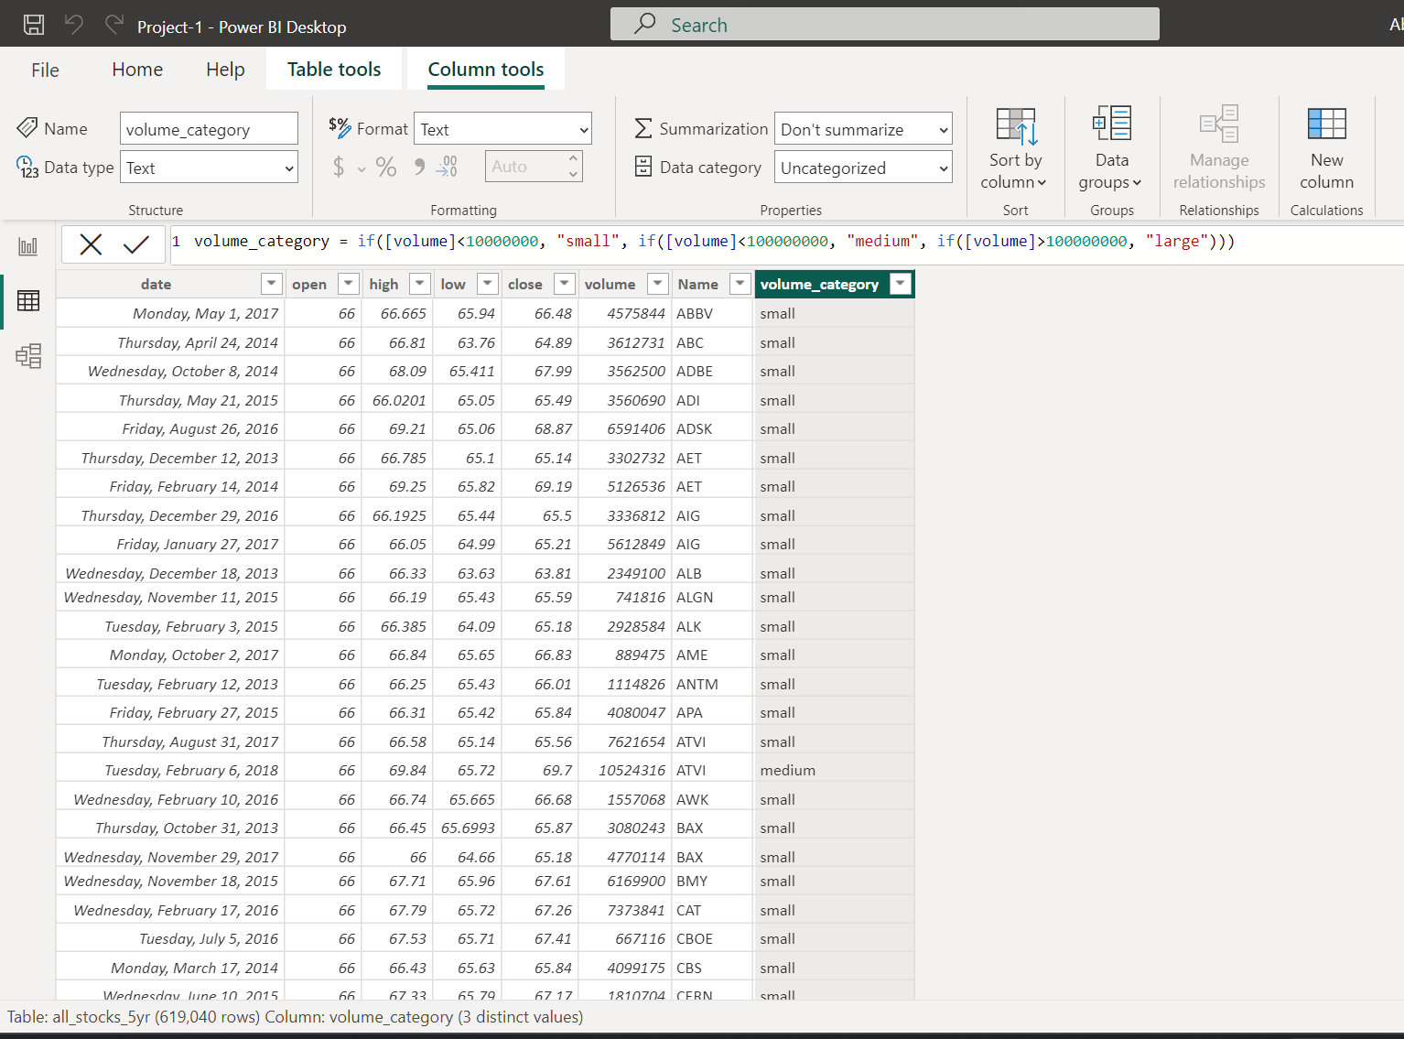

Here, volume_category is the ordinal type of data.

**Visualization-3:**

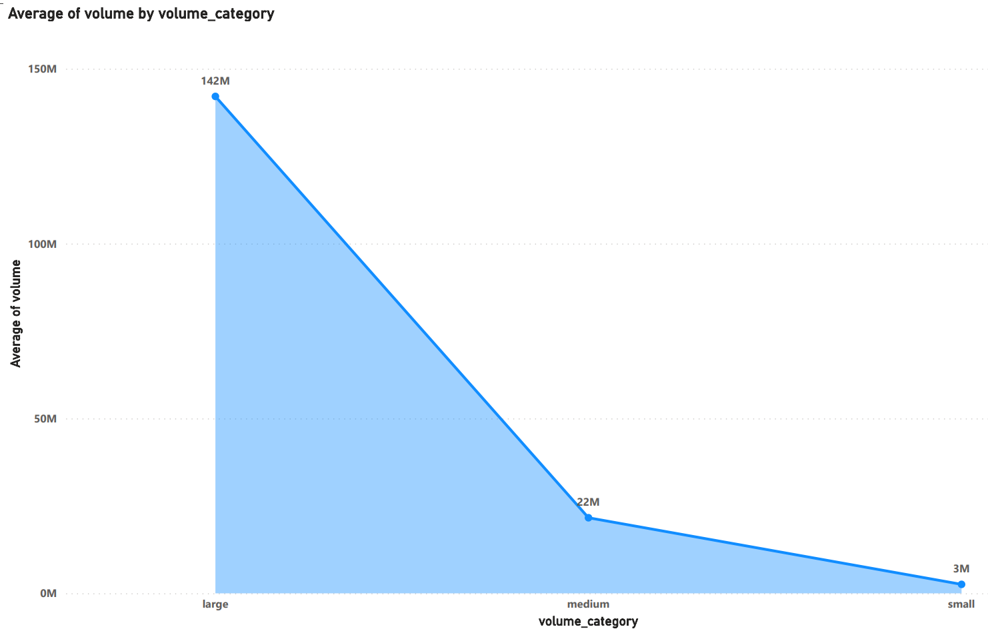

In the above area chart, we took x-axis as volume_category(N) with stock labels as large, medium and small, and on y-axis, we took the average of volume(Q) per each category, on a scale of 0 to 150M (million), which is auto generated. The height is 692 and width is 1123. The color is sky blue.

It describes the average of stock price that has been traded per each category.

As we can see, for the large category of all data, the average of volume is 142M (Million) and for medium category, the average of volume is 22M and followed by small category with volume average is 3M.

**Visualization-4:**

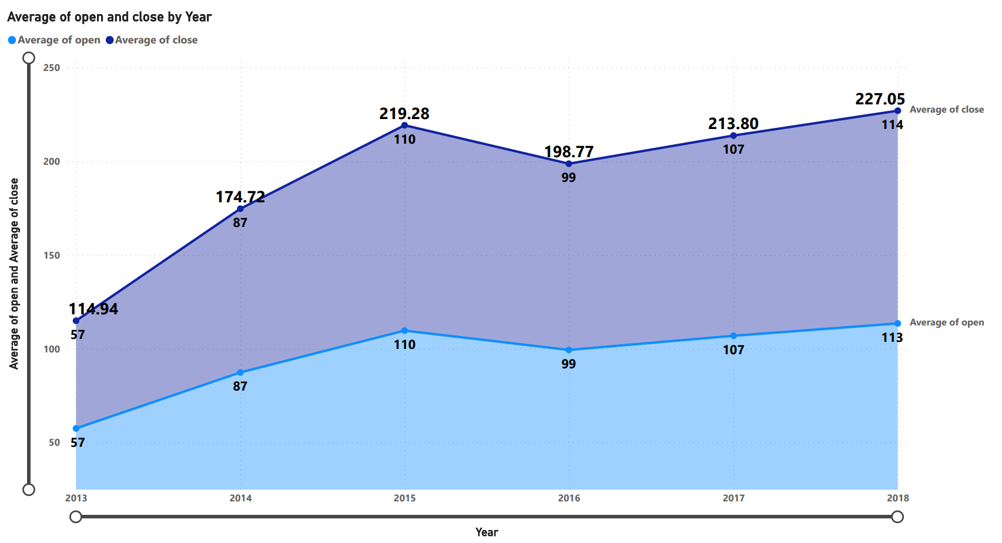

In the above stacked area chart, we took x-axis as Year(Q) on a scale of 2013 to 2018 and y-axis with average values(Q) of open and close stock prices of all stocks over a year on a scale of 0 to 250, which is auto generated. Here, the sky blue represents the average of open stock prices and purple represents the average of close stock prices. The labels of legends are Average of open and Average of close. The height is 668 and width is 1231.

As we can see, in 2013, the average stock price of open and close was 57, with a total of 114.94 units. In 2014, the average stock price of open and close was 87, with a total of 174.72 units. In 2015, the average stock price of open and close was 110, with a total of 219.28 units. In 2016, the average stock price of open and close was 99, with a total of 198.77 units. In 2017, the average stock price of open and close was 107, with a total of 213.80 units. In 2018, the average stock price of open is 113 and close is 114, with a total of 227.05 units.

From the above information, we can conclude that, the highest average stock of open was in 2018 and close was also in 2018.