**Logistic Regression**

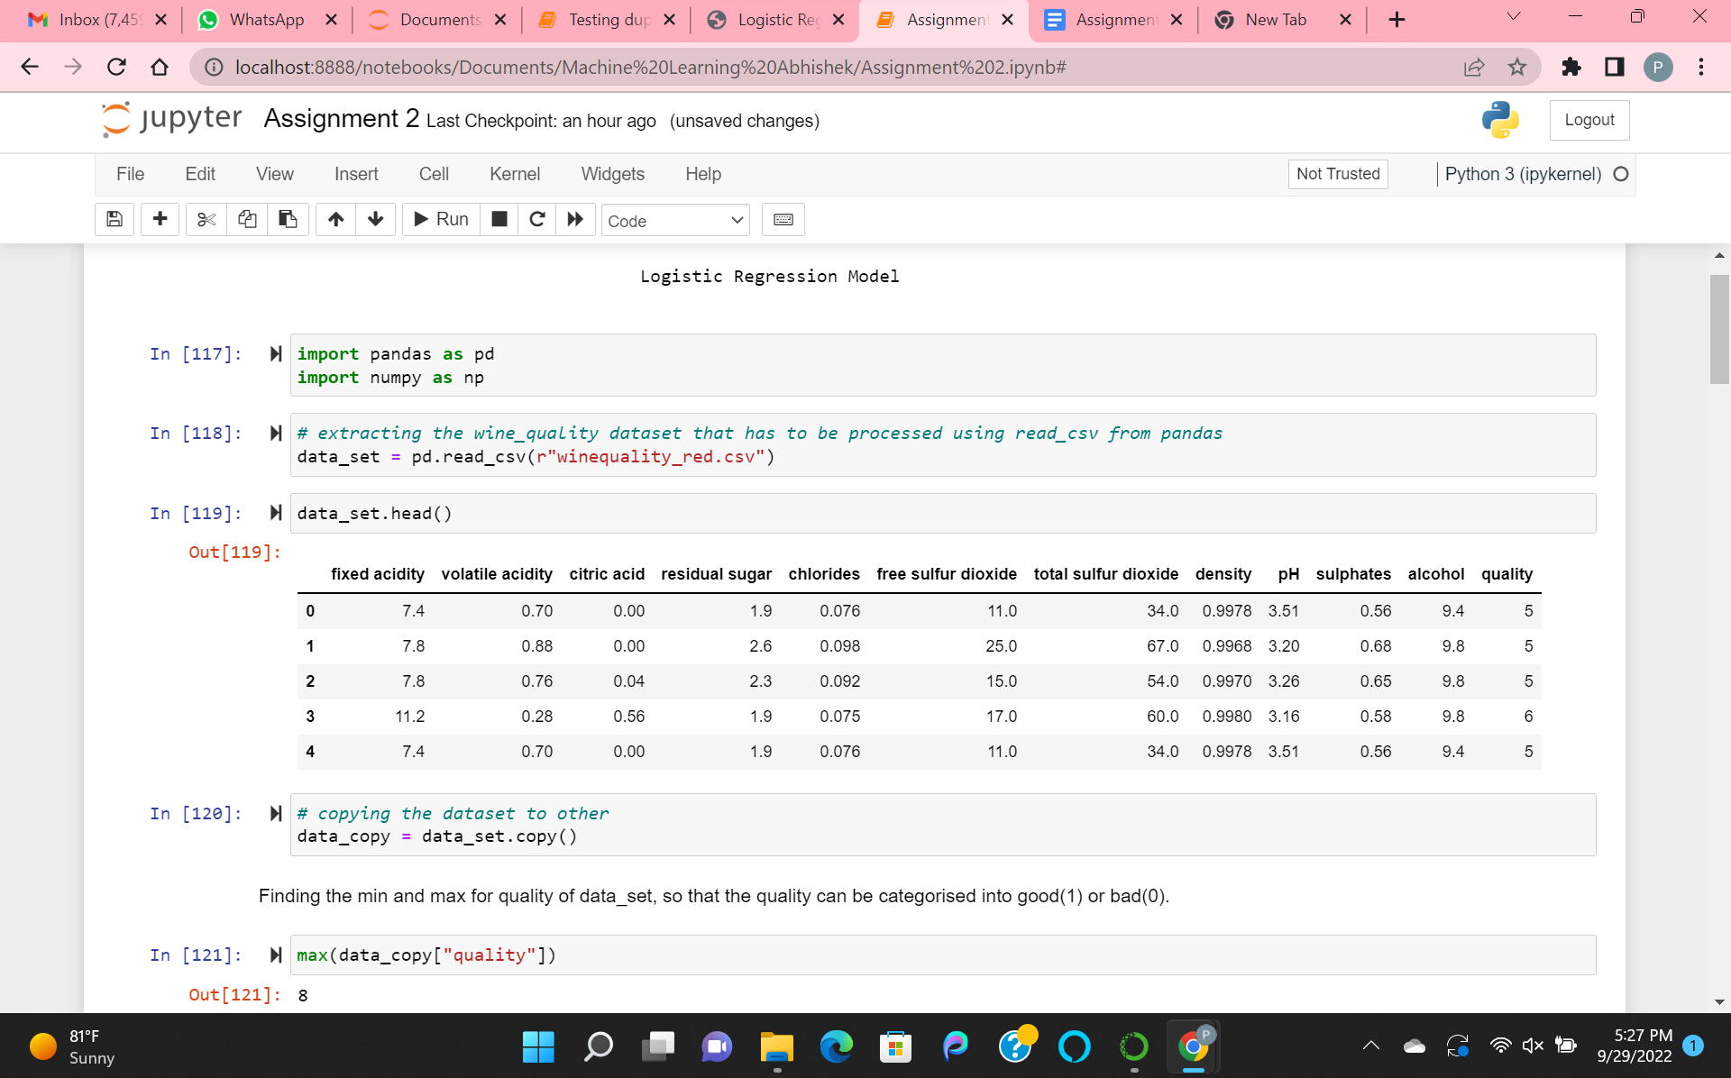

Fetching the winequality_red data set and analyzing

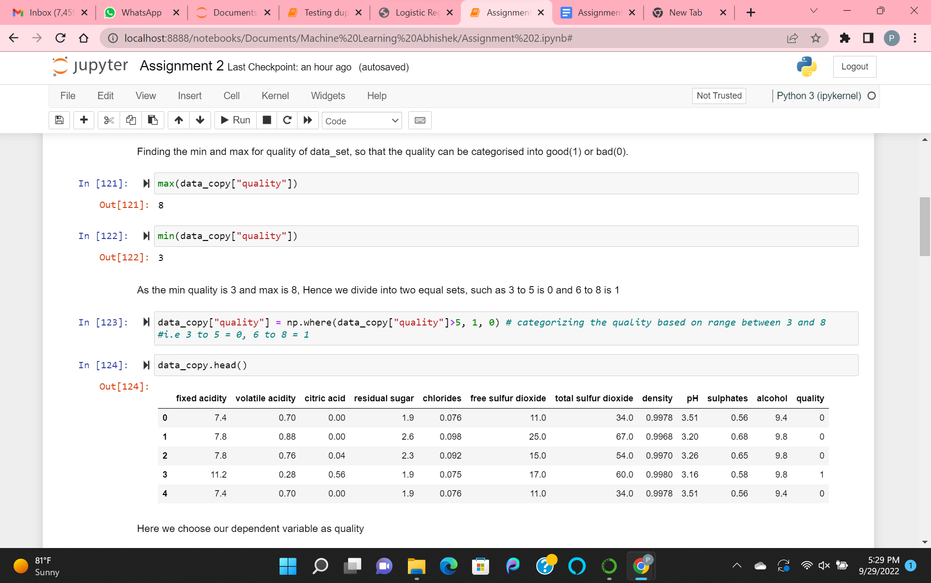

Finding the min and max of quality data. And categorizing it into good(1) or bad(0).

As the minimum quality is 3 and maximum is 8, hence dividing into two equal sets. Such as 3 to 5 as 0 and 6 to 8 as 1.

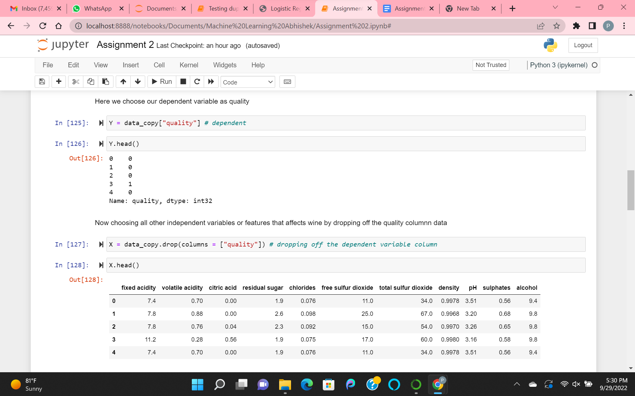

Getting the dependent and independent variables.

Dependent variable as quality.

Getting Independent based on variables that are affecting wine quality. Dropping off quality.

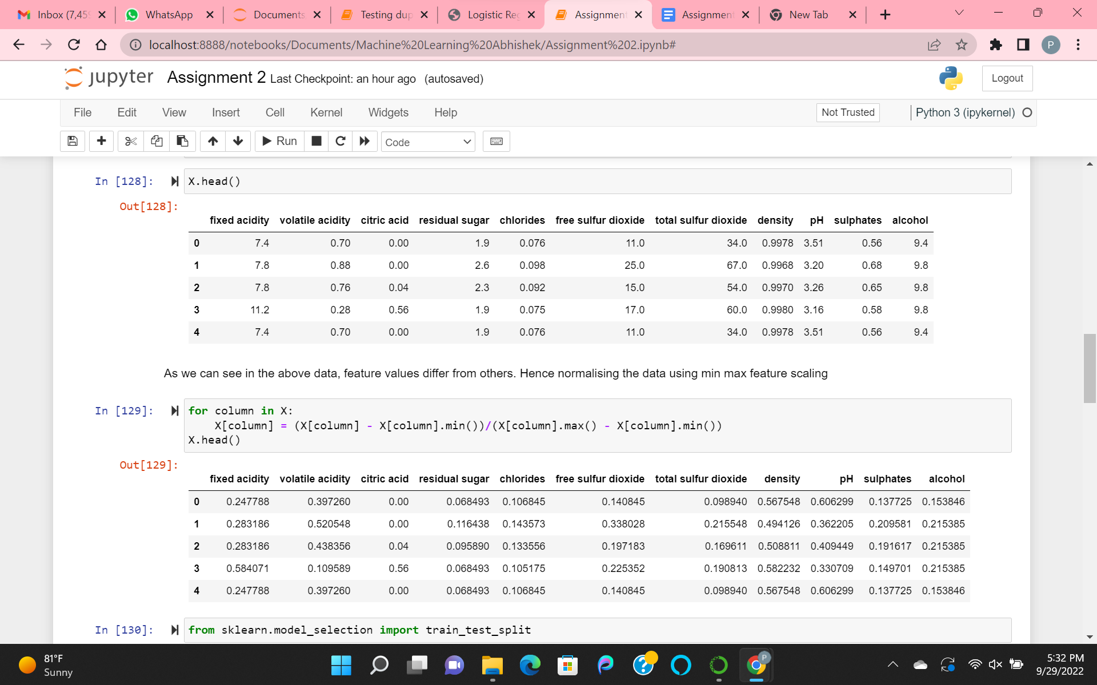

As here, the feature values differ from others. Hence normalizing the data using min max feature scaling.

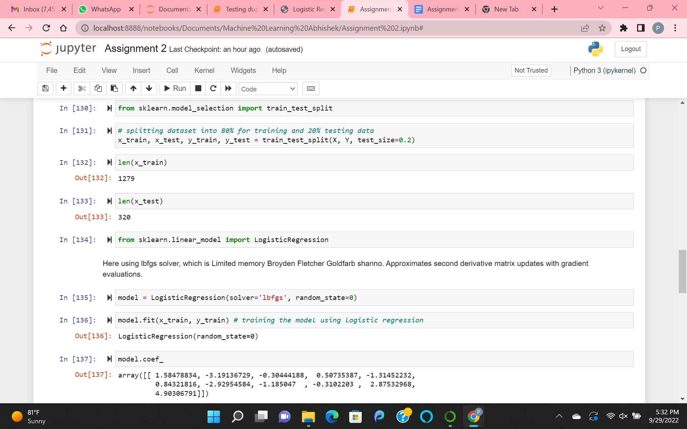

Here splitting the train and test data. Where test_data is 20%.

Training the model using logistic regression with lbfgs solver and getting the coefficients.

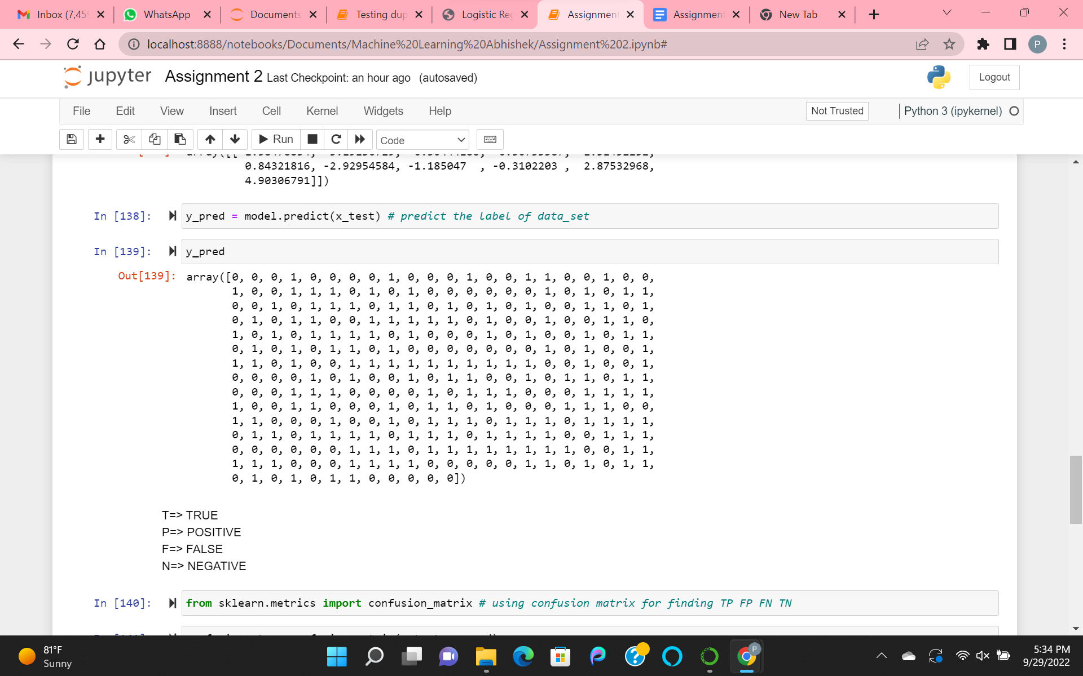

Predict the label of the dataset.

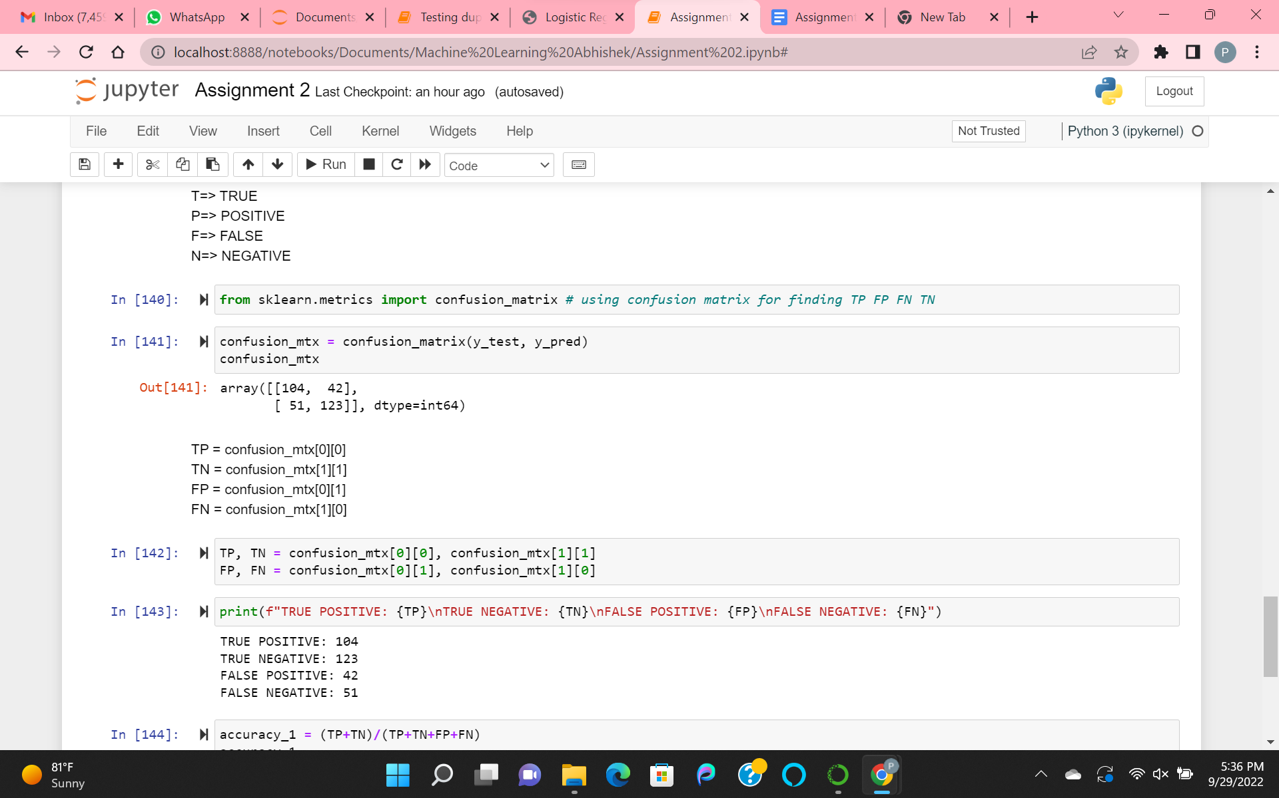

Finding the metrics, i.e TP(true_positive), FP(false_positive), TN(true_negative), FN(false_negative).

With the help of Confusion_Matrix.

Which helps to find the accuracy.

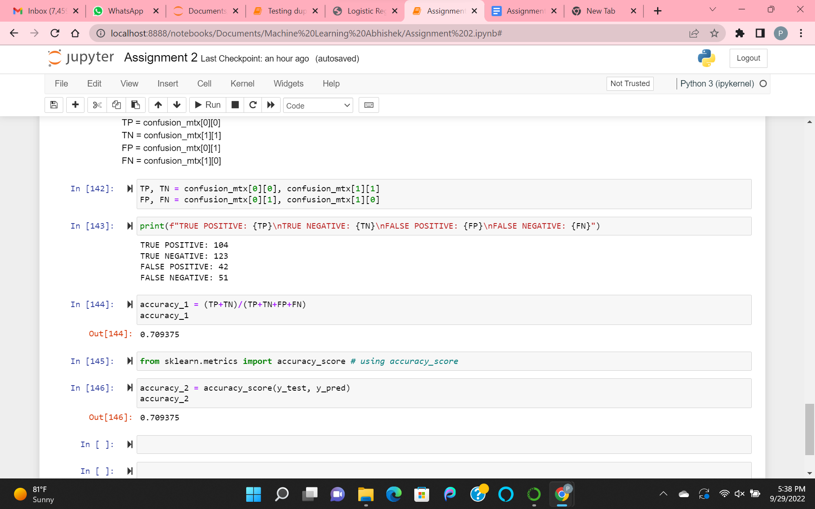

Found the accuracy of the model. With the help of accuracy_score and formula.

Accuracy = (TP+TN)/(TP+TN+FP+FN)