 | <Project Name>  Technical Design Document
 | Prepared By / Last Updated By | Reviewed By | Approved By
Name
Role
Signature
Date

Table of Contents

1.0 Introduction 3
1.1 Purpose of this document 3
1.2 Project overview 3
2.0 Solution Summary 3
2.1 Scope 3
2.2 Assumptions 3
2.3 Dependencies 3
2.4 Risks 3
3.0 Schematic Diagram 3
4.0 System Design 4
4.1 Proposed design 4
4.2 Component inventory 4
5.0 Database Design 4
5.1 Data Model 4
5.2 Tables Structure 4
6.0 Appendices 4
6.1 Glossary 4
6.2 Other 5
7.0 Terms & Conditions 5
8.0 Change Log 5

Introduction

Purpose of this document

The main purpose of this project is to provide shopping online and fulfilling our needs. This document Project overview provides a better understanding of the technical design, component details and database design of Smart Shopping System. The provided document also specifies the scope, assumptions, risks, and dependencies of the project.

1.1 Objectives
The goal of the project is to develop a web application for users to shop online. The main objectives of this system development can be defined as follows:
1. To develop a system that provides functions to support users to register using their given credentials and view the shopping items on the page.
2. To develop a system that provides functions to support shop managers to register using their given credentials and add the product details or modify the details.
3. To support the shop manager to provide billing for the selected products of the customer.
4. To develop a system to update the stock once the item is billed.

5. To develop a system to update the aisle and shelf details by the shop manager.

1.2 Project overview
The Smart Shopping System project, helps many people by providing the right need at the right time in a sophisticated and user friendly platform.
This project describes the user interface being implemented and have a better understanding towards the flow of the Smart Shopping System.
It will provide a user friendly platform to access and purchase the products with and access the bill.

Solution Summary

Scope
Smart Shopping System has the ability to register many users and makes easier to find the product, view its details and purchase it.
- User registration & credential authentication
- Super manager registration & credential authentication
- Fetching product information and product availability information according to the user’s requirement
- Adding and modifying the details of the products by the super manager
- Producing the bill after purchasing the product by manager and updating the stock details
- Ability of the system to disconnect from the system on clicking Log off

Assumptions
The smart shopping helps each person, who is need of any products at the right time, by posting the products and its details in the homepage after registration of user through user credentials. The main aim of this project is to maintain the complete information of the products, with super manager credentials. Product details modification and stock updates with billing are also managed by super manager.

Dependencies
- MySQL is needed for database operations.
- Without Eclipse software, we will not be able to run the application.
- Visual Studio is needed for front end operations.
- Tomcat server the application will not run.
- Spring Boot ,Spring web are used in the applications

Risks
As we are using HTTP Session objects, the data is transferred using http, which is less secured than https, so there is a possibility of data corruption. As we are using HTTP Session objects, the data is transferred using http, which is less secured than https, so there is a possibility of data corruption.

Schematic Diagram
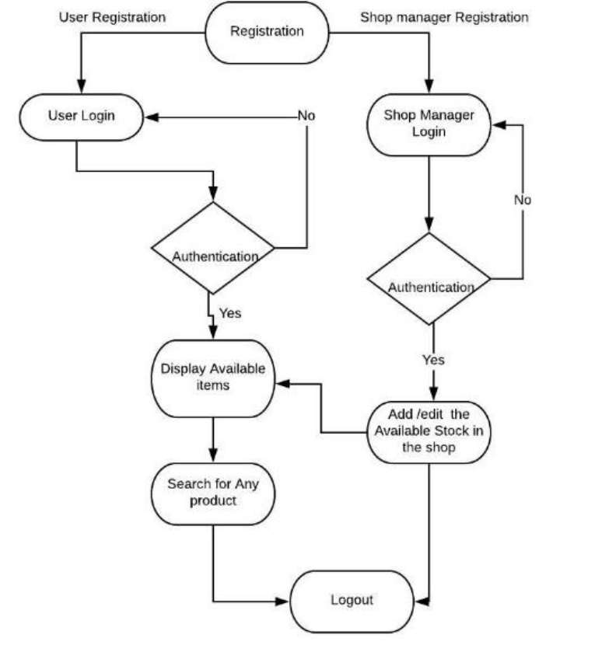

System Design

Proposed design
Considering the anomalies in the existing system computerization of the whole activity is being suggested after initial analysis. The “Smart Shopping System” is an online shopping management system that helps in managing user needs effectively by purchasing the products. This is a web application allows you to access the whole information about the product details, readily scalable and adaptable to meet the complex need of customers.

Component inventory

Model Components
- PurchaseHIstory.java
- Product.java
- Purchase.java
- Quantity.java
- User.java

Controller
- PurchaseController.java
- PurchaseHistory.java
- PendingRequests.java
- ProductController.java
- UserController.java

Service
- PendingServices.java
- PurchaseService.java
- ProductService.java
- UserService.java

Repository
- PurchaseHistoryRepository.java
- PurchaseRepository.java
- QuantityRepository.java
- ProductRepository.java
- UserRepository.java

UI-Angular-Components
- Login
- Signup
- Interface
- Search
- Services
- Add Product
- Edit Product
- Inventory
- Productdetails
- User
- Pending details

Database Design

Data Model
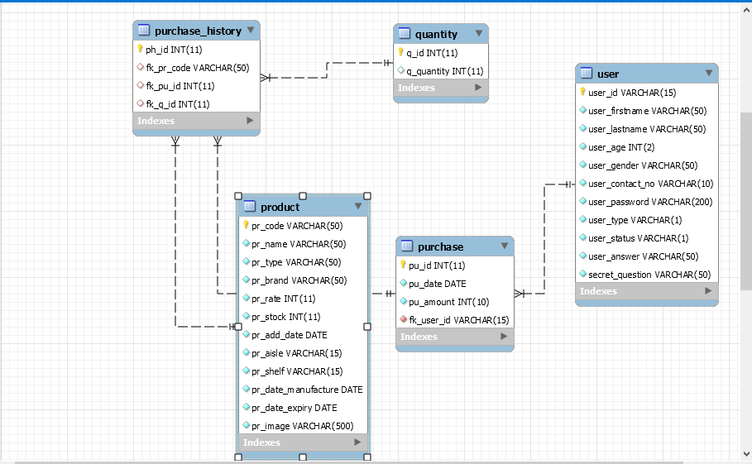

Tables Structure
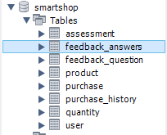
Table Name: quantity
Column Name | Data Type | Length | Nulls
q_id | Int | auto_increment | Not Null
q_quantity | Varchar | 15 | Not Null

Table Name: purchase
Column Name | Data Type | Length | Nulls
pu_id | Int | auto_increment | Not Null
pu_date | Date | - | Not Null
pu_amount | INT | 10 | Not Null
fk_user_id | Varchar | 15 | Not Null

Table Name: purchase_history
Column Name | Data Type | Length | Nulls
ph_id | Int | auto_increment | Not Null
fk_pr_code | Varchar | 50 | Not Null
fk_pu_id | Int | 11 | Not Null
fk_q_id | Int | 11 | Not Null

Table Name: product
Column Name | Data Type | Length | Nulls
pr_code | Varchar | 50 | Not Null
pr_name | Varchar | 15 | Not Null
pr_type | Int | 2 | Not Null
pr_brand | Varchar | 50 | Not Null
pr_rate | Decimal | 15,2 | Not Null
pr_stock | Decimal | 15,2 | Not Null
pr_add_date | Date | - | Not Null
pr_aisle | Varchar | 15 | Not Null
pr_shelf | Varchar | 15 | Not Null
pr_date_manufacture | Date | - | Not Null
pr_date_expiry | Date | - | Not Null
pr_image | Varchar | 500 | Not Null

Table Name:user
Column Name | Data Type | Length | Nulls
user_id | Varchar | 15 | Not Null
user_firstname | Varchar | 50 | Not Null
user_lastname | Varchar | 50 | NotNull
user_age | Int | 2 | NotNull
user_contact_no | Varchar | 10 | NotNull
user_password | Varchar | 15 | NotNull
user_type | Varchar | 1 | NotNull
user_status | Varchar | 1 | NotNull
user_answer | Varchar | 50 | NotNull
Fk_sq_id | Int | 2 | NotNull

Appendices

Glossary
Acronyms | Definitions
http | Hypertext Transfer Protocol

Other

Terms & Conditions
Interns shall be solely responsible for all its acts and omissions under this program. Interns will comply at all times with all applicable laws. Interns shall not use Cognizant’s name, logo and trademark in any promotional materials or other communications with third parties without the prior written consent of Cognizant. Any materials used by interns in relation to program will not infringe the copyrights, trademarks, patents, trade secrets or other intellectual property rights, privacy or similar rights of any person or entity. Interns agrees not to post, draw, make, display any content that is threatening, libelous, obscene, defamatory, abusive, pornographic, or advocates/encourages any conduct that could constitute a criminal offence or give rise to any civil liability. Cognizant its associates’ personal details including but not limited to name, address, contact number shall not be shared or forwarded to any third party, without prior written consent of Cognizant, its associates. All intellectual property provided by Cognizant, as part of program shall be owned exclusively by Cognizant. Intern shall indemnify, defend and indemnify Cognizant its associates, officers, directors from and against any claims, demands, loss, damage, liability, causes of action, judgments, or costs and expenses of every nature (including attorney’s fees and expenses) incurred by Cognizant based on any claim that any breach of terms and conditions of this program

Change Log
Please note that this table needs to be maintained even if a Configuration Management tool is used.
Version Number | Changes made
V<n.n> | <If the change details are not explicitly documented in the table below, reference should be provided here>
V<n.n> | Page no | Changed by | Effective date | Changes effected

