A) System Requirements:
1. Linux Server
2. Apache 2.0+ Server
3. PHP 5.3+
4. Enable curl extension
5. Enable register_argc_argv

B) How to Install:
1. Upload all the script on the server
i) xerox/create_issue.php
ii) xerox/lib/OAuthApi.php
iii) xerox/lib/OAuthApiException.php

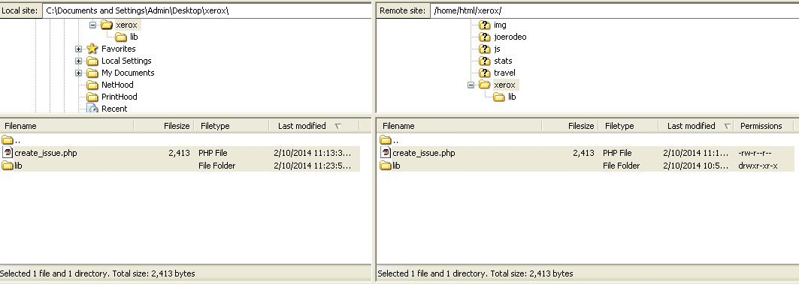

2. Open command line and connect to server via host username & host password

3. Change directory to xerox
e.g. cd /var/home/html/xerox/

4. Run Command line command to post repository issue on the github|bitbucket
e.g. php create_issue.php username password "https://github.com/example/test" "Issue Title" "Issue Description"
e.g. php create_issue.php username password "https://bitbucket.org/example/test" "Issue Title" "Issue Description"

