**Visualisation of Observations:**

* **Introduction:**
* The purpose of this project is to put in practice what I learned in data wrangling data section from Udacity Data Analysis Nanodegree program. The dataset that is wrangled is the tweet archive of Twitter user @dog_rates, also known as WeRateDogs.It is a twitter account which rate peoples dogs with a humorous comments about the dog.
* **About Dataset:**

To analyze the tweets from WeRateDogs™, we have used three different source. The first source is an archive of the past tweets from @dog_rates (https://twitter.com/dog_rates) provided via a CSV from Udacity. The second source is from the Twitter API used to retrieve more information about the tweets like number of each was retweeted. The third data source provides us the predicted dog breed in each tweet's image programatically determined from a neural network. This was also provided by Udacity. This third source is particularly important as it was not determined how accurate the predictions were. Combining this data from these sources, we ended up analyzing 2174 tweets from WeRateDogs. These tweets were from before August 2017 and were used to analyze the relationship between retweets and favorites amongst the different "dog stage" (floofer, pupper, doggo, etc.), the distribution of dog breeds in the tweets, and the popularity of the dog breeds based on retweets and favorites.

**Visualisation:**

* **Most common dog category:**

After cleaning the dataset we can conclude that pupper is most common dog category amongst the other categories. It can be seen that of all the dog stages tweeted, pupper was the most common. However, we see that doggos (the next most common) and puppos were favorited more than retweeted compared to the average tweets.

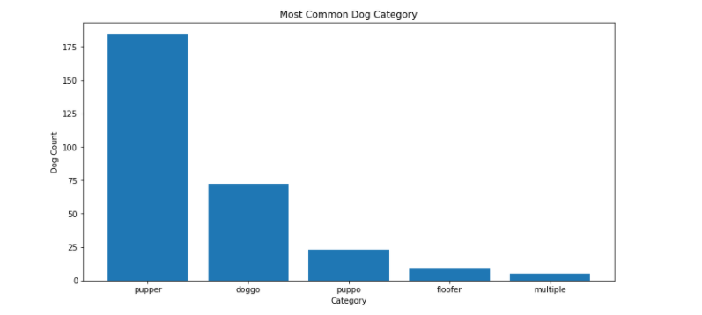

* **Tweet source comparison:**

To check which is the most used platforms peoples used to tweet about the dogs,I used the tweet source comparison.So we can conclude that most of the people uses twitter for iphone to tweet.

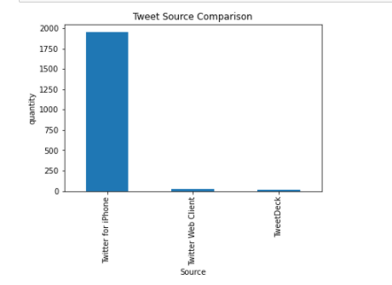

* **Most favourite dog breed:**

Amongst all other findings of this dataset was which is the favourite dog breed?

After analysing the dataset we see that the most popular dog breed is the golden retriever, followed by the labrador retriever, the pembroke and so on.

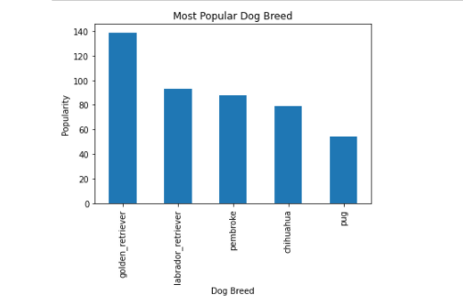

**Conclusion:**

After analysing this dataset we can see that data wrangling is a skill every data analyst should be familiar with. After gathering the data from various sources ,then assessing the data and last cleaning the data for better analysis these are the main processes of data wrangling. After analysis there is more things in this dataset we can analyse for better understanding of dataset and the things happening through social media by analysing the peoples opinions.