Zoomify Video Conferencing App

Project Description
Zoomify is a real-time video conferencing web application developed using the MERN stack (MongoDB, Express.js, React.js, Node.js). The application enables users to create and join virtual meeting rooms with secure authentication, real-time video/audio communication, and an intuitive user interface. Zoomify is designed with scalability, modularity, and performance in mind, following industry-standard best practices such as MVC architecture, JWT-based authentication, and protected routes.

Scenario
With the increasing demand for remote communication, Zoomify aims to provide a reliable and user-friendly platform for online meetings, team collaboration, and virtual discussions. The system supports authenticated users, secure room management, and seamless real-time interaction.

System Requirements

1. Software Requirements
The following tools and technologies are required to develop, test, and run the Zoomify application:
- Operating System: Windows 10/11, macOS, or Linux
- Node.js: v16 or above (JavaScript runtime for frontend and backend)
- npm: v8 or above (Dependency management)
- React.js (CRA): Frontend library for building responsive UIs
- Express.js: Backend framework for RESTful APIs
- MongoDB: NoSQL database for user and room data storage
- Browser: Google Chrome / Mozilla Firefox (latest versions)
- Postman: API testing tool
- Visual Studio Code: Code editor
- Git & GitHub: Version control and source code management

2. Hardware Requirements
- Processor: Intel Core i5 (8th Gen or above) / AMD Ryzen 5 or better
- RAM: Minimum 8 GB (16 GB recommended)
- Storage: At least 1 GB free space
- Display Resolution: 1366×768 or higher

Project Architecture

Technical Architecture
Zoomify follows a client-server architecture:
- Frontend (Client): Built using React (CRA), responsible for UI rendering, routing, and interacting with backend APIs.
- Backend (Server): Built with Node.js and Express.js, responsible for business logic, authentication, and API handling.
- Database: MongoDB stores user credentials, room details, and session-related data.
- Real-Time Communication: Implemented using agora WebRTC and Socket.IO for video, audio, and signaling.

ER Diagram (Conceptual Explanation)
- User Entity: Stores user details such as name, email, and encrypted password.
- Room Entity: Stores room ID, room name, host name, and participants.
- Relationship: One user can create multiple rooms, and multiple users can join a single room.

Features
- User Registration and Login (JWT Authentication)
- Create and Join Video Conference Rooms
- Real-Time Video and Audio Communication
- Secure Protected Routes
- Responsive UI using Bootstrap
- MVC Architecture in Backend
- Environment-Based Configuration

Roles and Responsibilities
- Frontend Developer: UI design, React components, routing, API integration
- Backend Developer: API development, authentication, database integration
- Database Management: Schema design and data handling using MongoDB
- Testing: API testing using Postman and UI testing via browser

User Flow
- User registers or logs in.
- JWT token is generated upon successful authentication.
- User accesses protected routes.
- User creates or joins a video room.
- Real-time communication starts.
- User exits the room and logs out.

MVC Pattern Implementation
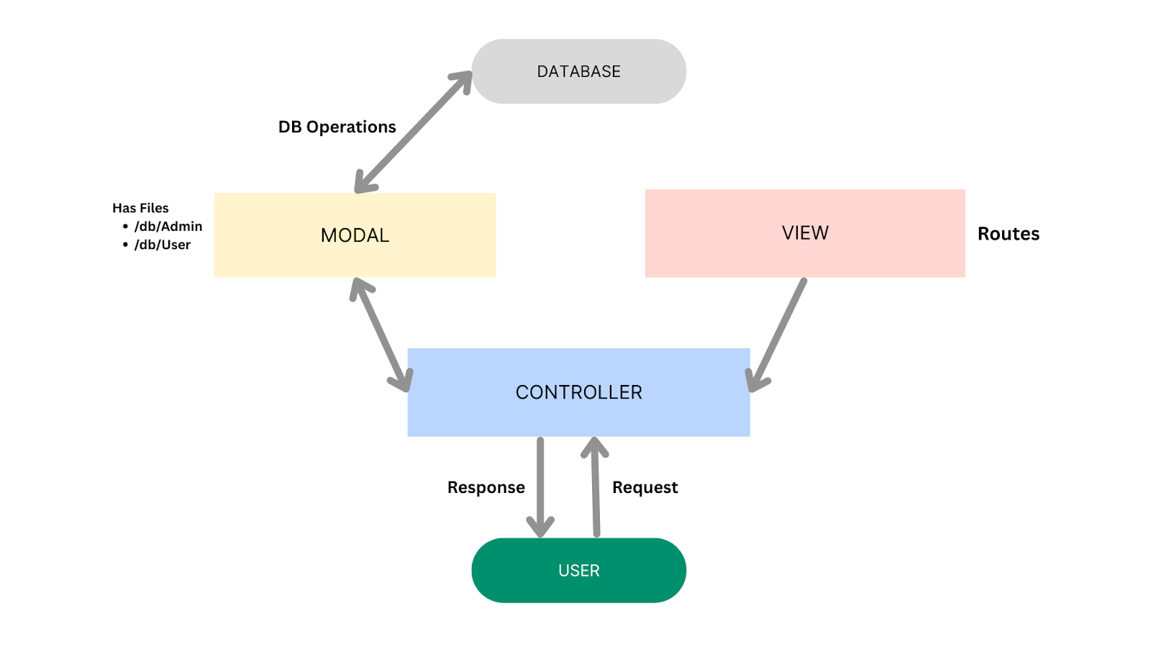

Model Layer
Handles data schemas and database operations using Mongoose.

Controller Layer
Contains business logic, processes requests, interacts with models, and sends responses.

View Layer (Routes)
Defines API endpoints and maps requests to controllers.
Register: /auth/register
Login : /auth/login

Advantages of MVC
- Clear separation of concerns
- Improved scalability and maintainability
- Easier testing and debugging
- Collaboration-friendly structure

Project Setup and Configuration

Folder Structure
- Root Folder: zoomify
  - client (Frontend – React)
  - server (Backend – Node/Express)

Client Setup (React)
cd client
npm install
npm start

Frontend runs on: http://localhost:3000

Server Setup (Backend)
cd server
npm install
nodemon index.js

Backend runs on: http://localhost:6001

Environment Configuration
Create a .env file inside the server folder:
MONGO_URI=mongodb_url
JWT_SECRET=your_secret_key
FRONTEND_URL = your_client_url

Backend Development
- RESTful APIs built using Express.js
- JWT for authentication and authorization
- Socket.IO for real-time signaling
index.js
import express from 'express';
import bodyParser from 'body-parser';
import mongoose from 'mongoose';
import cors from 'cors';
import { Server } from 'socket.io';
import http from 'http';
import dotenv from 'dotenv';

import roomHandler from './socket/roomHandler.js';
import authRoutes from './routes/auth.js';

dotenv.config();

/* ------------------ APP INIT ------------------ */
const app = express();

/* ------------------ MIDDLEWARE ------------------ */
app.use(express.json());
app.use(bodyParser.json({ limit: "30mb", extended: true }));

const corsOptions = {
origin: process.env.FRONTEND_URL, // Allow requests from this origin
methods: ['GET', 'POST'], // Allow specific methods (adjust as needed)
allowedHeaders: ['Content-Type', 'Authorization'], // Allow specific headers (if necessary)
};
app.use(cors(corsOptions));

/* ------------------ ROUTES ------------------ */
app.use('/auth', authRoutes);

/* ------------------ SERVER ------------------ */
const server = http.createServer(app);

/* ------------------ SOCKET.IO ------------------ */
const io = new Server(server, {
cors: {
origin: process.env.FRONTEND_URL,
methods: ["GET", "POST"],
// credentials: true
}
});

io.on("connection", (socket) => {
console.log("User connected");
roomHandler(socket);

socket.on("disconnect", () => {
console.log("User disconnected");
});
});

/* ------------------ DB + LISTEN ------------------ */
const PORT = process.env.PORT || 6001;

mongoose
.connect(process.env.MONGO_URL)
.then(() => {
server.listen(PORT, () => {
console.log(`Server running on port ${PORT}`);
});
})
.catch((err) => {
console.error("DB connection error:", err);
});

(Reference: Backend demo video with Screenshot)

Database Development
- MongoDB used for storing users and rooms
- Mongoose schemas define data structure
Rooms schema
import mongoose from "mongoose";

const RoomSchema = new mongoose.Schema({
roomName: {
type: String
},
host: {
type: String,
require: true
},
meetType: {
type: String,
},
meetDate: {
type: String,
default: null
},
meetTime: {
type: String,
default: null
},
participants: {
type: Array
},
currentParticipants: {
type: Array
}
}, { timestamps: true });

const Rooms = mongoose.model("rooms", RoomSchema);
export default Rooms;

User Schema
import mongoose from 'mongoose';

const UserSchema = new mongoose.Schema({
username:{
type: String,
require: true
},
email:{
type: String,
require: true,
unique: true
},
password:{
type: String,
require: true
},
});

const User = mongoose.model("users", UserSchema);
export default User;

(Reference: Database demo with screenshots)

Frontend Development
- React (CRA) for Frontend development
- Bootstrap for UI
- Axios for API communication
Home.jsx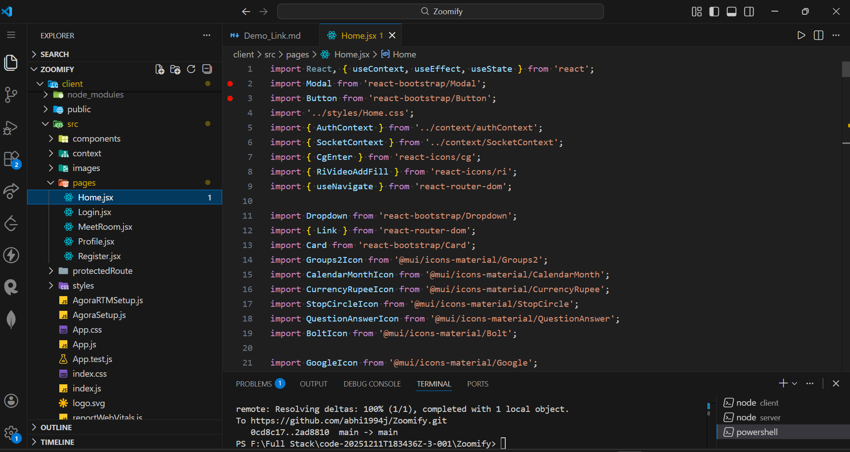
Package.json
"dependencies": {
"@emotion/react": "^11.11.0",
"@emotion/styled": "^11.11.0",
"@mui/icons-material": "^5.11.16",
"@mui/material": "^5.13.4",
"@testing-library/jest-dom": "^5.16.5",
"@testing-library/react": "^13.4.0",
"@testing-library/user-event": "^13.5.0",
"agora-rtc-react": "^1.1.3",
"agora-rtc-sdk-ng": "^4.17.2",
"agora-rtm-react": "^1.1.2",
"agora-rtm-sdk": "^1.6.0-205",
"axios": "^1.13.2",
"bootstrap": "^5.3.0",
"downloadjs": "^1.4.7",
"peerjs": "^1.4.7",
"react": "^18.2.0",
"react-bootstrap": "^2.7.4",
"react-cookie": "^4.1.1",
"react-dom": "^18.2.0",
"react-icons": "^5.5.0",
"react-router-dom": "^6.30.2",
"react-scripts": "5.0.1",
"react-toastify": "^11.0.5",
"recordrtc": "^5.6.2",
"socket.io-client": "^4.6.2",
"web-vitals": "^2.1.4"
},

(Reference: Frontend demo screenshots)

Project Execution Steps
- Start MongoDB service
- Run backend server
- Run frontend server
- Open browser and access the application

Output
- Screenshots with explanation
After opening browser home page is opened


- Demo Video Link (ZOOMIFY_demo_video.mp4 )
- Code Drive Link (https://github.com/abhi1994j/Zoomify)

Mandatory Functionalities Checklist
- MVC Architecture in Backend
- JWT Authentication
- React with CRA
- Protected Routes
- Modern UI with Bootstrap

End of Documentation

