**TOYOTA’s Diesel Engine Plant Opening Ceremony**

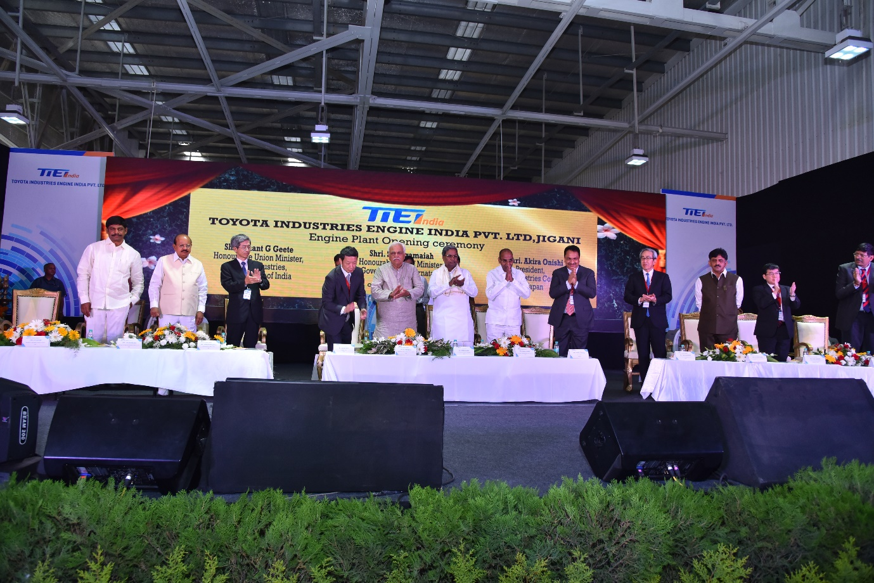

Toyota Industries Corporation (President: Akira Onishi; hereinafter: “Toyota Industries”) held an opening ceremony for its engine production subsidiary, Toyota Industries Engine India Private Limited (hereinafter "TIEI"), on June 23. The ceremony was attended by chief guests Anant G Geete, Honorable Union Minister of Heavy Industries and Public Enterprises, Government of India, Siddaramaiah, Honorable Chief Minister of Karnataka, Government of Karnataka, as well as Japan's envoy to India, Minister Akio Isomata, and a number of representatives from Toyota Motor Corporation and TIEI's suppliers.

At the opening ceremony, Kiyotsugu Kurimoto, president of TIEI, revealed his ambitions for the company: “My goal is for TIEI to become an India's leading engine manufacturer in the near future, and I hope that TIEI's monozukuri (manufacturing) will contribute to the sustainable growth and development of local communities.” Akira Onishi, president of Toyota Industries, spoke of his expectations of TIEI employees: “I believe that TIEI will grow in the promising market of India, and I wish for it to become a company that is trusted both by local communities and by Indian society as a whole.”

India is the world's sixth largest automobile manufacturer*, with production exceeding four million vehicles in 2012. It is a major market for diesel-engine vehicles, which account for some 40 percent of production. In order to have as many customers as possible drive cars fitted with TIEI diesel engines, Toyota Industries and TIEI aim to make TIEI a highly competitive factory, which not only prioritizes quality but also promotes safety and the environment. In addition, the two companies will strive to ensure that TIEI becomes an important base for engine production in India, and so TIEI will play a role in contributing to the automotive-related industries in India.  
  
Toyota Industries will continue to contribute to Toyota's creation of ever-better cars, and strive to construct and improve its global supply system.