**TALK MAGAZINE Vol.35 PHOTO CONTEST**

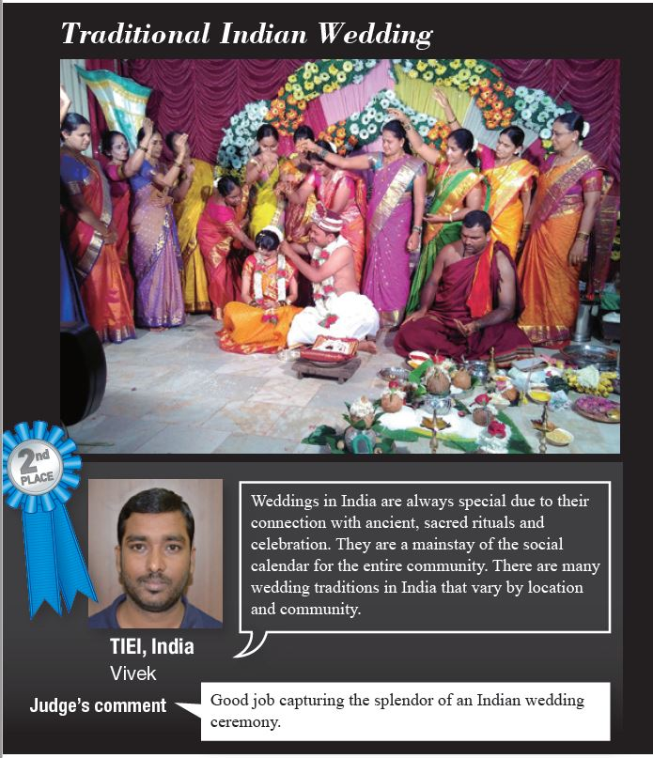

Toyota Industries Group Magazine conducted “TALK Plaza Photo Contest” for its Group of Company. TIEI Participated in the contest and sent Indian traditional wedding photo for the contest. “Weddings in India are always special due to their connection with ancient, sacred rituals and celebration. They are a mainstay of the social calendar for the entire community. There are many wedding traditions in India that vary by location and community.”

This photo won the 2nd place in the contest with Judge’s Commenting on the photo “Good Job to capturing the splendour of an Indian wedding ceremony.”