Adaptive web - Assignment 1   
Abhishek Rao(ASU ID: 1210425135)

The submission contains a Zip file Assign1-Abhishek Rao and a Readme file.

**Build and Run Instructions:**

* Chrome Plugin:
  + - 1. Unzip the Zip file in a folder
      2. Go to chrome://extensions/ in the chrome browser.
      3. Check box on developer mode.
      4. Click on load unpacked extensions.
      5. Navigate to the current directory and select Chrome_Plugin folder.
      6. Check on enabled button and the extension is successfully added to the browser.
* Run the Project :
  + - 1. We have to install Node.js in the system if not installed before.
      2. Open terminal and navigate to the current directory
      3. **mainPage.js** is the main file from which the server will be started, so

Run command “**node mainPage.js**”

* + - 1. Go to chrome and type in the url: <http://localhost:1338/>
      2. You any one of the following accounts :

**UserName** : aaa ; **Password** : 123 ;

**UserName** : bbb ; **Password** : 123 ;

**UserName** : ccc ; **Password** : 123 ;

(6)Click on Logout and log back again so that you can check **the User Login history.**

* + - 1. Click on Stack overflow button.
      2. You can click on tags, click a question , Upvote/ Downvote a question,

Add Bookmark/ Remove Bookmark on a post, Sort the tagged list by “Frequent”, “Votes”, “Unanswered”.

* + - 1. Come back to the Home page and click on logout and login Again to see the **User behavioral logs history** captured.

**Behavioral Logs Captured:**

(1) **Click on a Question:**

I decided to capture this action as it will be helpful for the user to visit the question again.

(2) **Click on tags:**

This action is helpful to understand the interests of the user.

(3) **Upvote/Downvote :**

The user can revisit the questions which he has up voted / down voted before.

(4)**Add Bookmark/ remove Bookmark:**

This action can help to understand that the post is important and the user might want to access it again.

(5) **Sort List by Frequent/Votes/Unanswered:**

User can sort the tagged posts on the basis of most frequent, most votes and can check the relevant posts. He can also click on answered questions and can give the answers to the posts which he has a better understanding on.

**Screenshots:**

* Selection of Different tags

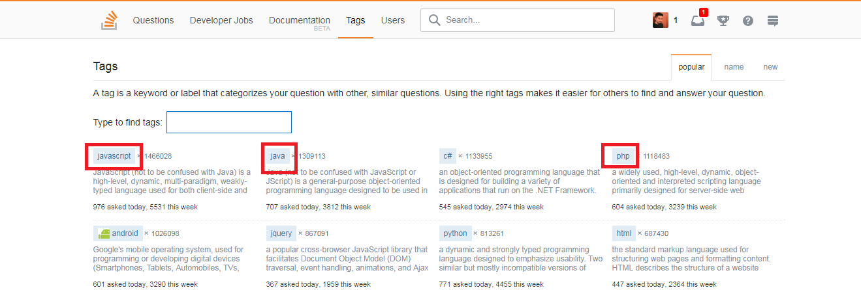

* Selection of a question, Sort the tags by frequent, votes and unanswered.

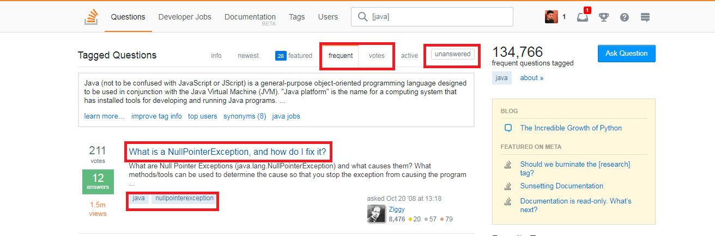

* Upvote/Downvote and Add Bookmark/Remove bookmark.

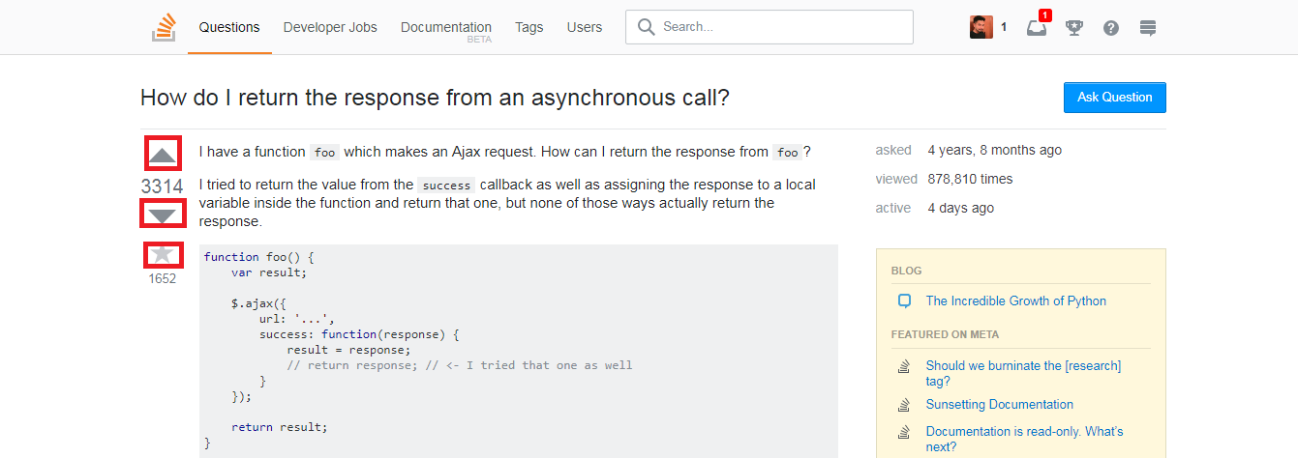

**Different screens:**

**(1)** Index Page**:** This page is built from indexPage.ejs. This page is the first page of the application through which user will login.

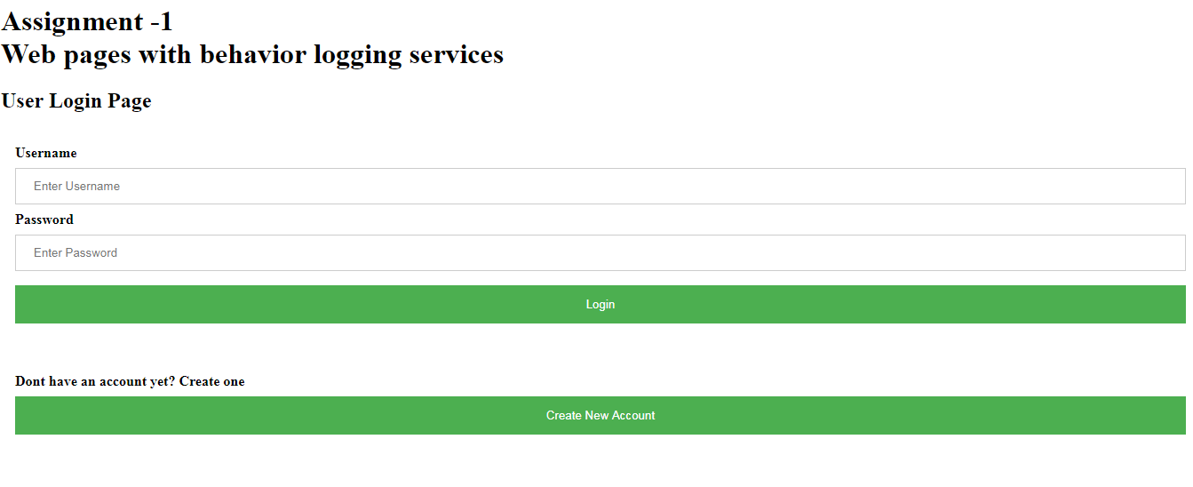

(2)UserHome Page: This page is built from homePage.ejs. The loggedIn history and Behaviour logs history is all shown in this page.

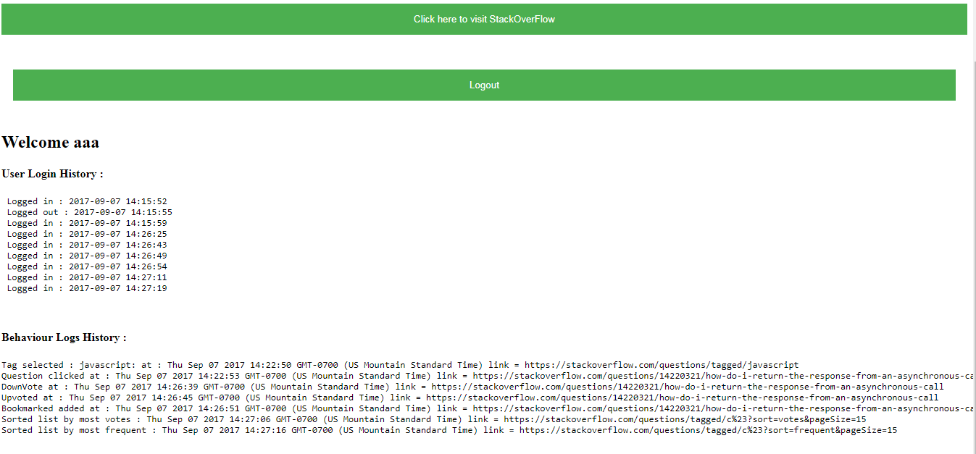

(3) Create Account page: New user account can be created from this page

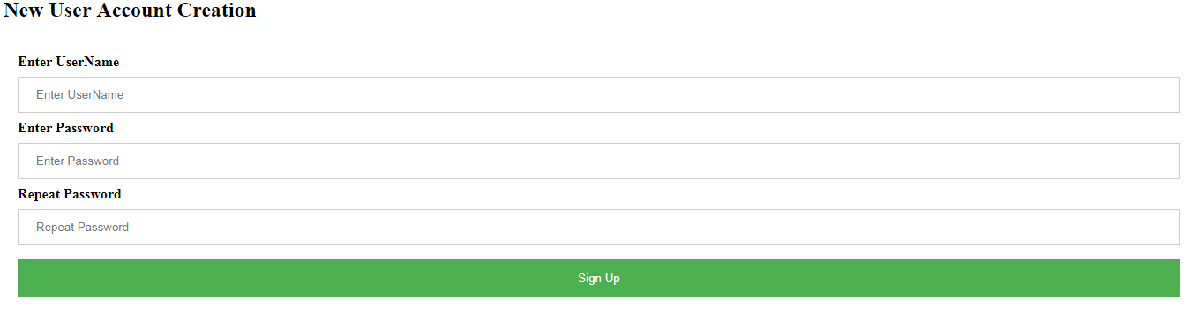

**Note** : The data is stored in text files and is fetched and shown in the application.

* ./files/LoginHistory.txt: This file stores the Login history of all the users.
* ./files/BehaviourHistory.txt: This file stores the behavior logs of all the users.
* ./files/AccountsInformation.txt: This file stores all the accounts information.