EXPERIMENT 2 – IMPLEMENTATION OF MIDPOINT CIRCLE DRAWING ALGORITHM
Course Name – Computer Graphics and Virtual Reality
Course Code – CS4104
Name – Aarya J
USN – 1RVU23CSE006
Section – A

1. Aim
To implement the Midpoint Circle Drawing Algorithm for generating a circle on a raster display using OpenGL by exploiting the eight-way symmetry of a circle.

2. Program – Midpoint Circle Drawing
from OpenGL.GL import *
from OpenGL.GLUT import *
from OpenGL.GLU import *
import sys

# Midpoint Circle Drawing Algorithm
def plot_circle_points(xc, yc, x, y):

# Eight-way symmetry
glVertex2i(xc + x, yc + y)
glVertex2i(xc - x, yc + y)
glVertex2i(xc + x, yc - y)
glVertex2i(xc - x, yc - y)

glVertex2i(xc + y, yc + x)
glVertex2i(xc - y, yc + x)
glVertex2i(xc + y, yc - x)
glVertex2i(xc - y, yc - x)

def midpoint_circle(xc, yc, radius):

x = 0
y = radius

# Initial decision parameter
p = 1 - radius

glBegin(GL_POINTS)

while x <= y:

# Plot the eight symmetric points
plot_circle_points(xc, yc, x, y)

x += 1

# Midpoint decision
if p < 0:
p = p + 2 * x + 1
else:
y -= 1
p = p + 2 * x - 2 * y + 1

glEnd()

# Display text
def draw_text(x, y, text):

glRasterPos2i(x, y)

for character in text:
glutBitmapCharacter(
GLUT_BITMAP_HELVETICA_18,
ord(character)
)

# Display function
def display():

glClear(GL_COLOR_BUFFER_BIT)

# Green circle
glColor3f(0.0, 1.0, 0.0)
glPointSize(3.0)

# Center = (300, 300), Radius = 180
midpoint_circle(300, 300, 180)

# Algorithm name
glColor3f(1.0, 1.0, 1.0)
draw_text(220, 520, "Midpoint Circle")

glFlush()

# Initialization
def init():

glClearColor(0.0, 0.0, 0.0, 1.0)

glMatrixMode(GL_PROJECTION)
glLoadIdentity()

gluOrtho2D(0, 600, 0, 600)

glMatrixMode(GL_MODELVIEW)
glLoadIdentity()

# Main function
def main():

glutInit(sys.argv)

glutInitDisplayMode(
GLUT_SINGLE | GLUT_RGB
)

glutInitWindowSize(600, 600)
glutInitWindowPosition(100, 100)

glutCreateWindow(
b"Midpoint Circle Drawing Algorithm"
)

init()
glutDisplayFunc(display)
glutMainLoop()

if __name__ == "__main__":
main()

3. Execution
Install the required packages:
pip install PyOpenGL PyOpenGL_accelerate

Run the program:
python midpoint_circle.py

4. Output
Midpoint Circle Drawing Output
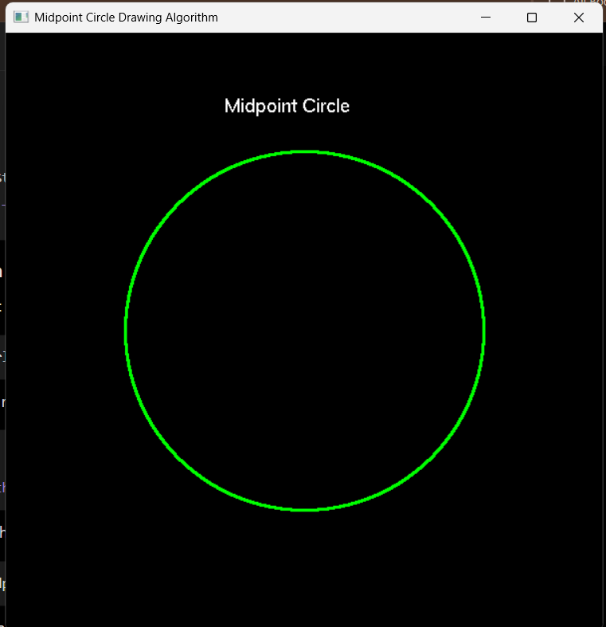
Figure 1: Circle generated using the Midpoint Circle Drawing Algorithm.

5. Result
The Midpoint Circle Drawing Algorithm was successfully implemented using Python and OpenGL. A rasterized circle was generated by plotting the calculated points and using the eight-way symmetry property of the circle.

6. Conclusion
The experiment demonstrated the generation of a circle on a raster display using the Midpoint Circle Drawing Algorithm. The eight-way symmetry property was used to generate the complete circle efficiently from the calculated points.

