EXPERIMENT – 4
IMPLEMENT COMPOSITE TRANSFORMATIONS USING MATRIX REPRESENTATION
Name – Aarya J
USN – 1RVU23CSE006

- Code

- """
- Experiment 3 - 2D Geometric Transformations
- ============================================
- Implements fundamental 2D transformations using homogeneous coordinates:
- - Translation
- - Rotation
- - Scaling
- - Reflection
- - Shearing

- Controls:
- 1 - Translation
- 2 - Rotation
- 3 - Scaling
- 4 - Reflection (X-axis)
- 5 - Reflection (Y-axis)
- 6 - Shearing
- R - Reset to original
- ESC - Quit
- """

- import sys
- import glfw
- from OpenGL.GL import *
- import math

- WIN_W, WIN_H = 800, 600
- CX, CY = WIN_W // 2, WIN_H // 2

- # ═══════════════════════════════════════════════════════════════
- # HOMOGENEOUS COORDINATE TRANSFORMATION MATRICES (3x3)
- # ═══════════════════════════════════════════════════════════════

- def identity_matrix():
- """3x3 Identity matrix"""
- return [
- [1, 0, 0],
- [0, 1, 0],
- [0, 0, 1]
- ]

- def translation_matrix(tx, ty):
- """
- Translation by (tx, ty)

- [1 0 tx]
- [0 1 ty]
- [0 0 1 ]
- """
- return [
- [1, 0, tx],
- [0, 1, ty],
- [0, 0, 1]
- ]

- def rotation_matrix(angle_deg):
- """
- Rotation about origin by angle (degrees)

- [cos θ -sin θ 0]
- [sin θ cos θ 0]
- [ 0 0 1]
- """
- theta = math.radians(angle_deg)
- c = math.cos(theta)
- s = math.sin(theta)
- return [
- [c, -s, 0],
- [s, c, 0],
- [0, 0, 1]
- ]

- def scaling_matrix(sx, sy):
- """
- Scaling by factors (sx, sy)

- [sx 0 0]
- [0 sy 0]
- [0 0 1]
- """
- return [
- [sx, 0, 0],
- [0, sy, 0],
- [0, 0, 1]
- ]

- def reflection_x_matrix():
- """
- Reflection about X-axis

- [1 0 0]
- [0 -1 0]
- [0 0 1]
- """
- return [
- [1, 0, 0],
- [0, -1, 0],
- [0, 0, 1]
- ]

- def reflection_y_matrix():
- """
- Reflection about Y-axis

- [-1 0 0]
- [ 0 1 0]
- [ 0 0 1]
- """
- return [
- [-1, 0, 0],
- [0, 1, 0],
- [0, 0, 1]
- ]

- def shearing_matrix(shx, shy):
- """
- Shearing transformation

- [1 shx 0]
- [shy 1 0]
- [0 0 1]
- """
- return [
- [1, shx, 0],
- [shy, 1, 0],
- [0, 0, 1]
- ]

- # ═══════════════════════════════════════════════════════════════
- # MATRIX OPERATIONS
- # ═══════════════════════════════════════════════════════════════

- def matrix_multiply(A, B):
- """Multiply two 3x3 matrices: result = A × B"""
- result = [[0, 0, 0] for _ in range(3)]
- for i in range(3):
- for j in range(3):
- for k in range(3):
- result[i][j] += A[i][k] * B[k][j]
- return result

- def transform_point(matrix, x, y):
- """
- Transform a 2D point using homogeneous coordinates.
- Point: [x, y, 1]ᵀ
- Result: [x', y', 1]ᵀ = Matrix × [x, y, 1]ᵀ
- """
- x_new = matrix[0][0] * x + matrix[0][1] * y + matrix[0][2]
- y_new = matrix[1][0] * x + matrix[1][1] * y + matrix[1][2]
- w = matrix[2][0] * x + matrix[2][1] * y + matrix[2][2]

- # Normalize by w (for homogeneous coordinates)
- if w != 0:
- x_new /= w
- y_new /= w

- return (x_new, y_new)

- def transform_polygon(matrix, vertices):
- """Transform all vertices of a polygon"""
- return [transform_point(matrix, x, y) for x, y in vertices]

- # ═══════════════════════════════════════════════════════════════
- # SAMPLE OBJECTS
- # ═══════════════════════════════════════════════════════════════

- def create_triangle():
- """Create a triangle centered near origin"""
- return [
- (0, 50), # Top
- (-40, -25), # Bottom left
- (40, -25) # Bottom right
- ]

- def create_square():
- """Create a square centered at origin"""
- s = 40
- return [
- (-s, -s), # Bottom left
- (s, -s), # Bottom right
- (s, s), # Top right
- (-s, s) # Top left
- ]

- # ═══════════════════════════════════════════════════════════════
- # MAIN PROGRAM
- # ═══════════════════════════════════════════════════════════════

- def main():
- print("\n" + "=" * 60)
- print(" 2D Geometric Transformations - Homogeneous Coordinates")
- print("=" * 60)
- print("\nControls:")
- print(" 1 - Translation (+50, +30)")
- print(" 2 - Rotation (30°)")
- print(" 3 - Scaling (1.5x, 1.5x)")
- print(" 4 - Reflection (X-axis)")
- print(" 5 - Reflection (Y-axis)")
- print(" 6 - Shearing (0.3, 0)")
- print(" R - Reset to original")
- print(" ESC - Quit")
- print("=" * 60 + "\n")

- if not glfw.init():
- sys.exit()

- window = glfw.create_window(WIN_W, WIN_H,
- "2D Transformations | Press 1-6, R, ESC",
- None, None)
- if not window:
- glfw.terminate()
- sys.exit()

- glfw.make_context_current(window)
- glMatrixMode(GL_PROJECTION)
- glLoadIdentity()
- glOrtho(0, WIN_W, 0, WIN_H, -1, 1)
- glMatrixMode(GL_MODELVIEW)
- glLoadIdentity()

- # Original object (triangle)
- original = create_triangle()

- # Transformed object (starts as copy of original)
- transformed = list(original)

- # Current transformation matrix
- current_matrix = identity_matrix()

- # Track transformation type for display
- transform_name = "Original (No transformation)"

- def on_key(win, key, sc, action, mods):
- nonlocal transformed, current_matrix, transform_name

- if action != glfw.PRESS:
- return

- if key == glfw.KEY_ESCAPE:
- glfw.set_window_should_close(win, True)

- elif key == glfw.KEY_1: # Translation
- matrix = translation_matrix(50, 30)
- current_matrix = matrix_multiply(matrix, current_matrix)
- transformed = transform_polygon(current_matrix, original)
- transform_name = "Translation: T(50, 30)"
- print("→ Translation applied: (tx=50, ty=30)")
- print_matrix(matrix)

- elif key == glfw.KEY_2: # Rotation
- matrix = rotation_matrix(30)
- current_matrix = matrix_multiply(matrix, current_matrix)
- transformed = transform_polygon(current_matrix, original)
- transform_name = "Rotation: R(30°)"
- print("→ Rotation applied: θ=30°")
- print_matrix(matrix)

- elif key == glfw.KEY_3: # Scaling
- matrix = scaling_matrix(1.5, 1.5)
- current_matrix = matrix_multiply(matrix, current_matrix)
- transformed = transform_polygon(current_matrix, original)
- transform_name = "Scaling: S(1.5, 1.5)"
- print("→ Scaling applied: (sx=1.5, sy=1.5)")
- print_matrix(matrix)

- elif key == glfw.KEY_4: # Reflection X
- matrix = reflection_x_matrix()
- current_matrix = matrix_multiply(matrix, current_matrix)
- transformed = transform_polygon(current_matrix, original)
- transform_name = "Reflection: X-axis"
- print("→ Reflection about X-axis")
- print_matrix(matrix)

- elif key == glfw.KEY_5: # Reflection Y
- matrix = reflection_y_matrix()
- current_matrix = matrix_multiply(matrix, current_matrix)
- transformed = transform_polygon(current_matrix, original)
- transform_name = "Reflection: Y-axis"
- print("→ Reflection about Y-axis")
- print_matrix(matrix)

- elif key == glfw.KEY_6: # Shearing
- matrix = shearing_matrix(0.3, 0)
- current_matrix = matrix_multiply(matrix, current_matrix)
- transformed = transform_polygon(current_matrix, original)
- transform_name = "Shearing: Shx(0.3, 0)"
- print("→ Shearing applied: (shx=0.3, shy=0)")
- print_matrix(matrix)

- elif key == glfw.KEY_R: # Reset
- current_matrix = identity_matrix()
- transformed = list(original)
- transform_name = "Original (Reset)"
- print("→ Reset to original")

- glfw.set_key_callback(window, on_key)

- while not glfw.window_should_close(window):
- glClearColor(0.08, 0.08, 0.08, 1.0)
- glClear(GL_COLOR_BUFFER_BIT)

- # Draw axes
- glColor3f(0.3, 0.3, 0.3)
- glLineWidth(1.0)
- glBegin(GL_LINES)
- glVertex2f(0, CY); glVertex2f(WIN_W, CY)
- glVertex2f(CX, 0); glVertex2f(CX, WIN_H)
- glEnd()

- # Draw original object (gray, dashed look via points)
- glColor3f(0.5, 0.5, 0.5)
- glPointSize(2.0)
- glBegin(GL_LINE_LOOP)
- for (x, y) in original:
- glVertex2f(CX + x, CY + y)
- glEnd()

- # Draw transformed object (bright green)
- glColor3f(0.2, 1.0, 0.3)
- glLineWidth(3.0)
- glBegin(GL_LINE_LOOP)
- for (x, y) in transformed:
- glVertex2f(CX + x, CY + y)
- glEnd()

- # Draw vertices as points
- glColor3f(1.0, 1.0, 0.0)
- glPointSize(8.0)
- glBegin(GL_POINTS)
- for (x, y) in transformed:
- glVertex2f(CX + x, CY + y)
- glEnd()

- glfw.swap_buffers(window)
- glfw.poll_events()

- glfw.terminate()

- def print_matrix(matrix):
- """Pretty-print a 3x3 matrix"""
- print(" Matrix:")
- for row in matrix:
- print(f" [{row[0]:7.3f} {row[1]:7.3f} {row[2]:7.3f}]")
- print()

- if __name__ == "__main__":
- main()

- Reflection
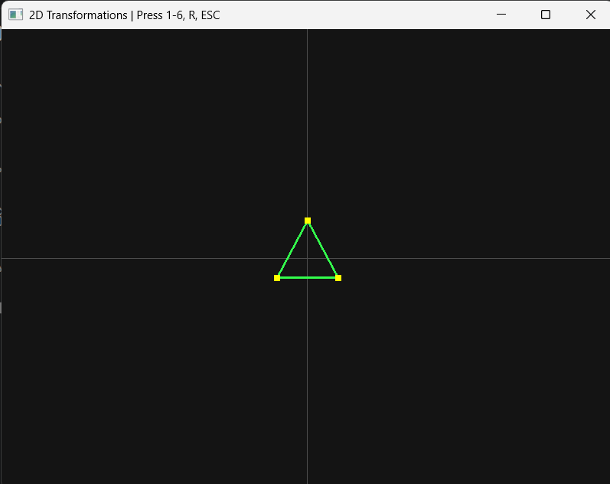

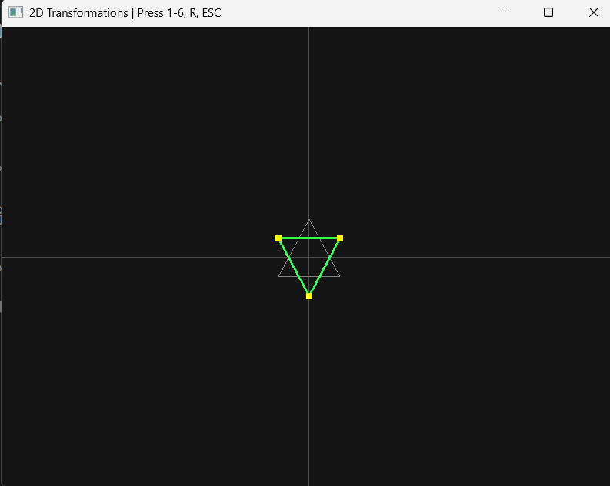

- Scaling
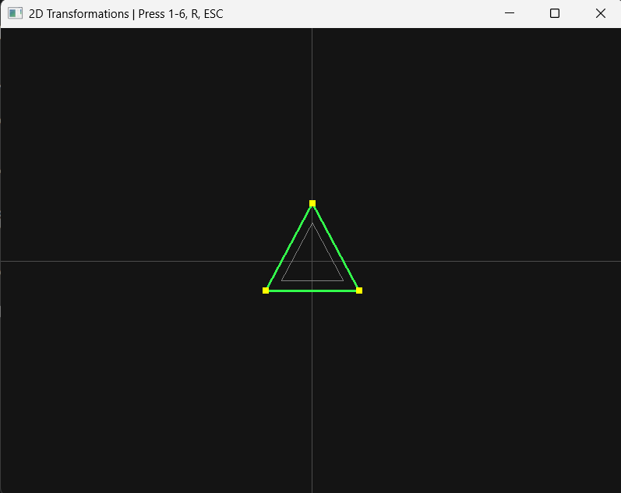



- Rotation


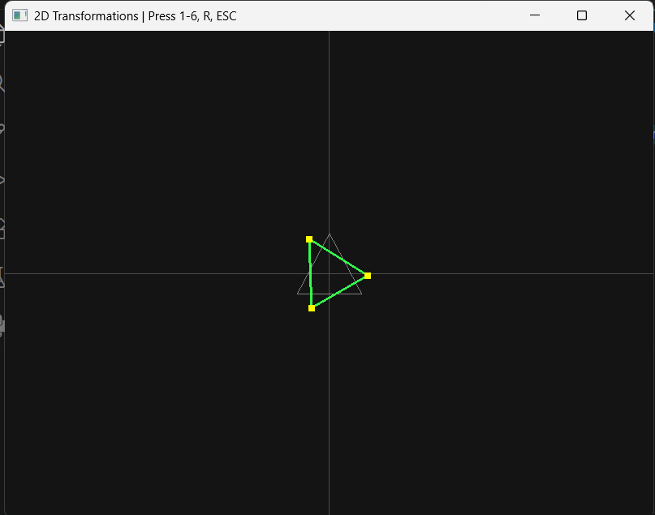

- Translation


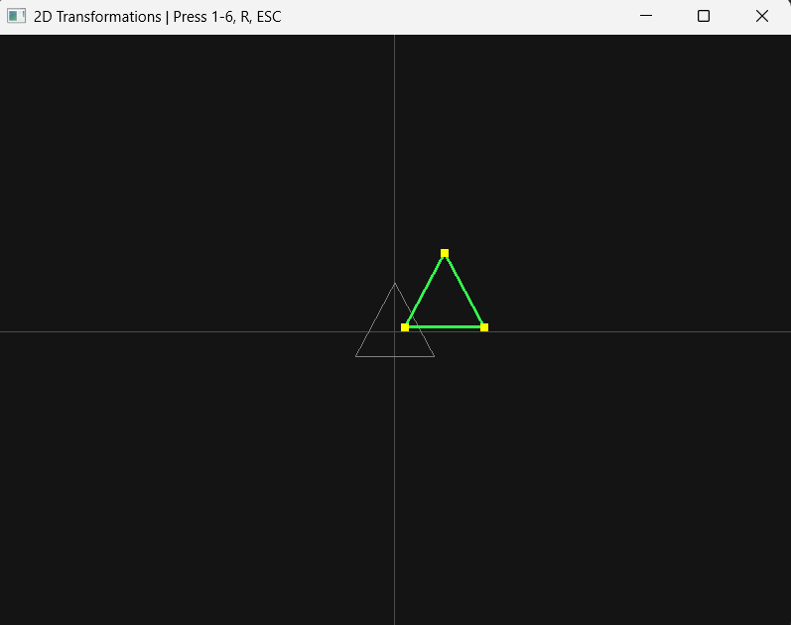

- Shearing


