MLOps Repo (Code Repository in Azure DevOps)

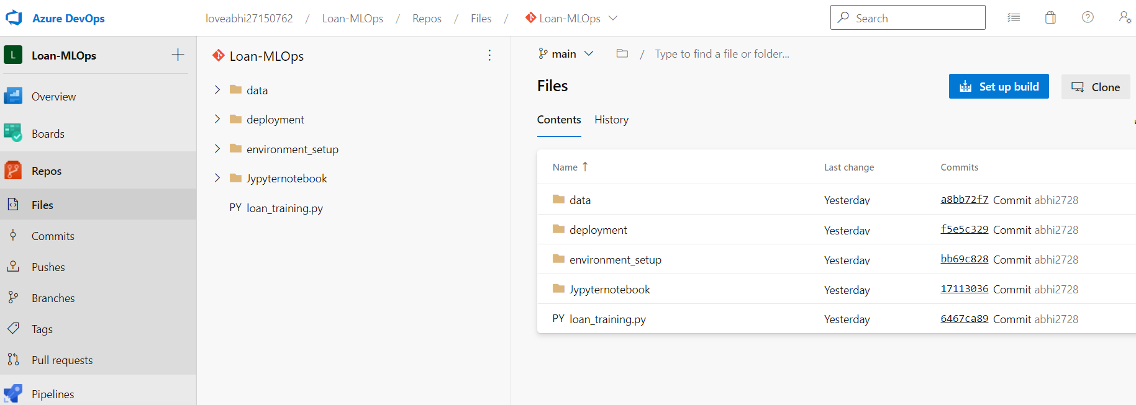

MLOps CI pipeline in Azure to build ML model

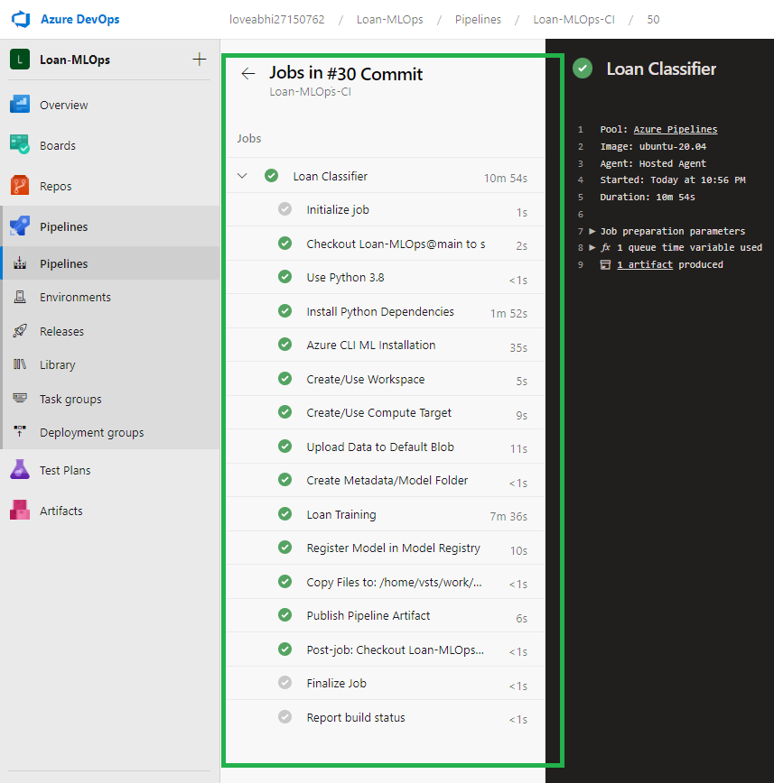

MLOps CI pipeline in Azure to deploy ML model

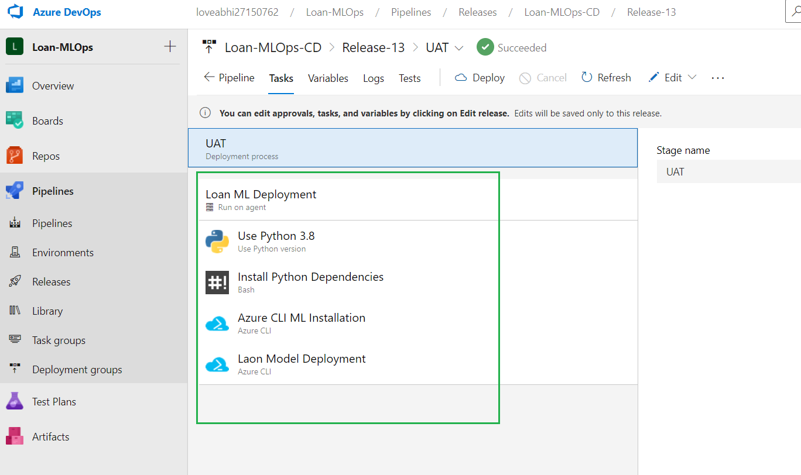

Once Model Register it shows in Azure Workspace, Model information like version, Artifacts available

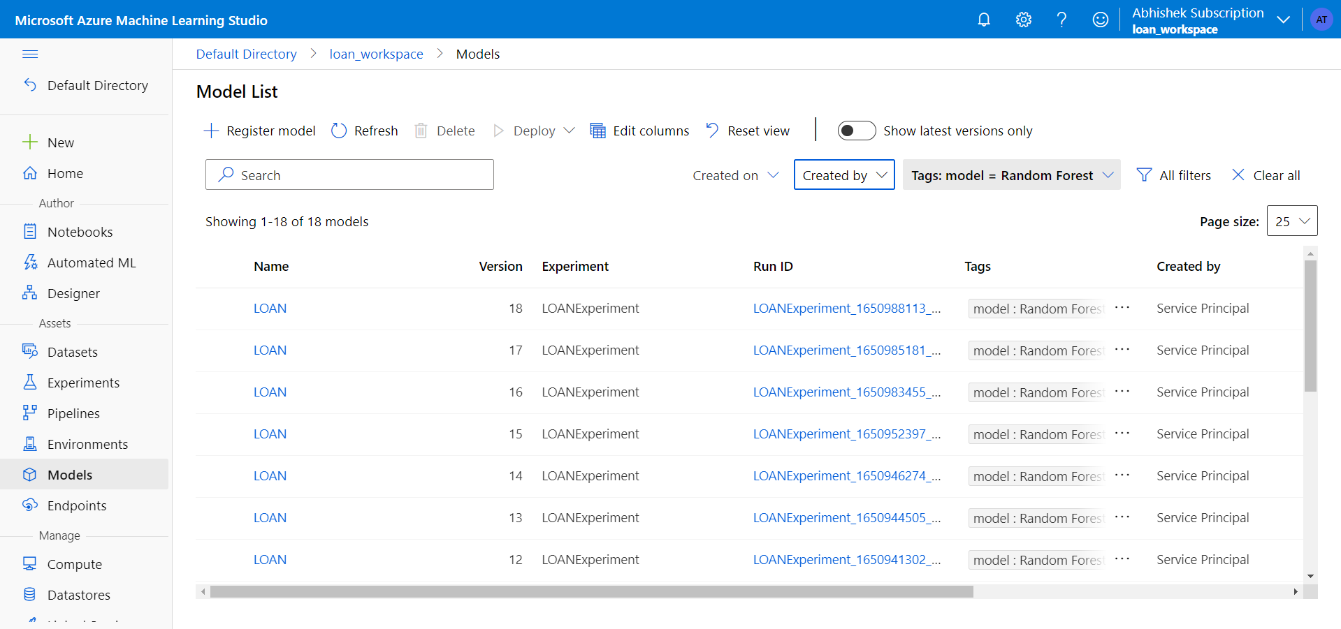

Once model successfully deployed to Azure cloud, it provide end points and also provide test option to test the model

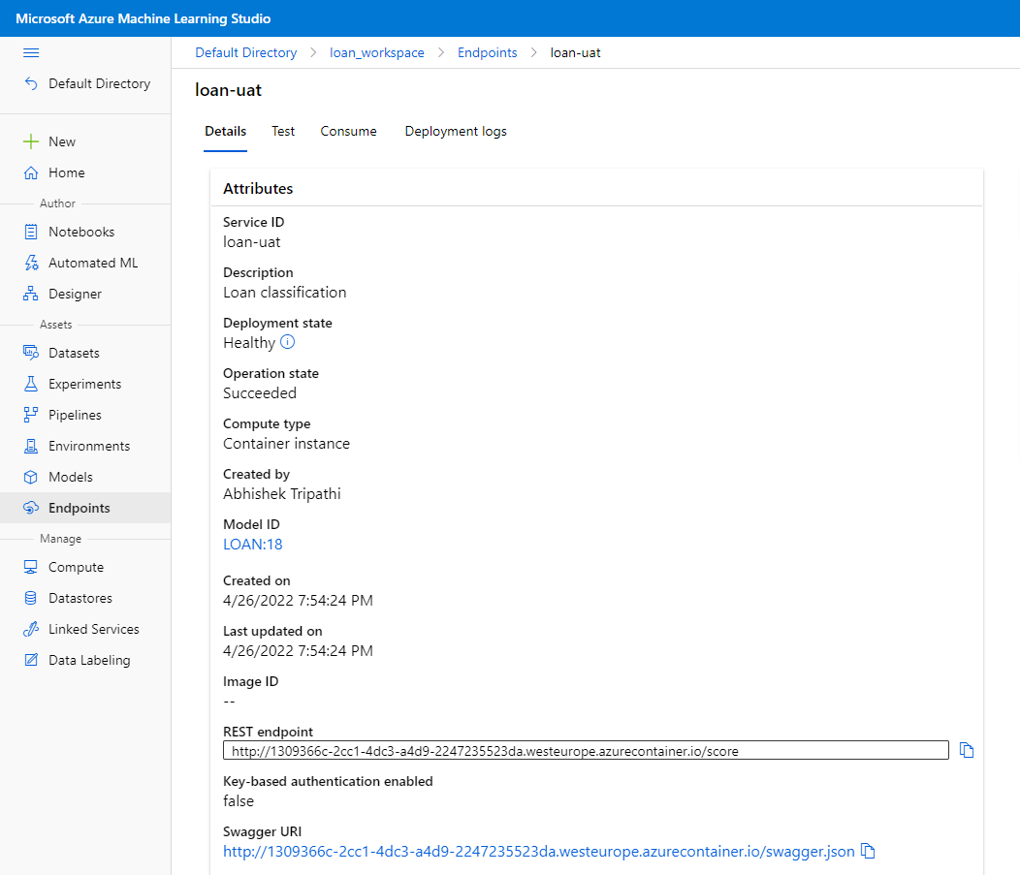

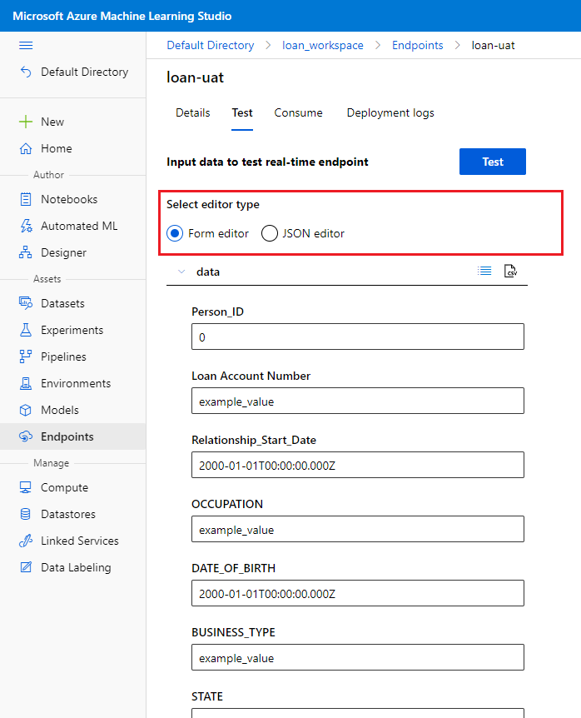

Build process also create entries in Experiments, Metric, Log, Details and other information available here

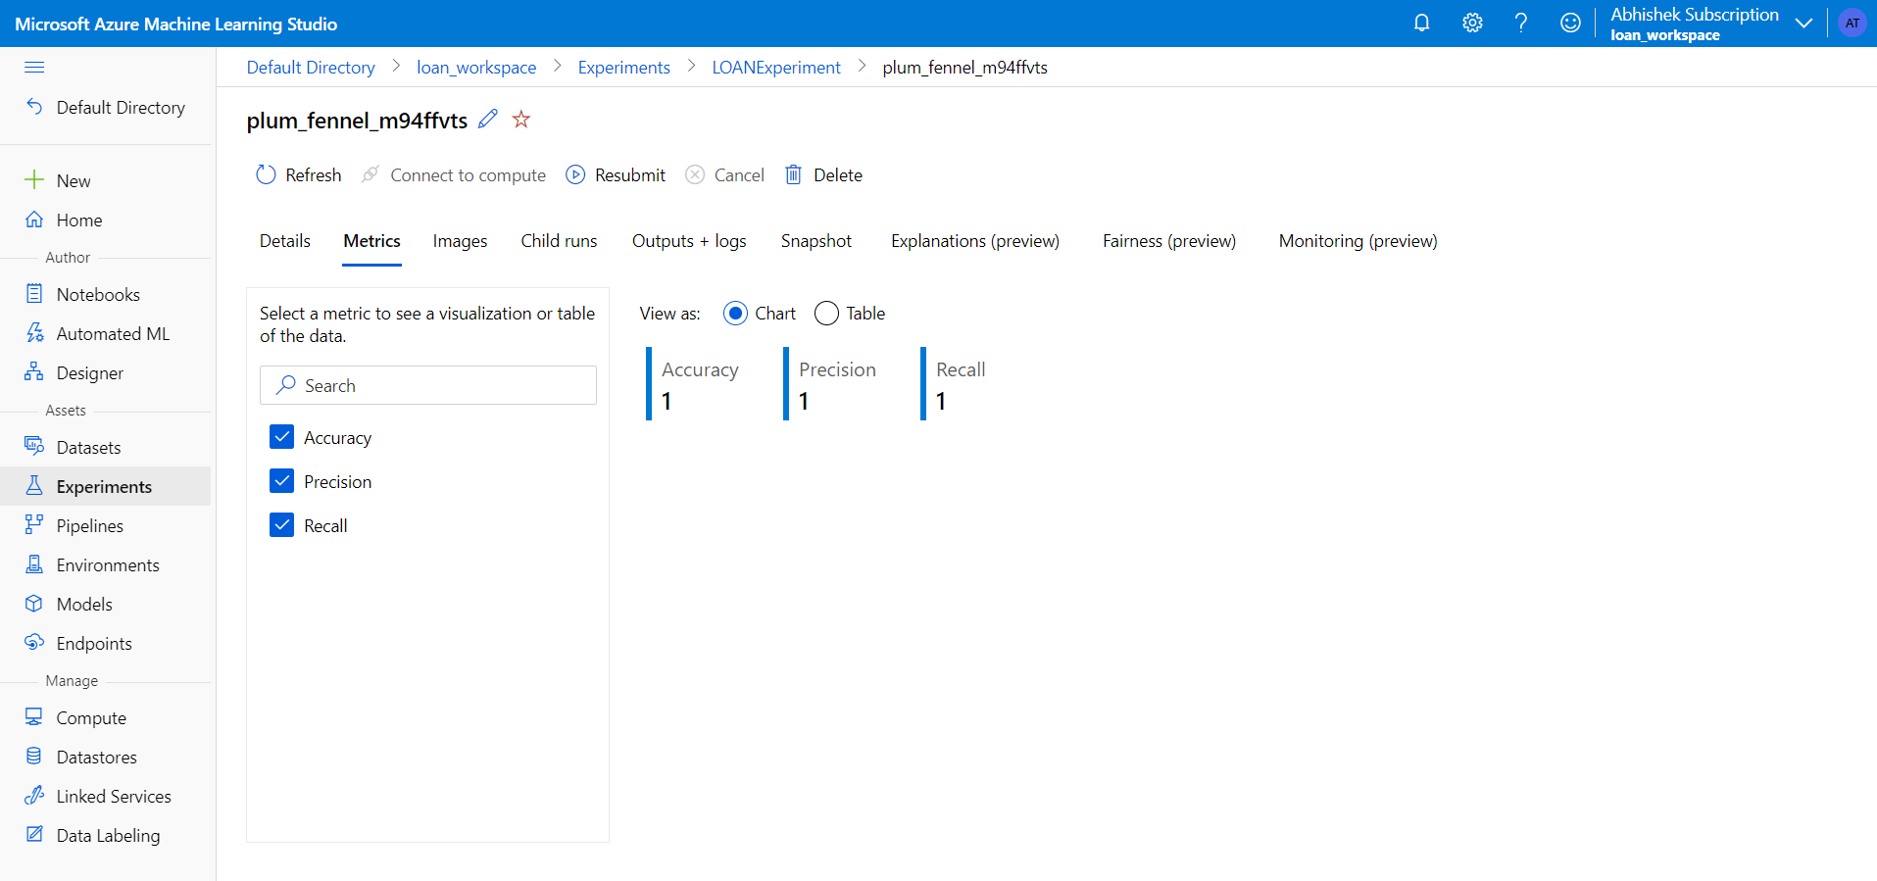

MLOps build pipeline also register the training dataset with workspace

