**Information on the Shiny Application:**

The basic outline of the application:

* A drop-down menu for selecting various plots based on the analysis requirement.
* A map indicating various zip codes in New York city and a popup window for each of them with information on Average growth rate, Median Price per Night, Cost expected (size of properties in the map is corresponding to its cost, bigger the circle markers larger the cost) and the breakeven time (in Years) expected in the particular zip code after buying a property.
* The main panel consists of the plots associated, which we have generated from calling the scalable functions in the main program.

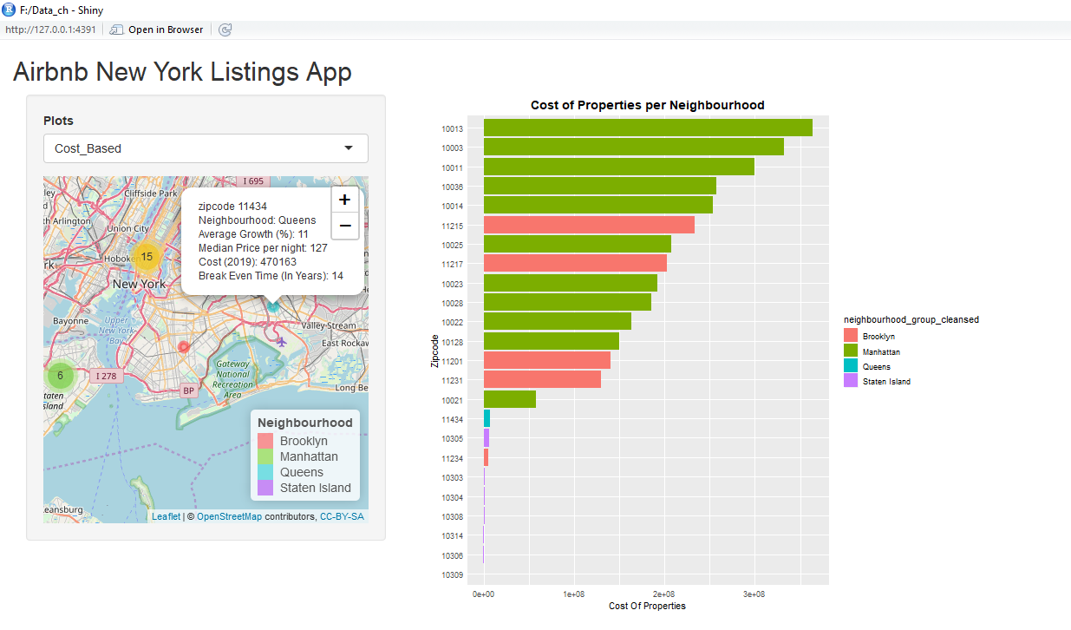Salient Features:

* This application gives a user interface to the organization as opposed to checking distinct plots from a report.
* The occupancy rate and Availability per year are scalable options to simulate different scenarios for the organization. We have to change the corresponding values in the config file.
* The parameter for checking profit after a certain year can also be made scalable by replacing the value: **n_year** in the config file. I have kept this constant on the application for now for the purpose of my interpretation **while keeping the core program scalable.**
* We also have scalability option for changing the number of bedroom (num_bed: in config) and for a different city (zillow_city: in config) that needs to be analyzed.

**How to run:** Once the **step 3** in README file is completed open file: Shiny_App.R and Click on:  on R STUDIO.