Build Your First Marketing Intelligence Agent (Essentials)

What You Need to Do (Step-By-Step)
A simple guide to help you get started quickly during the hands-on lab.

1. Download the Project Files from GitHub
This folder contains all the data, the Snowflake Notebook, SQL scripts, and documentation needed for the lab.
Actions:
- Open the GitHub link shared by the facilitator (git-link-snowflake-marketing-intelligence-agent).
- Click Code - Download ZIP
(or) clone the repo if preferred.
- Extract the ZIP locally you will see folders like:
  - notebooks/ (contains the main Notebook)
  - data/ (CSV files)
  - sql/ (SQL scripts for setup)
  - docs/ (Essentials document: Quick Start instructions)
  - next_steps/(Guidance to extend the current use case)

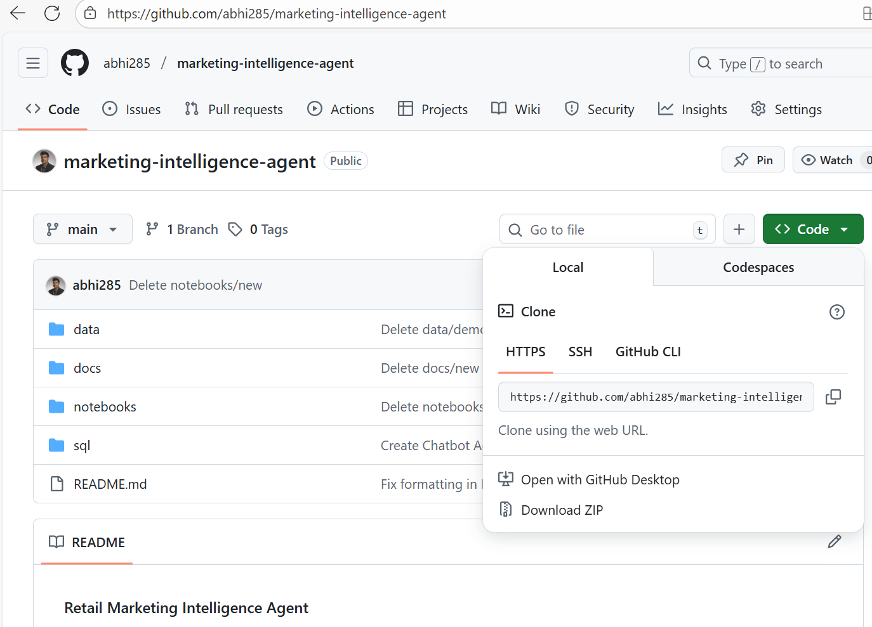
Figure 1: GitHub repository page with “Code - Download ZIP”.

2. Log in to the Snowflake Environment
You will use the Snowflake-provided HOL (Hands-On Lab) account.
Actions:
- If you need a temporary Snowflake account, then please use your email to claim it here: https://go.dataops.live/jan-tampa-hands-on-lab-snowflak/register.
- Open the Snowflake URL provided in step 1.
- Log in using the username/password provided in step 1.
- Setup MFA step: using passkey

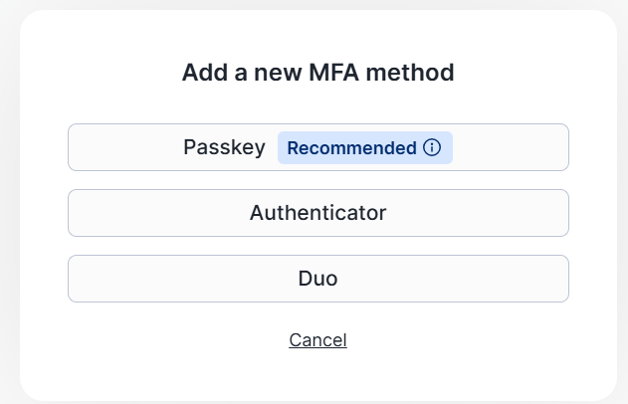
Figure 2: Select passkey for setting up MFA
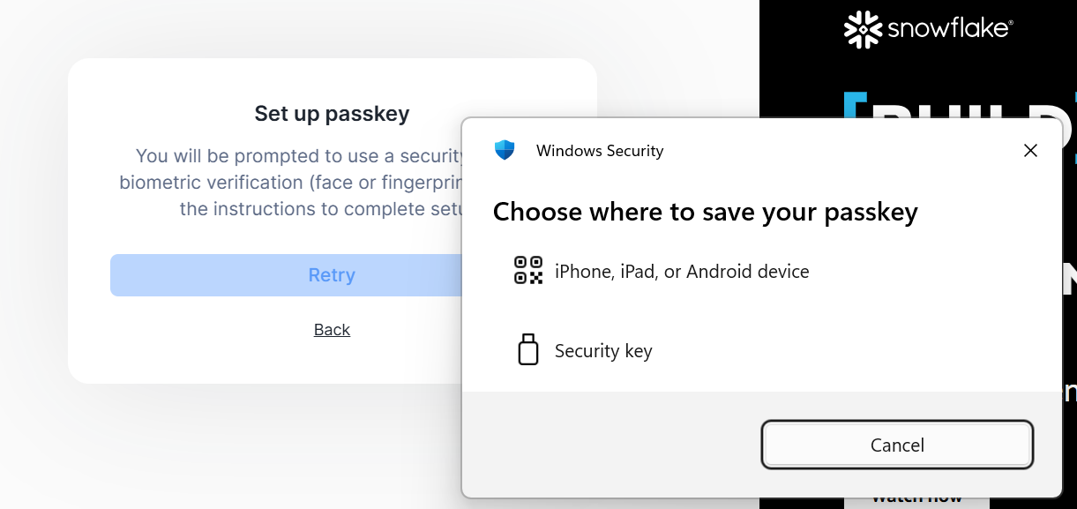
Figure 3: Continue with the given options to complete the setup

3. Open the Provided Snowflake Notebook
Everything you need is packaged into one clean notebook.
Actions:
- Navigate inside Snowflake to: Projects - Notebooks
- Click: +Notebook > Import .ipynb file
- Upload the notebook from the notebooks/ folder you downloaded.
- Open: “Snowflake Marketing Intelligence”
- Accept the defaults on the Create Notebook window.
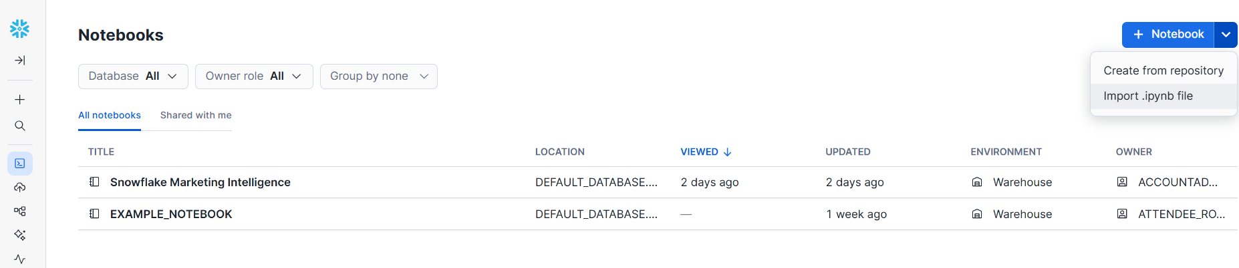
Figure 4: Notebook upload dialog.

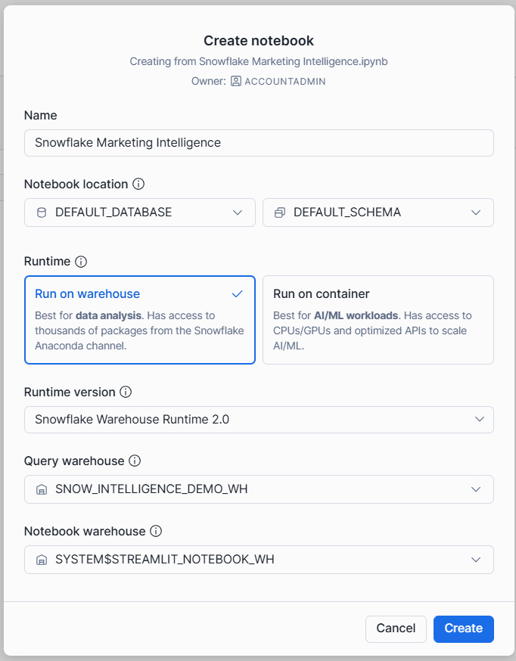
Figure 5: Select Default Database and Schema to get started

4. Run Each Section in the Notebook
The notebook is broken into clear numbered steps.
You will:
- Create the environment (role, warehouse, schemas)
- Upload & load sample marketing CSVs (thanks to stop here and follow the walk through steps on the screen)
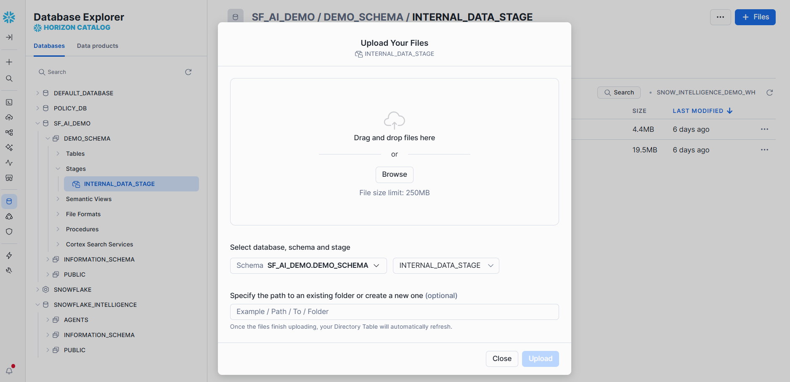
Figure 6: Upload data files into the internal stage created
- Build the Marketing Semantic View (for Cortex Analyst)
- Parse PDFs and build the Search Service
- Register the custom tools (email + doc link)
- Create the Marketing Intelligence Agent
Run each cell in order everything is pre-written.

5. Validate Your Setup
The notebook ends with validation queries to ensure:
- Tables loaded successfully
- Semantic View responds correctly
- Search Service is active
- Custom Tools execute
- Agent registration completed
Once validations pass, you’re ready to move to the agent demo.

6. Add and validate email
Before we can use the Email Send tool within Snowflake Intelligence, we need to add a valid email and complete the validation process. Below are the screenshots, for how to add the same.
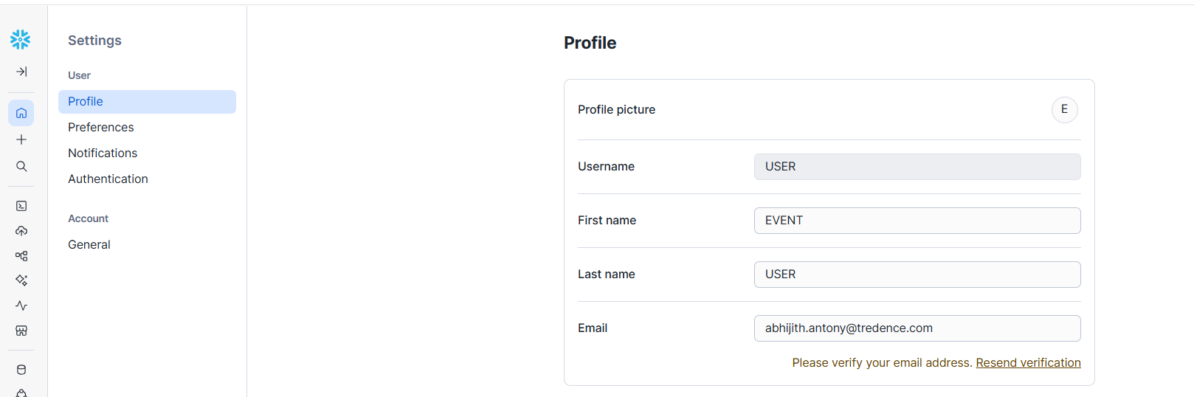
Figure 7: Add valid Email to the account

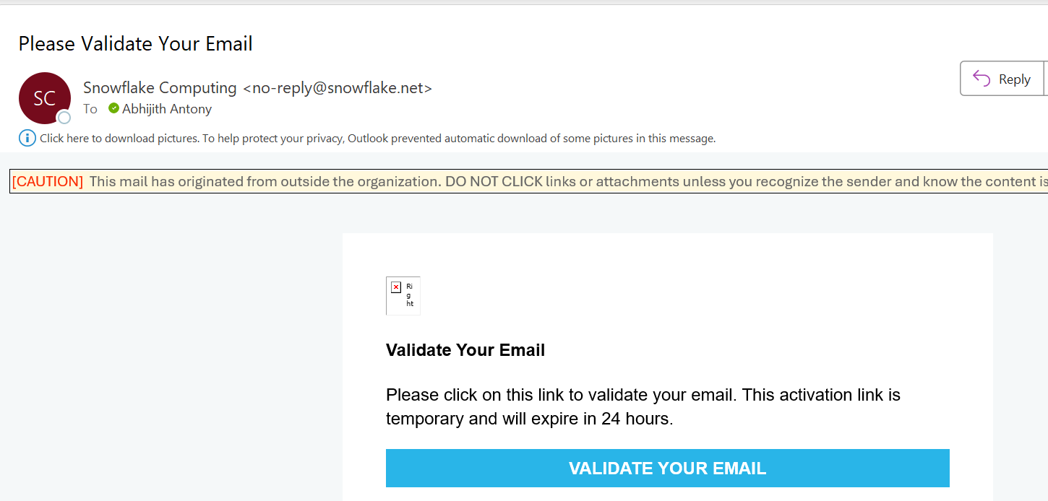
Figure 8: Validate Email

7. Open the Retail Marketing Intelligence Agent
Actions:
- In Snowflake, navigate to: AI & ML - Agents
- Select: Retail Marketing Intelligence Agent
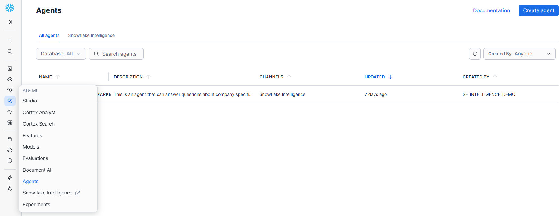
Figure 9: Open Agents tab

8. Ask Your First Marketing Question
Descriptive/Historical:
- For 2025, show me monthly total spend by channel.
Diagnostic/Reasoning:
- Considering different metrics for ROAS (return on ad spend), which channels are performing better against the others in what scenarios?
- Based on all the data across all the channels do you see certain seasonality and trend which typically gives a low ROI for certain time of the year, day of the month? I am looking for this information so I can plan my spend better.
- What could be the possible reason behind certain days of month or months of years underperforming compared to the rest?
Cortex Search:
The agent should present two separate sections: (A) results from Analyst and (B) snippets from Search.
- Can you describe the Q4 2024 Campaign Performance from pdfs and give me the link to the corresponding pdfs(dynamic_doc_url_tool)?
Custom Tools:
- Email send tool: Can you send me an email with monthly total spend for 2025?

9. Explore Agent Monitoring

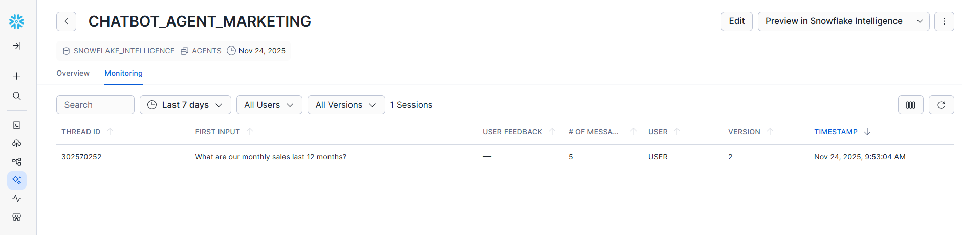
Figure 10: Navigate to Agent monitoring view
Cortex Analyst Execution View
Shows:
- Natural language - SQL translation, Reasoning trace, Verified queries usage, Execution success & time
LLM Planning View
Shows:
- Why did the agent use Analyst or Search? How it decided the tool sequence, Token usage + cost.

