**ASSIGNMENT NO: 04**

**a) Find the number of players that bowled in the ODI match 2689.**

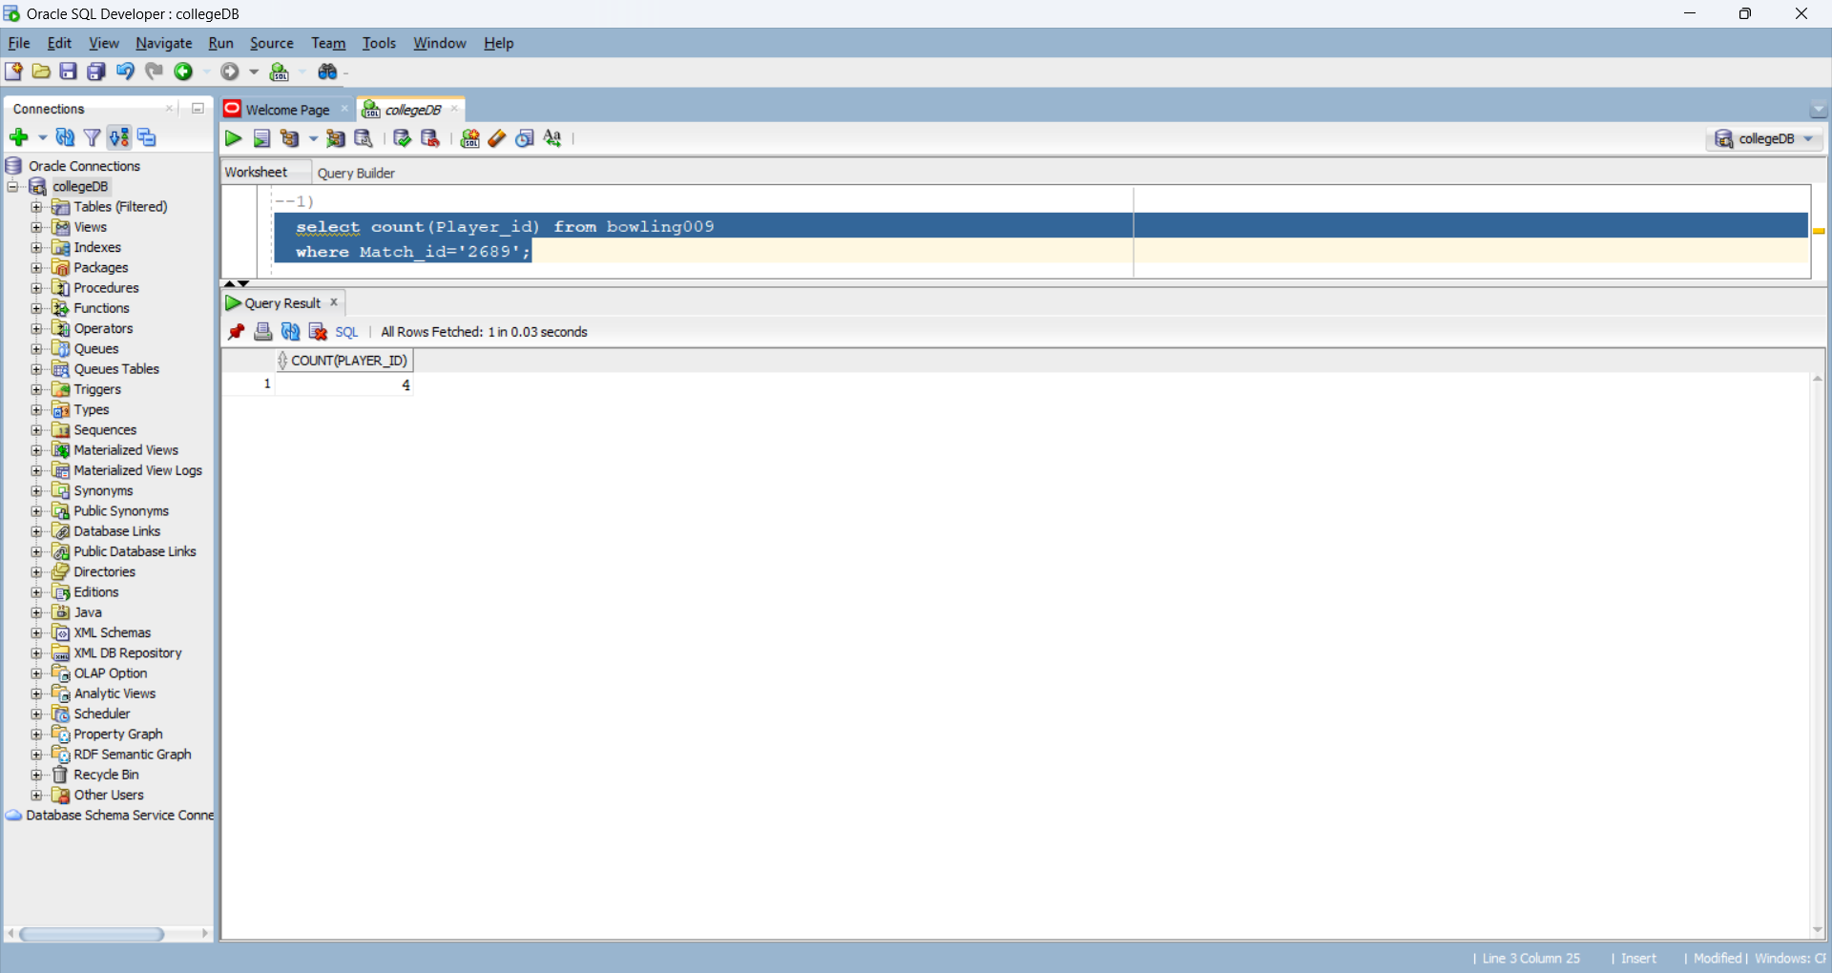

**b) Find the average batting score of all the players that batted in the ODI match 2689.**

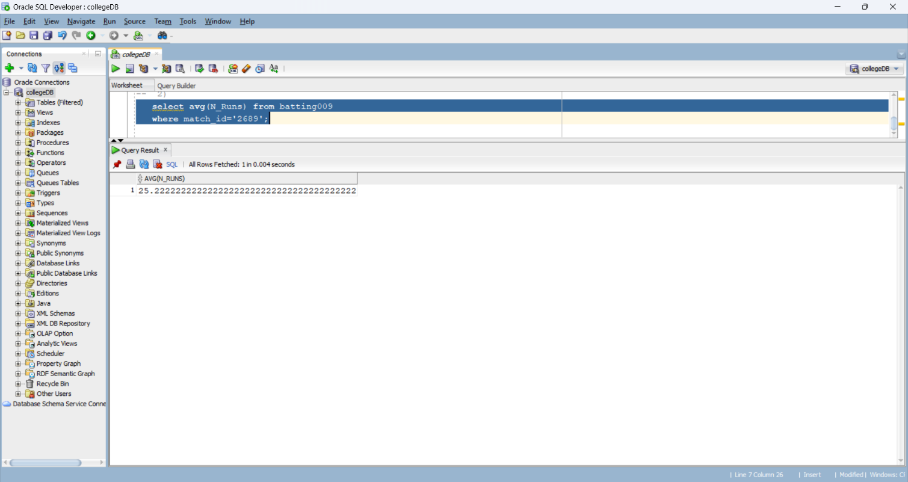

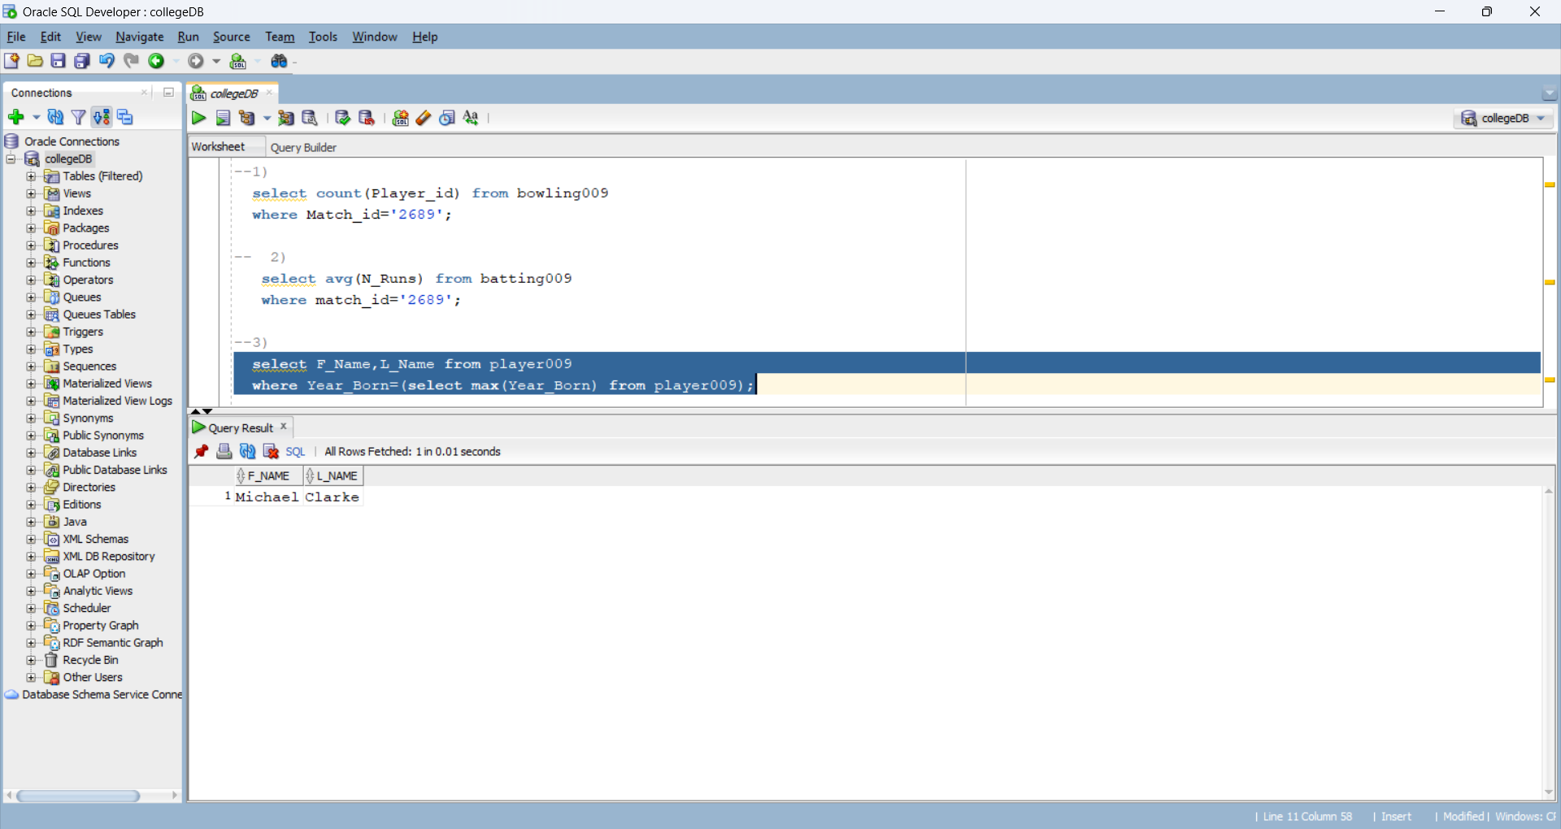**c) Find the youngest player in ODI database.**

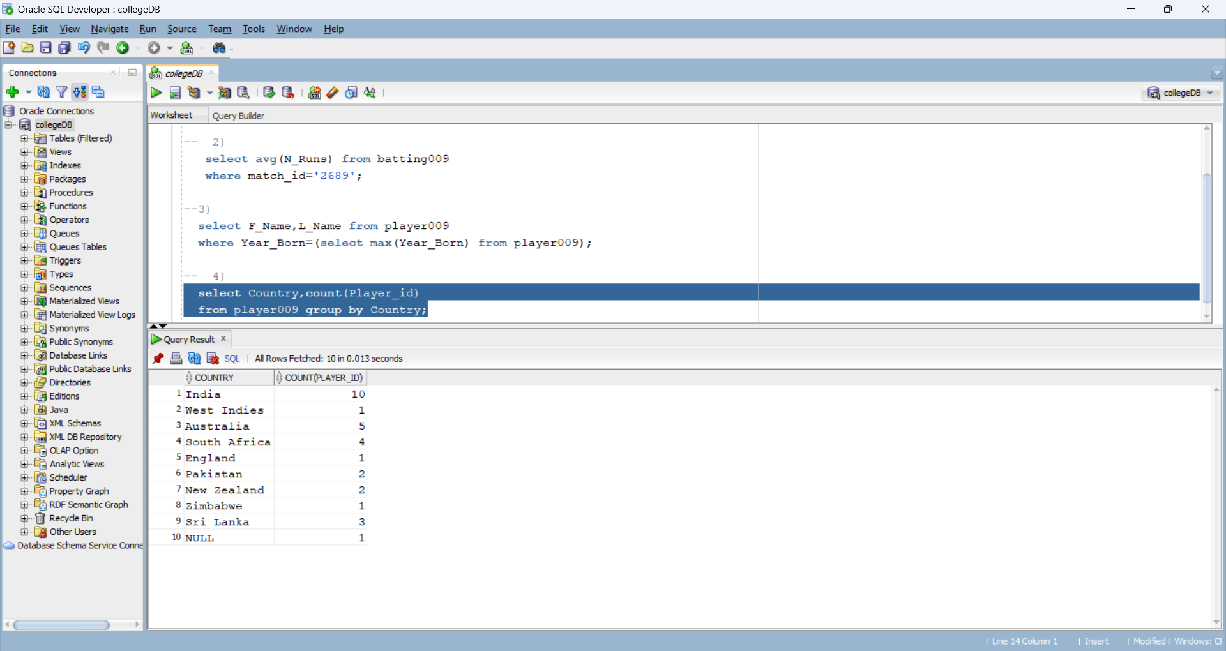**d) Find the number of players in the ODI database from each country.**

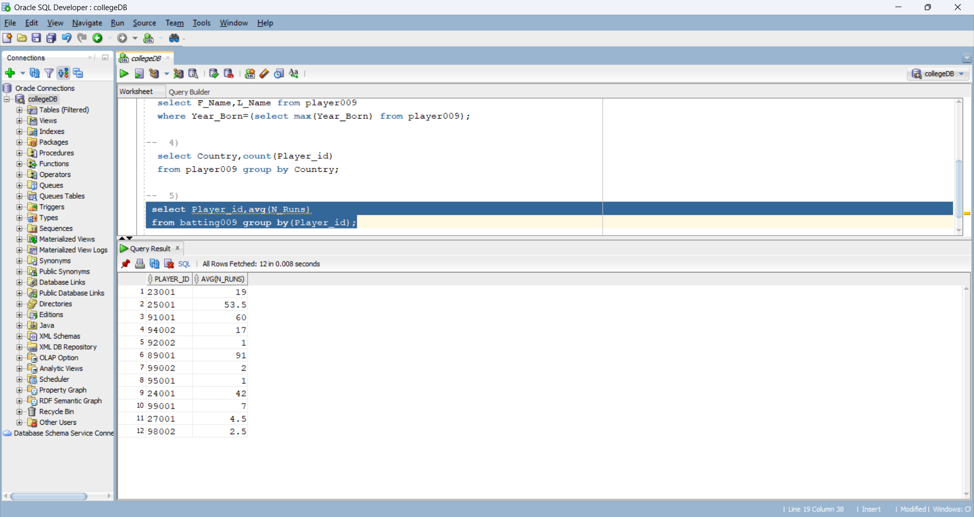**e) Find the batting average of each player.**

**f) Find the batting average of each player from India along with their first name.**

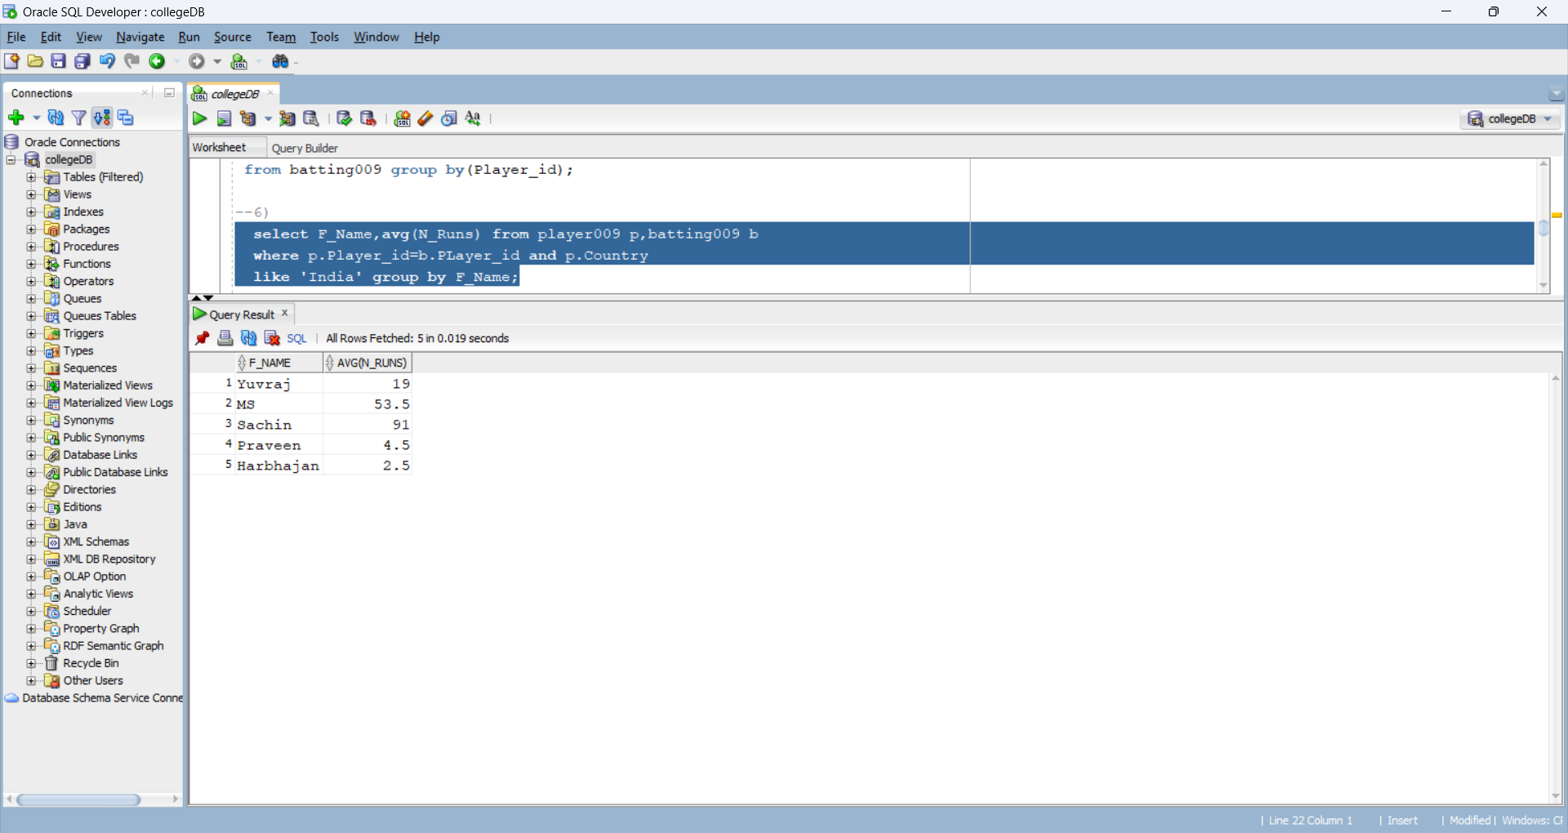

**g) Find the average scores for each player when playing in Australia.**

