**Assignment: 6**

**a) Find player ids of players who have scored more than 30 in every ODI match that they have batted.**

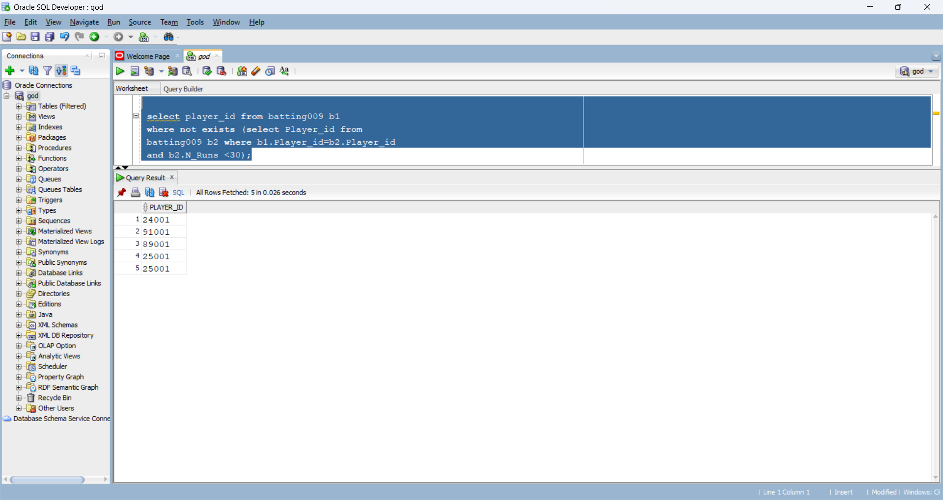

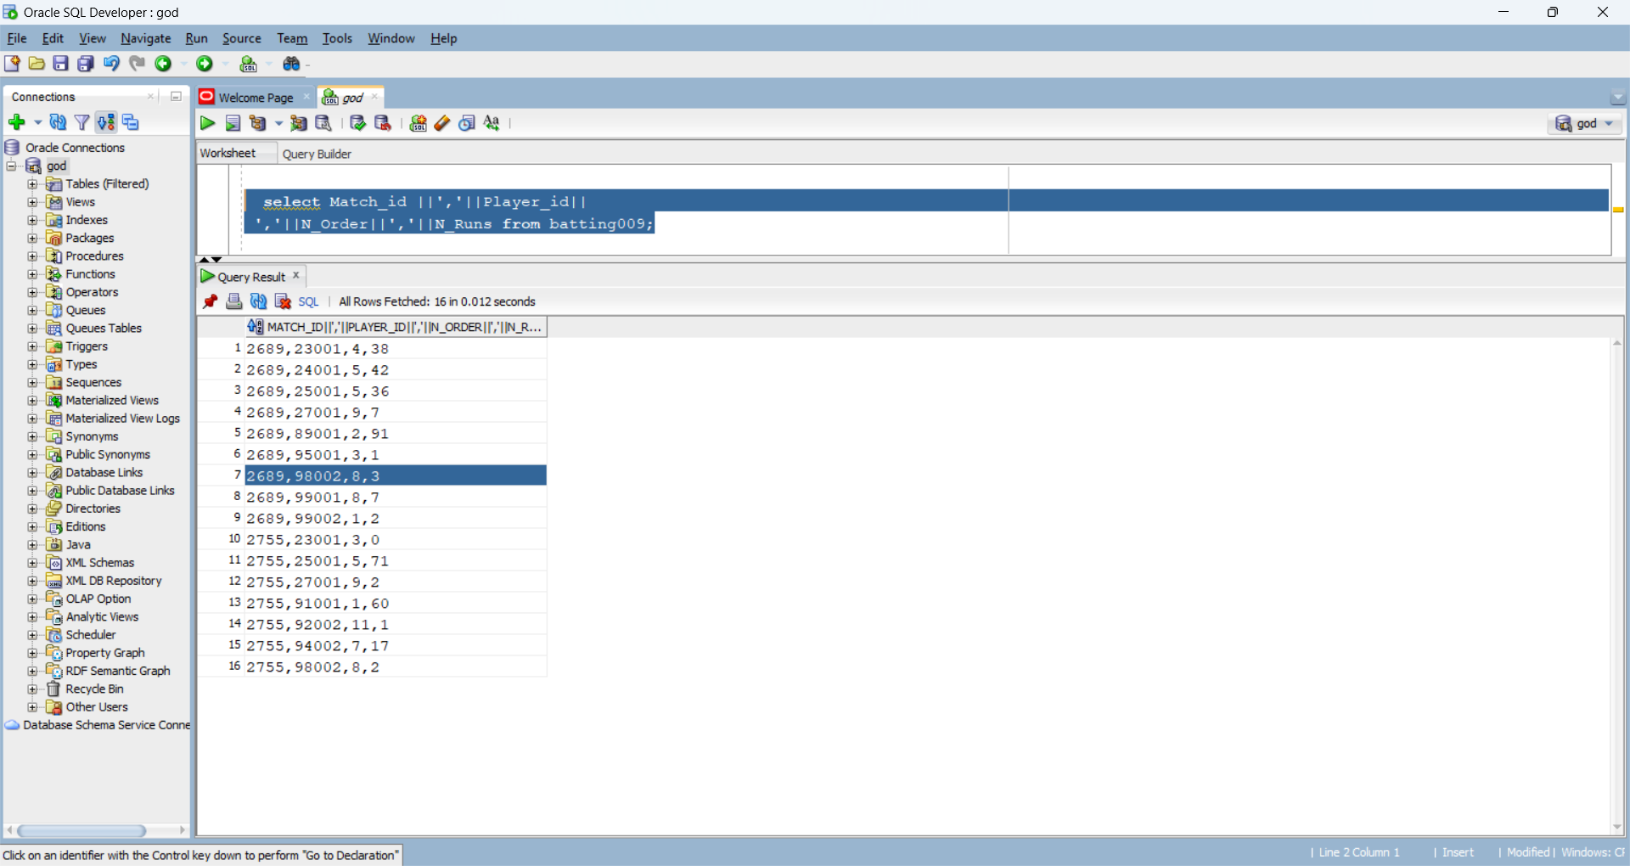**b) List the attributes of BATTING separated by comma.**

**c) Find match ids of those matches in which ‘Lee’ bowled.**

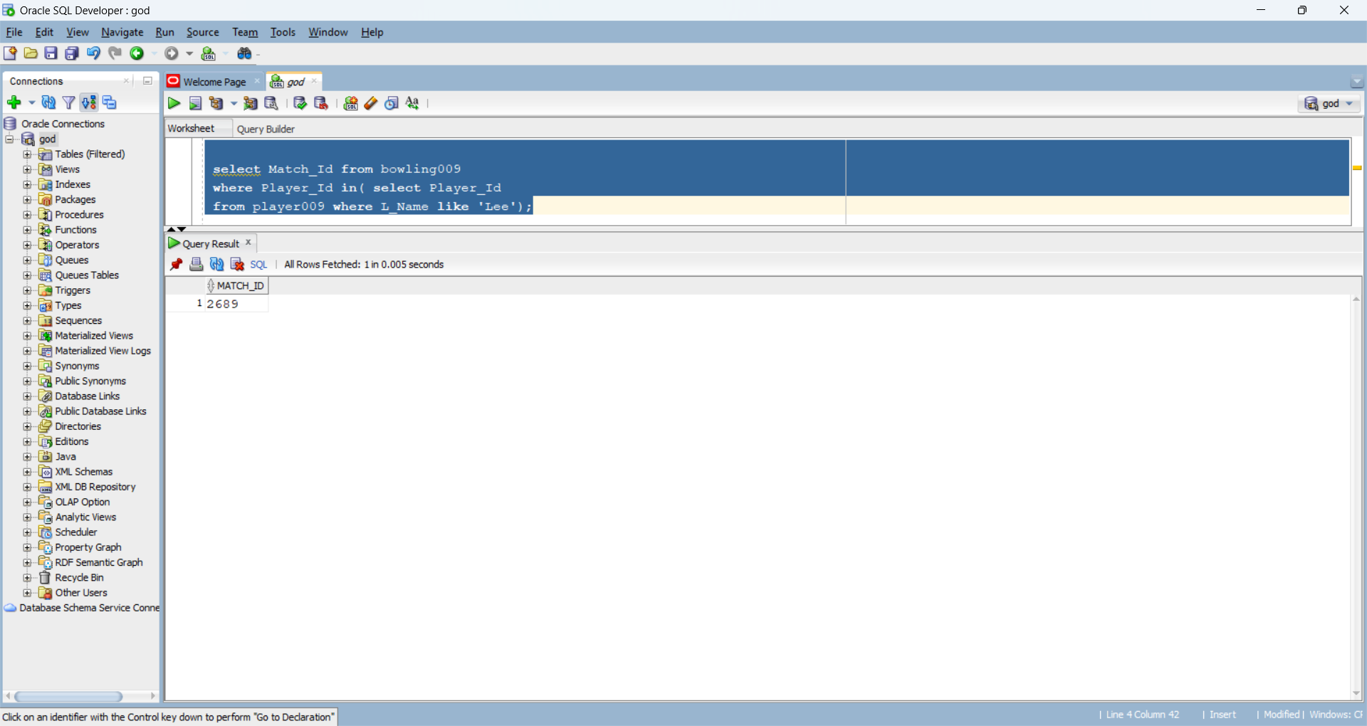

**d) Find ids of players that have both bowled and batted in the ODI match 2689.**

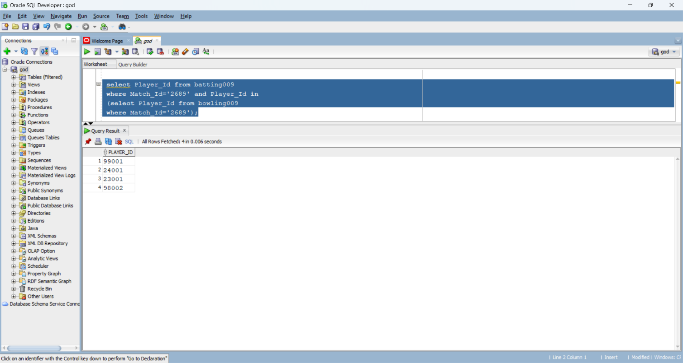

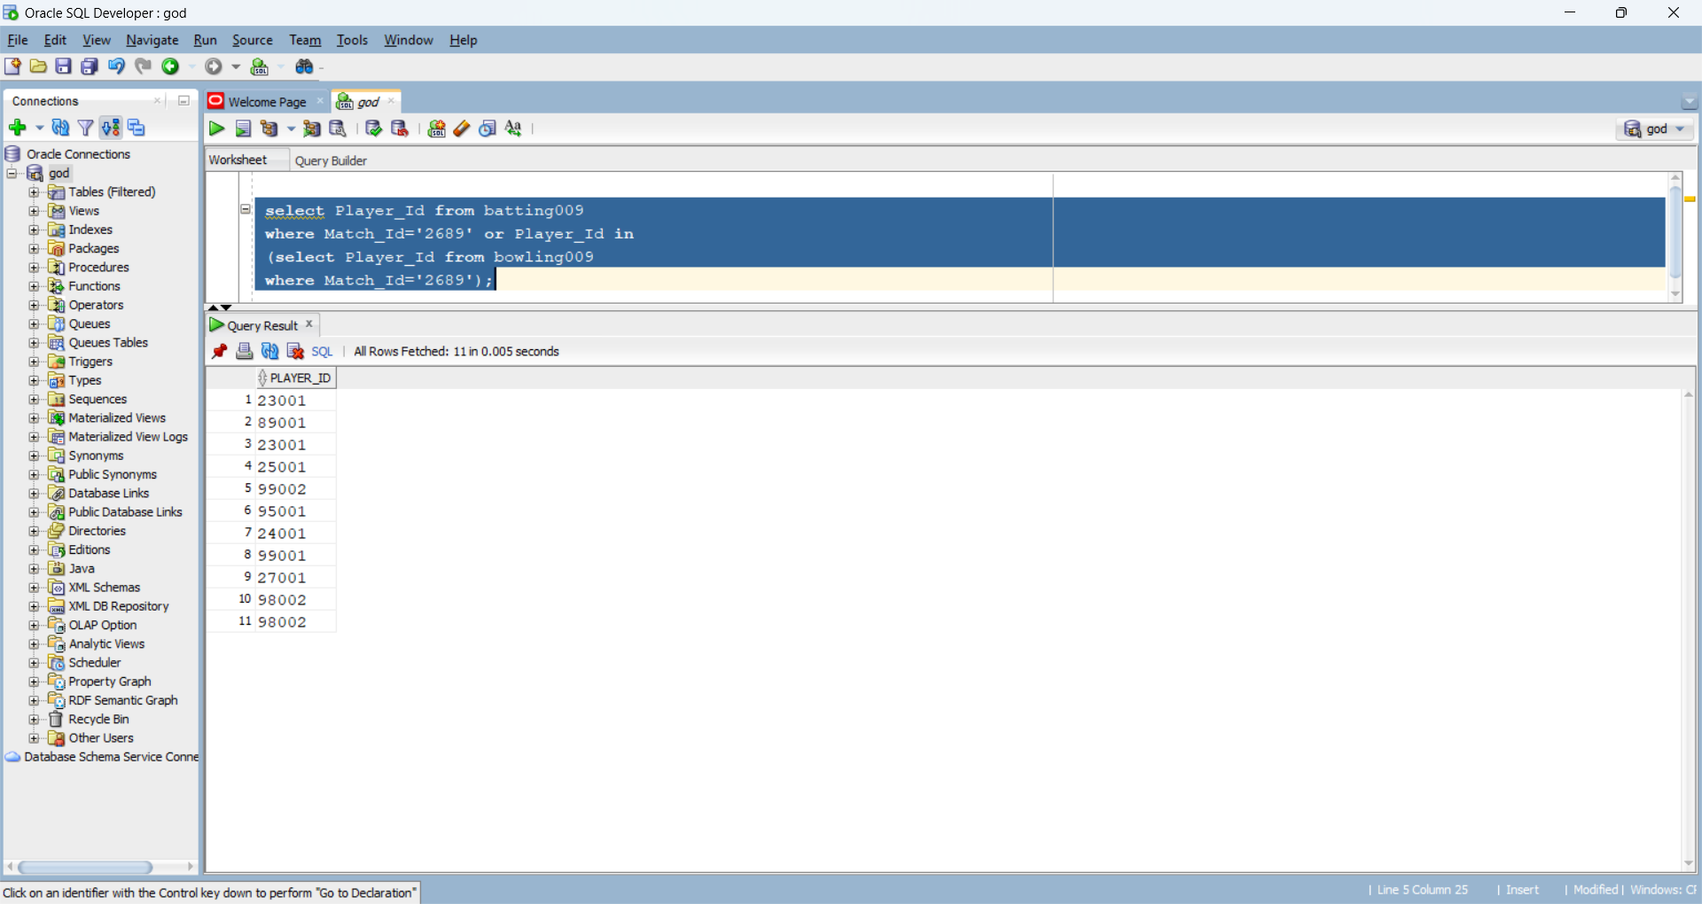**e) Find ids of players that have either bowled or batted in the ODI match 2689.**

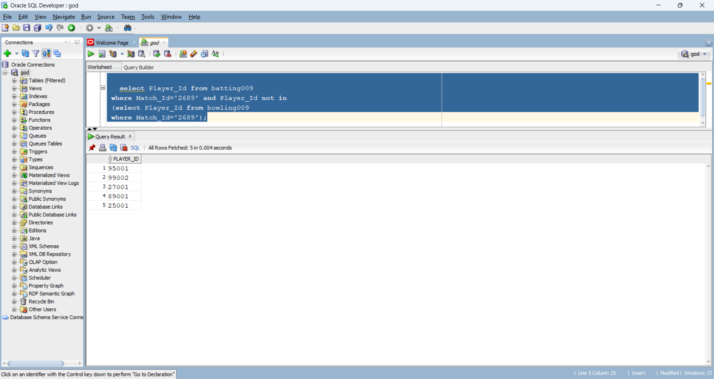**f) Find ids of players that have batted in match no 2689 but have not bowled.**

**g) Find the senior player in ODI database.**

* select F_Name, L_Name from (select F_Name, L_Name, dense_rank () over (order by Year_Born) as rank from player009) where rank =1;

