**Assignment No: 02**

**a) Find all the information about players who are from ‘INDIA’ and was born after 1980.**

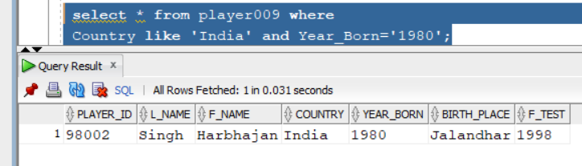

**b) Find details of matches that have been played in ‘AUSTRALIA’.**

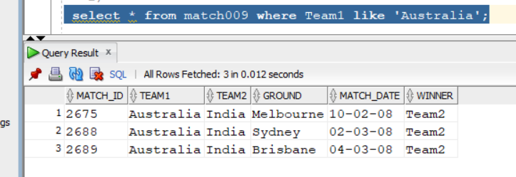

**c) List the matches played in which INDIA or ENGLAND was team1.**

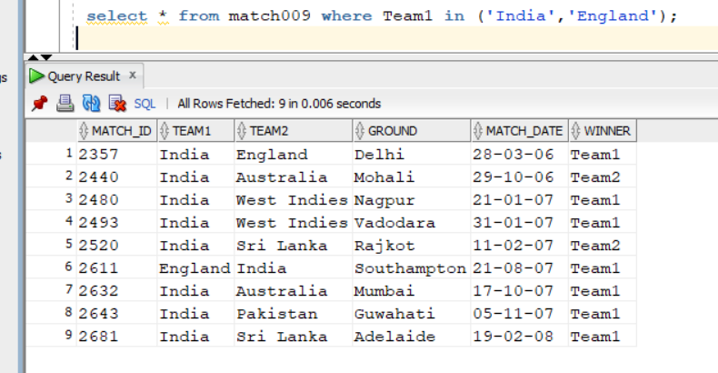

**d) Find ids of all players those have bowled in an ODI match.**

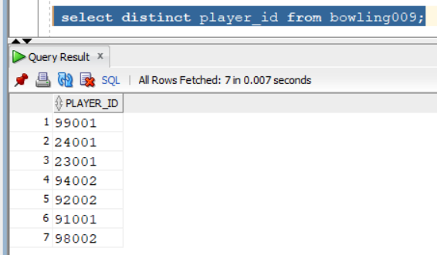

**e) Find names of teams and grounds where India has played an ODI match outside India.**

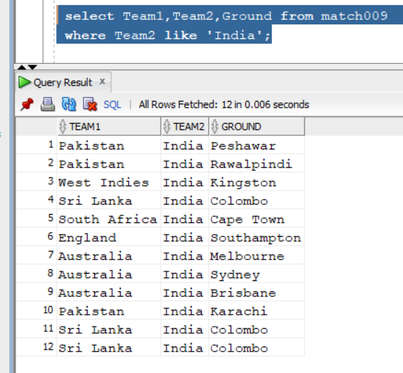

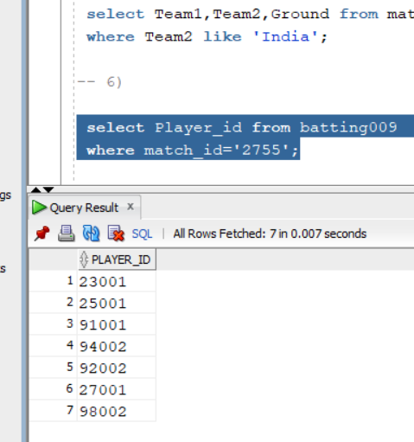**f) Find ids of all players that batted in match no 2755.**

**g) Find the player ids of players who have made a century in each of the ODI matches 2755 and 2689.**

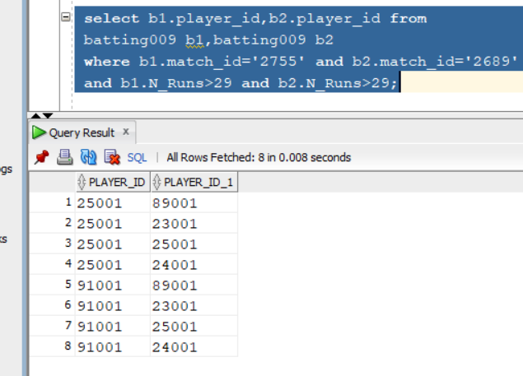

**h) Find the player ids of those players whose date of first test match (FTEST) is not given in the database.**

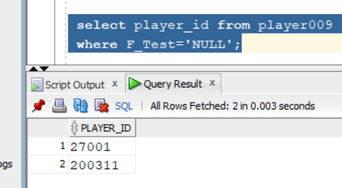

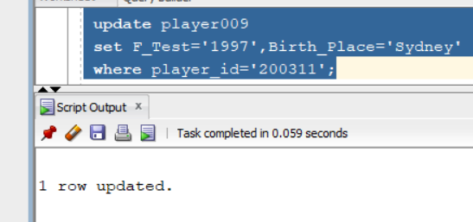**i)Modify the bplace and ftest of player id 200311 to Sydney and 28 respectively.**

**j) Delete match id 2689 from MATCH table.**

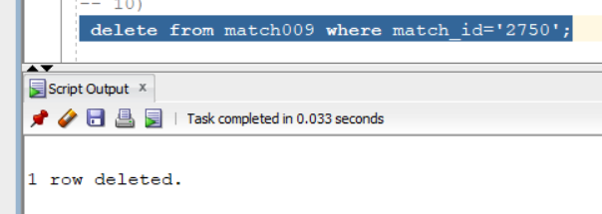

**k) Delete bowling records of Brian Lara.**

