**Assignment No: 03**

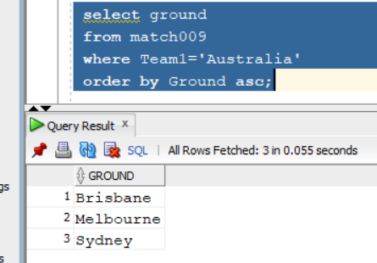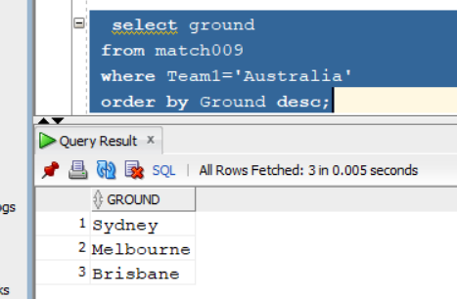**a) Display the sorted list of ground names in ascending & descending order where AUSTRALIA has played as team1.**

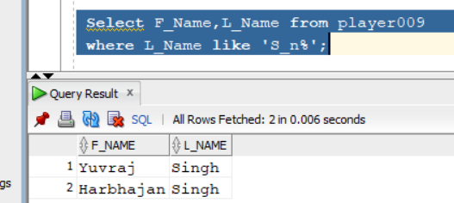**b)** **Find the name of all players whose last name starts with ‘s’, third letter is ‘n’.**

**c)Find match ids of those matches in which ‘Tendulkar’ batted.**

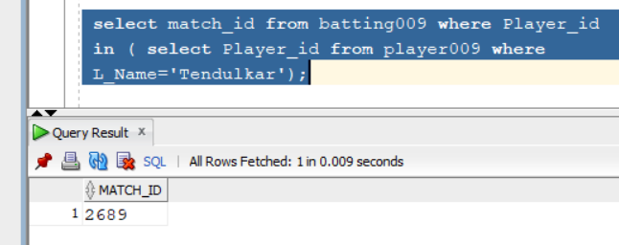

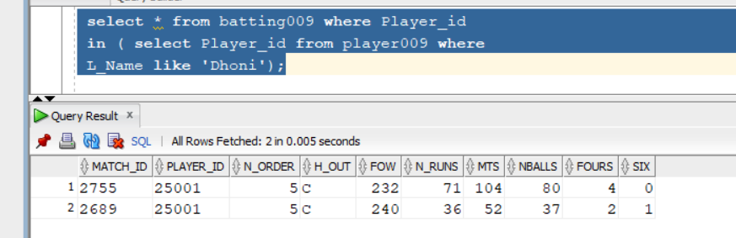**d)** **Find the match details of those matches in which ‘Dhoni’ has batted.**

**e)** **Find the match ids of matches in which Sachin Tendulkar has played.**

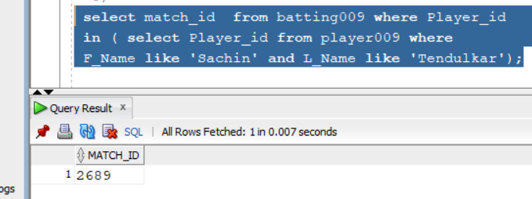

**f)** **Find ids and scores of players who scored less than 75 but more than 50 in Colombo.**

