YUVAINTERN
WEEK 2 TASK
Exploratory Data Analysis and Visualization

Bank Marketing Campaign Analysis

Prepared from the executed Google Colab notebook
Tools: Python, Pandas, Matplotlib, Seaborn
Dataset: UCI Bank Marketing Dataset

Prepared by: Kattubadi Abhilash

Executive Summary
This report documents an exploratory data analysis of the UCI Bank Marketing dataset. The analysis was performed in Python using Pandas for data manipulation and descriptive analysis, and Matplotlib and Seaborn for visualization. The working dataset contains 45,211 customer records and 17 variables. The primary analytical objective was to understand how customer characteristics, campaign context, prior campaign outcomes, and contact behavior relate to the likelihood of subscribing to a term deposit.
The EDA found a strong class imbalance: 88.3% of customers did not subscribe and 11.7% did. Several variables showed substantial differences in observed subscription rates. Students had the highest job-level rate (28.68%), while blue-collar customers had the lowest among the listed job groups (7.27%). The age analysis suggested a non-linear relationship, with the 66+ group reaching 42.61% and the 18-25 group 23.95%. Previous campaign success was the strongest categorical association identified, with a 64.73% subscription rate. Call duration also showed a notable numerical association with subscription (correlation 0.395), although duration is measured during the current interaction and therefore should not be interpreted as a pre-contact causal or predictive factor.
Campaign intensity displayed a clear inverse association with observed subscription rate: 14.60% for one contact versus 3.93% for 11+ contacts. Monthly rates also varied widely, with March at 51.99% and May at 6.72%. These results provide useful descriptive evidence for understanding the campaign but do not establish causation. All conclusions in this report are therefore framed as associations observed in the dataset.

1. Introduction and Objective
The Week 2 objective was to move beyond basic data inspection and perform a structured exploratory data analysis (EDA). The task required descriptive statistics, multiple visualizations, interpretation of patterns, analysis of correlations and anomalies, and explanation of any transformations or aggregations. The workflow was designed to answer practical questions about customer subscription behavior while keeping the analysis reproducible.
- Select and acquire a suitable public dataset.
- Summarize the structure and statistical characteristics of the data.
- Analyze individual variables using univariate EDA.
- Investigate relationships between features and subscription using bivariate and multivariate EDA.
- Use correlation analysis to examine numerical feature relationships.
- Create derived variables and grouped summaries where they improve interpretability.
- Translate visual patterns into evidence-based findings and discuss analytical limitations.

2. Dataset Selection and Acquisition
The Bank Marketing dataset was selected because it combines numeric and categorical variables and includes a binary outcome (`y`) indicating whether a client subscribed to a term deposit. This structure supports a broad range of EDA techniques, including demographic comparisons, campaign analysis, grouped rates, multivariate summaries and correlation analysis.
The dataset was acquired from the UCI Machine Learning Repository using the public ZIP endpoint for the Bank Marketing dataset. In the notebook, the ZIP archive was downloaded with Python, extracted, and the `bank-full.csv` file was loaded with Pandas using semicolon (`;`) as the separator.
url = "https://archive.ics.uci.edu/ml/machine-learning-databases/00222/bank.zip"
bank_zip = "bank.zip"
import urllib.request
urllib.request.urlretrieve(url, bank_zip)
with zipfile.ZipFile(bank_zip, "r") as zip_ref:
zip_ref.extractall("bank_data")
df = pd.read_csv("bank_data/bank-full.csv", sep=";")
The executed notebook confirmed a dataset shape of 45,211 rows and 17 columns and saved the acquired working copy as `bank_marketing_acquired.csv`.

3. Dataset Overview and Initial Statistical Analysis
Initial inspection used the DataFrame shape, column names, data types, sample records, descriptive statistics for numeric variables, categorical summaries, and unique-value checks. This stage established the analytical scope and highlighted variables that warranted deeper study.
The numeric fields include age, balance, day, duration, campaign, pdays and previous. Categorical fields include job, marital status, education, default, housing, loan, contact, month, poutcome and the target variable y.
The numeric summaries show substantial dispersion and skewness in several variables. For example, balance has a mean of approximately 1,362.27 but a maximum of 102,127, while duration has a mean of about 258.16 seconds and a maximum of 4,918 seconds. Campaign frequency is also highly concentrated at low values but has a long right tail.
Metric | Value | Analytical relevance
Total customers | 45,211 | Overall dataset size
Subscription rate | 11.70% | Strong target imbalance
Average age | 40.94 | Central demographic tendency
Average balance | 1,362.27 | Highly skewed monetary variable
Average call duration | 258.16 sec | Potentially important campaign variable
Average campaign contacts | 2.76 | Useful for contact-intensity analysis
Customers with previous contact | 8,257 | Prior campaign history is analyzable

4. Data Quality Findings
The quality assessment found zero standard missing values and zero duplicate rows. However, the dataset contains domain-specific representations that need interpretation. The `unknown` category appears in several categorical fields, including 28.80% of contact values and 81.75% of poutcome values. Similarly, 81.74% of pdays values are -1, while 81.74% of previous values are zero. These should not automatically be deleted because they encode campaign-history states.
The presence of such coded or unknown states motivated the decision to preserve the records during EDA and interpret them explicitly rather than applying arbitrary imputation. This avoids introducing assumptions not supported by the data source.

5. Univariate Exploratory Data Analysis
Univariate EDA examined individual variables to understand their distributions before studying relationships. The notebook used count plots, histograms with KDE overlays, and category counts.
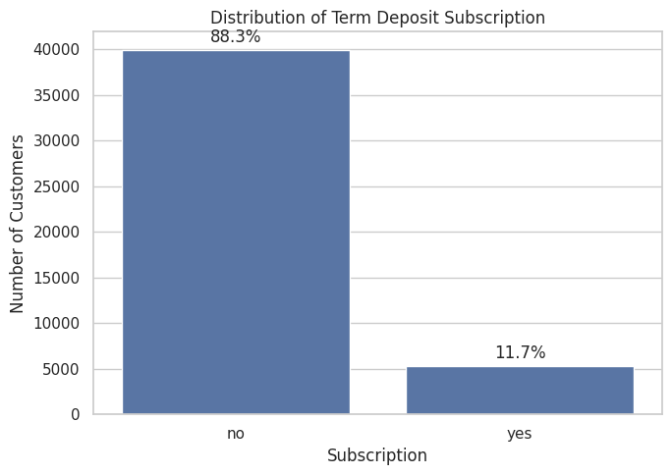
Figure 1. Distribution of term-deposit subscription.
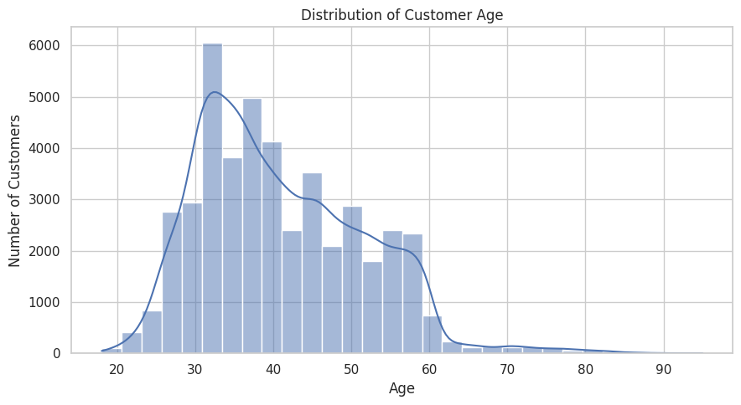
Figure 2. Distribution of customer age.
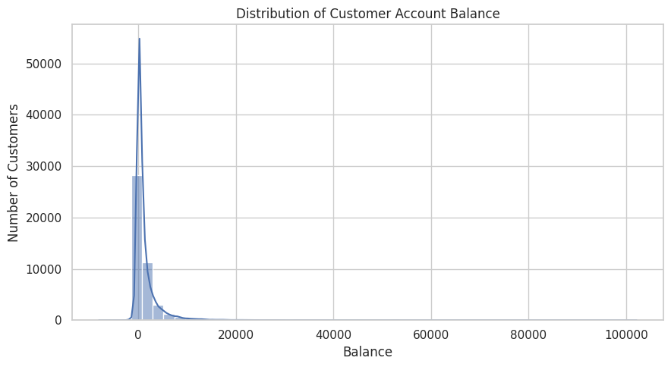
Figure 3. Distribution of customer account balance.
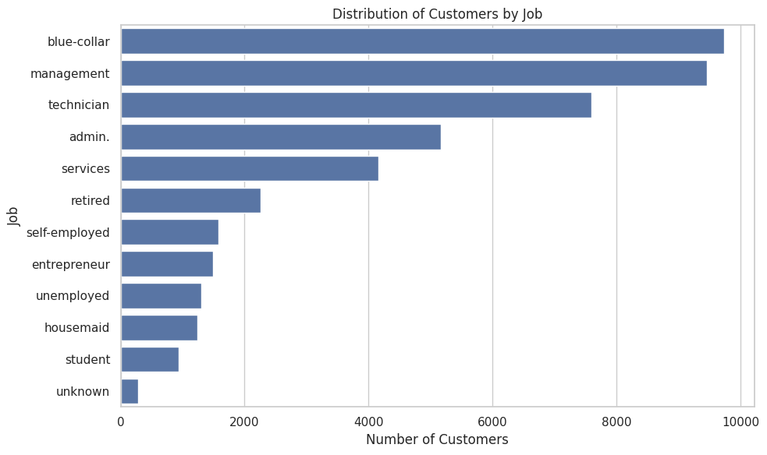
Figure 4. Distribution of customers by job.
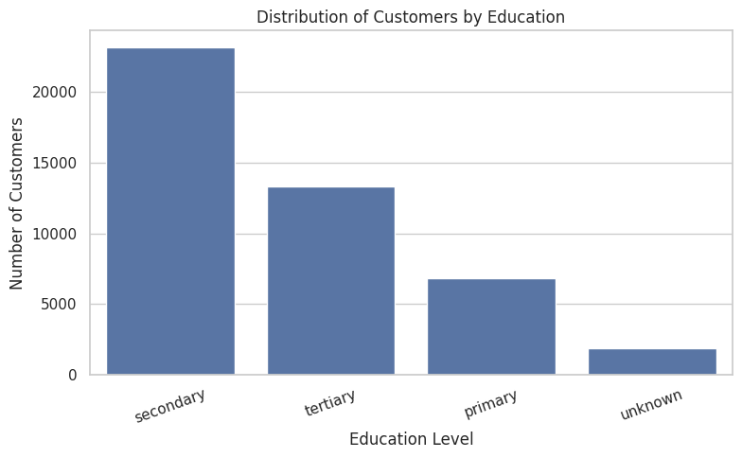
Figure 5. Distribution of customers by education.
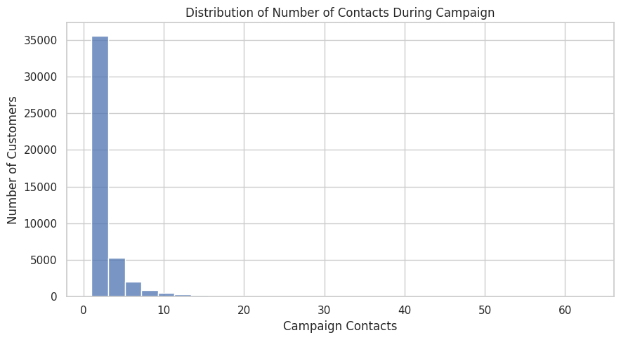
Figure 6. Distribution of campaign contacts.

5.1 Key Univariate Observations
- The target distribution is highly imbalanced: 88.3% of customers did not subscribe, while 11.7% subscribed.
- The age distribution is concentrated largely around the 30–50 range and has a right tail toward older customers.
- Account balance is strongly right-skewed, with most observations concentrated near lower values and a small number of very large balances.
- Blue-collar and management customers are among the largest job groups, while unknown and student categories are much smaller.
- Secondary education is the most common education category.
- Campaign contacts are strongly right-skewed: most customers received only a few contacts, while a small number received many.

6. Bivariate Exploratory Data Analysis
Bivariate EDA focused on the relationship between individual explanatory variables and the subscription outcome. For categorical features, the analysis used within-group subscription rates rather than raw subscriber counts. This choice controls for the fact that some categories contain many more customers than others.
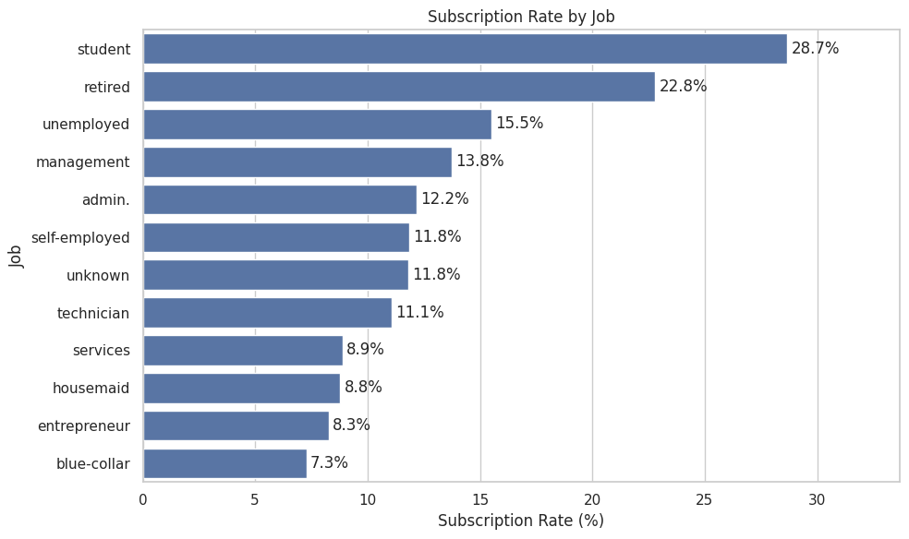
Figure 7. Subscription rate by job.
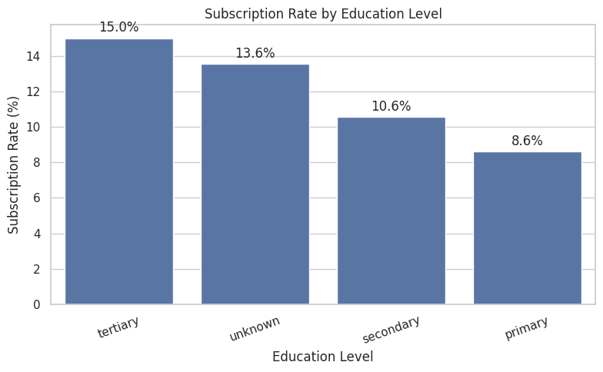
Figure 8. Subscription rate by education level.
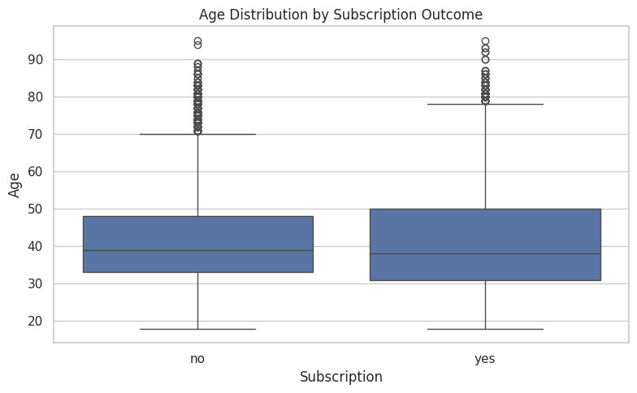
Figure 9. Age distribution by subscription outcome.
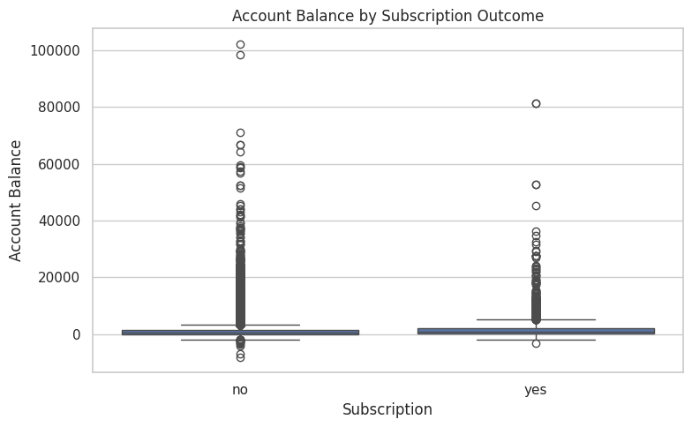
Figure 10. Account balance by subscription outcome.
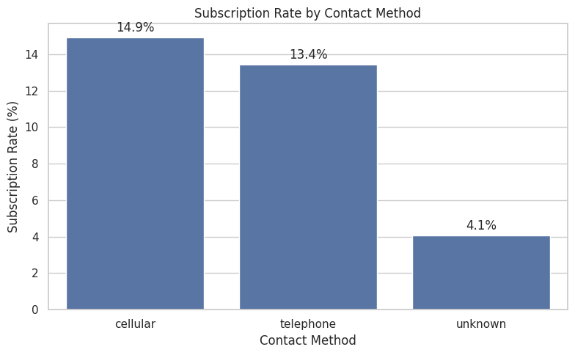
Figure 11. Subscription rate by contact method.
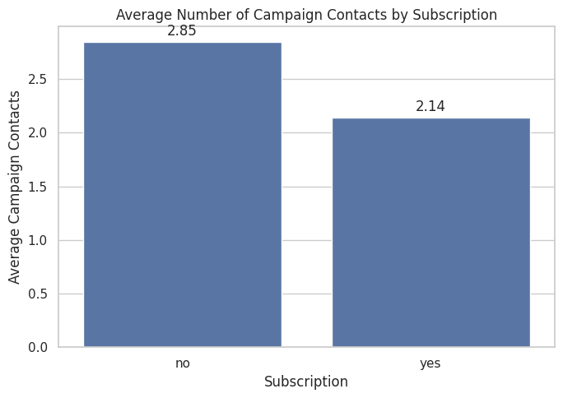
Figure 12. Average campaign contacts by subscription outcome.

6.1 Interpretation of Bivariate Relationships
Occupation shows substantial variation in observed subscription rates. Students have the highest observed rate at 28.68%, followed by retired customers at 22.79%, while blue-collar customers have 7.27%. This indicates an association between job category and subscription, but not a causal relationship.
Education also varies: tertiary customers show 15.01%, compared with 10.56% for secondary and 8.63% for primary education. The pattern suggests that education level may carry useful information when examining customer response.
The age boxplot shows broadly similar distributions but a wider and somewhat older upper range among subscribers. Because the distributions overlap strongly, age alone does not appear to provide a complete explanation of subscription behavior.
Account balance is highly skewed in both outcome groups, with many extreme observations. This motivates the later log-scale visualization for improved visual readability.
Contact method is also associated with response: cellular 14.92%, telephone 13.42%, and unknown 4.07%. The unknown category should be interpreted as a missing/unspecified contact state rather than a conventional contact method.
Average campaign contacts are lower among subscribers (2.14) than non-subscribers (2.85). The direction of the relationship is consistent with the later campaign-intensity analysis, but the result should be interpreted descriptively.

7. Multivariate Exploratory Data Analysis
Multivariate analysis combined multiple dimensions to identify interactions that may be hidden when variables are examined separately. Three complementary analyses were performed: age groups versus subscription, job-by-education subscription rates, contact method combined with campaign behavior, and previous campaign outcome combined with age group.
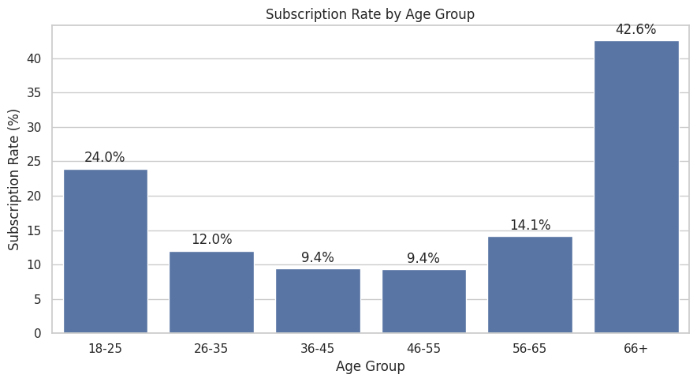
Figure 13. Subscription rate by age group.
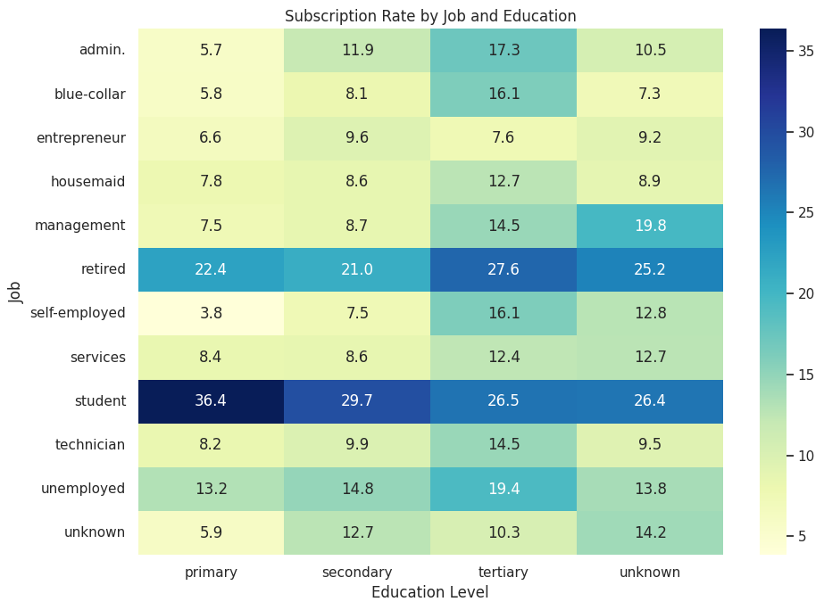
Figure 14. Subscription rate by job and education.
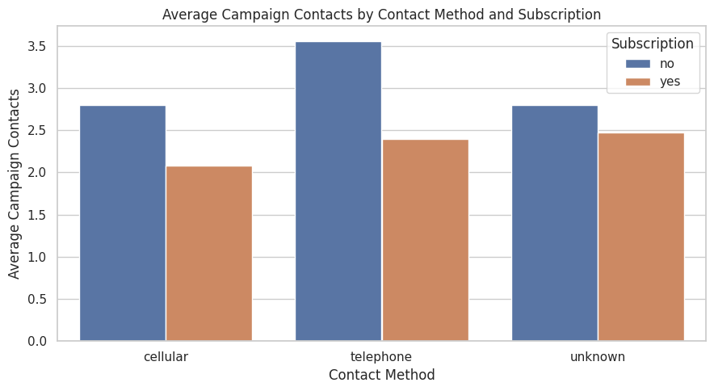
Figure 15. Average campaign contacts by contact method and subscription.
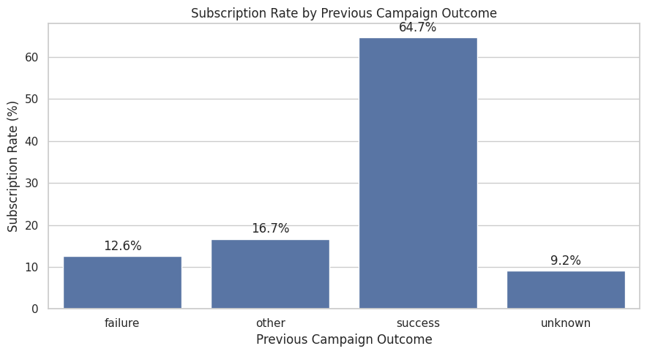
Figure 16. Subscription rate by previous campaign outcome.

7.1 Key Multivariate Findings
Age shows a non-linear pattern. The 66+ group has an observed subscription rate of 42.61%, while 36–45 and 46–55 are both around 9.4%. The 18–25 group is also comparatively high at 23.95%. This suggests that the relationship is not monotonic and that age may interact with other factors.
The job-by-education heatmap demonstrates interaction effects. For example, students show high rates across education categories, while retired customers also show comparatively high rates. This supports using grouped analyses rather than relying only on one-factor summaries.
The previous campaign outcome is especially informative. Customers with a previous successful outcome have a 64.73% observed subscription rate, far above failure (12.61%), other (16.68%) and unknown (9.16%). Across age groups, successful previous outcomes remain visibly high, suggesting a robust association between prior campaign success and the current outcome.

8. Correlation Analysis
Pearson correlation was calculated for the numerical variables age, balance, day, duration, campaign, pdays and previous. The results were visualized with a heatmap and then compared with the binary subscription representation.
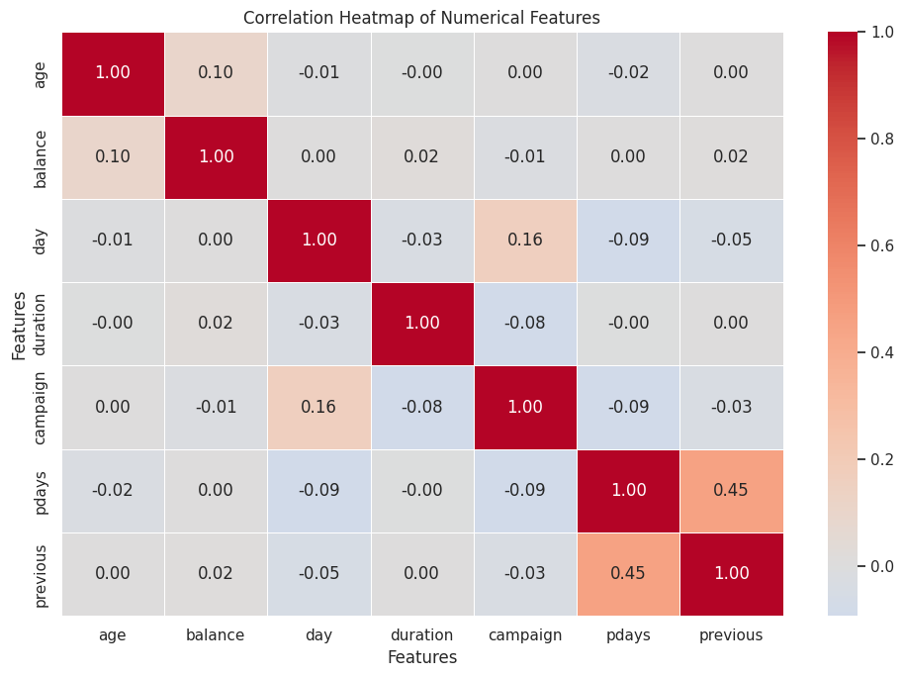
Figure 17. Correlation heatmap of numerical features.
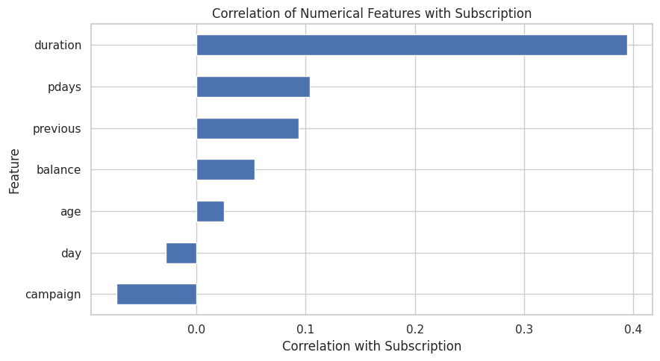
Figure 18. Correlation of numerical features with subscription.
Feature | Correlation with subscription
duration | 0.395
pdays | 0.104
previous | 0.093
balance | 0.053
age | 0.025
day | -0.028
campaign | -0.073
The strongest numerical feature-to-subscription association is duration (0.395), followed by pdays (0.104) and previous (0.093). Most variables have weak linear relationships with the binary outcome. Among the numerical features themselves, pdays and previous show the strongest relationship at approximately 0.455, which is reasonable because both describe prior campaign-contact history.
A critical limitation is that Pearson correlation measures linear association and does not capture all non-linear or categorical relationships. Therefore, the correlation analysis was used as one component of the EDA rather than as a complete measure of feature importance.

9. Data Transformations and Aggregations
Several derived variables and aggregations were introduced specifically to make patterns easier to interpret. These transformations did not replace the original source data.
- `age_group` grouped age into 18–25, 26–35, 36–45, 46–55, 56–65 and 66+.
- `campaign_group` grouped campaign contacts into 1, 2, 3, 4–5, 6–10 and 11+.
- `subscription_binary` mapped no to 0 and yes to 1 for correlation calculations.
- `balance_shifted` added a positive offset only for the log-scale balance visualization because raw balances include negative values.
- Grouped tables used normalized cross-tabulations or groupby aggregations to calculate subscription rates and average campaign metrics.
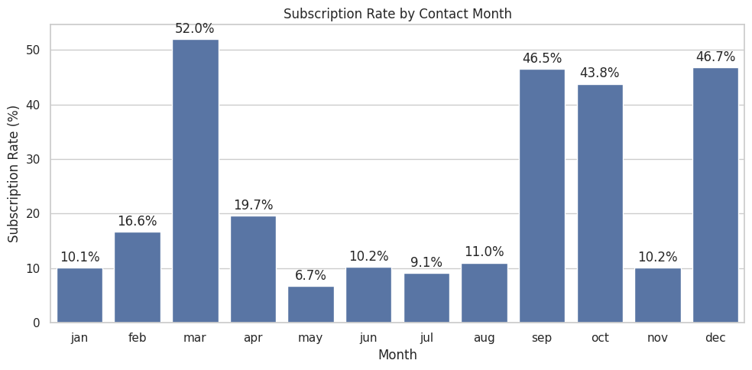
Figure 19. Subscription rate by contact month.
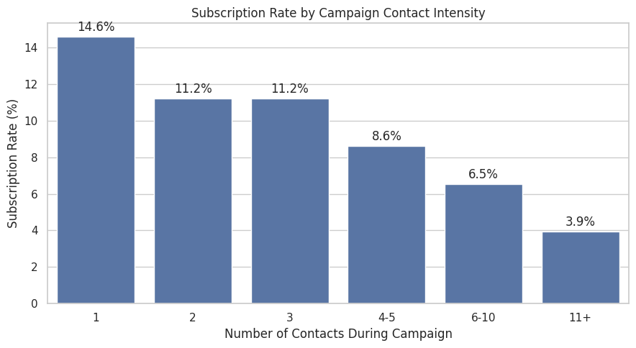
Figure 20. Subscription rate by campaign contact intensity.
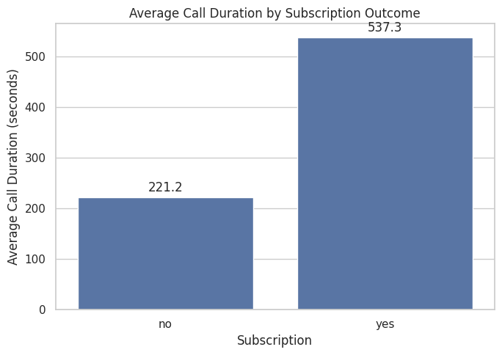
Figure 21. Average call duration by subscription outcome.
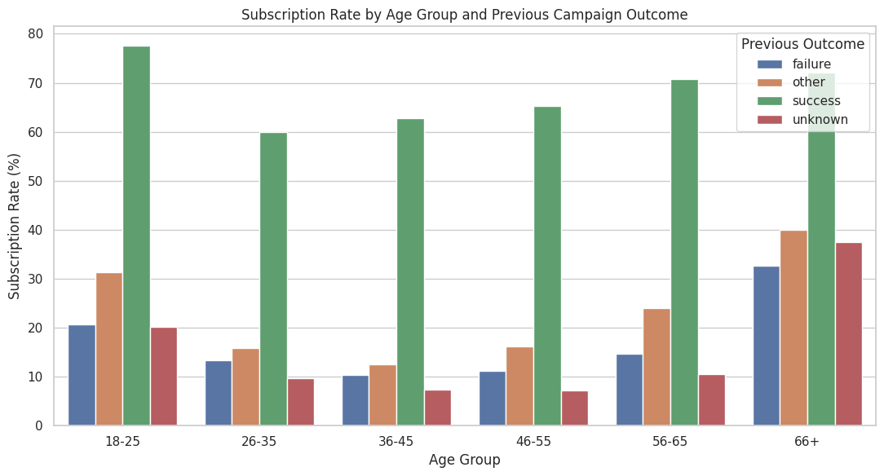
Figure 22. Subscription rate by age group and previous campaign outcome.
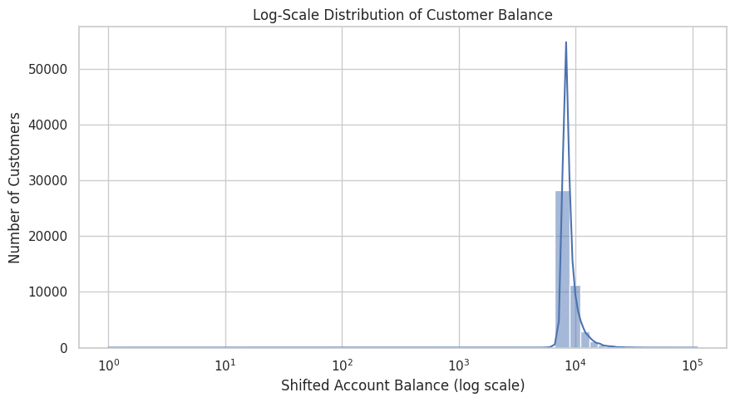
Figure 23. Log-scale visualization of customer balance.

9.1 Transformation Results
The monthly aggregation revealed large differences in observed subscription rates. March reached 51.99%, followed by December (46.73%), September (46.46%) and October (43.77%), while May was the lowest at 6.72%. Month-level results should be interpreted with sample-size awareness; a high percentage based on a small number of observations can be unstable.
Campaign intensity showed a clear decreasing pattern: 14.60% for one contact, 11.20% for two, 11.19% for three, 8.63% for four to five, 6.52% for six to ten, and 3.93% for 11 or more contacts. This pattern is consistent with the hypothesis that excessive repeated contact may coincide with lower observed response, but the EDA alone cannot establish why.
Call duration differs strongly by outcome: the mean is 221.18 seconds for non-subscribers versus 537.29 seconds for subscribers, with medians of 164 and 426 seconds respectively. This large difference explains why duration has the strongest numerical association with subscription. However, duration occurs during the current contact, so it is not a pure pre-contact explanatory variable.

10. Consolidated Key Findings
Target imbalance: Only 11.70% of customers subscribed, compared with 88.30% who did not. This imbalance should be considered in any future predictive modeling.
Previous campaign success: The strongest categorical pattern was prior success: 64.73% of customers with a successful previous outcome subscribed in the current campaign.
Campaign intensity: Subscription rate decreased from 14.60% for one contact to 3.93% for 11+ contacts.
Age non-linearity: The 66+ group had 42.61% subscription, while 36–55 groups were near 9.4%, showing a non-linear age pattern.
Occupation differences: Student customers had the highest observed job-level subscription rate at 28.68%, while blue-collar customers had 7.27%.
Contact method: Cellular contact showed 14.92% subscription, telephone 13.42%, and unknown 4.07%.
Call duration: Subscribers had much longer calls on average (537.29 sec) than non-subscribers (221.18 sec), with a feature-to-target correlation of 0.395.
Seasonal/monthly pattern: March had the highest observed monthly rate at 51.99%, while May had the lowest at 6.72%; month effects require sample-size-aware interpretation.

11. Critical Discussion and Limitations
- EDA identifies associations, not causation. A higher subscription rate in one group does not prove that group membership causes the outcome.
- The target variable is strongly imbalanced. Raw counts can therefore be misleading; normalized rates were preferred for group comparisons.
- Unknown and coded values such as `unknown` and `pdays = -1` were preserved because they represent information states in the source dataset and deleting them would substantially change the sample.
- Duration is strongly related to the outcome but is measured during the current contact, so it should be treated cautiously when discussing pre-contact prediction.
- Month-level percentages can be sensitive to the number of observations in each month; percentages should be interpreted together with group sizes.
- Pearson correlation captures linear relationships and cannot fully describe categorical effects or non-linear patterns.

12. Conclusion
The Week 2 EDA successfully progressed from basic dataset understanding to a structured investigation of customer subscription behavior. The analysis combined descriptive statistics, univariate distributions, bivariate comparisons, multivariate interaction analysis, correlation analysis, and targeted transformations. This produced a set of interpretable findings around previous campaign success, occupation, age, contact method, campaign intensity, monthly variation and call duration.
The most important methodological outcome is that the strongest insights came from combining descriptive statistics with normalized group rates and multivariate analysis. The resulting dataset and analytical outputs are now suitable for further statistical analysis or machine-learning work, with the documented limitations kept in view.

Appendix A – Representative Python Code
The following excerpts illustrate the main analytical operations used in the executed notebook. The full executed notebook is included separately in the project repository.

A1. Descriptive statistics
print(df.describe())
print(df.describe(include="object").T)

A2. Target rate
df["y"].value_counts(normalize=True).mul(100).round(2)

A3. Job subscription rate
job_subscription = (
pd.crosstab(df["job"], df["y"], normalize="index") * 100
)

A4. Correlation
correlation_matrix = df[numeric_features].corr()
df[numeric_features + ["subscription_binary"]].corr()["subscription_binary"]

A5. Age grouping
df["age_group"] = pd.cut(
df["age"],
bins=[17, 25, 35, 45, 55, 65, 100],
labels=["18-25", "26-35", "36-45", "46-55", "56-65", "66+"]
)

A6. Campaign intensity grouping
df["campaign_group"] = pd.cut(
df["campaign"],
bins=[0, 1, 2, 3, 5, 10, np.inf],
labels=["1", "2", "3", "4-5", "6-10", "11+"]
)

Appendix B – Project Files
Recommended repository structure:
- YuvaIntern_Week2_EDA.ipynb
- week2_eda.py
- bank_marketing_acquired.csv
- README.md
- requirements.txt
- Week2_EDA_Report.docx
- figures/

Dataset Source
UCI Machine Learning Repository, Bank Marketing dataset. The notebook used the public UCI ZIP endpoint to download the dataset and loaded `bank-full.csv` with Pandas.
Source endpoint used in the notebook:
https://archive.ics.uci.edu/ml/machine-learning-databases/00222/bank.zip

