# BACKGROUND

Data Analytics is a very crucial component for robust performance of any Semiconductor Industry. And Semiconductor Laboratory (SCL) is no different in this regard. Better Data Analytics would help in pre-determining of any faulty equipment part by visualizing at the parameter(s)’ drifts in process charts & improve the device yield.

This document illustrates the Data Analytics on “**Average Product Lot yield with Device’s Effective Area”** for year-2020. Please, read the DISCLAIMER section in the end before forming any opinion based on the data shown.

The data visualization chart:

* shows the trend of ‘Lot Yield’ with Device’s Effective Area
* shows the yield of lot ids for any ‘Device’ like Vikram 1601, etc.., independently.
* visualizes the zone where device(s) has maximum & minimum ‘Lot Yield’.
* features interactive (zoom-in/out, hover, 360° rotation) with portability (in .html format) via mails, etc…

# ANALYTICS

Data Analytics is comprised of 3 main modules:

1. Data Acquisition:

* The data is available in form of excel file (in .xlsx format).
* Each device has min. 1 lot ID.
* There are total **40** device names.
* The effective area varies from **0.89 mm2** to **203.08 mm2**.

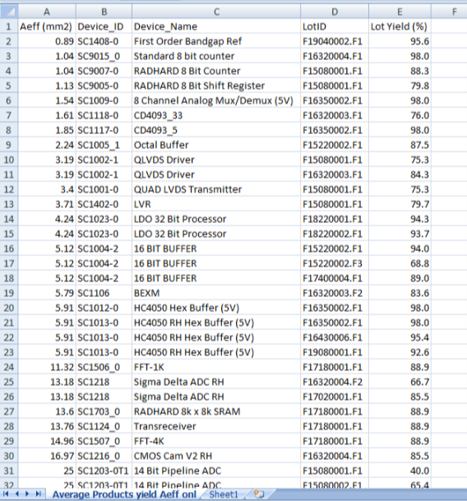

Fig. Data of Avg. Product Yield with Effective Area in Excel format

* For this, the coding script is written as:

1. Data Wrangling

* This module is for cleansing of acquired data and converts into a palette for data visualization.
* Here, the acquired data is converted into “structured & filtered” format.

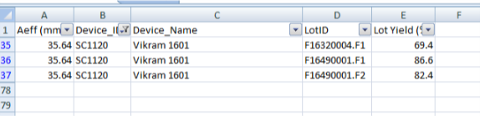

Fig. Filtered Excel data e.g. ‘Vikram 1601’ device

1. Data Visualization

* Below is the chart generated out of the filtered data using data wrangling method, done in the previous module.

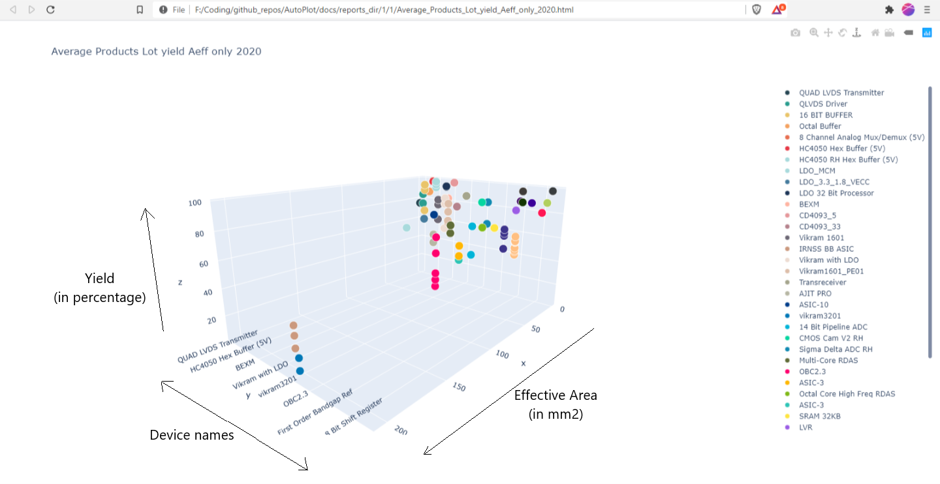

Fig. 3-D Chart Visualization for all devices

* The chart can be visualized for devices independently like Vikram 1601, etc… Here, please note that the data points are lying in a straight line, as the y-value (i.e. device name) is same for all these data points.

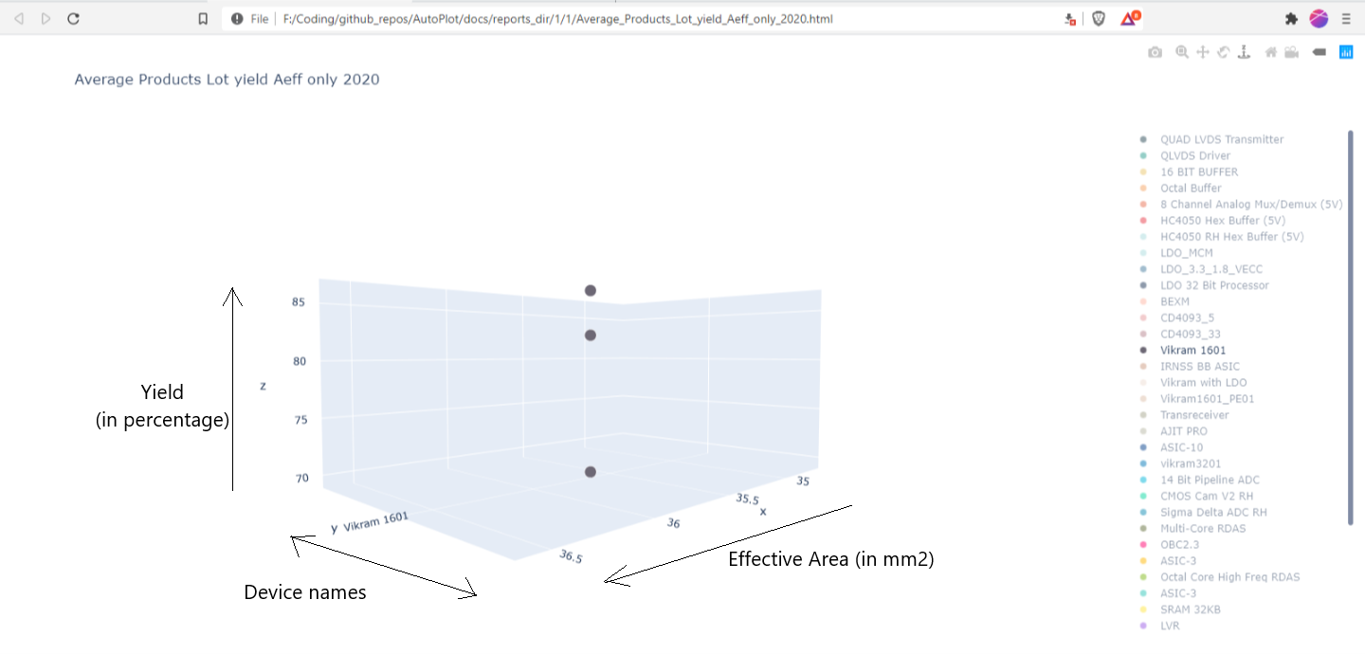

Fig. 3-D Chart Visualization for a device e.g. ‘Vikram 1601’

* Specific zone is visually found where device(s) has maximum ‘Lot Yield’. Then we can hover on the data points & see the corresponding device names & Lot IDs. Similarly, we can do the same for finding out the zone where devices have minimum yield. Therefore, further actions can be taken based on the max/min yield results for respective devices.

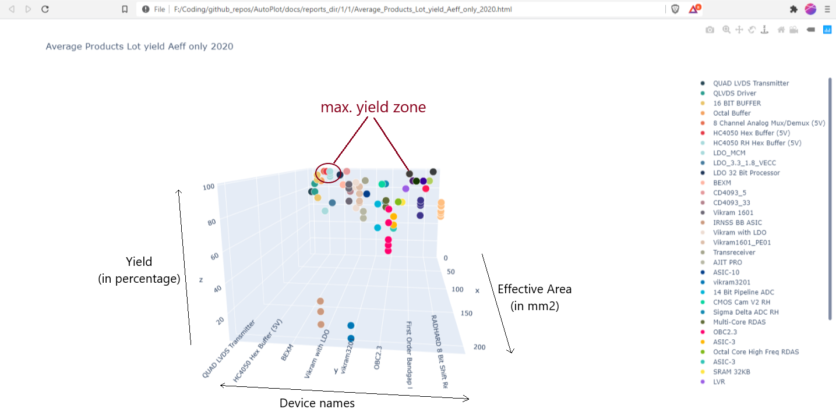

Fig. 3-D Chart Visualization for zone defining of max./min. yield

# INFERENCE

The

* Fab-out dates can be added in one of the axes in charts. This would give the information about *“whether the lot_id (pointed at) is recent or not in terms of Fab-out”*.

# APPENDIX

# DISCLAIMER

TODO

* Add no.s to the figures