## Works related to Data Visualization, Data Analysis/Mining/Scraping

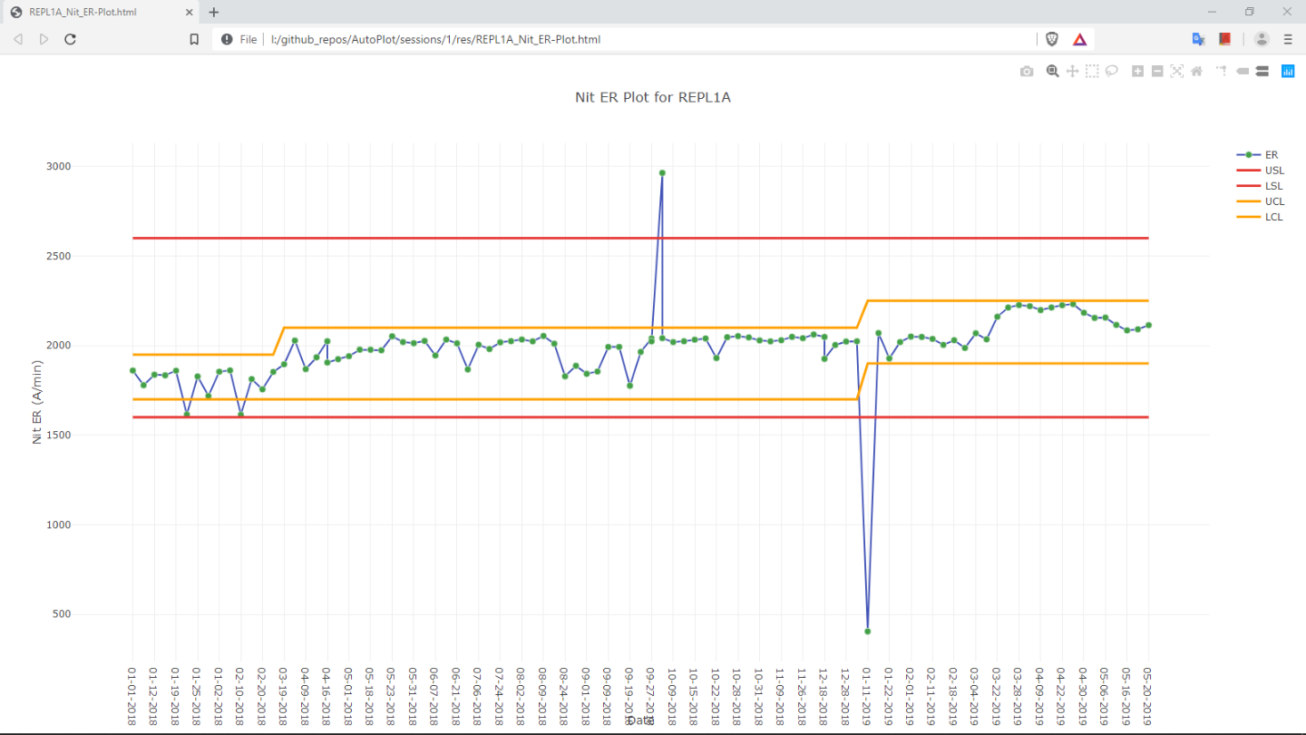

**Fig. 1:** Line Plot with single main trace

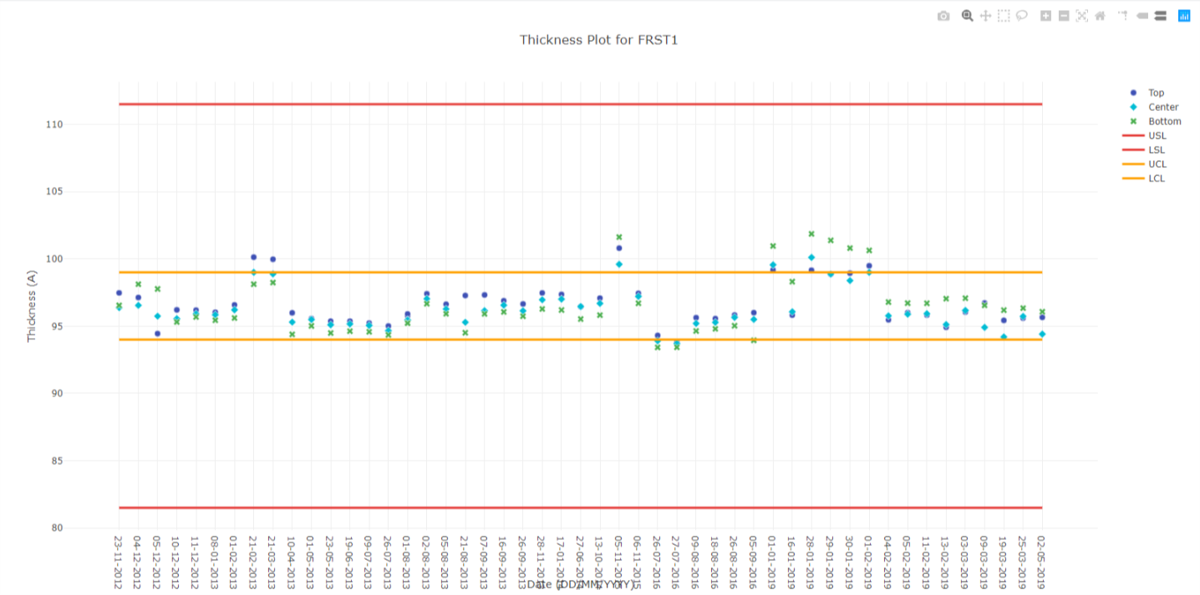

**Fig. 2**: Scatter Plot with multiple main traces

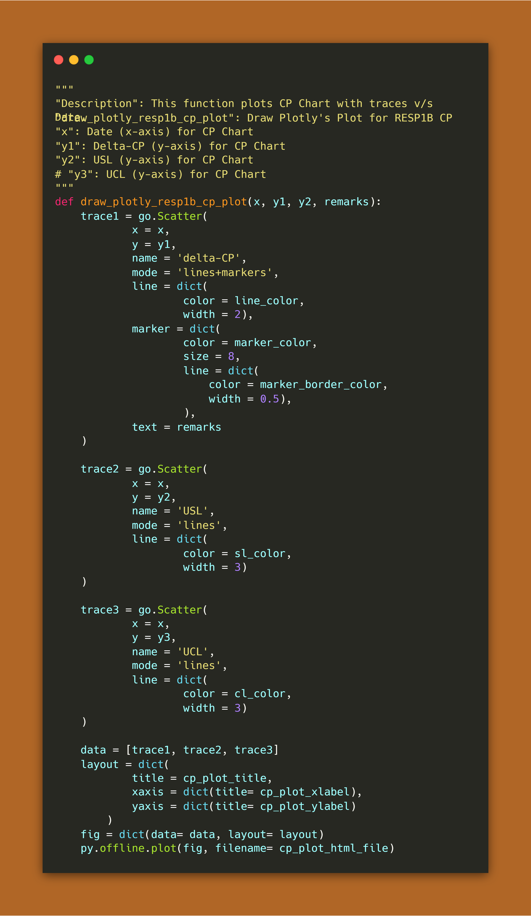

**Fig. 3:** Python Script for Fig. 1 shown above

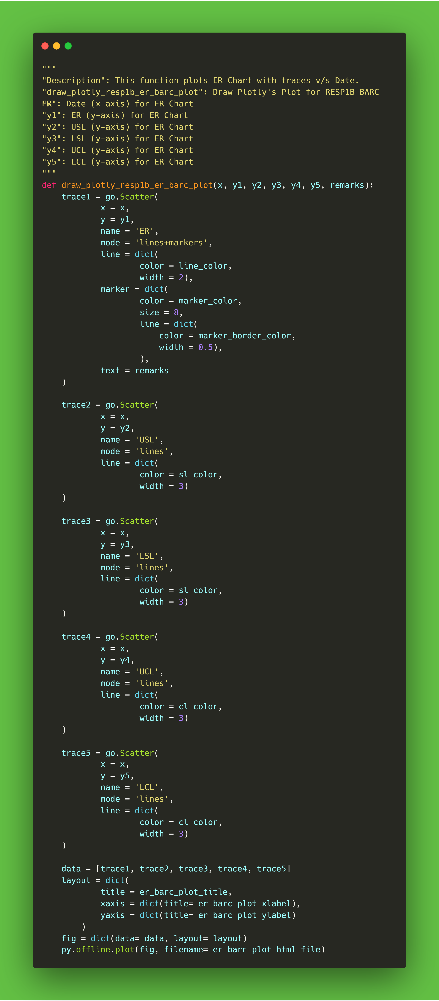

**Fig. 4:** Python script used for Line & Scatter Plot

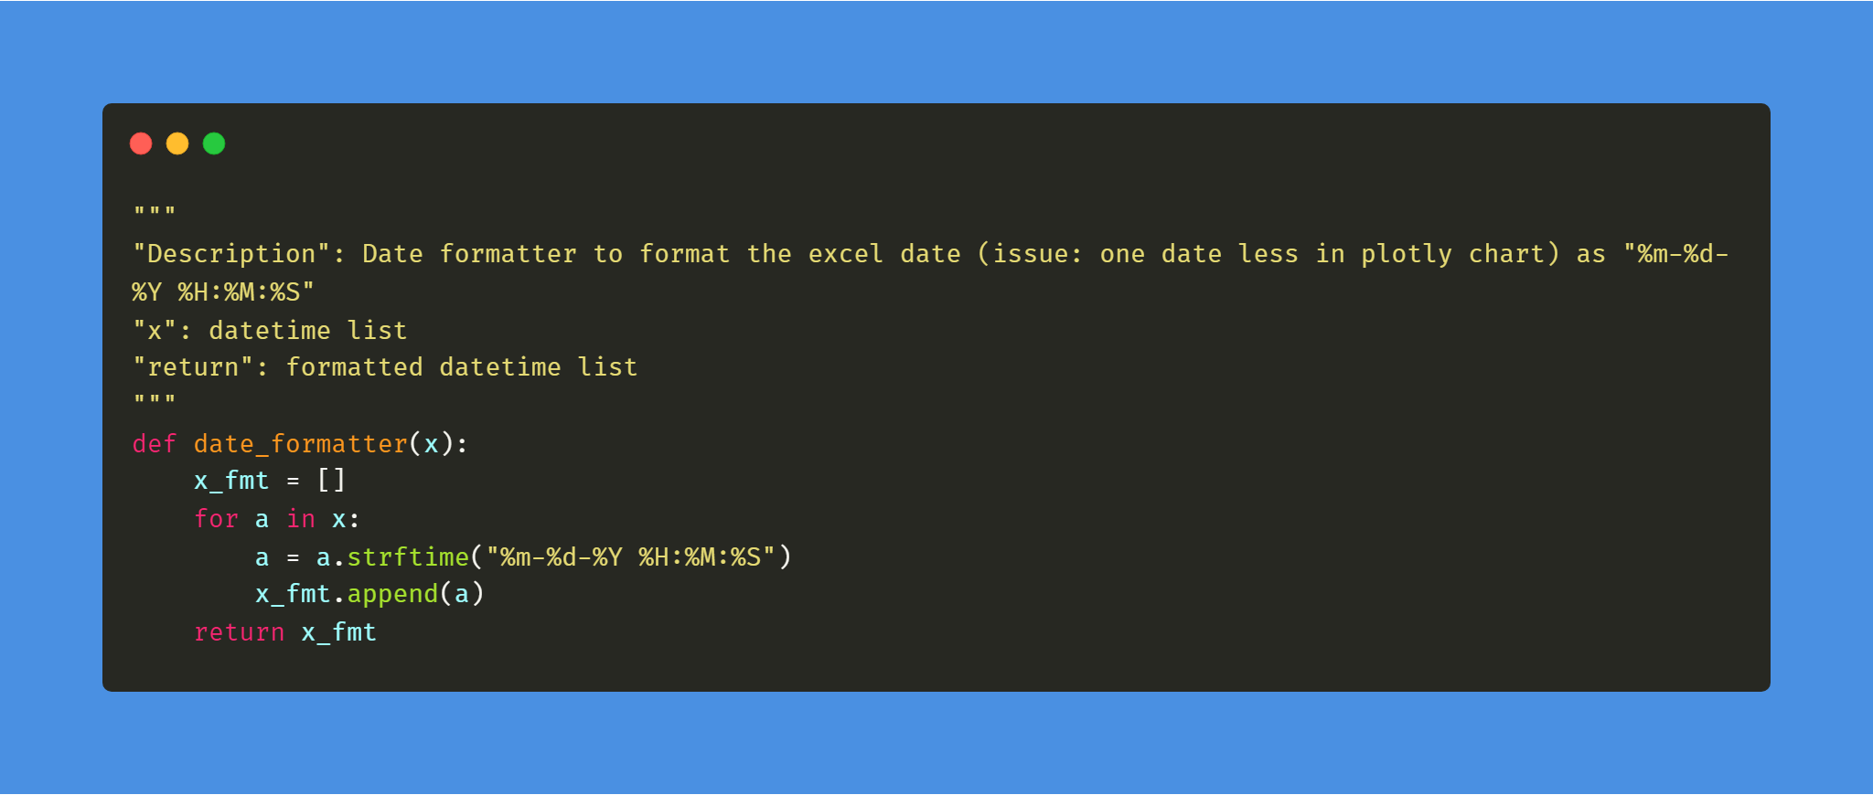

Fig. 5: Automatic Date formatter function for formatting ‘Date’ column into a custom one

## Works related to Telegram Bot

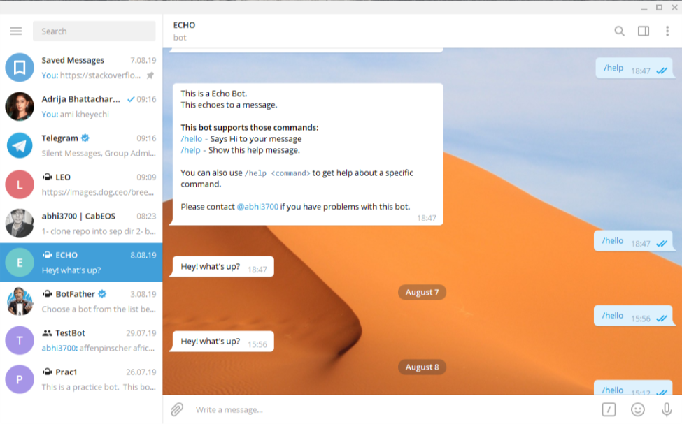

**Fig. 6:** Echo Bot – Echoes “Hey! What’s up?” for a user command – ‘/hello’. Also can be used for FAQs application for creating smooth interaction with clients/customers

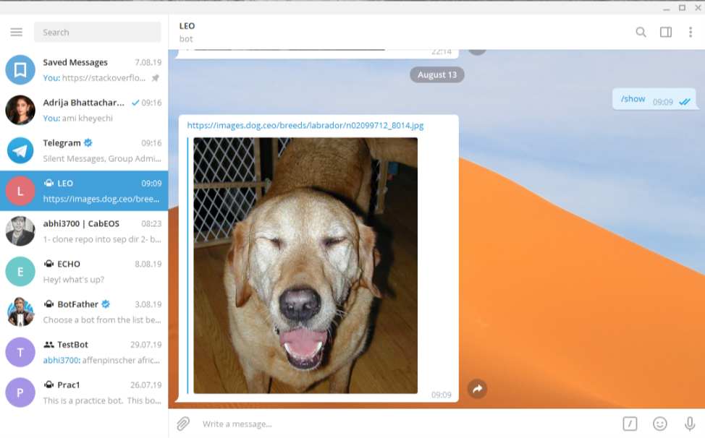

**Fig. 7:** Dog Bot – Shows random images based on ‘breed’ asked by a user