# PU-CET (PG) 2020 – M.A. English

* Exam weightage

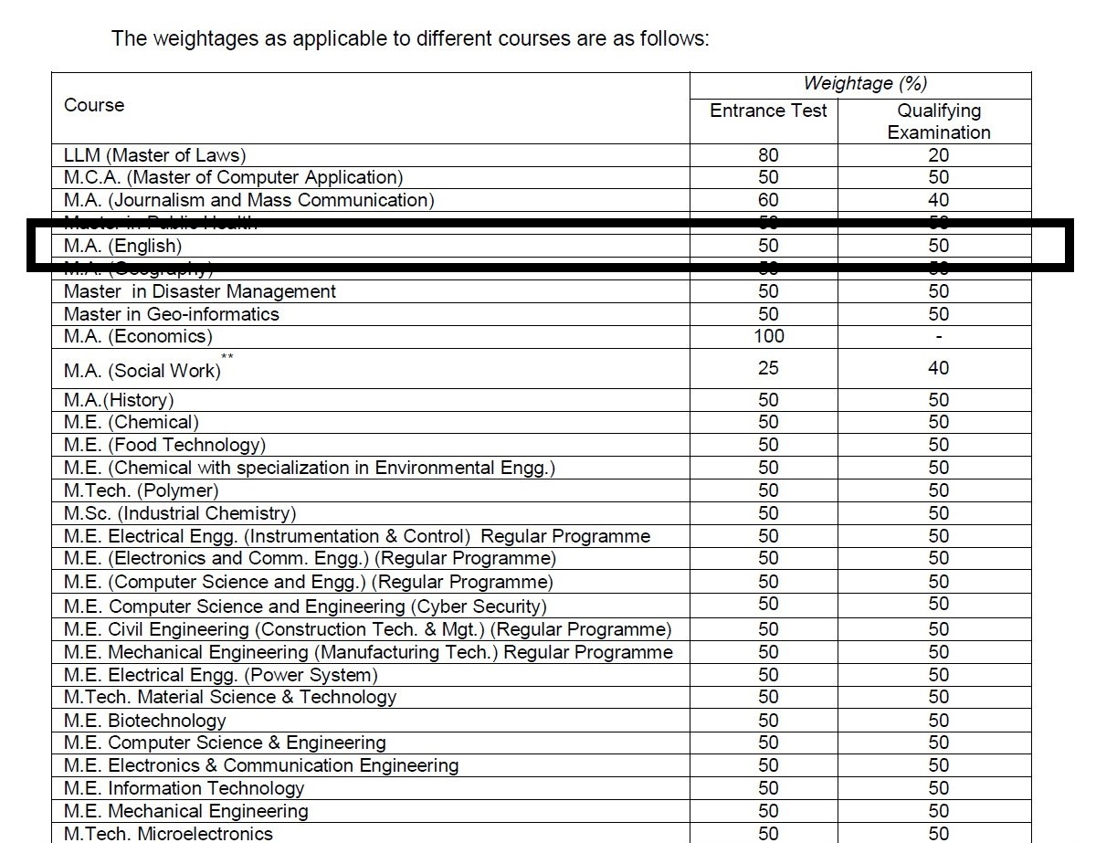

* Eligibility

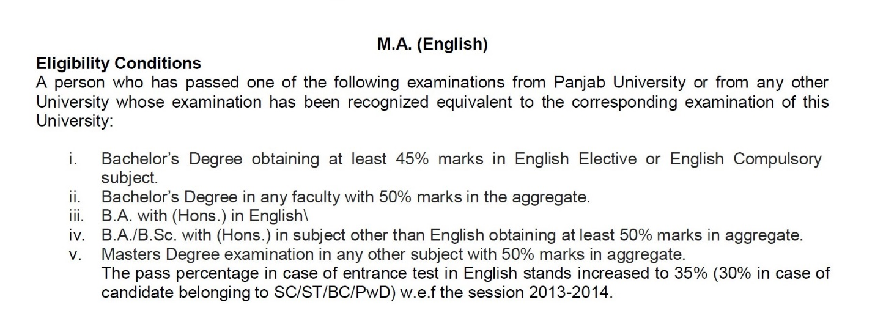

* Exam Pattern / Scheme of Test

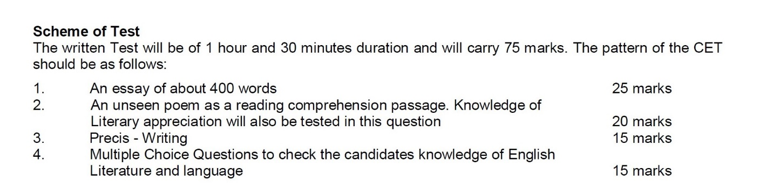

* Sample Question Paper

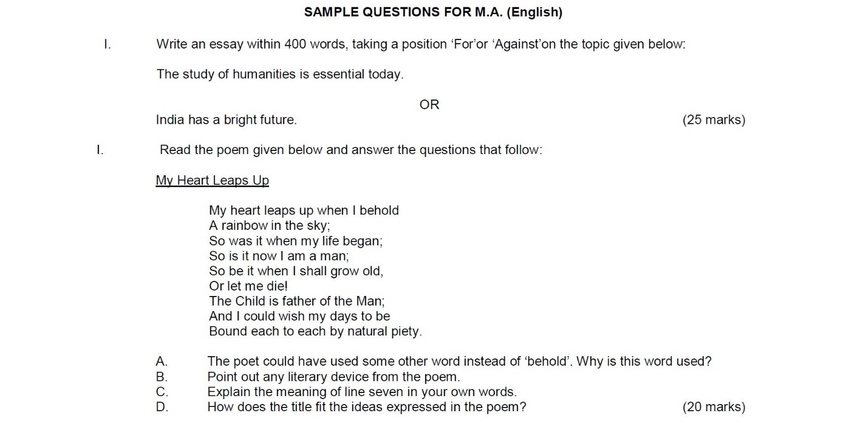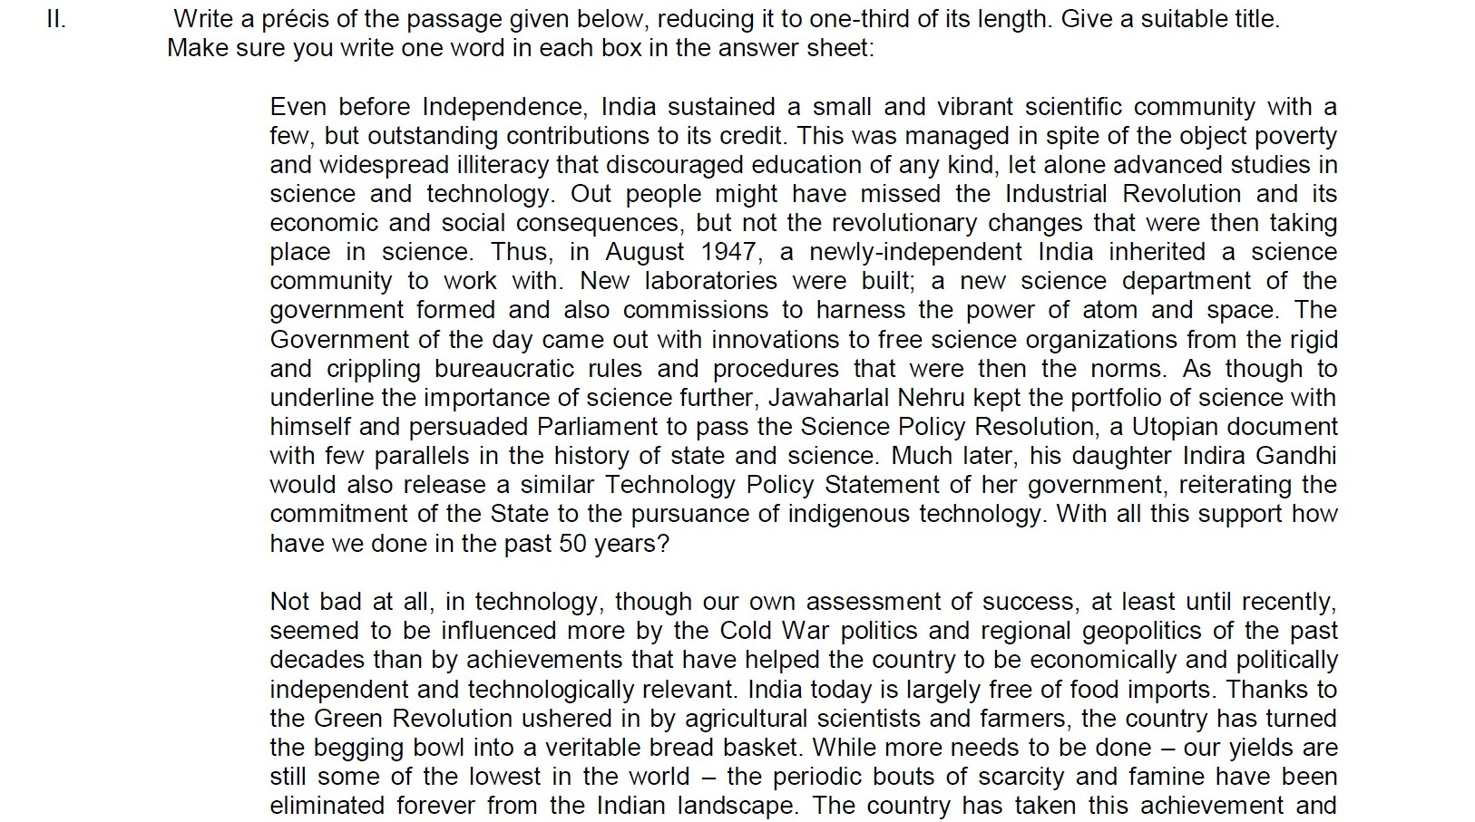

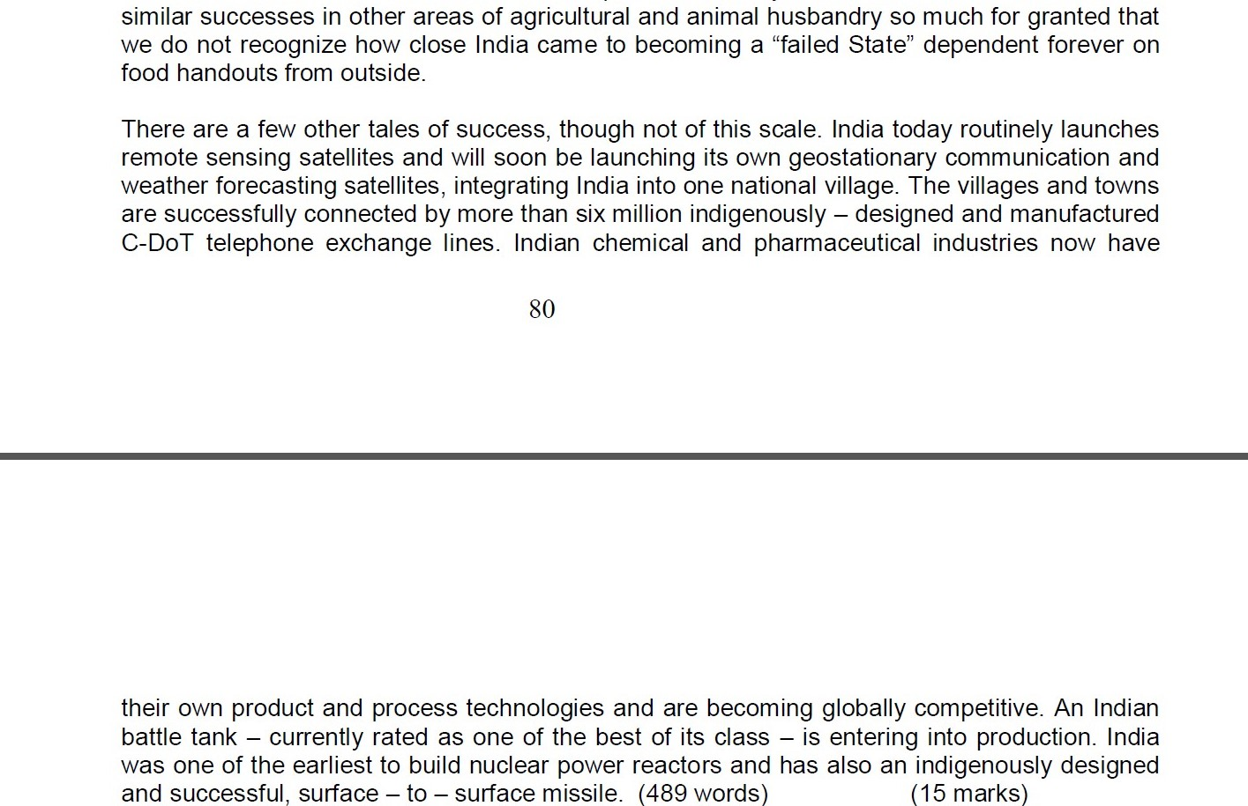

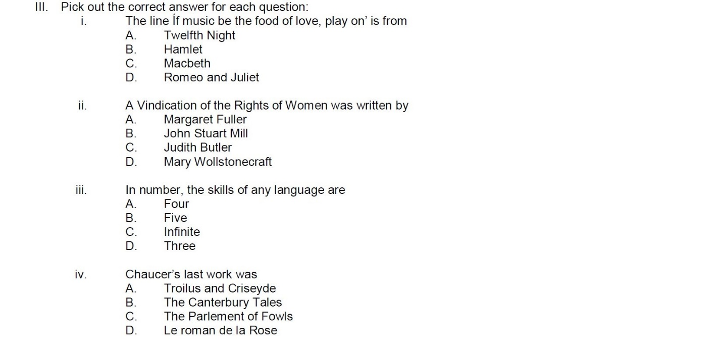

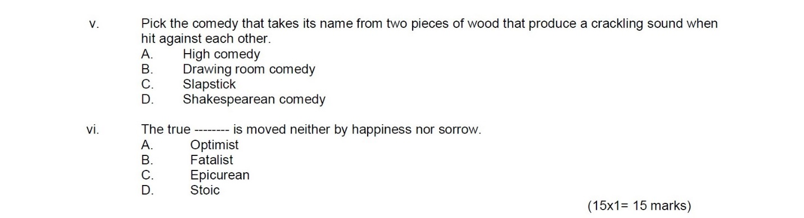

# B.A. English Syllabus & Exam Outline

* 1st Semester for (2017-18), (2018-19), (2019-20) Sessions

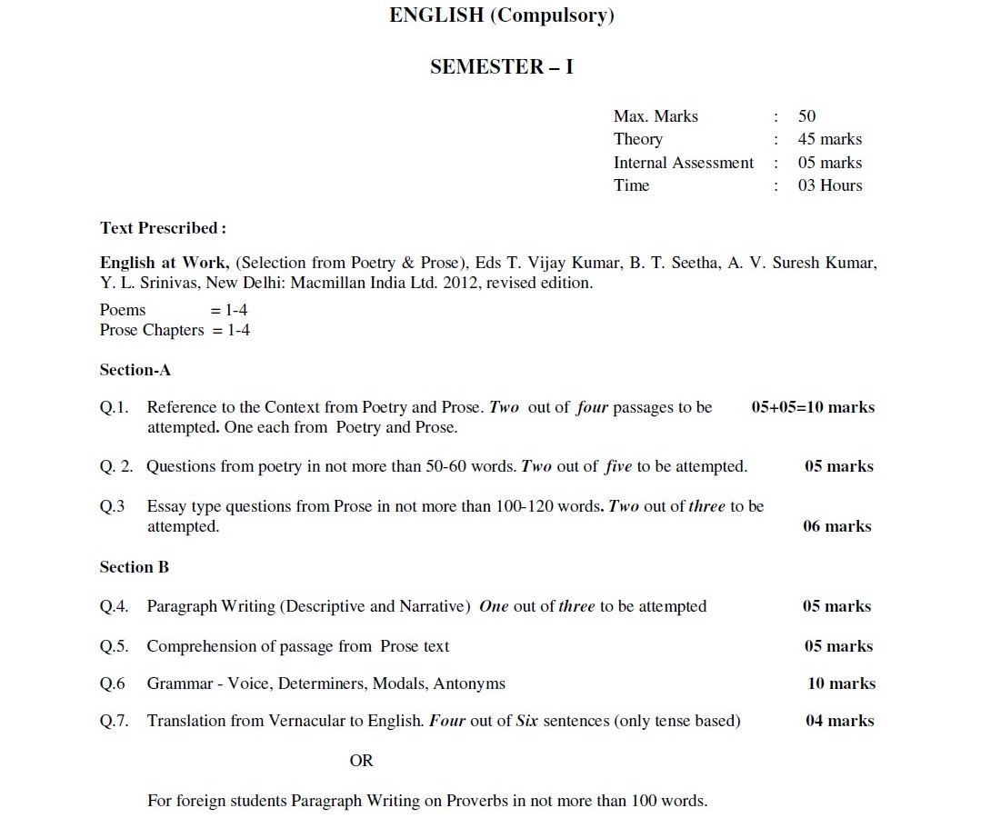

* 2nd Semester for (2017-18), (2018-19), (2019-20) Sessions

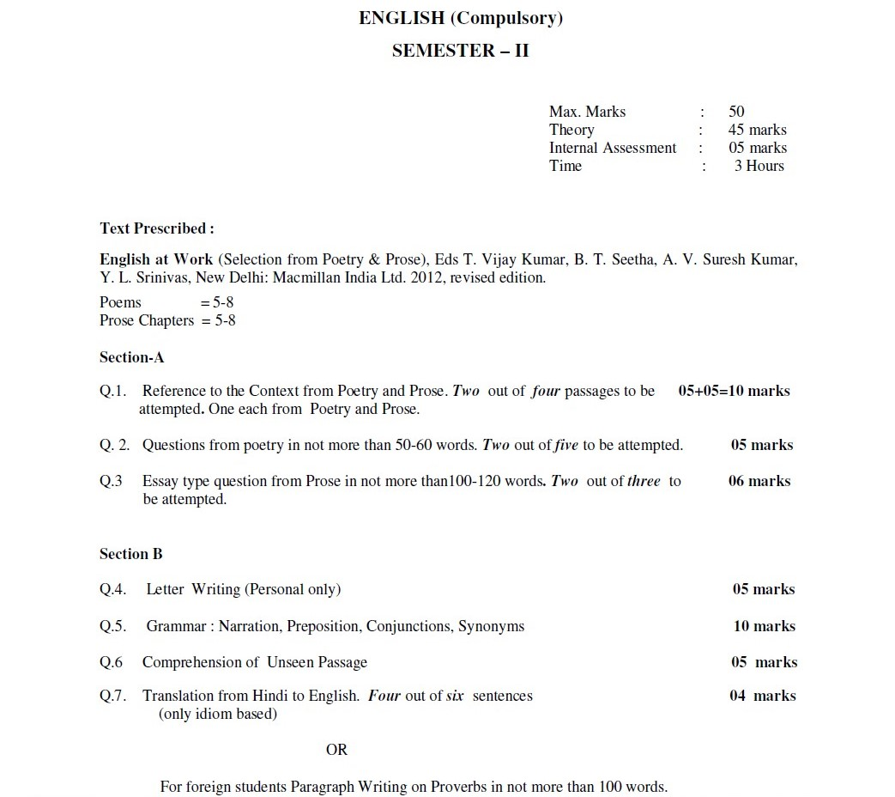

* 3rd Semester for (2017-18), (2018-19), (2019-20) Sessions

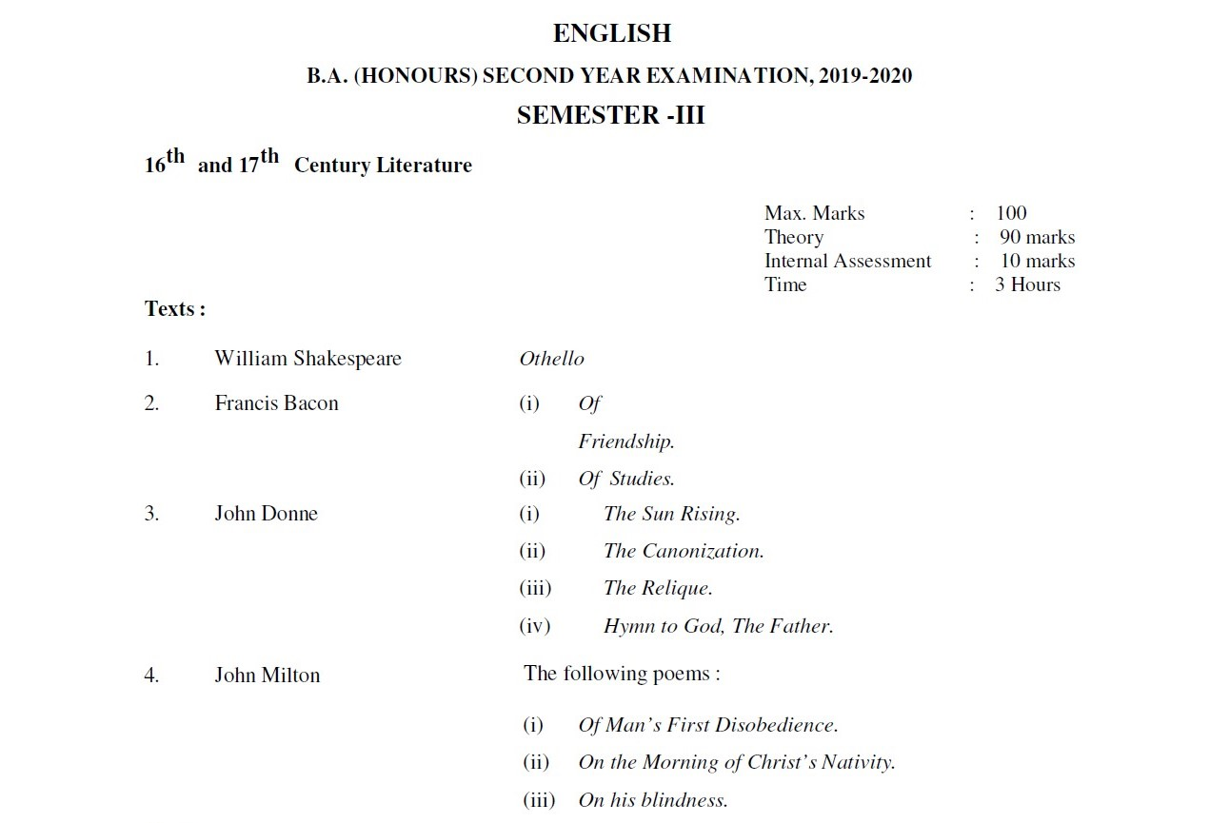

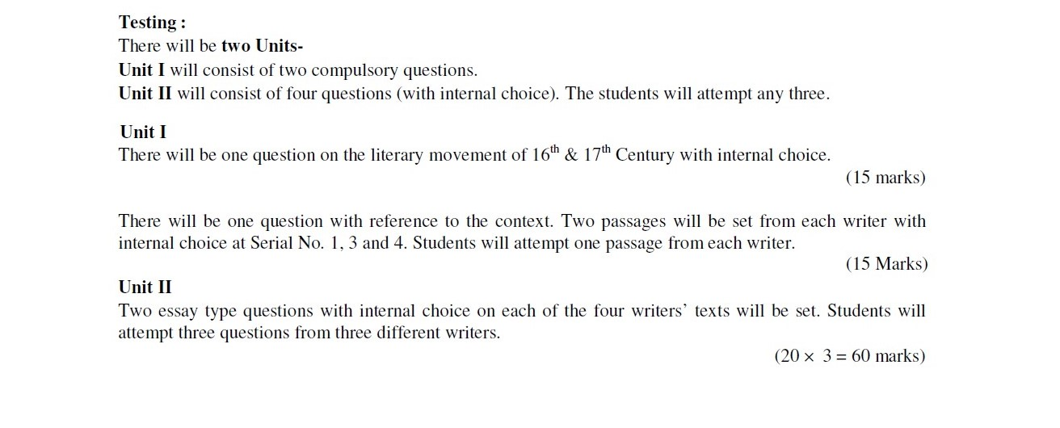

* 4th Semester for (2017-18), (2018-19), (2019-20) Session

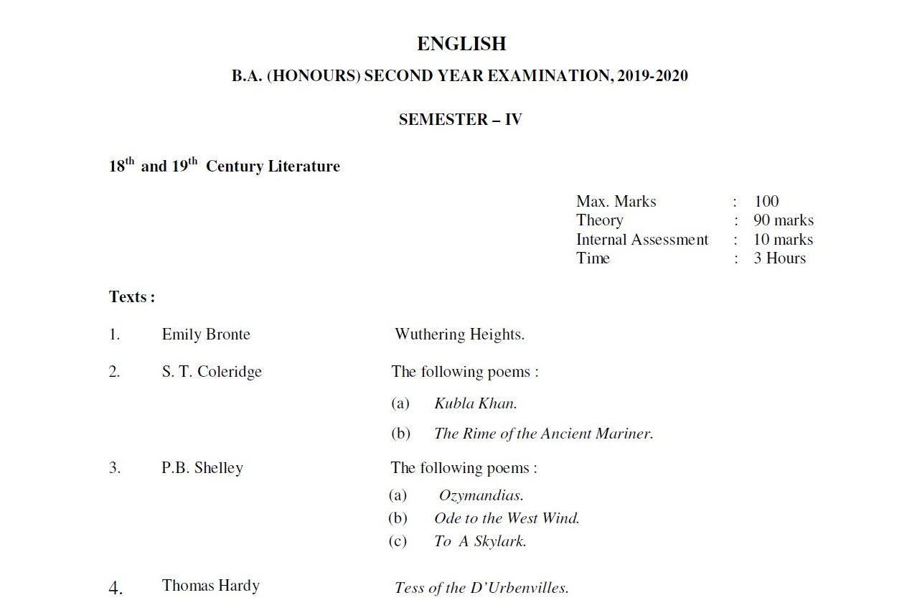

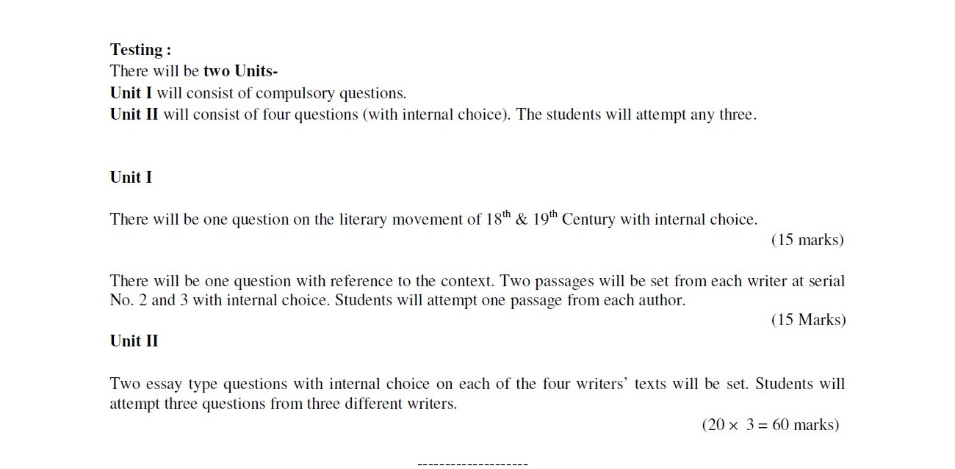

* 5th Semester for (2017-18), (2018-19), (2019-20) Session

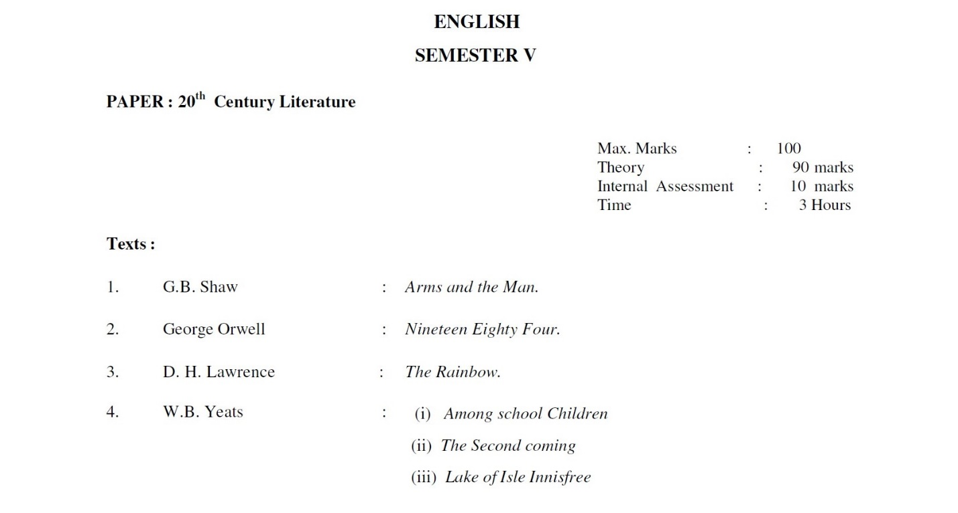

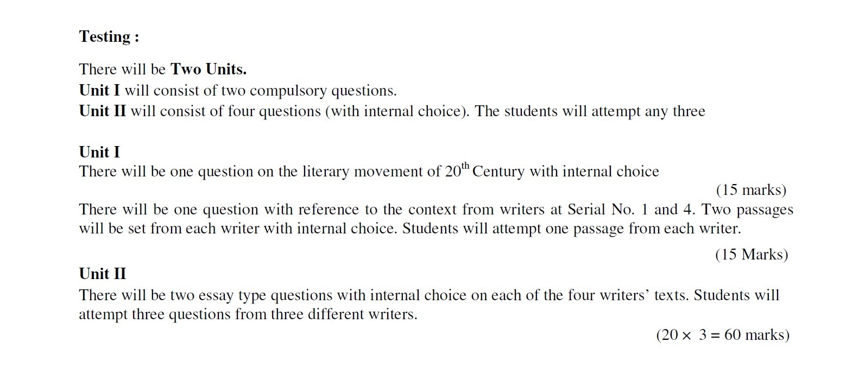

* 6th Semester for (2017-18), (2018-19), (2019-20) Session

