Assignment-10

Abhitej Date

Sagar Lakhia

We already learnt about many different services that amazon and google provides. So we decided to try something new to us. Since we were planning to host a web application we came across various cloud providers, but as we were using python as our programming language, we decided to go with

“PythonAnywhere.com-Host, run, and code Python in the cloud”

Application:

Our application currently does two things:   
(1) Cluster in a 3 Dimensional Data and   
(2) Generate a word cloud on the words provided by the user.

The link to the dataset that we used for clustering:  
  
https://storage.googleapis.com/cloudbucket786/imptry4.csv

1. We used Python libraries namely Scipy, Numpy, Matplotlib , etc to plot our 3-D clustering
2. We used D3.js to generate a wordcloud

Link to the Web application:

<http://sagarlakhia188.pythonanywhere.com>

<http://abhitej.pythonanywhere.com>

Note: Both the links point to the same project created by each team member

Screenshots:

The first screen:

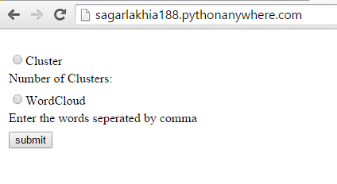

On selecting Cluster a box pops up and the user enters the number of cluster he wants:

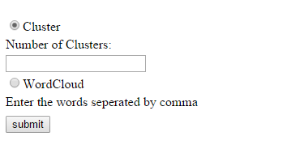

Result:

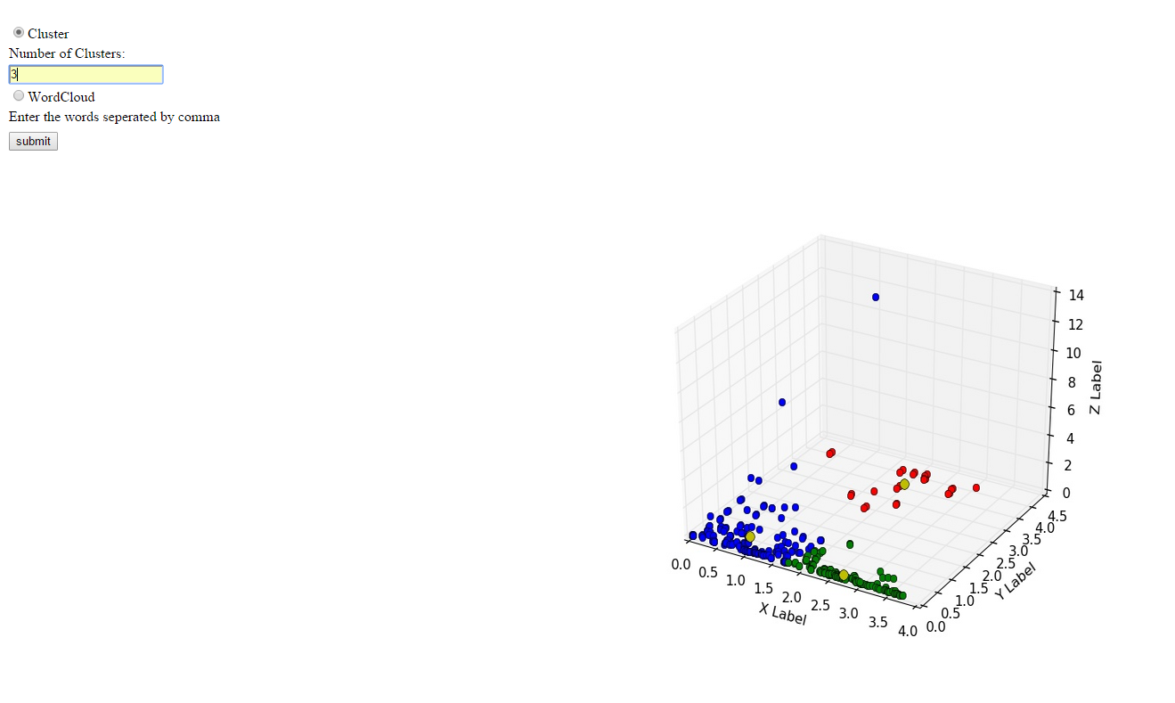

When the user clicks on the word cloud, a text area appears where he can enter the words he wants to be in the cloud, on clicking submit he gets the result. We achieved this wordcloud using d3.js

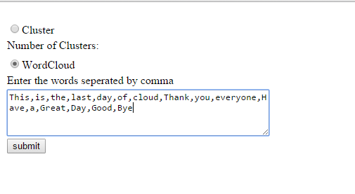

Result:

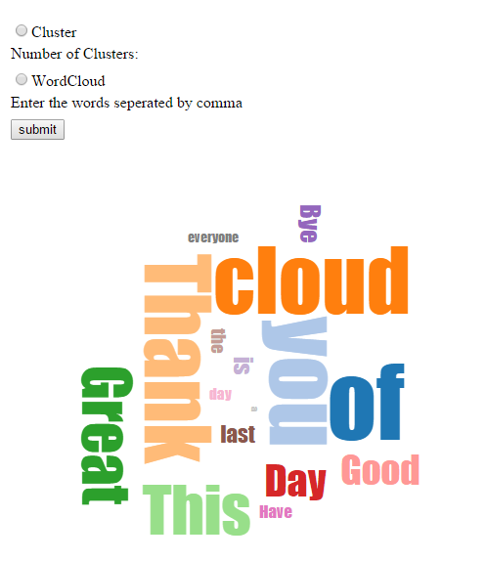

**References:  
  
[1]** <http://glowingpython.blogspot.com>

**[2]** <https://www.jasondavies.com>