**Assignment 8**

Machine Learning (Cloud)

Team

Abhitej Date

Rasika Dhanurkar

Sagar Lakhia

We used Python libraries like Scipy, Numpy, Matplotlib, etc to achieve our goal of creating different clusters as well as plotting them on the graph.

Below are the screenshots of our output:

**Screenshots:**

When we run the program, the user gets two options, (1) DisplayResult and (2) Exit

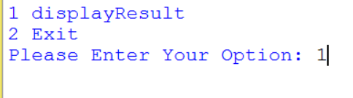

We entered option 1

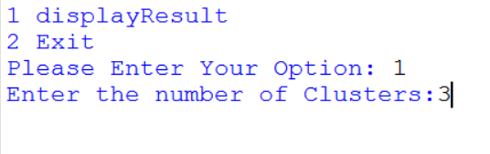

Now the program asks us to input the number of clusters, we enter 3.

On hitting the Enter button, we see 3 clusters with the data that fall under that particular cluster.

Note: In our data set the IDs (i.e. the first column) were same so we can same id repeating

Please refer to our dataset (public) at

<https://storage.googleapis.com/cloudbucket786/imptry4.csv>

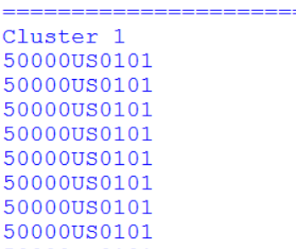

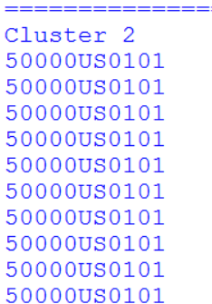

Along with this we see a plotted graph :

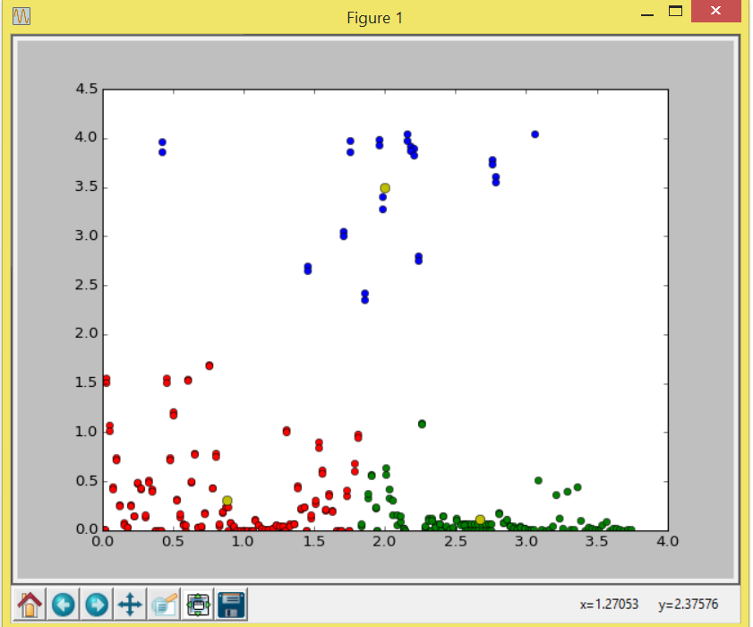

Centroids are shown by Yellow circles and we have selected different colors for different clusters.

Few more screenshots:

4 clusters:

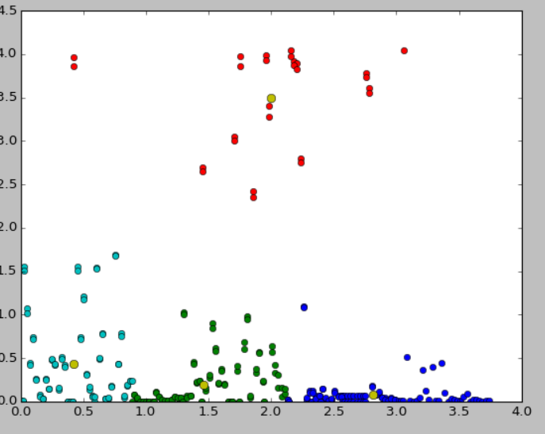

5 clusters:

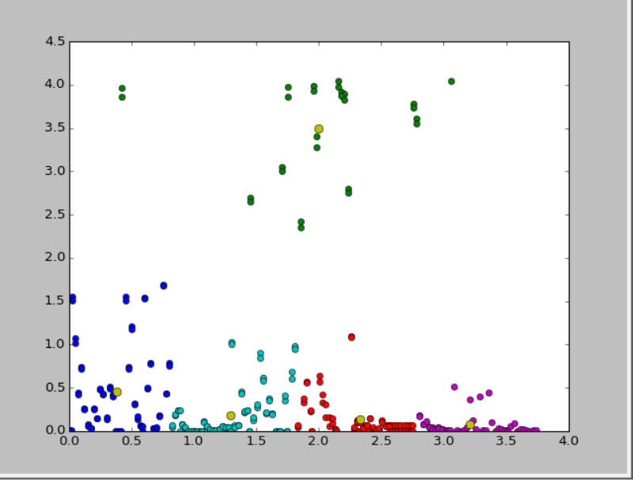

References:

[1] http://glowingpython.blogspot.com/2012/04/k-means-clustering-with-scipy.html

[2] stackoverflow.com