**Learning Management System**

**By: -**

Abhinav Singh - 20BCS008

Gautam Singhal - 20BCS087

Abhishek Ramgoliyan - 20BCS014

**Software Requirements Specification**

**Date: 6/10/2021**

**Table of Contents**

1. **Introduction**
   1. Introduction --------------------- 3
   2. Purpose ---------------------3
2. **The Overall Description**
   1. Modules and their descriptions --------------4
   2. Technology Stack --------------------------5
3. **Database Description**
   1. Er- Diagram -------------------------------6
   2. Database Schema --------------------------7
4. **UI Screenshots** --------------------------------8

**Introduction:**

This Learning management system is a web application which can conduct most online courses and exams. In general, it has basic tools for assessment, communication, exam conduct, data collection, and reporting. The learning management system allows students to access their classes, exams, assignments, doubts and announcements. They can also find their class syllabus and files regarding their course.  
  
It will not only ensure functionality but will also focus on ease of access and user-friendly experience for both teachers and students.

**Purpose and Scope:**

The main objective of this project is to enhance the learning process via better management and ease of access.  
It should not only deliver content but also handle courses, administration, tracking, and reporting. It will be web-based and will be used in various educational institutes to improve classroom teaching, learning methodology, and records.  
It provides many advantages to online education such as it helps in easier management by providing a platform to both teachers and students where teachers can create courses, take exams, upload assignments, resolve doubts and make an announcement and for students, it helps to take courses, exams see announcements, etc It helps in easier accessibility where both students and teacher can access their content as many times as they want with the mere presence of internet. We can all realize the scope of this project. Since the pandemic hit the country, all colleges and schools got shut down and it’s only the LMS that has catered the needs of students and teachers; we can't realize online education without LMS, so that's why we have decided to make this project.

**Modules and their descriptions:**

* Sign up and Login page:

In this Login Page, the user will enter an email and password which will be further authenticated and recognized as a student, teacher or admin and accordingly the respective dashboard will open up. This page will also offer

The forgot password option.

* Sidebar that contains:

1. **Profile**

It will contain user (teacher/student) information such as name, contact, address, qualifications etc.

1. **Courses**

Courses will contain:

a) All courses you opted for or teach currently

i) Announcement

ii) Assignments

iii) Files/notes

iv) Quizzes

b) Courses you finished/previous courses

1. **Calendar (google calendar)**

We aim to add deadlines and schedule in this feature. It will help both teachers and students keep track of the dates.

1. **Doubts (open-forum)**

This feature will allow students to ask doubts to both teachers and students.

1. **Settings**

This will contain features such as time zone, theme and notifications etc.

1. **Help**

This option will be used to contact the admin / it department by generating an email thread between the user and the authorised person.

**Technology Stack:**

* **Frontend:**
* HTML5
* CSS3
* React JS (And Bootstrap library)
* **Backend:**
* NODE JS



* **Database:**
* MYSQL
* **Deployment:**
* Heroku
* Netlify

**ER- Diagram:**

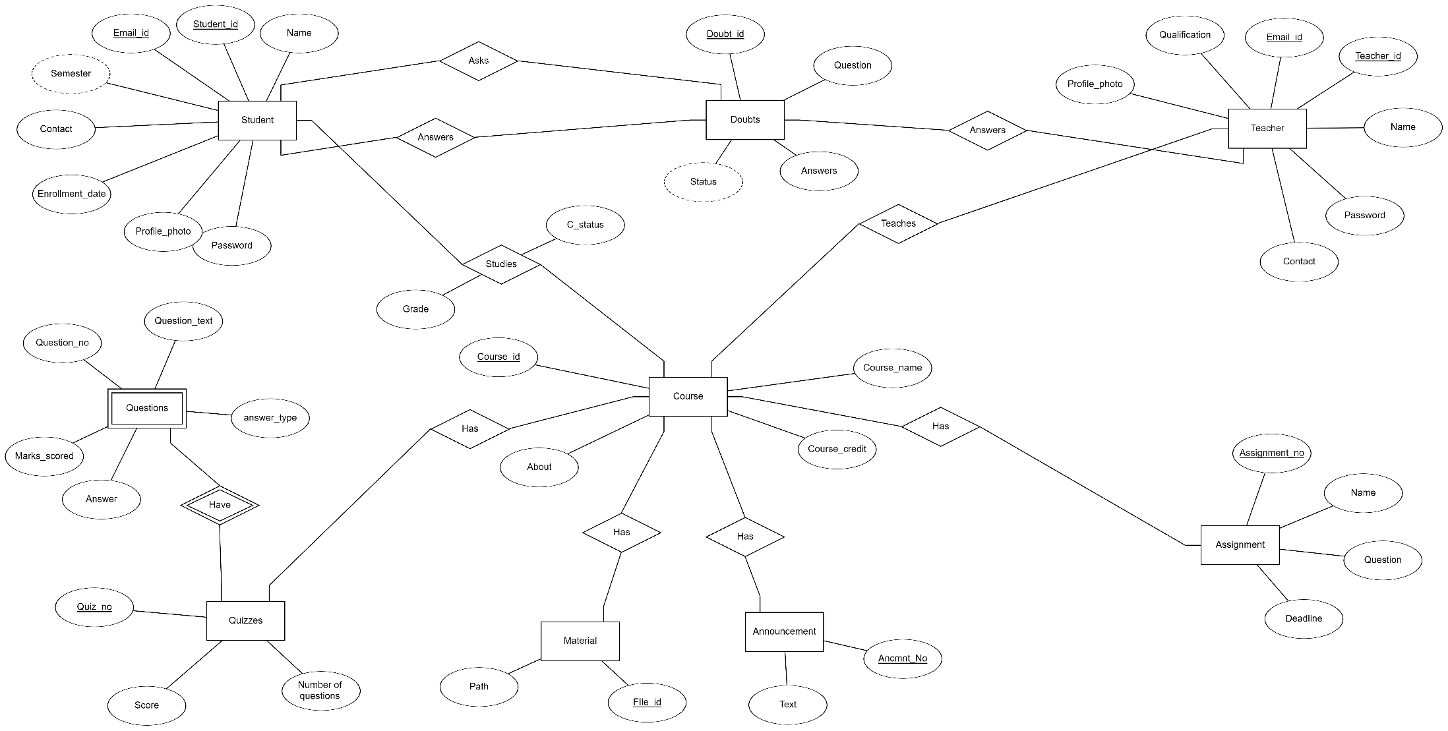

**Database Schema:**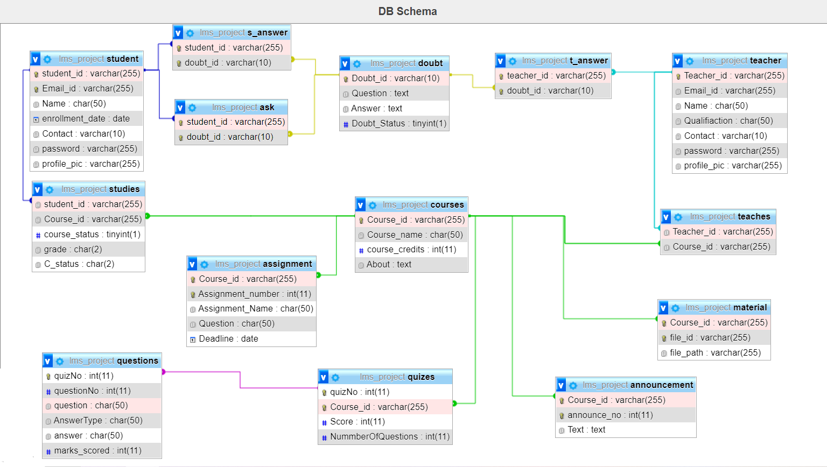



**UI Screenshot:**

