A Report On

**Learning Management System**

Submitted By: -

**Abhinav Singh - 20BCS008**

**Gautam Singhal - 20BCS087**

**Abhishek Ramgoliyan - 20BCS014**

Submitted To: -

**Prof. Pritee Khanna**



**PDPM INDIAN INSTITUTE OF INFORMATION TECHNOLOGY, DESIGN**

**AND**

**MANUFACTURING JABALPUR, INDIA**

**NOVEMBER 16TH , 2021**

**Table of Contents**

1. **Introduction**---------------------------------------------1
2. **Purpose & scope**---------------------------------------1
3. **Users**-----------------------------------------------------2
4. **The Overall Description**
   1. System Features ------------------------------------------4
   2. Functional Requirements ----------------------------------5
   3. External Interface Requirements----------------------------6
   4. Non-functional Requirements------------------------------
5. **Technology Used**-----------------------------------------
6. **Database Description**------------------------------------
7. **Project Screenshots** -------------------------------------8

**Introduction:**

This Learning management system is a web application that can conduct most online courses and exams. In general, it has basic tools for assessment, communication, exam conduct, data collection, and reporting. The learning management system allows students to access their classes, exams, assignments, doubts, and announcements. They can also find their class material and files regarding their course.  
  
It will not only ensure functionality but will also focus on ease of access and a user-friendly experience for both teachers and students.

**Purpose and Scope:**

The main objective of this project is to enhance the learning process via better management and ease of access.

It should not only deliver content but also handle courses, administration, tracking, and reporting. It will be web-based and will be used in various educational institutes to improve classroom teaching, learning methodology, and records.

It provides many advantages to online education such as it helps in easier management by providing a platform to both teachers and students where teachers can create courses, take exams, upload assignments, resolve doubts and make an announcement and for students, it helps to take courses, exams see announcements, ask doubts, etc It helps in easier accessibility where both students and teacher can access their content as many times as they want with the mere presence of internet. We can all realize the scope of this project. Since the pandemic hit the country, all colleges and schools got shut down and it’s only the LMS that has catered to the needs of students and teachers; we can't realize online education without LMS, so that's why we have decided to make this project.

**User:**

Anyone with a valid Email Account can login as a teacher or student. People who want to learn or teach can enrol in a course or create one respecively. Our system offers them the functionalities of announcements, quizzes and file uploads and downloads as teachers and students respectively. Teachers can create announcements, quizzes, and upload files of notes/books. A student may attempt quizzes and download material.

**System Features:**

* Sign up and Login page:

In this Login Page, the user will enter an email and password which will be further authenticated and recognized as a student or teacher and accordingly the respective dashboard will open up. This page also offers login as Gmail.

* Sidebar that contains:

1. **Profile**

It will contain user (teacher/student) information such as name, picture, contact, address, qualifications etc.

1. **Courses**

Courses will contain:

i) Announcement

ii) Assignments

iii) Quizzes

iv) Files/notes

1. **Doubts (open-forum)**

This feature will allow students to ask doubts to both teachers and students.

1. **Help**

This option will be used to contact the admin / it department.

**Functional Requirements:**

* Sign up and Register page for teacher and student through Gmail:
* Login page
* Enrol in a course (student) & Create a Course (teacher)
* Any user teacher or student can change their profile information.
* A teacher can make announcements which will be visible to students in his/her course.
* Assignment features allows teachers to assign tasks to students which they can answer by submitting respective files.
* Quizzes can be created by the teacher and students can attempt them with their grade being automatically updated in the database.
* Using the files section, a teacher can share notes/books/questionnaires and much more in the form of pdf/docx/ppt/mp4 format files.
* Doubt section is useful for the students to interact with teachers and even their peers.
* Help section allows the user to contact the admin, regarding any issues in the system, via email/phone.

**External Interface Requirements: -**

The minimum external requirements are:

* Node JS
* My SQL workbench
* Any code editor
* Node Package Manager

**Non-functional Requirements: -**

* **Performance:** The website’s load time should not be more than one second for users.
* **Reliability:** Applicants can access their accounts 98% of the time without failure.
* **Maintainability:** The database and the website is easily maintainable with minimal personnel effort required
* **Recoverability:** If a major incident happens on the website recovery should be very rapid due to the simplicity of the Web Application
* **Capacity:** Depends on the capacity of the database on PHP My Admin.
* **Usability:** The website’s interface is very user-friendly and easy to use.

**Technology Used:**

* **Frontend:**
  + HTML5
  + CSS3 (And Bootstrap library)
  + React JS

* **Backend:** 
  + NODE JS
* **Database:** 
  + MYSQL

**Database Schema:**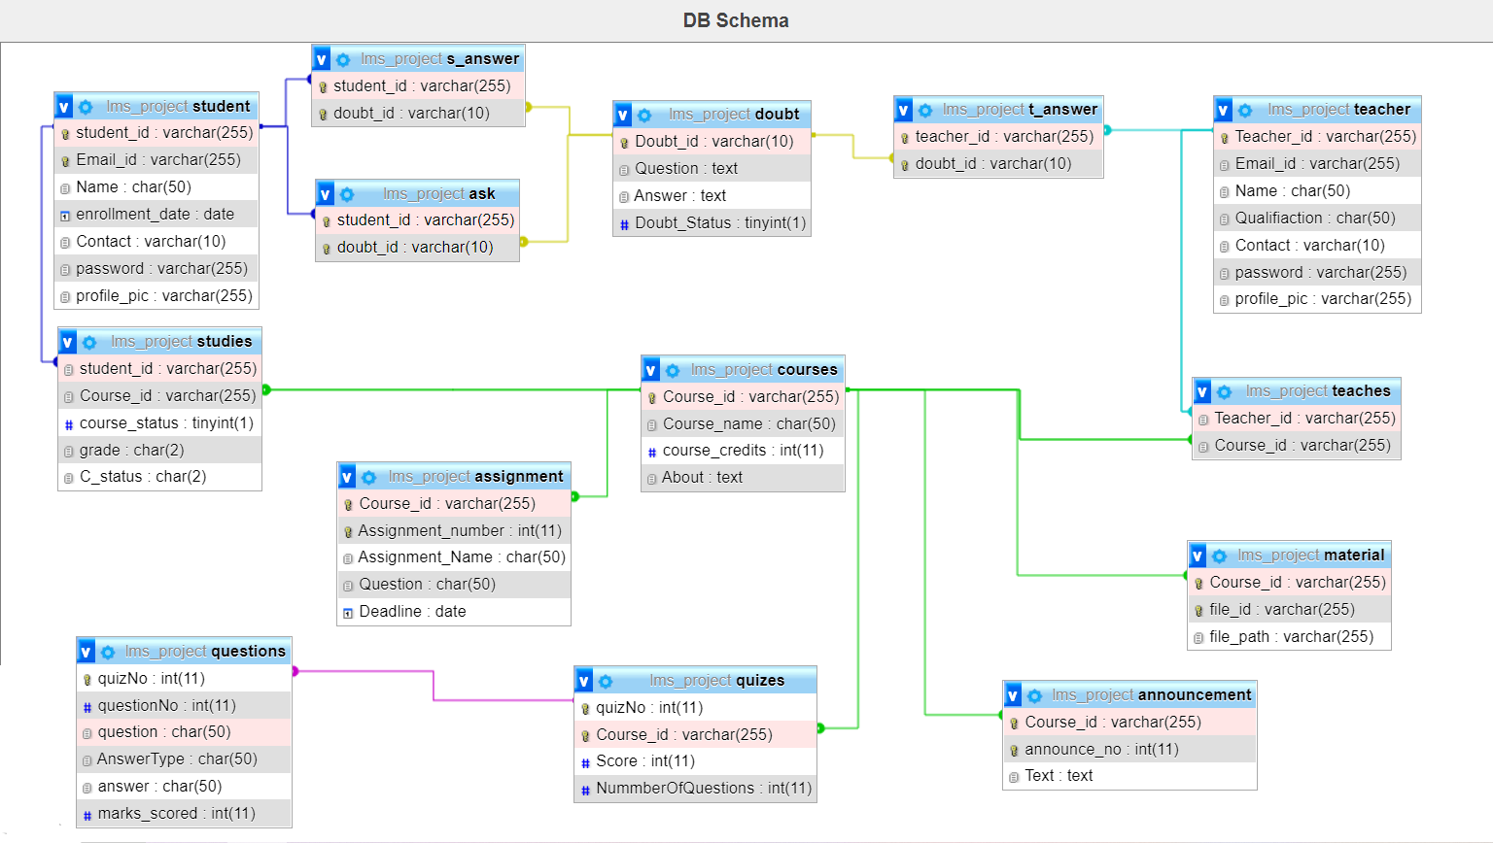

**Project Screenshots**

