- Tournament Project Charter
Project Title: Mangere United Soccer Club (MUSC) Summer Soccer Tournament
Project Start Date: 1st April, 2008 |  |  | Project End Date: 2nd December, 2008
Budget Information:
It is estimated the Club should initially expect to contribute $30,000 to this project, with the expectation that corporate sponsorship and return on sales will refund the majority of this expense.
Project Manager: Nicolette Conway - Nicolette@musc.co.nz
Project Objectives:
Organize an invitational summer Soccer Tournament to assist raising funds needed to sustain the clubs investment in young players to develop them
It is the key objective of the project to feature registered teams and fields of play, with a tournament structure and qualifies referees and a management plan to elevate injustices which may occur. Opportunities in increase fund-raising possibility through corporate sponsorship and the sale of tournament T-Shirts and Sweat shirts will be explored. It is also a critical objective that there are awards to present to the tournament winners in an awards ceremony.
Approach:
- Source the use of local colleges playing fields to co-ordinate a number of teams, over several days competition
- Take registration for team entry to the tournament, which will be screened before acceptance of entry.
- Feature qualified referees’ and develop a management plan to eliminate injustices experienced, making a fair and accurate tournament competition
- Have corporate sponsorship from local businesses and provide for sale tournament T-Shirts and Sweat-Shirts
- Feature an awards ceremony to award the winners of the tournament and celebrate the club success
Roles & Responsibility
Name | Role | Position |  | Contact Information
Nicolette Conway | Project Manager | Project Manager |  | nicolette@musc.co.nz
Grahame Lee | Project Sponsor | Club President |  | grahame@musc.co.nz
Mike Weltman | Project Champion | Club Organizer |  | mike@musc.co.nz
Brett O’Connor | Committee Member | Marketing Coordinator |  | brett@musc.co.nz
JP Pasche | Committee Member | Research Analysis |  | JP@musc.co.nz
Emma Jeffrey | Committee Member | Team Manager |  | emma@musc.co.nz
Extras:
Further Budgetary forecasts and estimates are required as part of project planning for this task.
It is estimated that as local colleges will be utilized when sourcing playing fields, that costs will not be too high. At this stage further estimates about the cost of the activities undertaken during the tournament process are vague, however corporate sponsorship is expected to again alter such decisions, depending on the circumstances that develop.
The cost of outsourcing the design, printing and organization of the tournament T-Shirts and Sweat-Shirts will be a large initial cost, which will have to be backed by the club initially. It is expected that corporate sponsor will also effect this.

- Work Break Down Structure
Attached as separate page (see Page 2)

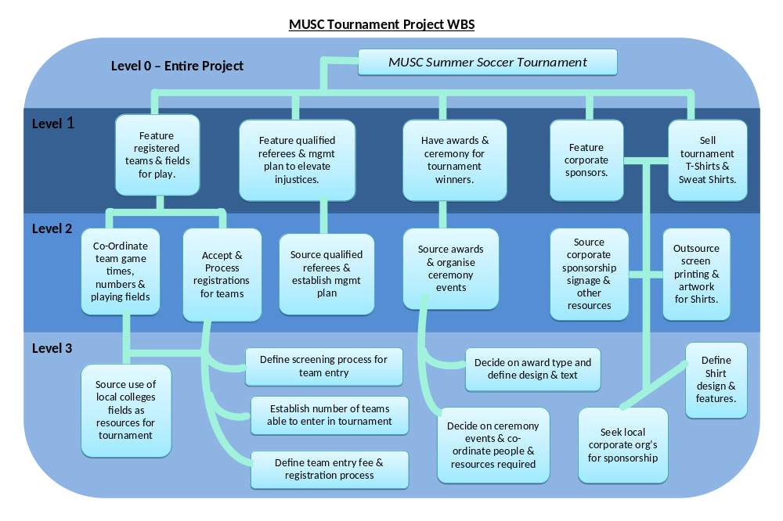

- How would developing a WBS alleviate some of the problems occurred during the first meeting?
A work break down structure assists in providing a clear plan and task break down. This allows members of the committee to be allocated roles, where we can utilize people’s strengths and experiences by allocating them appropriately. The allocation of roles will also help to eliminate disagreements as we can members will have particular roles within which they are able to contribute to the project in a way which allows them some flexibility within that.
The WBS also provides a sense of direction and co-ordination to the project, this also ensures that members are able to contribute as fully as possible, enabling the event organized to be a success. The needs and knowledge of stakeholders within the project need to incorporated into a WBS, so developing one will also allow members to understand where their place is within the project. The WBS also helps more clearly portray the important aspects of the project and ensure all members are aligned and the task and process which is being undertaken in understood by all stakeholders.

- Where can additional information be found to help develop WBS?
To obtain additional information to assist Nicolette in developing the WBS could be based off past events or other events plans in the industry. By utilizing past events WBS as a resource we can help to avoid some issues which may have occurred in the past and also access a ‘best practice’ within this particular industry. There is already information to suggest that these kind of tournaments are held by other clubs in the area and by getting in contact with their project managers from the past tournaments, Nicolette could gain some understanding of what to expect in under taking this project.
Further to this by asking people within the Committee and Club who have been involved with a tournament of this nature, either in the organization or participation, to assist defining the requirements and critical factors to the project management, will help assess the steps required. By contacting industry organizations, for example, The New Zealand Football Association, Nicolette could not only benefit from access to professional referees but also advice from organizers of other events in the industry.

- How can WBS be used to generate cost estimates for the tournament? Why would this be useful?
By breaking down the tasks required to complete a project, in terms of creating a WBS, the project manager is clearly able to see all the individual tasks and requirements in order to complete the project as a whole. By being able to identify the individual task requirements, the project manager is also able to more accurately identify and estimate the costs incorporated within that.
It is useful to understand and estimate the costs incorporated in the project for many reasons. Firstly the Project Sponsors & Champions, whom are the drivers of this project, need to have estimates of the total costs required to enable them to provide the recourses require. An objective of this project is to raise funds required to support the running of MUSC, for this reason, it is important to ensure there is enough corporate sponsorship along with revenue generated from the cost of team entry and sale of tournament T-shirts and Sweat-shirts.
To ensure enough corporate sponsorship is generated we need to be able to estimate how much we will need. By being able to see the different tasks within this process, the cost of each can also be allocated with more accurate measure. The estimates of costs may also affect the size of the tournament produced (along with other influential factors), the type of awards ceremony organised and expenses spent on producing tournament paraphernalia, among many other important decisions.

