**Exercise 1: Write a REST service in the spring learn application created earlier, that returns the text "Hello World!!" using Spring Web Framework.**

**Controllers\HelloController.java**

package com.cognizant.spring_learn.controllers;

import org.slf4j.Logger;

import org.slf4j.LoggerFactory;

import org.springframework.web.bind.annotation.GetMapping;

import org.springframework.web.bind.annotation.RestController;

import com.cognizant.spring_learn.SpringLearnApplication;

@RestController

public class HelloController {

private static final Logger log = LoggerFactory.getLogger(SpringLearnApplication.class);

@GetMapping("/hello")

public String hello(){

log.info("Started request");

log.info("ended request");

return "Hello World";

}

}

**Output:  
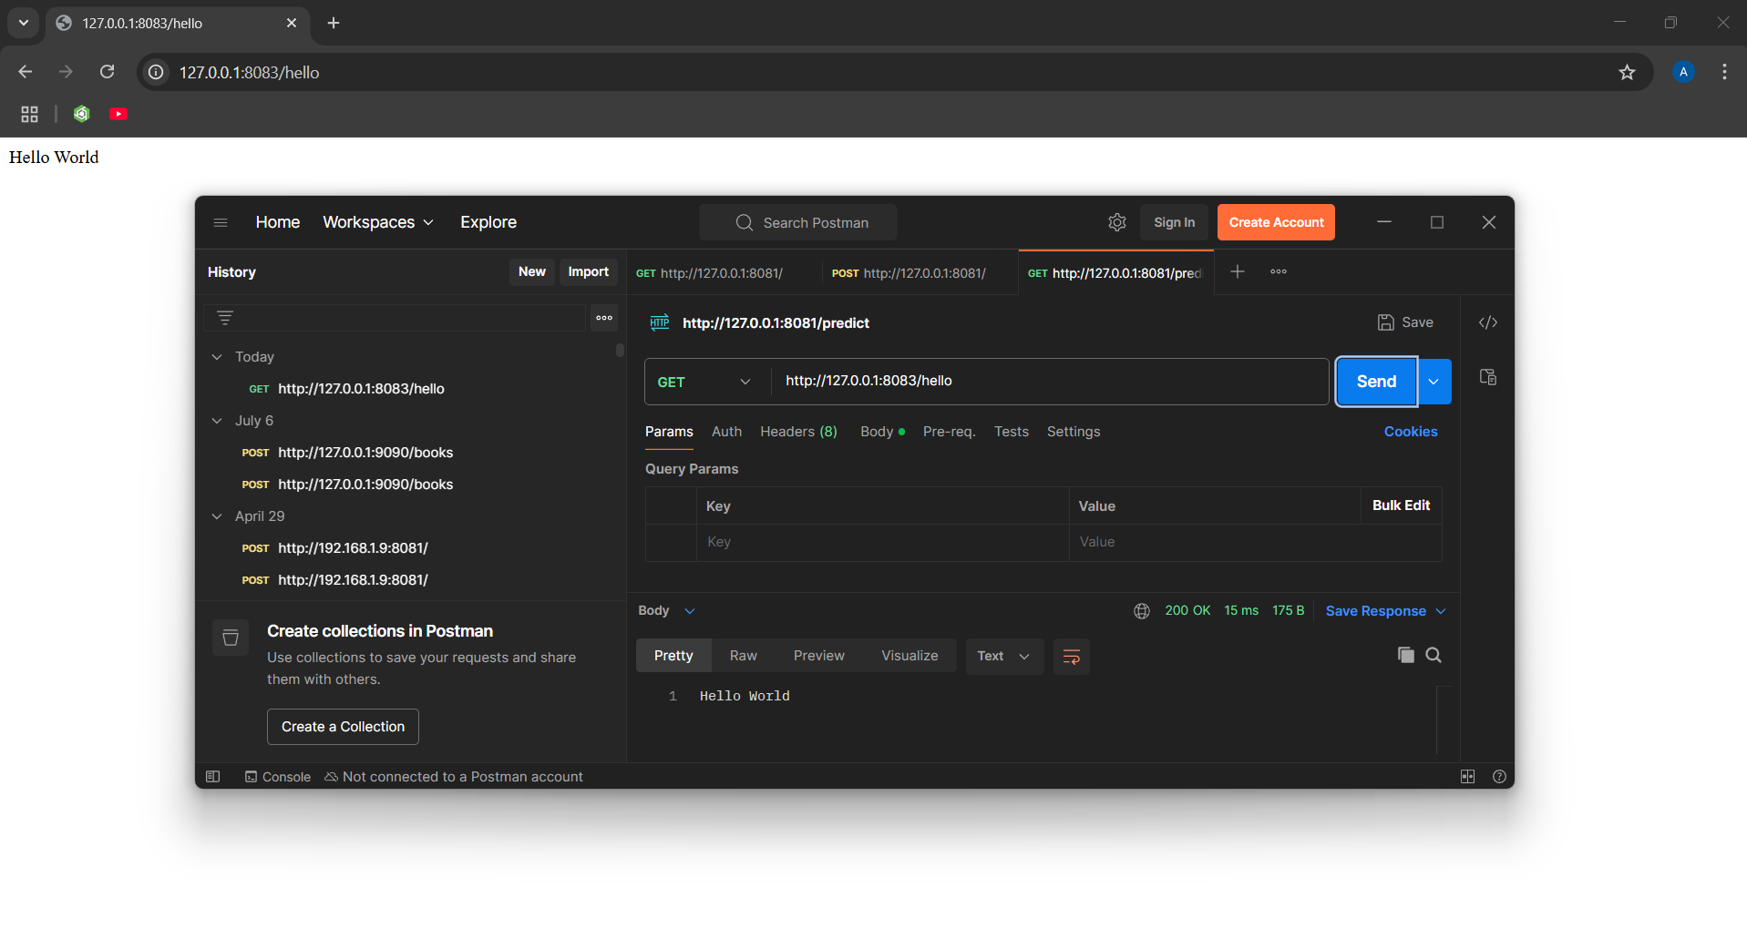**

**Exercise 2 : REST - Country Web Service**

**Controllers\CountryCountroller.java**

package com.cognizant.spring_learn.controllers;

import org.springframework.context.ApplicationContext;

import org.springframework.context.support.ClassPathXmlApplicationContext;

import org.springframework.web.bind.annotation.GetMapping;

import org.springframework.web.bind.annotation.RestController;

import com.cognizant.spring_learn.Country;

@RestController

public class CountryController{

    ApplicationContext context = new ClassPathXmlApplicationContext("beanConfig.xml");

    @GetMapping("/country")

    public Country getCountryIndia(){

        Country country = context.getBean("country3", Country.class);

        return country;

    }

}

**Output:**

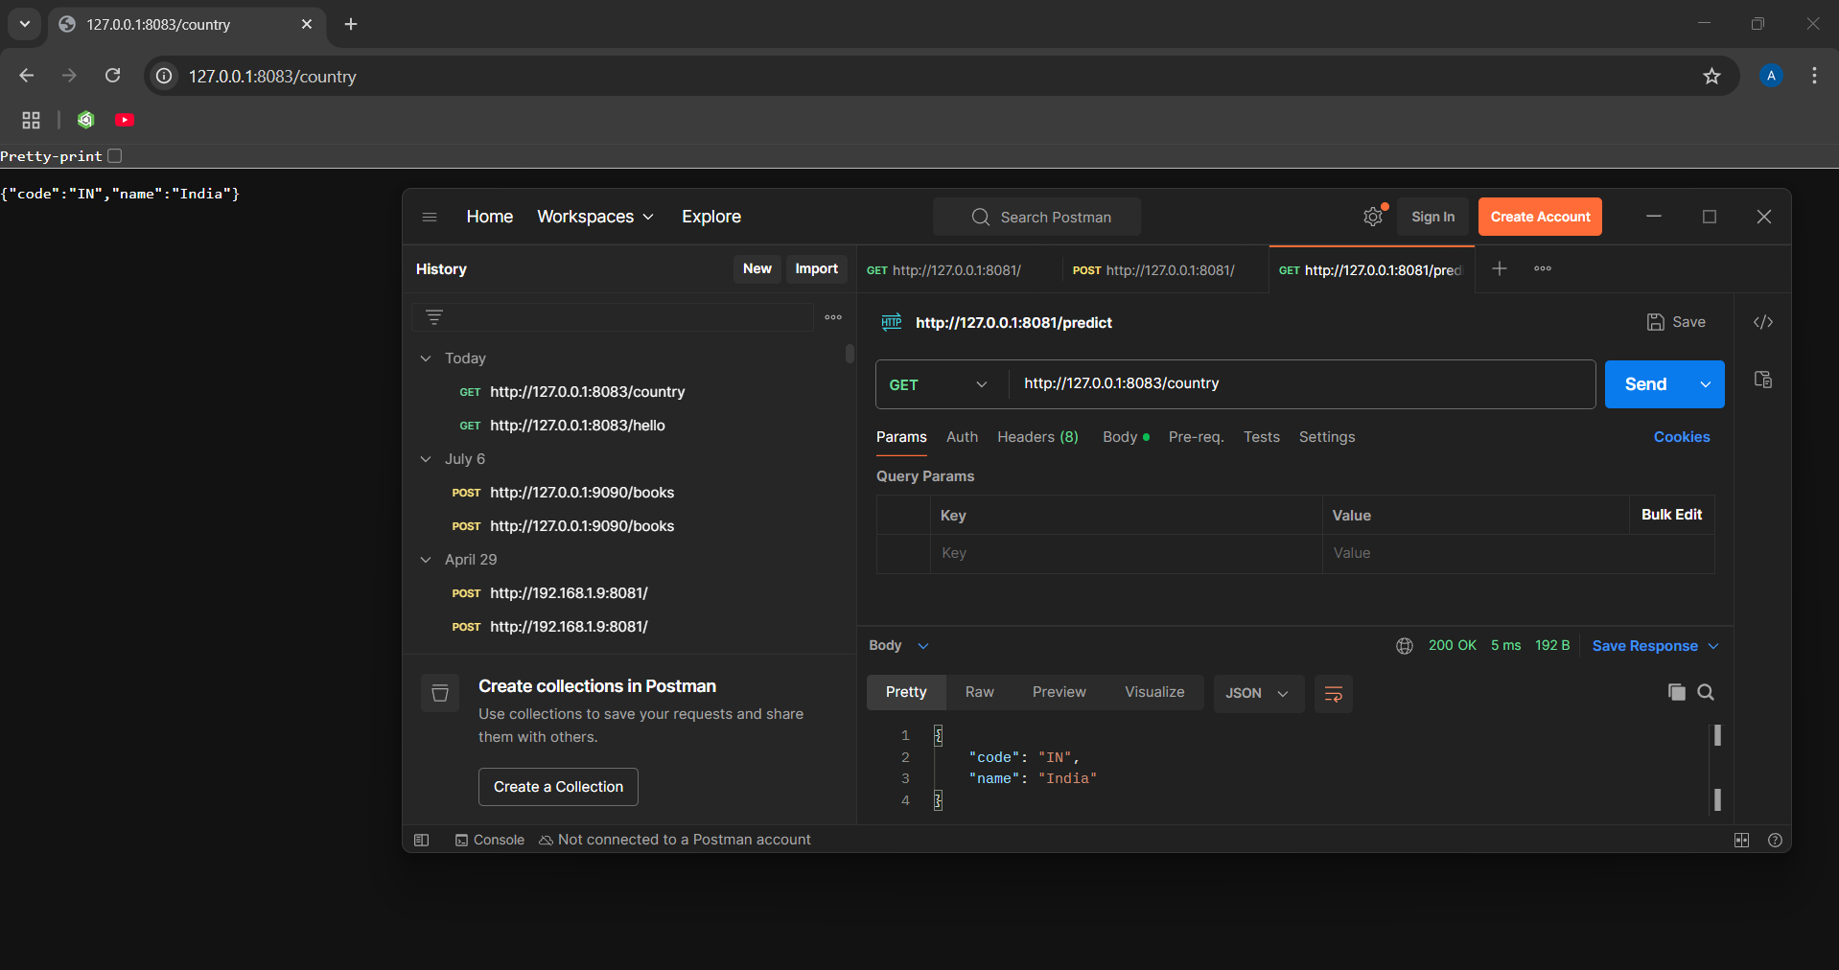

**Exercise 3: REST - Get country based on country code**

**Controllers\CountryCountroller.java**

package com.cognizant.spring_learn.controllers;

import org.springframework.beans.factory.annotation.Autowired;

import org.springframework.context.ApplicationContext;

import org.springframework.context.support.ClassPathXmlApplicationContext;

import org.springframework.web.bind.annotation.GetMapping;

import org.springframework.web.bind.annotation.PathVariable;

import org.springframework.web.bind.annotation.RestController;

import com.cognizant.spring_learn.Country;

import com.cognizant.spring_learn.CountryService;

@RestController

public class CountryController{

    ApplicationContext context = new ClassPathXmlApplicationContext("beanConfig.xml");

    @Autowired

    private CountryService countryService;

    @GetMapping("/country")

    public Country getCountryIndia(){

        Country country = context.getBean("country3", Country.class);

        return country;

    }

    @GetMapping("/countries/{code}")

    public Country getCountry(@PathVariable String code) {

        Country country = countryService.getCountry(code);

        return country;

    }

}

**Country.xml**

 <bean id="countries" class="java.util.ArrayList">

        <constructor-arg>

            <list>

                <ref bean="country1"/>

                <ref bean="country2"/>

                <ref bean="country3"/>

                <ref bean="country4"/>

            </list>

        </constructor-arg>

    </bean>

**CountryService.java**

package com.cognizant.spring_learn;

import java.util.List;

import org.slf4j.Logger;

import org.slf4j.LoggerFactory;

import org.springframework.context.ApplicationContext;

import org.springframework.context.support.ClassPathXmlApplicationContext;

import org.springframework.stereotype.Service;

@Service

public class CountryService {

    private static final Logger log = LoggerFactory.getLogger(CountryService.class);

    public Country getCountry(String code) {

        log.info("START: getCountry() in Service");

        ApplicationContext con = new ClassPathXmlApplicationContext("beanConfig.xml");

        List<Country> countryList = (List<Country>) con.getBean("countries");

        Country a = countryList.stream().filter(c -> c.getCode().equalsIgnoreCase(code)).findFirst().orElse(null);

        log.info("END: getCountry() in Service");

        return a;

    }

}

