Creating Microservices for account and loan

AccountController.java

package com.cogniznt.account;

import java.util.HashMap;

import java.util.Map;

import org.springframework.web.bind.annotation.GetMapping;

import org.springframework.web.bind.annotation.PathVariable;

import org.springframework.web.bind.annotation.RequestMapping;

import org.springframework.web.bind.annotation.RestController;

@RestController

@RequestMapping("/accounts")

public class AccountController {

    @GetMapping("/{num}")

    public Map<String,Object> getAccount(@PathVariable String num){

        Map<String,Object> res=new HashMap<>();

        res.put("number",num);

        res.put("type","savings");

        res.put("balance","232343");

        return res;

    }

}

Output

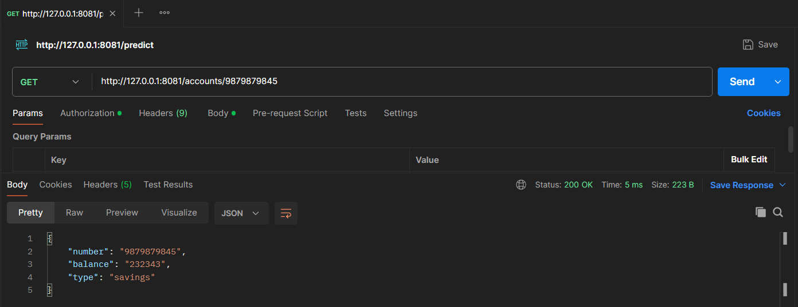

LoanController.java

package com.cogniznt.account;

import java.util.HashMap;

import java.util.Map;

import org.springframework.web.bind.annotation.GetMapping;

import org.springframework.web.bind.annotation.PathVariable;

import org.springframework.web.bind.annotation.RequestMapping;

import org.springframework.web.bind.annotation.RestController;

@RestController

@RequestMapping("/loans")

public class LoanController {

     @GetMapping("/{num}")

    public Map<String,Object> getAccount(@PathVariable String num){

        Map<String,Object> res=new HashMap<>();

        res.put("number",num);

        res.put("type","car");

        res.put("loan","400000");

        res.put("emi","3258");

        res.put("tennure","18");

        return res;

    }

}

Output

