**Exercise 01: myfirstreact**

Code:

import './App.css';

function App() {

  return (

    <>

    <h1>Welcome to First session of React</h1>

    </>

  );

}

export default App;

output:

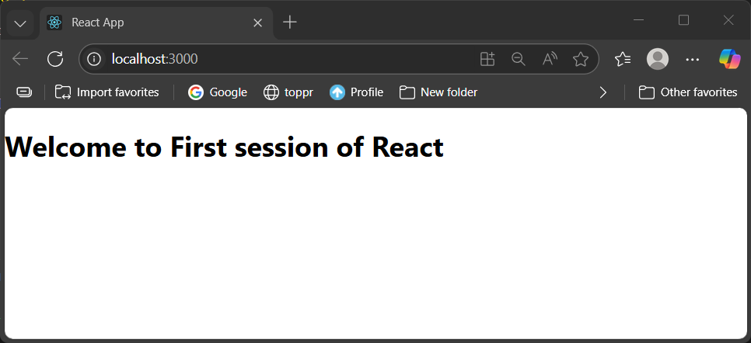

**Exercise 02: studentapp**

Code:

import React,{Component} from 'react';

class About extends Component{

    render(){

        return(

        <div>

            <h3> Welcome to the About Page of Student Management Portal </h3>

        </div>

        );

    }

}

export default About;

import React,{Component} from 'react';

class Contact extends Component{

    render(){

        return(

        <div>

            <h3> Welcome to the Contact Page of Student Management Portal </h3>

        </div>

        );

    }

}

export default Contact;

import React,{Component} from 'react';

 class Home extends Component{

    render(){

        return(

            <div>

                <h3> Welcome to the Home Page of Student Management Portal </h3>

            </div>

        );

    }

}

export default Home;

import './App.css';

import Home from './Components/Home';

import Contact from './Components/Contact';

import About from './Components/About';

function App() {

  return (

    <div className="App">

      <Home />

      <Contact />

      <About />

    </div>

  );

}

export default App;

output:

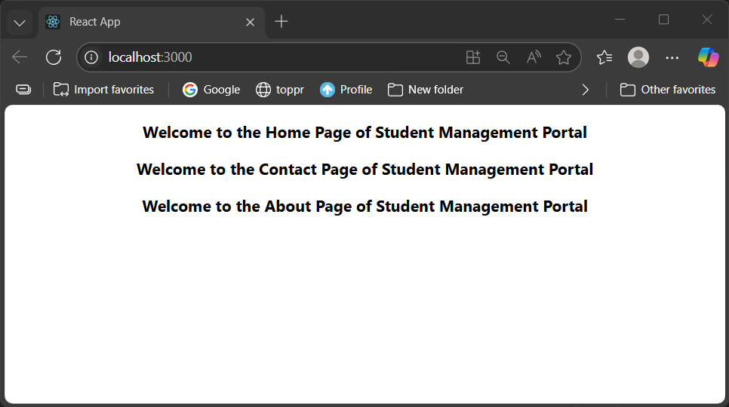

**Exercise 03: scorecalculatorapp**

Code:  
import React, { Component } from 'react'

export class CalculatorScore extends Component {

  percentToDecimal(x){

    return x.toFixed(2)+'%';

  };

  calcScore(total,goal){

    return this.percentToDecimal((total/goal)*100);

  }

  render() {

    const {Name,School,total,goal}=this.props;

    return (

      <div className='formatstyle'>

        <h1 style={{color:'brown'}}>Student Details</h1>

        <div className='Name'>

          <b><span>Name:</span></b>

          <span>{Name}</span>

        </div>

        <div className='School'>

          <b><span>School:</span></b>

          <span>{School}</span>

        </div>

        <div className='Total'>

          <b><span>Total:</span></b>

          <span>{total}</span>

          <span>Marks</span>

        </div>

        <div className='Score'>

          <b>School:</b>

          <span>{this.calcScore(total,goal)}</span>

        </div>

      </div>

    );

  }

};

export default CalculatorScore;

.Name{

    font-weight: 300;

    color:blue;

}

.School{

    color:crimson;

}

.Total{

    color: darkmagenta;

}

.formatstyle{

    text-align: center;

    font-size: large;

}

.Score{

    color: forestgreen;

}

import './App.css';

import CalculatorScore from './Components/CalculatorScore';

import './Stylesheets/mystyle.css'

function App() {

  return (

    <div >

      <CalculatorScore Name={"Steeve"}

      School={'DNV Public School'}

      total={284}

      goal={3}

      />

    </div>

  );

}

export default App;

output:

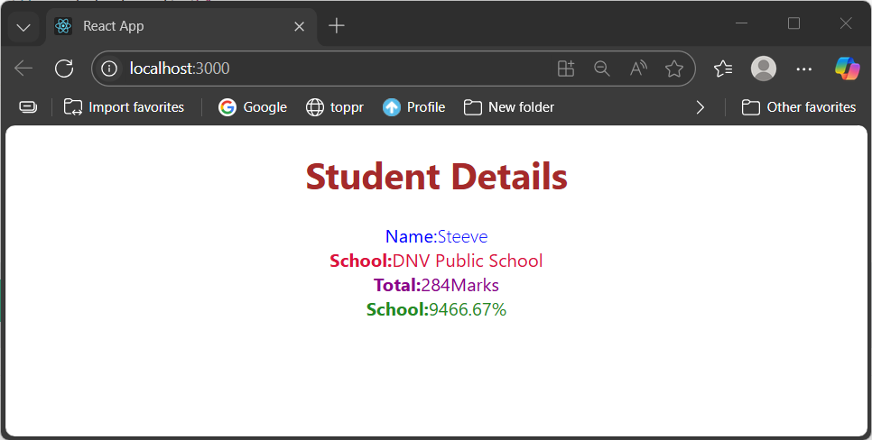

**Exercise 04: blogapp**

Code:  
class Post{

    constructor(id,title,body){

        this.id=id;

        this.title=title;

        this.body=body;

    }

}

export default Post;

import React from 'react';

import Post from './Post';

class Posts extends React.Component{

    constructor(props){

        super(props);

        this.state={

            posts: [],

        };

    }

    loadPosts(){

        fetch('https://jsonplaceholder.typicode.com/posts')

        .then(res=>res.json())

        .then(data=>{

            const x=data.map(y => new Post(y.id,y.title,y.body));

            this.setState({posts:x});

        });

    }

    componentDidMount(){

        this.loadPosts();

    }

    componentDidCatch(error,info){

        console.error("error",error,info);

    }

    render(){

        return (

            <div>

                <h1>Blog Posts</h1>

                {this.state.posts.map(post =>(

                    <div key={post.id}>

                        <h2>{post.title}</h2>

                        <p>{post.body}</p>

                        <hr />

                    </div>

                ))}

            </div>

        );

    }

}

export default Posts;

import Posts from './Posts';

import './App.css';

function App() {

  return (

    <div className="App">

      <Posts />

    </div>

  );

}

export default App;

output:  
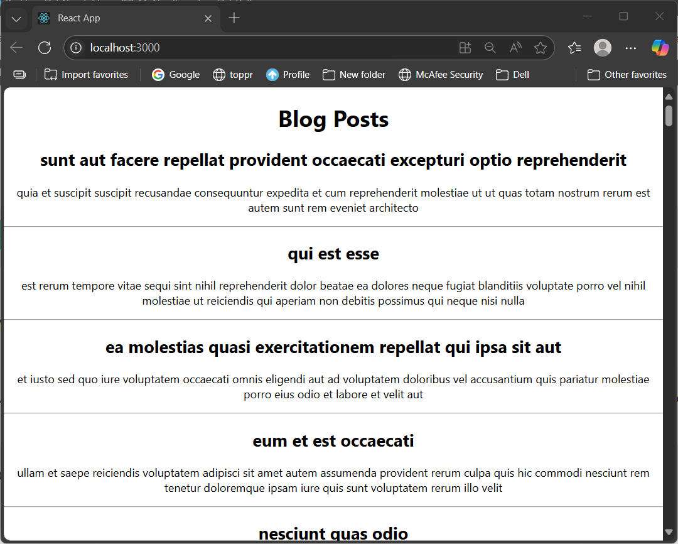

**Exercise 05: cohorttracker**

Code:

.box{

  width:300px;

  display: inline-block;

  margin: 10px;

  padding: 10px 20px;

  border: 1px solid black;

  border-radius: 10px;

}

dt{

  font-weight: 500;

}

function CohortDetails(props) {

    const headingStyle = {

        color: props.cohort.currentStatus.toLowerCase() === 'ongoing' ? 'green': 'blue',

    }

    return (

        <div className="box">

            <h3 style={headingStyle}>

                {props.cohort.cohortCode} -

                <span>{props.cohort.technology}</span>

            </h3>

            <dl>

                <dt>Started On</dt>

                <dd>{props.cohort.startDate}</dd>

                <dt>Current Status</dt>

                <dd>{props.cohort.currentStatus}</dd>

                <dt>Coach</dt>

                <dd>{props.cohort.coachName}</dd>

                <dt>Trainer</dt>

                <dd>{props.cohort.trainerName}</dd>

            </dl>

        </div>

    );

}

export default CohortDetails;

Output:

