Exercise 09 : cricketapp

**Code:**

**App.js**

import './App.css';

import ListofPlayers, { Scorebelow70 } from './ListofPlayers';

import ListofIndianPlayers,{ OddPlayers,EvenPlayers } from './ListofIndianPlayers';

const players=[

    {name:"Jack",score:50},

    {name:"Michael",score:70},

    {name:"John",score:40},

    {name:"Ann",score:61},

    {name:"Elisabeth",score:61},

    {name:"Sachin",score:95},

    {name:"Dhoni",score:100},

    {name:"Virat",score:84},

    {name:"Jadeja",score:64},

    {name:"Raina",score:75},

    {name:"Rohit",score:80},

]

const IndianPlayers=[

  {name:"Sachin",score:95},

  {name:"Dhoni",score:100},

  {name:"Virat",score:84},

  {name:"Jadeja",score:64},

  {name:"Raina",score:75},

  {name:"Rohit",score:80},

]

const IndianTeam=["Sachin","Dhoni","Virat","Jadeja","Raina","Rohit"]

function App() {

  var flag=true;

  if(flag===true){

    return(

      <div>

        <h1>List of Players</h1>

        <ListofPlayers players={players} />

        <hr />

        <h1> List of Players having Scores Less than 70</h1>

        <Scorebelow70 players={players} />

      </div>

    )

  }

  else{

    return (

      <div>

        <div>

          <h1>Indian Team</h1>

          <h1>Odd Players</h1>

          {OddPlayers(IndianTeam)}

          <hr />

          <h1>Even Players</h1>

          {EvenPlayers(IndianTeam)}

        </div>

        <hr />

        <div>

          <h1>List of Indian Players Merged:</h1>

          <ListofIndianPlayers IndianPlayers={IndianPlayers} />

        </div>

      </div>

    );

  }

}

export default App;

**ListofPlayers.js**

import React from 'react';

export default function ListOfPlayers({players}) {

  return (

    <div>

        <ul>

        {players.map((item)=>{

            return(

                <div>

                <li>Mr.{item.name}<span> {item.score}</span></li>

                </div>

            )

        }

        )}

        </ul>

    </div>

  )

}

export const Scorebelow70 =({players}) => {

  return(

    <div>

        <ul>

        {

    players.map((item)=>{

      if(item.score<=70){

          return(

            <div>

              <li> Mr.{item.name}<span> {item.score}</span></li>

            </div>

          )

      }

    })

    }

        </ul>

    </div>

  );

}

**ListofIndianPlayers.js**

import React from 'react'

function ListofIndianPlayers({IndianPlayers}) {

  return (

    <div>

        <ul>

        {IndianPlayers.map((item)=>{

            return(

                <div>

                <li>Mr.{item.name}<span> {item.score}</span></li>

                </div>

            )

        }

        )}

        </ul>

    </div>

  )

}

export default ListofIndianPlayers;

export function OddPlayers([first,,third,,fifth]){

  return(

    <div>

      <ul>

        <li>First : {first}</li>

        <li>Third : {third}</li>

        <li>Fifth : {fifth}</li>

      </ul>

    </div>

  )

}

export function EvenPlayers([,second,,fourth,,sixth]){

  return(

    <div>

      <ul>

        <li>Second : {second}</li>

        <li>Fourth : {fourth}</li>

        <li>Sixth : {sixth}</li>

      </ul>

    </div>

  )

}

**Output:**

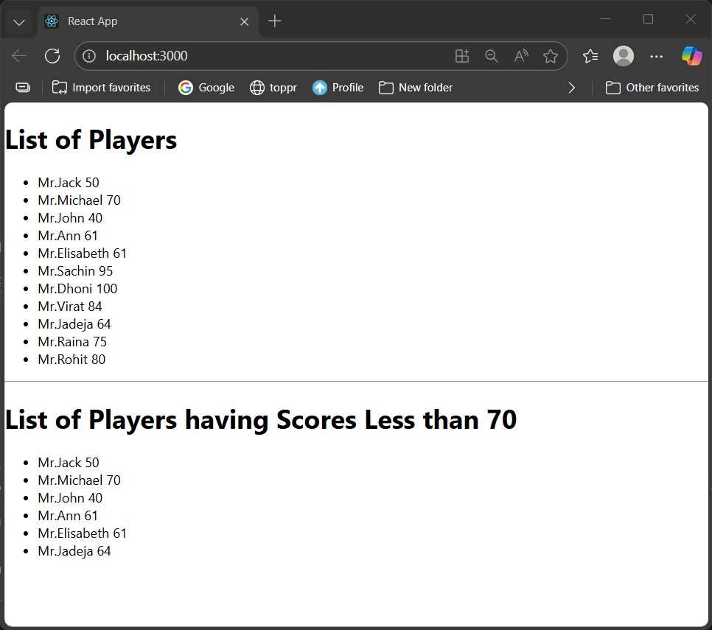

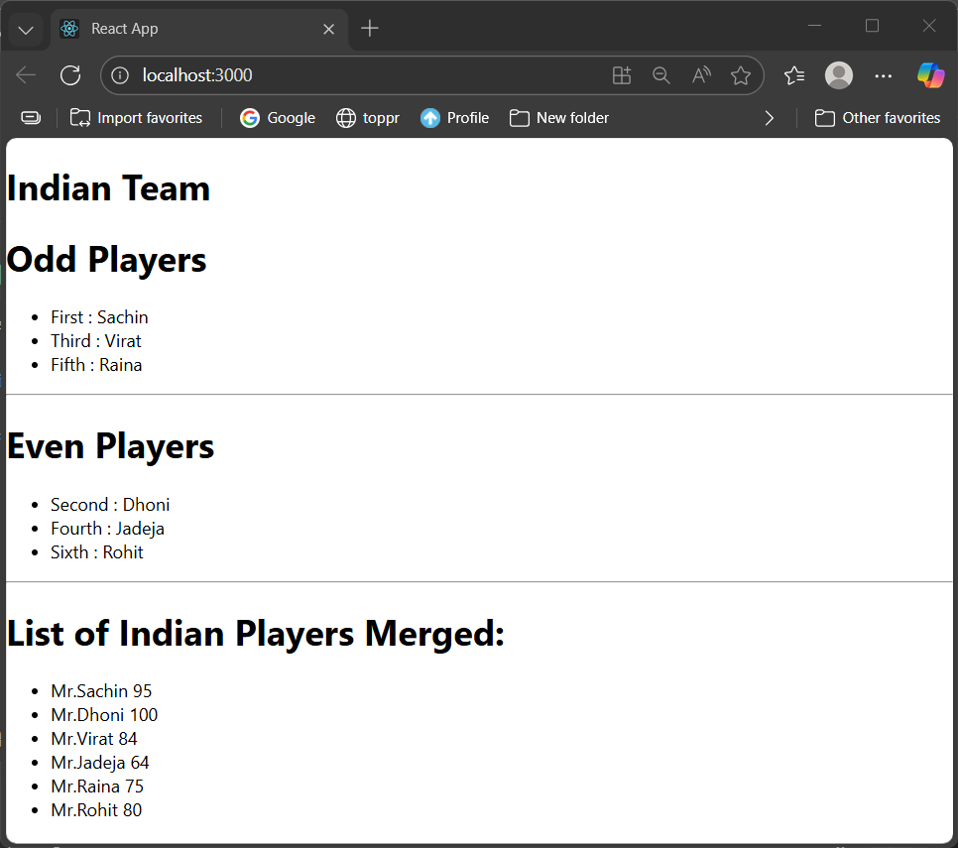

Exercise :10 officespacerentalapp

**Code:**

**App.js**

import logo from './logo.svg';

import './App.css';

const offices=[

  {

    name:'DBS',

    rent:50000,

    address:'Chennai'

  },

  {

    name:'TCS',

    rent:35000,

    address:'Delhi'

  },

  {

    name:'Tech Mahindra',

    rent:64000,

    address:'Bengaluru'

  },

  {

    name:'Cognizant',

    rent:70000,

    address:'Hyderabad'

  }

]

function App() {

  return (

    <div>

      <h1>Office Space,at Affordable Range</h1>

      {

        offices.map((office,index)=>{

          const st={color:office.rent<60000?'red':'green'};

          return(

            <div>

              <img src='/office.jpeg' width='25%' height='25%' alt='Office Space' />

              <h4>Name : {office.name}</h4>

              <h4 style={st} >Rent : {office.rent}</h4>

              <h4>Address : {office.address}</h4>

              <hr />

            </div>

          )

        })

      }

    </div>

  );

}

export default App;

**Output:**

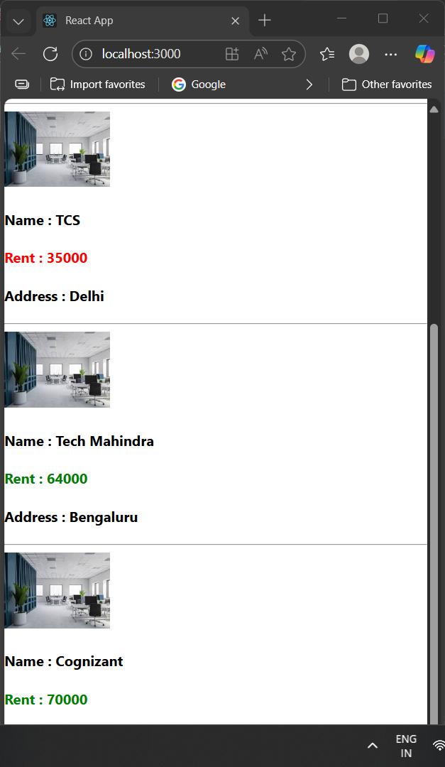

Exercise 11: eventexamplesapp

**Code:**

**App.js**

import React, { Component } from 'react'

import CurencyConvertor from './CurencyConvertor';

export default class App extends Component {

  constructor(props){

    super(props);

    this.state={

      counter:0

    };

    this.increment=this.increment.bind(this);

    this.decrement=this.decrement.bind(this);

  }

  increment(){

    this.setState(prev=>({

      counter:prev.counter+1

    }),()=>{setTimeout(() => {

          alert('Hello there!');

        }, 0);});

  }

  decrement(){

    this.setState(prev=>({

      counter:prev.counter-1

    }));

  }

  alertmsg(msg){

    alert(msg);

  }

  OnPress(){

    alert("I was clicked");

  }

  render() {

    return (

      <div>

        {this.state.counter}<br />

        <button onClick={this.increment}>Increment</button><br />

        <button onClick={this.decrement}>Decrement</button><br />

        <button onClick={()=>this.alertmsg("Welcome")}>Say welcome</button><br />

        <button onClick={this.OnPress}>Click on me</button><br />

        <CurencyConvertor />

      </div>

    )

  }

}

**CurrencyConvertor.js**

import React, { Component } from 'react'

export class CurencyConvertor extends Component {

  constructor(props){

    super(props);

    this.state=({

      rs:'',

      eu:''

    });

  }

  handleChange=(event)=>{

    this.setState({ rs:event.target.value});

  };

  onsubmit=()=>{

    const rs=parseFloat(this.state.rs);

    if(!isNaN(rs)){

      const eu=(rs/101).toFixed(2);

      this.setState({eu});

    }

  }

  render() {

    return (

      <div>

        <h1 style={{color:'green'}}>Curency Convertor</h1><br />

        <label>Amount :</label>

        <input type='text' value={this.state.rs} onChange={this.handleChange}/><br />

        <label>Currency:</label>  {this.state.eu}<br />

        <button onClick={this.onsubmit}>submit</button>

      </div>

    )

  }

}

export default CurencyConvertor

**Output:**

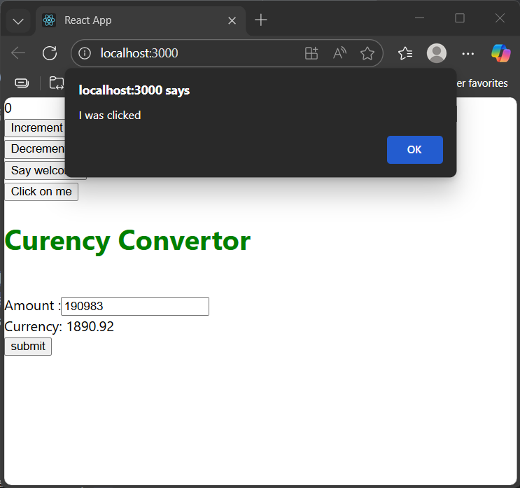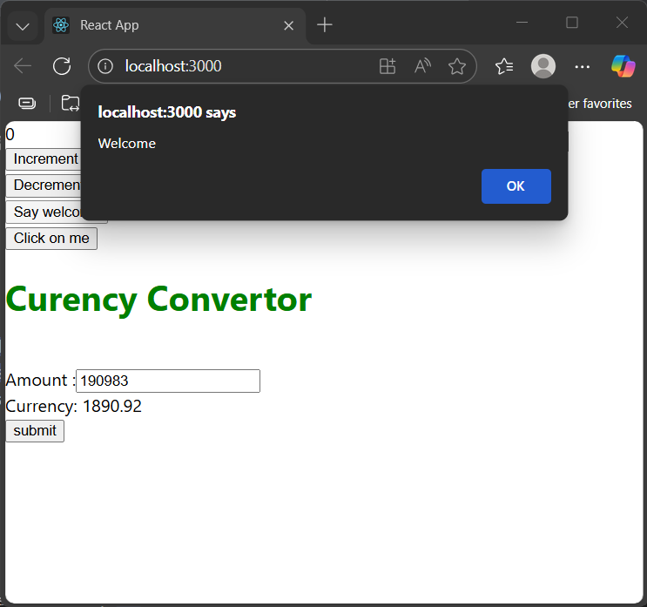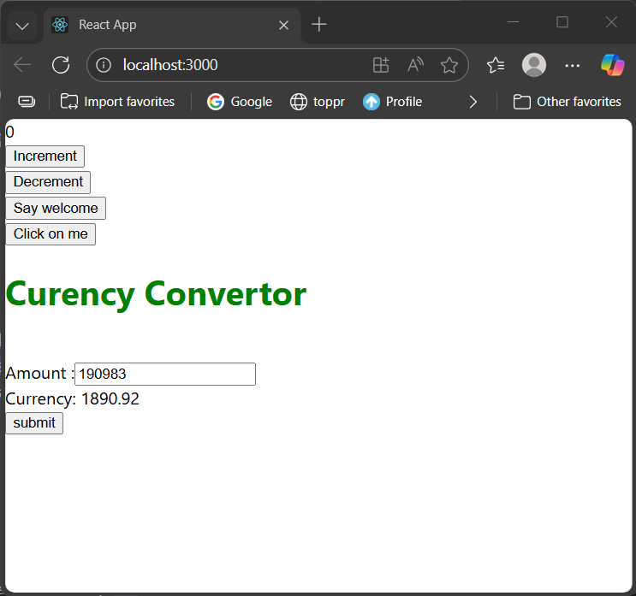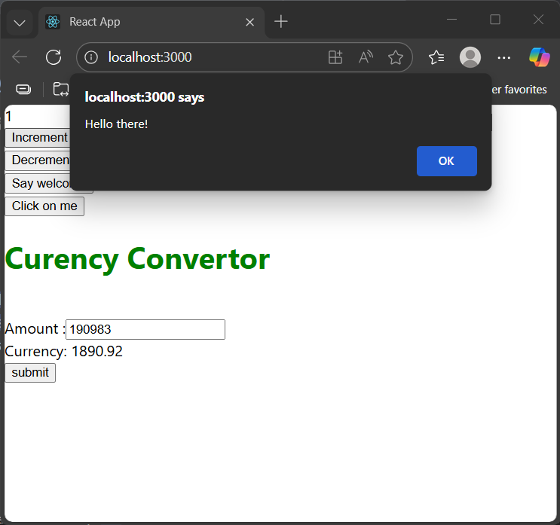

Exercise 12 : ticketbookingapp

**Code:**

**App.js**

import { useState } from 'react';

import UserPage from './UserPage';

import GuestPage from './GuestPage';

function App() {

  const [log,setLog] = useState(false);

  return (

    <div>

      <h1>Ticket booking</h1>

      {

        log?<UserPage toggle={()=>setLog(false)} />:<GuestPage toggle={()=>setLog(true)}/>

      }

    </div>

  );

}

export default App;

**UserPage.js**

import React from 'react'

const data=[

  {

    name:'Air India',

    time:'08:00',

    price:6500

  },

  {

    name:'Indigo',

    time:'08:45',

    price:6000

  },

  {

    name:'Spicejet',

    time:'09:15',

    price:7000

  }

]

function UserPage({toggle}) {

  return (

    <div>

      <table border={1}>

        <tr>

          <th>Name</th>

          <th>Time</th>

          <th>Price</th>

        </tr>

        {

          data.map((details)=>{

            return(

              <tr>

              <td>{details.name}</td>

              <td>{details.time}</td>

              <td>{details.price}</td>

              </tr>

            )

          })

        }

      </table>

      <button onClick={toggle}>Logout</button>

    </div>

  )

}

export default UserPage

**GuestPage.js**

import React from 'react'

const data=[

  {

    name:'Air India',

    time:'08:00'

  },

  {

    name:'Indigo',

    time:'08:45'

  },

  {

    name:'Spicejet',

    time:'09:15'

  }

]

function GuestPage({toggle}) {

  return (

    <div>

      <table border={1}>

        <tr>

          <th>Name</th>

          <th>Time</th>

        </tr>

        {

          data.map((details)=>{

            return(

              <tr>

              <td>{details.name}</td>

              <td>{details.time}</td>

              </tr>

            )

          })

        }

      </table>

      <h2>Log in to see the price</h2>

      <button onClick={toggle}>Login</button>

    </div>

  )

}

export default GuestPage

**Output:**

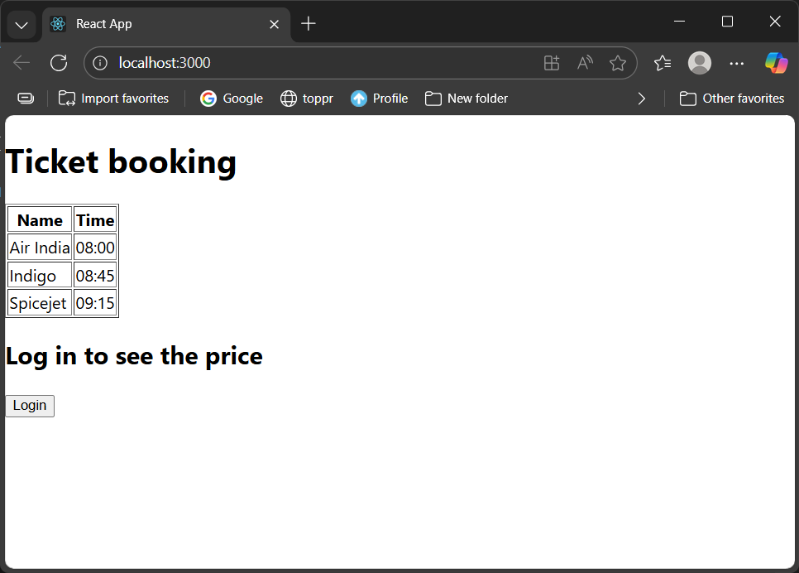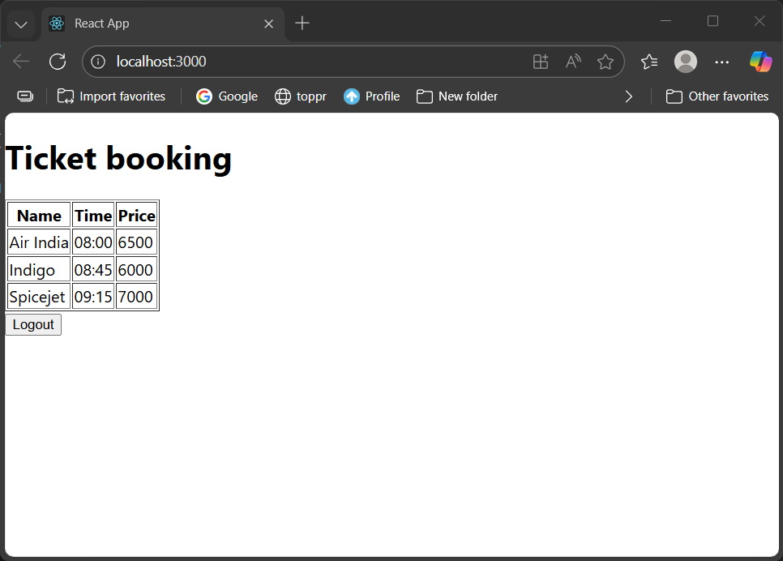

Exercise 13 : bloggerapp

**Code:**

**App.js**

import { useState } from "react";

import BookDetails from "./BookDetails";

import BlogDetails from "./BlogDetails";

import CourseDetails from "./CourseDetails";

function App() {

  const [view,setView]=useState({book:false,blog:false,course:false});

  const handleCheckbox = (event) => {

    const { name, checked } = event.target;

    setView(prev => ({

      ...prev,

      [name]: checked

    }));

  };

  return (

    <div >

      Book Details

      <input type="checkbox" name="book" checked={view.book} onChange={handleCheckbox} /><br />

      {view.book && <BookDetails />}<br />

      Blog Details

      <input type="checkbox" name="blog" checked={view.blog} onChange={handleCheckbox} /><br />

      {view.blog && <BlogDetails />}<br />

      Course Details

      <input type="checkbox" name="course" checked={view.course} onChange={handleCheckbox} /><br />

      {view.course && <CourseDetails />}<br />

    </div>

  );

}

export default App;

**BlogDetails.js**

import React from 'react'

function BlogDetails() {

  return (

    <div>

      Lorem ipsum dolor sit amet, consectetur adipiscing elit, sed do eiusmod tempor incididunt ut labore et dolore magna aliqua. Ut enim ad minim veniam, quis nostrud exercitation ullamco laboris nisi ut aliquip ex ea commodo consequat. Duis aute irure dolor in reprehenderit in voluptate velit esse cillum dolore eu fugiat nulla pariatur. Excepteur sint occaecat cupidatat non proident, sunt in culpa qui officia deserunt mollit anim id est laborum.

    </div>

  )

}

export default BlogDetails

**BookDetails.js**

import React from 'react'

const data=[

  {

    name:"HP Deathly Hallows",

    author:"JK Rowling"

  },

  {

    name:"Eragon",

    author:"C Paolin"

  },

  {

    name:"The Lost Symbol",

    author:"Dan Brown"

  }

]

function BookDetails() {

  return (

    <div>

      <table border={1}>

        <tr>

          <th>Name</th>

          <th>Author</th>

        </tr>

        {

          data.map((details)=>{

            return(

              <tr>

              <td>{details.name}</td>

              <td>{details.author}</td>

              </tr>

            )

          })

        }

      </table>

    </div>

  )

}

export default BookDetails

**CourseDetails.js**

import React from 'react'

const data=[

  {

    name:"Computer Organization",

    credits:3

  },

  {

    name:"Operating Systems",

    credits:2

  },

  {

    name:"modern c++",

    credits:3

  }

]

function CourseDetails() {

  return (

    <div>

      <table border={1}>

        <tr>

          <th>Name</th>

          <th>Credits</th>

        </tr>

        {

          data.map((details)=>{

            return(

              <tr>

              <td>{details.name}</td>

              <td>{details.credits}</td>

              </tr>

            )

          })

        }

      </table>

    </div>

  )

}

export default CourseDetails

**Output:**

