**Exercise 1**

**Code:**

git --version

git config --global user.name "abhiram5446"

git config --global user.email "baduguabhiram04@gmail.com"

git config --list

git config --global core.editor "notepad++ -multiInst -nosession"

git config --global -e

git init

echo "Welcome to version control system" >> welcome.txt

git add welcome.txt

git commit -m "fir"

git remote add origin https://gitlab.com/abhiram5446-group/gitDemo.git

git pull origin master

git push origin master

**Output:**

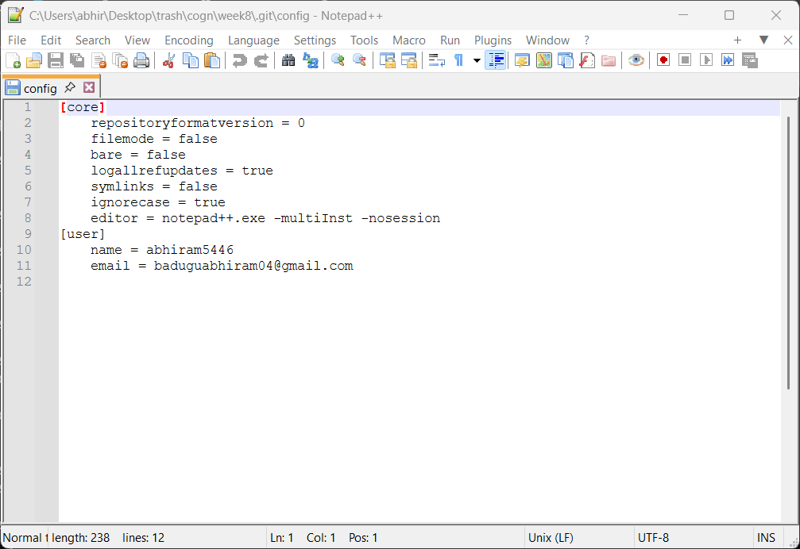

**Exercise 2**

**Code:**

git add .

git commit -m "sec"

git push origin master

**Output:**

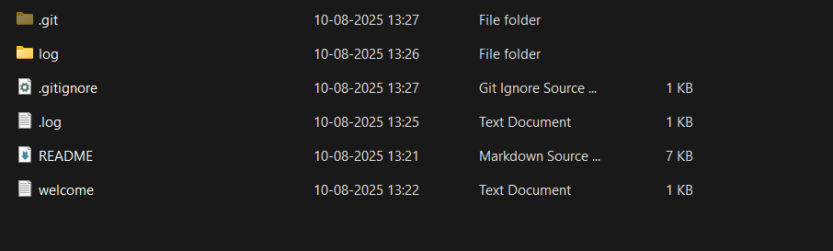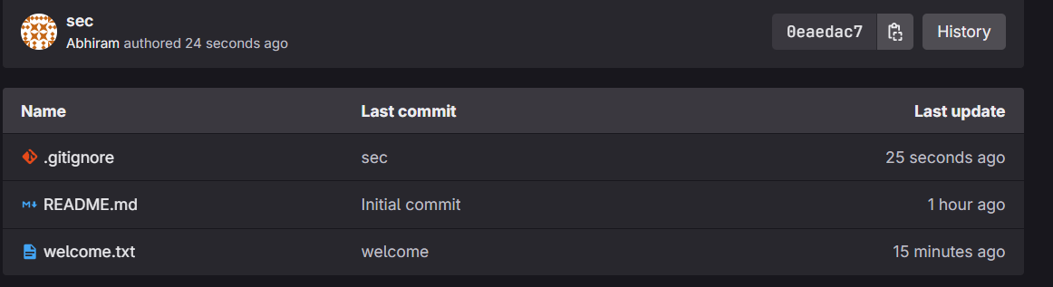

**Exercise 3**

**Code:**

git branch GitNewBranch

git branch -a

git checkout GitNewBranch

echo "This file is of git branch new">>branch.txt

git add branch.txt

git commit -m "added new branch"

git status

git checkout master

git diff master GitNewBranch

git config --global diff.tool p4merge

git config --global difftool.p4merge.path "C:/Program Files/Perforce/p4merge.exe"

git config --global difftool.prompt false

git difftool master GitNewBranch

git merge GitNewBranch

git add .

git commit -m "merging"

git log --oneline --graph --decorate

git branch -d GitNewBranch

**Output:**

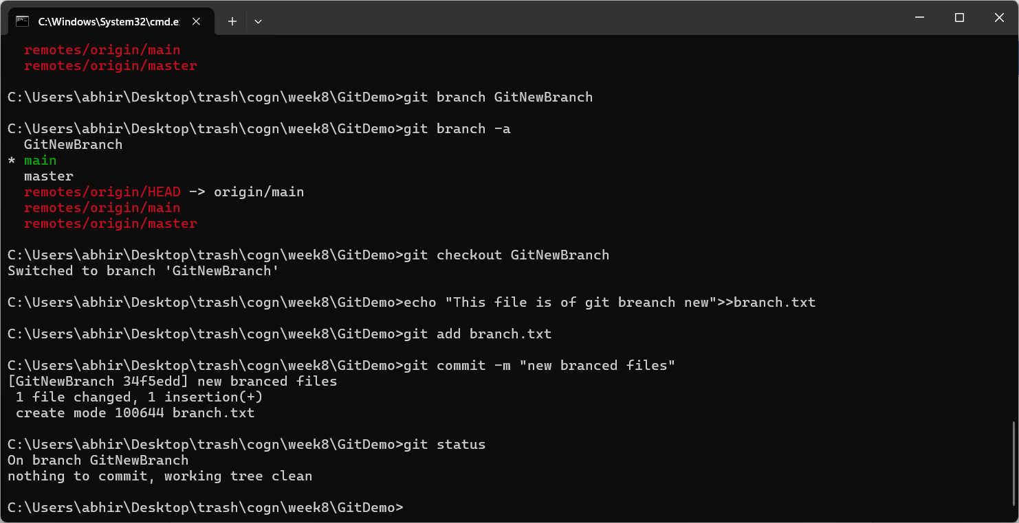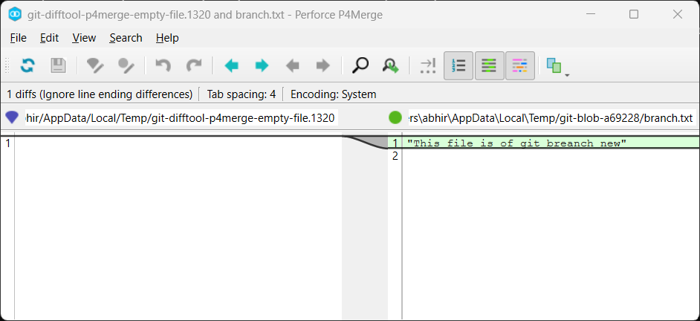

**Exercise 4**

**Code:**

git branch GitWork

git checkout GitWork

echo "<msg>Hello</msg>">>hello.xml

git add hello.xml

git commit -m "branch gitwork hello xml"

git checkout master

git add .

git commit -m "c1"

git log --oneline --graph --decorate --all

git diff master GitWork

git difftool master GitWork

git merge GitWork

cat hello.xml

git mergetool

git commit -m "Merging gitwoork into master"

git status

git add .gitignore

git commit -m "Ignore update to remove merge files"

git branch -a

git branch -d GitWork

git log --oneline --graph –decorate

**Output:**

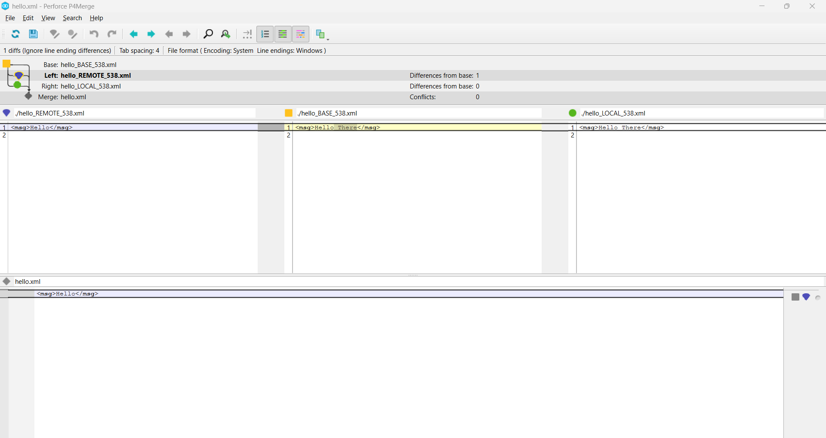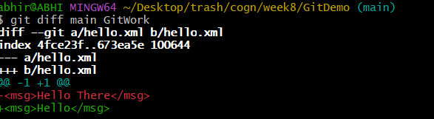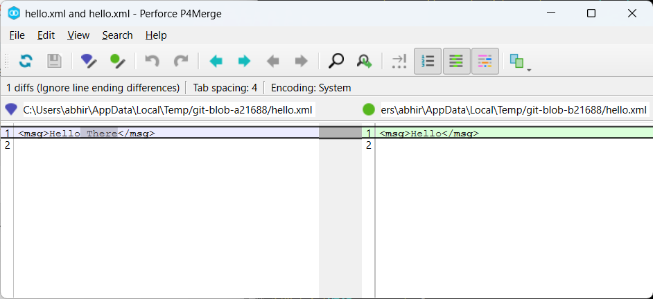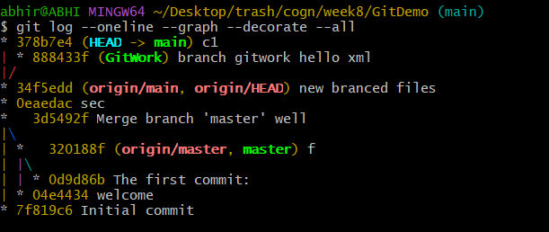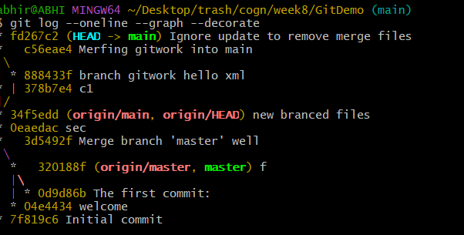

**Exercise 5**

**Code:**

git checkout master

git status

git branch -a

git pull origin master

git push origin master

**Output:**

