ASSIGNMENT 1

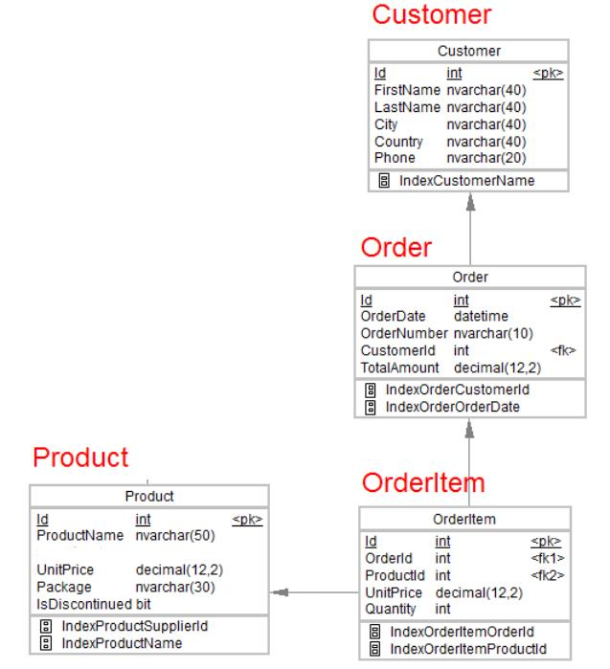

1. Desgin the above database with following table by applying Primary key and Foreign key

CUSTOMER TABLE :

CREATE TABLE Customer

(Id int NOT NULL PRIMARY KEY,

FirstName nvarchar(50) NOT NULL,

LastName nvarchar(50),

City nvarchar(50),

Country nvarchar(50),

Phone nvarchar(20));

ALTER TABLE Customer ADD FAX INTEGER;

SELECT * FROM Customer;

**ORDERS TABLE :**

CREATE TABLE Orders(

Id int NOT NULL PRIMARY KEY,

OrderDate datetime NOT NULL,

OrderNumber nvarchar(10),

CustomerId int FOREIGN KEY REFERENCES Customer(Id) ,

TotalAmount decimal(12,2));

ALTER TABLE Orders ADD ShipName varchar(50);

alter table Orders add ShippingDate date;

**PRODUCT TABLE :**

CREATE TABLE Product(

Id int NOT NULL PRIMARY KEY,

ProductName nvarchar(50),

UnitPrice decimal(12,2),

Package nvarchar(30),

IsDiscontinued bit);

alter table Product ADD supplier varchar(50);

alter table Product ADD CategoryName varchar(50);

SELECT * FROM Product;

truncate table Product;

**ORDERITEM TABLE :**

CREATE TABLE OrderItem(

Id int NOT NULL PRIMARY KEY,

OrderID int FOREIGN KEY REFERENCES Orders(Id),

ProductId int FOREIGN KEY REFERENCES Product(Id),

UnitPrice decimal(12,2),

Quantity int);

SELECT * FROM OrderItem;

drop table OrderItem;

**SHIPPING TABLE :**

CREATE TABLE Shipping(

ShipName VARCHAR(50) NOT NULL Primary key,

ShipCompany VARCHAR(50) NOT NULL,

IsOperational BIT

);

drop table Shipping;

SELECT * FROM Shipping;

**EMPLOYEE TABLE :**

CREATE TABLE Employee(

EmpID INT NOT NULL PRIMARY KEY,

EmpRole NVARCHAR(20)

);

alter table Employee Add EmpName nvarchar(50);

alter table Employee Add EmpLName nvarchar(50);

select * from Employee;

drop table Employee;

1. Insert Records in all tables.

INSERT INTO Customer(Id, FirstName, LastName, City, Country, Phone) VALUES ('1001', 'Abhi', 'Pawar', 'Pune', 'India', '998765432'),

('1002', 'Harsh', 'Mehta', 'HOF', 'Germany', '999876543'),

('1003', 'Tushar', 'Kadve', 'Florida', 'America', '999987654');

INSERT INTO Orders(Id, OrderDate, OrderNumber, CustomerId, TotalAmount) VALUES ('1201', '2018-10-7 1:36:00', '1', '002', '11100'),

('1202', '2020-05-15 02:07:57', '2', '003', '22230'),

('1203', '2015-08-27 01:12:11', '3', '001', '73360');

INSERT INTO Orders(Id, OrderDate, OrderNumber, CustomerId, TotalAmount,ShippingDate) VALUES ('1204', '2018-11-27 04:26:10', '4', '1002', '8000','2022-05-11');

INSERT INTO Orders(Id, OrderDate, OrderNumber, CustomerId, TotalAmount,ShippingDate) VALUES ('1205', '2018-02-25 5:36:13', '5', '1001', '4000','2022-05-28');

INSERT INTO Product(Id, ProductName, UnitPrice, Package, IsDiscontinued) VALUES ('1301', 'TV', '2250.00', '500000', '0'),

('1302', 'Chair', '1140.00', '150000', '0'),

('1303', 'Tables', '4400.00', '683000', '1');

INSERT INTO OrderItem(Id, OrderID, ProductId, UnitPrice, Quantity) VALUES ('1401', '2001', '3001', '250', '200'),

('1402', '2002', '3002', '200', '30'),

('1403', '2003', '3003', '350', '10'),

('1404', '2004', '3002', '10', '19'),

('1405', '2005', '3001', '17', '18');

INSERT INTO Shipping(ShipName,ShipCompany,IsOperational) values ('La corned abondance','AA',1);

INSERT INTO Shipping(ShipName,ShipCompany,IsOperational) values ('Titanic','BB',0);

INSERT INTO Employee(EmpID,EmpRole,EmpName,EmpLName) VALUES (101,'Manager','Abhishek ','Fulwade'),

(102,'Manager','Vedant','Shetty'),

(103,'Employer','Kartik','Aryan');

1. In Customer table FirstName Attribute should not accept null value

In Order table OrderDate should not accept null value

1. Display all customer details

select * from Customer;

1. write a query to display Country whose name starts with A or I

select Country from Customer where Country like 'A%' or Country like 'I%';

1. write a query to display whose name of customer whose third character is i.

select FirstName from Customer where FirstName like '__i%';

ASSIGNMENT 2

1. Display the details from Customer table who is from country Germany

SELECT * FROM CUSTOMER WHERE COUNTRY = ‘GERMANY’;

1. Display the full name of the employee

SELECT FRISTNAME, LASTNAME FROM [CUSTOMER];

1. Display the customer details who has Fax number

SELECT * FROM [CUSTOMER] WHERE FAX IS NOT NULL;

1. display the customer details whose name holds second letter as U

SELECT FRISTNAME, LASTNAME FROM [CUSTOMER] WHERE FIRSTNAME LIKE ‘_U%’;

1. select order Details where unit price is greater than 10 and less than 20

SELECT * FROM [ORDERITEM] WHERE UITPRICE BETWEEN 10 AND 20;

1. Display order details which contains shipping date and arrange the order by date

SELECT * FROM [ORDER] WHERE SHIPPING_DATE IS NOT NULL ORDERBY ORDERDATE;

1. Print the orders shipped by ship name 'La corned'abondance' between 2 dates(Choose dates of your choice)

SELECT * FROM [ORDER] WHERE SHIPNAME=’LA CORNED’ABONDANCE’ AND SHIPPINGDATE BETWEEN ‘2022-01-23’ AND ‘2022-05-02’;

1. Print the products supplied by 'Exotic Liquids'

SELECT * FROM [PRODUCT] WHERE SUPPLIER_NAME=’EXOTIC LIQUIDS’;

1. print the average quantity ordered for every product

SELECT AVG(QUANTITY) GROUP BY PRODUCT_ID FROM [PRODUCTS];

1. Print all the Shipping company name and the ship names if they are operational

SELECT * FROM Shipping WHERE IsOperational = 1;

1. Print all Employees with Manager Name

SELECT * FROM Employee WHERE EmpRole = 'Manager';

1. Print the bill for a given order id .bill should contain Productname, Categoryname ,price after discount

SELECT PRODUCT NAME, CATEGORYNAME, PRICE-(PRICE*(DISCOUNT/100)) AS BILL FROM [ORDER]

ASSIGNMENT 3

1. write a query to display the orders placed by customer with phone number 030-0074321

SELECT OrderNumber FROM [Order] WHERE CustomerId =(SELECT Id FROM Customer WHERE Phone = '998765432');

2. fetching all the products which are available under Category ‘Seafood’.

SELECT * FROM [PRODUCTS] WHERE CATEGORY = ‘SEAFOOD’;

3. Display the orders placed by customers not in London

SELECT * FROM [Order] WHERE CustomerId IN (SELECT Id FROM Customer WHERE City = 'Pune');

4. selects all the order which are placed for the product Chai.

SELECT * FROM orderitem JOIN Product ON orderitem.ProductId = Product.Id WHERE Product.ProductName = 'chai';

5. Write a query to display the name , department name and rating of any given employee

SELECT EMP_NAME, DEPT_NAME, RATING FROM EMPLOYEE WHERE EMP_ID = ‘101’;

ASSIGNMENT 4

1. Print the Total price of orders which have the products supplied by 'Exotic Liquids' if the price is > 50 and also print it by Shipping company's Name

SELECT SUM(PRICE) FROM PRODUCT GROUP BY PRICE HAVING PRICE>50;

1. Display the employee details whose joined at first

SELECT TOP 1* FROM EMPLOYEE ORDER BY DOJ DESC;

1. Display the employee details whose joined at recently

SELECT TOP 1* FROM EMPLOYEE ORDER BY DOJ ASC;

1. Write a query to get most expense and least expensive Product list (name and unit price).

SELECT PRODUCTNAME, MIN(PRICE),MAX(PRICE) FROM [PRODUCT] GROUP BY PRODUCTNAME;

1. Display the list of products that are out of stock

SELECT ProductName FROM Products WHERE Stock = 0;

1. Display the list of products whose unitinstock is less than unitonorder

SELECT ProductName, Unitsinorder , Unitsinstock

FROM Products

WHERE (((Discontinued)=No) AND ((Unitssnstock)<Unitsonorder));

1. Display list of categories and suppliers who supply products within those categories

Select CategoryName , ProductSupplier from Product Group By CategoryName;

1. Display complete list of customers, OrderID and date of any orders they have made.

Select c.*, o.Id, o.OrderDate from [Order] o, [Customer] c where o.CustomerId=c.Id;

1. Write query that determines the customer who has placed the maximum number of orders

SELECT CustomerId, COUNT(Id) AS order_count FROM [Order] GROUP BY CustomerId ORDER BY order_count DESC;

1. Display the customerid whose name has substring ‘RA’

SELECT CustomerId FROM Customer WHERE FirstName LIKE '%RA%';

1. Display the first word of all the company name

SELECT Company_name, SUBSTR(Company_name,1, INSTR(Company_name, ' ')-1) FROM Company;