**Problem Statement :**To implement Star and Snowflake schema using the SQL power

Architect tool .

**STAR SCHEMA**

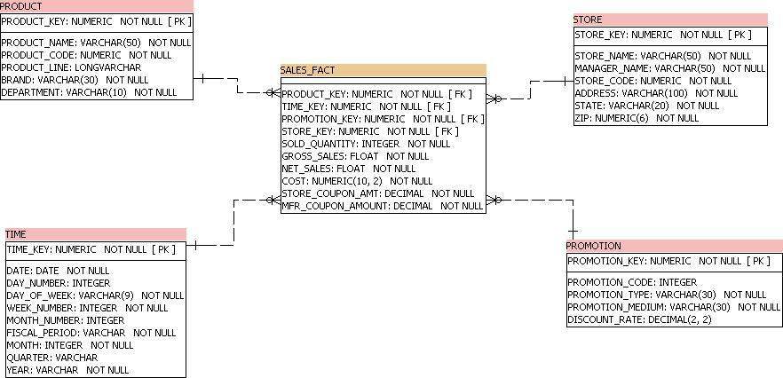

**SNOWFLAKE SCHEMA**

