UrjaSetu Agent Network and Deployment Guide
  - A concise reference for the hackathon problem statement
Purpose This guide explains the agents in UrjaSetu, the data each agent uses, whether it is AI, ML or algorithmic, and the output it produces. It also shows how the Vercel UI should connect to the Python backend on Render.
Main conclusion The active system is a deterministic multi-agent simulation. Its forecasting, auction, grid checks, optimization and settlement are algorithmic. No AI or ML model is active in the current runtime.

Problem statement fit
Requirement | Status | Meaning
Monitor hyper local generation | Implemented in simulation | Hourly load, rooftop solar, EV demand, weather and transformer topology are read for 64 nodes.
Predict grid failures | Partial | The system forecasts energy and detects overload, phase and voltage breaches. A real future failure probability is not yet active.
Autonomously respond | Implemented in simulation | A breach can trigger battery discharge, LP based trade reshaping and safe fallback curtailment.
Peer to peer energy trading | Implemented in simulation | Households bid and offer energy through a same transformer auction with settlement and network charges.

How to describe the technology
- Algorithmic means a fixed, explainable rule or mathematical model. This describes all seven active agents.
- Machine learning means a model learned from training data. LightGBM code exists, but it is disabled, trained only on synthetic labels when enabled, and not used by the main runner.
- Artificial intelligence means a model such as an LLM making or explaining decisions. LLM helper functions exist, but no provider is connected and the feature is disabled.

Accurate project description
UrjaSetu is a deterministic multi-agent digital twin for a local distribution grid. Household agents forecast supply and demand, a market agent clears peer to peer trades, grid agents check and reshape unsafe flows, and a settlement agent records energy and charges. The current prototype uses modelled Whitefield data. The planned deployment serves the UI from Vercel and runs the Python decision network on Render.

Agent network
The runner opens one hourly block and moves information through this network. If the sentinel finds a loading problem, the flow agent constrains the market before health and settlement are calculated.
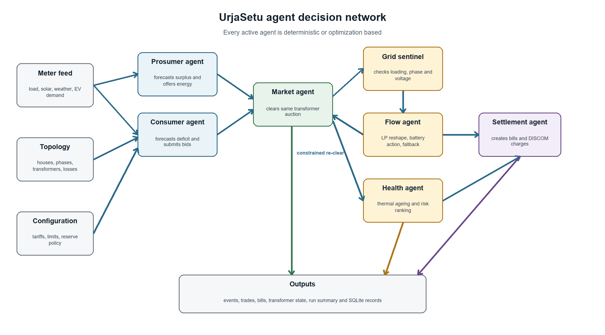
Figure 1 Active agent and decision flow
Important distinction: the agents are separate decision components, but they currently run inside one centralized Python process. This is an agent network, not a blockchain or distributed peer network.

Active agents
Agent | Type | What it does | Data used | Output
Prosumer Agent | Algorithmic | Predicts a solar home's surplus and creates a sell offer. | Feed forecast, 7 day same hour EWMA, tariff, price history, battery reserve | Order with quantity and minimum price
Consumer Agent | Algorithmic | Predicts a home's deficit and creates a buy bid below its retail tariff. | Feed forecast, 7 day same hour EWMA, retail tariff, buying strategy | Order with quantity and maximum price
Market Agent | Algorithmic | Matches buyers and sellers on the same transformer using a deterministic auction. | Orders, house to transformer mapping, market rules | Trades, clearing price, unmatched orders
Grid Sentinel | Algorithmic | Checks whether the cleared result violates transformer or feeder limits. | Meter ticks, trades, phases, ratings, distance and configured limits | Highest severity Breach or no breach
Flow Agent | Optimization | Changes trade retention and battery use to relieve a loading breach; uses fallback curtailment if required. | Trades, ticks, breach, battery state and grid limits | Reshape Plan with constrained orders and battery actions
Transformer Health Agent | Physics algorithm | Calculates hot spot temperature, insulation ageing and a next block wear charge. | Net transformer load, ambient temperature, rating and thermal parameters | Ageing Result and transformer states
Settlement Agent | Algorithmic | Creates buyer and seller ledger lines and applies losses and DISCOM charges. | Final trades, tariffs, transmission losses and ageing adder | Bill Lines, charges collected and ledger

Supporting components
Component | Responsibility
Runner | Orchestrates the seven stage block sequence and enforces the two pass limit.
Agent Pool | Owns all prosumer and consumer instances and forwards settlement feedback.
Battery Book | Tracks battery energy, ownership claims, capacity and charge or discharge limits.
Event Bus | Publishes ordered events for observability and the future WebSocket stream.
Persistence | Atomically writes ticks, orders, trades, bills and transformer state to SQLite.

Data used by the network
Source | Contains | Used by | Status
smart_meters.csv | Hourly household consumption | Feed and all downstream agents | Active
solar_inverters.csv | Hourly rooftop generation | Feed, prosumer and consumer forecasts | Active
ev_charging_hubs.csv | Transformer level EV demand | Feed as four pseudo premises | Active
weather.csv | Hourly ambient temperature | Thermal health calculation | Active
device_registry.json | Transformer mapping, PV and battery capacities, location and loss | Topology, settlement and UI scene | Active
transformer_registry.json | Transformer metadata and installed ratings | Feed and topology | Active with configured rating override
bangalore_real_reference_2024.csv | Daily demand and solar shape | Scales the representative day across 30 days | Active
home_batteries.csv | Recorded battery telemetry | Not loaded by WhitefieldFeed; BatteryBook starts from model state | Disconnected

Data limitation
The telemetry is physically modelled from published averages, not a live meter feed. One representative hourly day is scaled with the annual reference series. Transformer ratings are overridden in configuration so realistic demonstration breaches are reachable. These facts should be stated clearly during judging.

Readable output files
Output | Status | Purpose
run_summary.json | Implemented | Human readable run totals: blocks, trades, kWh, prices, breaches, battery movement, losses, charges, ageing and baseline comparison.
urjasetu.sqlite | Available when persistence is enabled | Detailed tables for every meter tick, order, trade, bill line and transformer state.
replay_run.json | Recommended addition | One UI ready file containing scene, block and event payloads plus backend calculated summary figures.
WebSocket stream | Recommended Render endpoint | Live scene, block and event messages for the Vercel LiveTransport.

Vercel and Render architecture
Vercel should host only the React and Three.js interface. Render should run the Python source of truth: data ingestion, agents, simulation, persistence, exports and WebSocket commands.
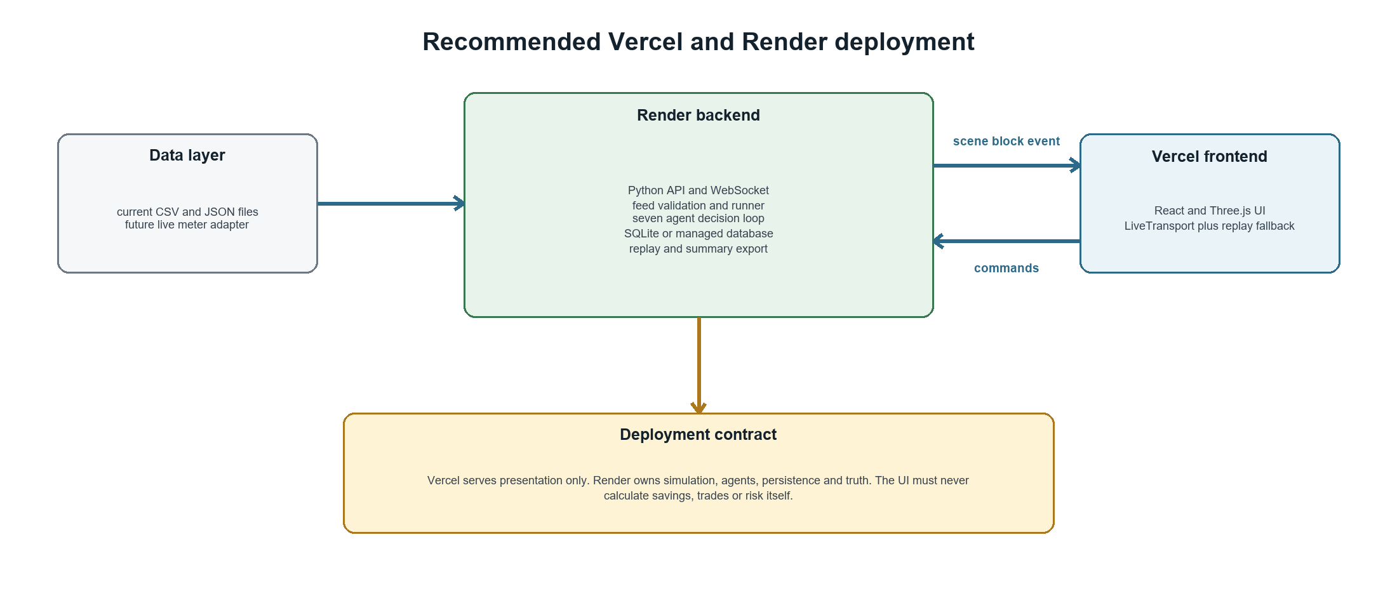
Figure 2 Target hosting and communication boundary

Render backend responsibilities
- Expose a health endpoint and a WebSocket endpoint.
- Start and stop runs, validate data, execute hourly blocks and persist results.
- Translate Bus events and Runner state into scene, block and event payloads.
- Handle derate, cloud and replay commands on the real simulation.
- Export run_summary.json and replay_run.json from completed runs.

Vercel frontend responsibilities
- Read the Render WebSocket URL from an environment variable.
- Use LiveTransport for normal operation and ReplayTransport when disconnected.
- Display backend values without recalculating trades, savings or risk.
- Send operator commands and show visible confirmation within two blocks.

Required integration work
Order | Work item | Status
1 | Create the Python API and WebSocket service on Render | Missing
2 | Serialize real Runner state into the existing UI payload types | Missing
3 | Select LiveTransport through a Vercel environment variable | Missing
4 | Generate replay and summary values from the backend | Missing
5 | Add a defensible future grid risk score or describe the system as detection plus prevention | Decision required

Recommended agents to add
Minimum recommendation Add the Forecast Agent, Failure Risk Agent, AI Strategy Agent and Dispatch Agent first. Together they make prediction and autonomous action explicit while keeping the current market and grid algorithms intact.
Agent | Type | What it does | Data used | Output | Priority
Forecast Agent | ML agent | Predicts load, solar and transformer demand for the next 1 to 6 hours. | Meter history, weather, hour, day, EV load | forecast.json with values and confidence | Essential
Failure Risk Agent | ML agent | Estimates the probability and expected time of an overload or thermal risk. | Forecasts, loading history, hot spot, voltage events, ambient | risk.json with score, horizon and causes | Essential
AI Strategy Agent | LLM or policy agent | Chooses bounded bid aggression, battery reserve and trading timing for the next period. | Forecast, risk, price history and allowed parameter ranges | strategy.json with clamped parameters | Essential
AI Coordinator | LLM tool using agent | Combines forecast and risk into an explainable proposed response. | Forecast, risk, market state and approved actions | action_plan.json with reason and confidence | Add later
Anomaly Agent | ML agent | Detects missing, stuck, drifting or impossible telemetry before decisions are made. | Recent sensor values, expected ranges and neighboring patterns | anomaly.json and data quality events | Add later
Dispatch Agent | Algorithmic executor | Executes only actions already approved by the sentinel and flow constraints. | Validated reshape plan and device limits | dispatch.json and execution events | Essential

Why these additions fit the problem
Problem requirement | Agent contribution
Monitor hyper local generation | Anomaly Agent validates live readings before they enter the network.
Predict grid failures | Forecast Agent predicts future demand and generation; Failure Risk Agent converts that forecast into a risk and time horizon.
Autonomously execute trading | AI Strategy Agent changes bounded trading behavior; the existing Market Agent clears trades automatically.
Protect the micro grid | AI Coordinator proposes a response; Sentinel, Flow and Dispatch enforce physical safety.

Recommended implementation order
- Forecast Agent using supervised time series features and the existing deterministic feed.
- Failure Risk Agent predicting a future threshold breach. Call it grid risk, not equipment failure, until real failure labels exist.
- AI Strategy Agent connected through the existing StrategyParams clamps and timeout fallback.
- Dispatch Agent that accepts only sentinel approved and flow validated actions.
- AI Coordinator and Anomaly Agent if time remains.

Future AI enabled network
The new intelligence layer predicts and proposes. The existing deterministic layer remains responsible for market invariants, grid limits, energy conservation and money conservation.
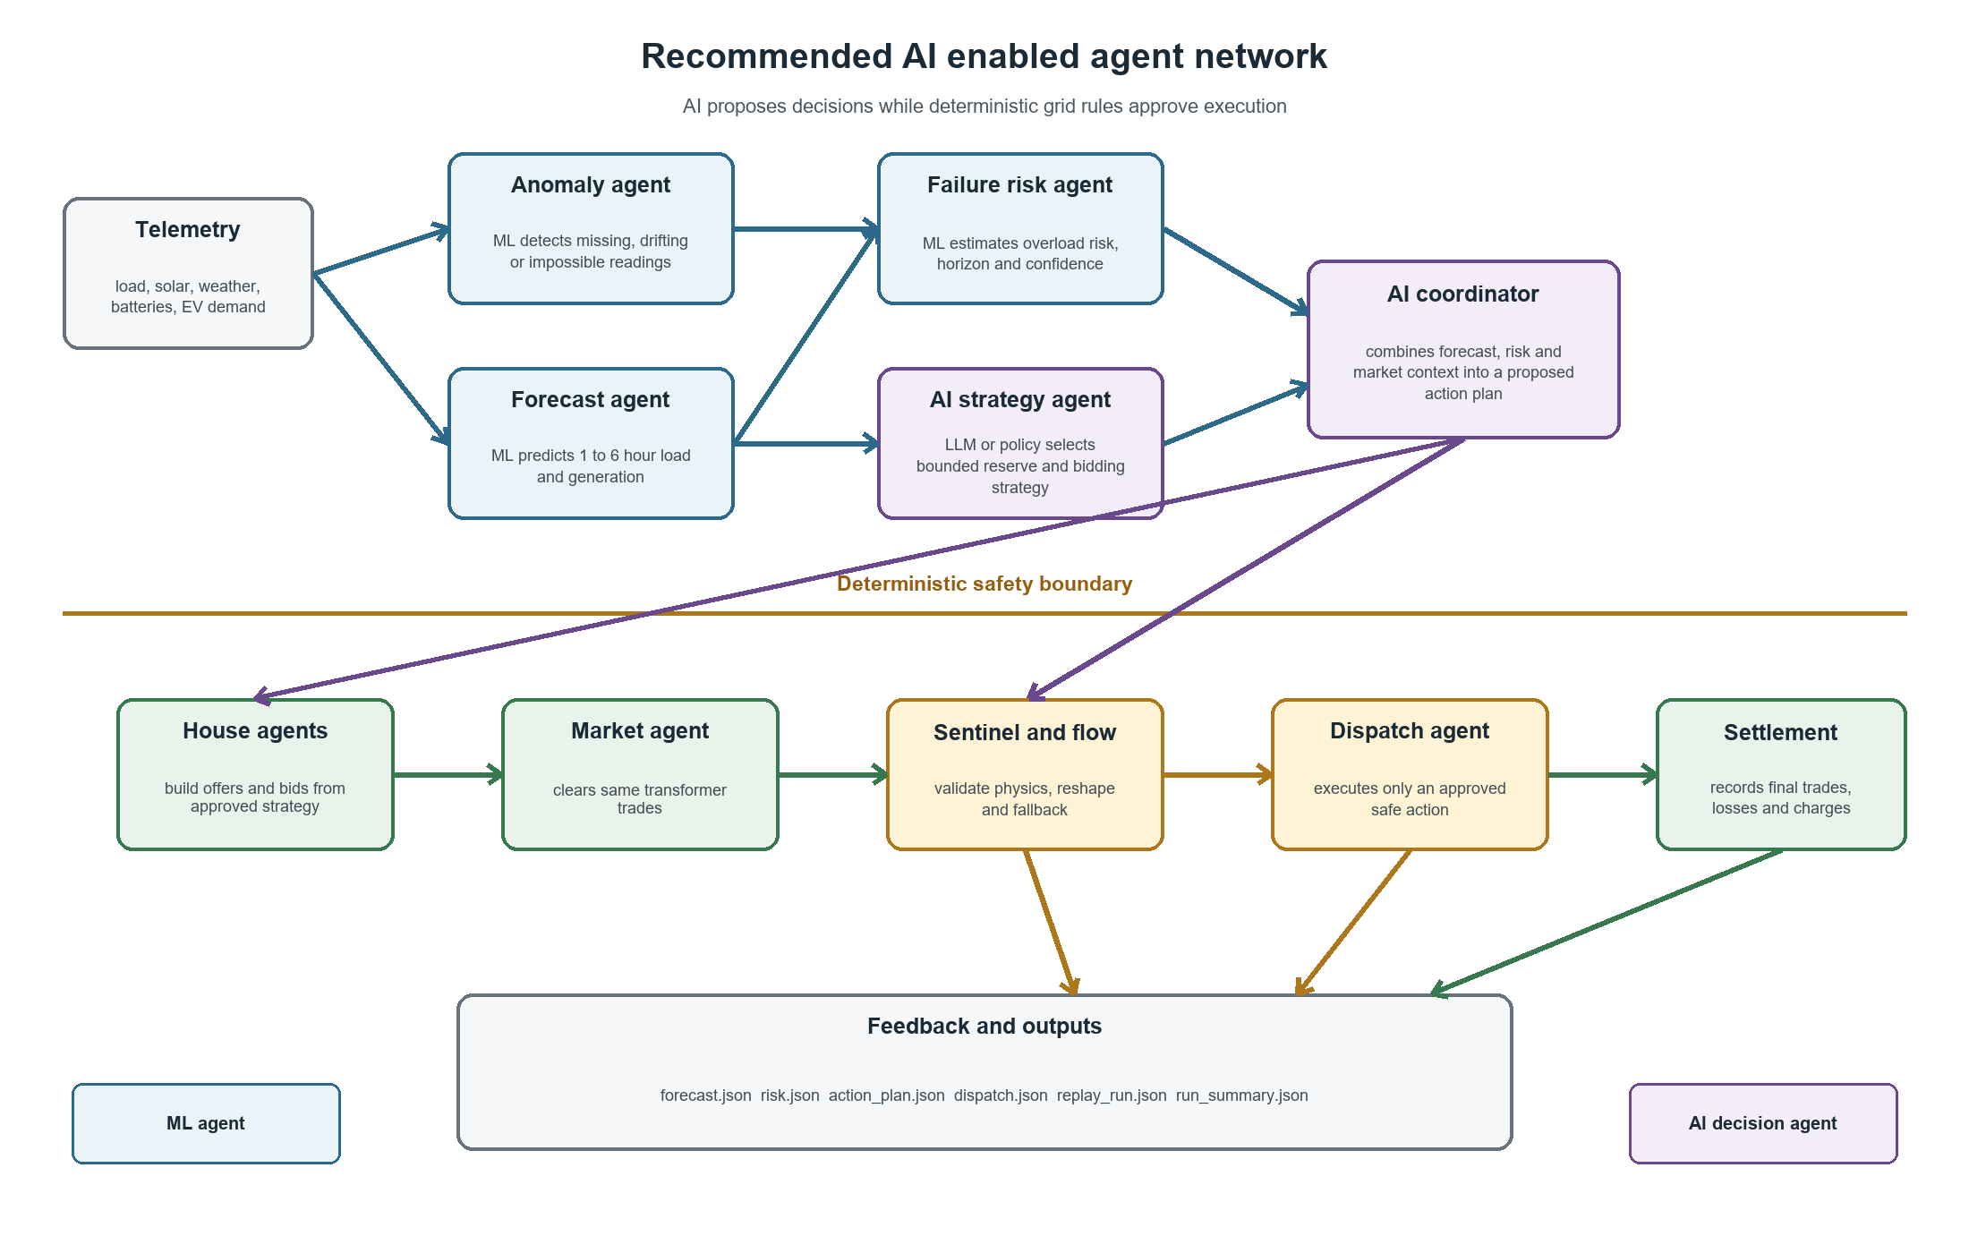
Figure 3 Recommended AI and deterministic safety architecture

Non negotiable AI guardrails
- An LLM may select only named actions and bounded StrategyParams. It must never invent meter readings, energy or prices.
- Every AI output must be structured JSON with model version, confidence, timestamp and input window.
- Sentinel and Flow remain the final authority. Unsafe or malformed AI output is rejected.
- A timeout or unavailable model returns the previous safe strategy and continues with deterministic logic.
- Store each recommendation, validation result and executed action so the UI can explain what happened.

Suggested updated project description
UrjaSetu is an AI enabled multi-agent energy network for local micro grids. ML agents forecast generation, demand and near term grid risk. AI strategy agents propose bounded trading and battery actions. Deterministic market and grid agents validate every decision, execute safe peer to peer trades and record settlement. The UI runs on Vercel while the Python agent network runs on Render.

