*A*

*Synopsis report on*

“Securing and Managing Patient Data of Rural Healthcare System Through Cloud Environment”

*Submitted by:*

Mr. Sourabh S. Patil

Mr. Sahil Y. Pathan

Mr. Vaibhav B. Chavan

Mr. Ajay S. Shete

*Under The Guidance of:*

Prof. N. M. Sawant

*For The Award of The Degree of*

**Bachelor of Engineering**



DEPARTMENT OF COMPUTER SCIENCE AND ENGINEERING

SKN SINHGAD COLLEGE OF ENGINEERING

## (PUNYASHLOK AHILYADEVI HOLKAR

## SOLAPUR UNIVERSITY)

2020-2021

**Synopsis**

|  |  |
| --- | --- |
| **Name of college :** | SKN Sinhgad College of Engineering , Korti, Pandharpur. |
| **Name of Department :** | Computer Science & Engineering. |
| **Name of Students :** | Mr. Sourabh S. Patil  Mr. Sahil Y. Pathan  Mr. Vaibhav B. Chavan  Mr. Ajay S. Shete |

**Name of Guide :** Prof. N. M. Sawant.

**Title of Project :** "Securing and Managing Patient Data of Rural Healthcare System Through Cloud Environment."

**Introduction:**

Rural healthcare system in India is managing patient data in a traditional paper based system. Most of the rural hospitals in India are lacking in resources to maintain and manage the patient health data. As the world moves towards digitization, one of the key challenges in developing countries like India is in making the healthcare data accessible from rural to urban in digital form. Advancement in IT technology in healthcare sector has made it possible to maintain and manage the patient data in digital form in all levels of healthcare system. Cloud computing has emerged as a main in providing healthcare IT solution. Therefore, rural healthcare organizations should move towards building their own private cloud infrastructure which could be an excellent solution for the country’s needs to have improved healthcare in rural areas. In private cloud, medical data is stored in databases in which some of the data in a medical database is sensitive in nature and access to this data should be limited to authorized persons.

In this project we propose a use cloud architecture by building private cloud. The proposed private cloud architecture makes to store medical data. To reduce the risk of the health information leakage and safeguard the health data, hash and the encryption operation are performed before transmitting to the cloud database. With this technique, path for a third party to obtain the sensitive information stored in the cloud is being blocked. Therefore the proposed framework provides better secured services to the users.

The world’s population is growing rapidly . Developed countries have been facing the trend of population aging, escalating costs, inconsistent provision of care, and a high burden of chronic diseases related to health behaviors. This situation makes healthcare management more and more important to all types of healthcare organizations. Health care is delivered mainly through Primary Healthcare Centre (PHC), Secondary Care Centre (SHC), and Tertiary Care Centre (THC). The different levels of healthcare system is depicted in Fig. 1. The primary healthcare centre deal with patients whose medical conditions can be managed on an outpatient basis. The secondary healthcare usually deals with acute care hospitals whereas tertiary care requires the resources of a sophisticated medical center.

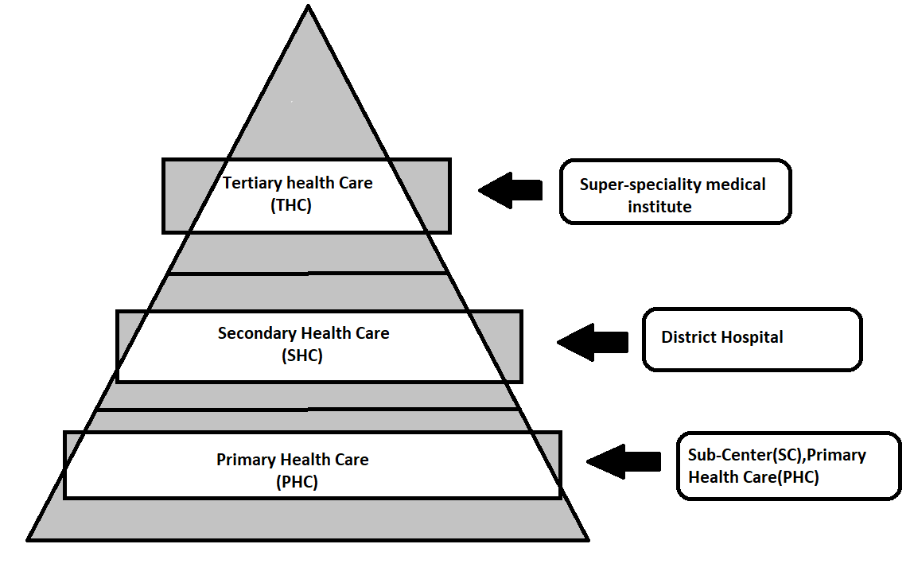

Fig. 1. Different Levels of health-care system

Healthcare ecosystem consists of physicians, nurse, pharmacist, radiologist, lab technician, and patient. Cloud computing helps in organizing the medical record at different levels of healthcare setting. Cloud computing is a promising and emerging technology for the users of the healthcare by connecting many health information management systems together with laboratory, pharmacy, radiology etc. The main obstacles and serious problem towards the rapid growth of cloud computing are data security and privacy issues. Most of the healthcare users of private cloud do not fully trust the inside threat of the healthcare organization for safeguarding sensitive health information4 data because there is no governance about how this information can be used by them and whether the healthcare organization actually control their information.

As part of the field study, hospitals at different healthcare levels namely Primary Healthcare Centre (PHC), Secondary Care Centre (SHC), and Tertiary Care Centre (THC) in Solapur district visited. Field study was conducted to understand the IT-infrastructure facility used for managing and maintaining the patient information. In this study it was observed that, in PHC levels, namely sub center, primary health center and community healthcare center are maintaining yearly paper-based records such as registration book, examination book and treatment book. In the record room only current five years of patient data is maintained and previous ones are discarded. Because of this the continuous health data about the patient is lost. Hence present requirement for Indian healthcare scenario is to capture lifelong summary of the patient from pre-birth to post-death with better IT infrastructure facility. So in this project we are going to manage all data(Previoud one and new) of patient regarding health and medical.

**Related Work:**

* Robert Birke discussed about how corporate data centers uses virtualization as a mainstream technology in current scenario and explained about how virtualization allows efficient and safe resource sharing in data Center. Author additionally discussed about changes in VM patterns by configuring memory and process settings of the VM. David Freet , proposed effective cloud based computing services for cloud based applications. They used vari-eties of hypervisors such as XEN, KVM and ESX for cloud deployment model. They also analyzed the performance of hypervisor by allowing simultaneous execution of entire OS instances. Repu Daman proposed an architecture for health cloud infrastructure in terms of security models. They discussed about how to protect patient data in private public cloud environment and also discussed security mechanism namely role based access control , data encryption, digital signature and time to time security audits for healthcare data
* Khanand Sakamura proposed a Discretionary Access Control (DAC) framework that provides healthcare organizations against security attacks and ascertains confidentiality of patient data. A trust-aware RBAC model has been used to demonstrate social healthcare networks application in a cloud environment. A similar cryptographic RBAC mode as also been designed that considers inheritance of the roles as well their hierarchy in the evaluation of trust worthiness of the users and how it can be deployed on the cloud. Yu, Wang Ren and Lu have combined Attribute-based encryption, proxy re-encryption and lazy re-encryption to achieve user access privilege confidentiality and secret key accountability of the users . An emergency medical system has also been developed to enable ubiquitous access to medical services. Besides access control systems, efforts have also been to ensure that records have been stored after encryption and that data is transferred over a secure connection. Zhifeng Xiao identified five most important security and privacy attributes such as integrity, availability, confidentiality, accountability and privacy preserve. In addition , author described about administrative and technical safeguard. Using administrative safeguards unauthorized disclosure of patient data through inappropriate email are prevented. In technical safeguard, access controls mechanism is incorporated to prevent unauthorized access to patient information.
* Wang discussed about how in-formation technology can be adopted in the healthcare to automate the process flow from old technology. They also discussed about the use of service-oriented architecture (SOA) during implementation of web-based healthcare plat-form techniques, and also considers some of the implementation factor which requires active recommendation and customization in health care services.

**Proposed Work:**

The efficient implementation of data management of patient through cloud environment will helps us to manage medical data of patient as well as availability of data at any time.

**Methodology:**

This section discusses about managing the patient data by building a private/public cloud with proposed security mechanism.

**Private cloud solution to manage patient data in rural healthcare system:**

Fig. 2 shows the architecture of proposed model which describes one simple application of IaaS on private cloud using AWS. All the necessary setup was done and an instance was launched with the windows server 2016. Then by launching server instance using remote desktop connection , proper network settings like proxy settings, dns servers were configured and the internet connection was given to the instance.

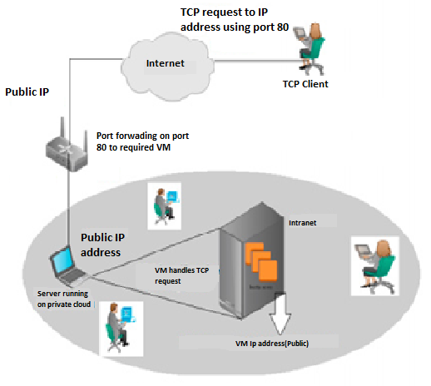

Fig. 2. Open source methodology for managing patient data in rural healthcare system

it may be necessary to provide access to the private cloud from outside the intranet (Internet). Providing access means providing access to one or some of the VMs that are running on the private cloud. These VMs can be accessed using remote desktop connection(For Maintainance Purpose). Private cloud is mainly built for accessing the data from the intranet of the organization. The provision is given to the user to access the private data remotely using port forwarding techniques as shown in the Fig. 3. This concept was tested on the private cloud using a single public IP address. The server running the private cloud was connected to the INTERNET using a router. A VM was started on the cloud with a local intranet IP which had the public address assigned to it was configured to forward all requests on port 80 to the VMs local IP address. Now from the INTERNET, an TCP request was sent to the public IP address.

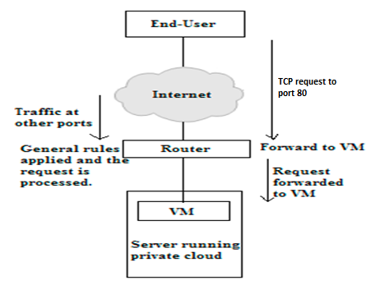

Fig. 3. Access the private data remotely using port forwarding techniques

The request first reaches the public IP address on the actual VM. The request now reaches the VM which handles it and responds back to the IP address from which the request was generated. For providing access to multiple VMs. Apart from this, the private cloud was used to host a simple website as well by using port forwarding on port 80.

**Supporting infrastructure for sustainability :**

The proposed private cloud model ensures or supports high availability as shown in the Fig. 4. The model is durable and likely to operate continuously without failure for a long time. Also fault tolerance characteristics features allows to remain in operation even if some of the component used to build the system fail. Major building blocks of high availability architectures are healthcare user, load balancer, availability zone, snapshot and replication layer. The healthcare users are requesting health care services from the health information system and receiving response from the system. With load-balancer features, availability of the system increases by distributing the load between the zone. The request always move to the healthy running instances instead of going to the unavailability zone. It also automatically distributes the incoming application traffic among multiple instances using the load-balancing facility. Also load balancer is configured to handle encrypted (HTTPS) traffic, session persistence, health checking, and more.



Fig. 4. High availability architecture for rural healthcare system

**Testing for sustainability of the system :**

The network connectivity is ensured by using the dedicated high speed optical networks, which connects all rural facilities including sub centre, primary health centre and community health centre. The private/Hybrid cloud services are created by using co-locating our server in Data Center(Institute TIER IV Certified).With this network connectivity is attained in all levels of healthcare system.

**Authorization model for proposed private cloud model :**

Authorization services include policy management, role management, and role-based access control. Cloud based EHR(Electronic Health Record) for authorization as shown in Fig.5. Authorization model contains four rows for representing user (browser), application, Authorization server and resource server. User or browser own the resources which is stored in the remote server or remote database. If user wants to access the resources, first he/she has to enter the credentials such as user-name and password. User credential validation is done at the authorization server where after validation, it is redirected back to user for further access to the resources. On behalf of the user application, the token(Aadhar number) is obtained and returned to the application.Using this token, application talk to the resource server and get required data to access.The presentation page is displayed to the user to view the data.



Fig. 5. Authorization Model for healthcare system

**Algorithm** :

1) Registration of doctors.

2) Verification of doctors by admin/authorized person.

3) Registration of patients via doctors.

4) Encryption and decryption of data (eg – credentials of doctors, Patient).

5) Managing all patient data (Insert, Update, Delete).

6) Doctor information management(Update, Delete).

Cloud computing is a broad term which refers to a collection of services that offer businesses a cost-effective solution to increase their IT capacity and functionality.

Depending on their specific requirements, businesses can choose where, when and how they use cloud computing to ensure an efficient and reliable IT solution.

Below we explore the different types of cloud computing, including the three main deployment models and the cloud services that can be hosted within these environments

**Types of cloud environment shown in fig 6:**

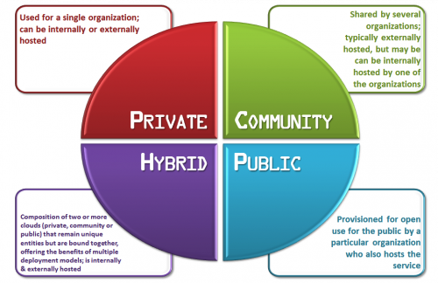

Fig. 6. Types of cloud environment available.

**Cloud service models available in fig 7:**

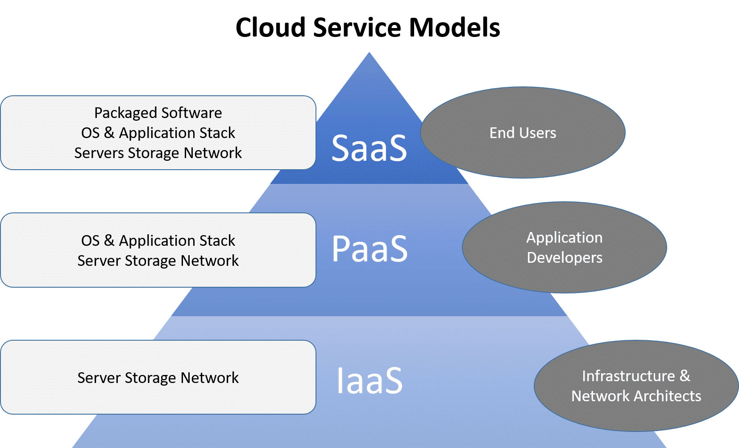

Fig. 7. Cloud service models available.

**Conclusion :**

Building private/public cloud is an extremely useful idea for rural healthcare sector to make data available in all levels of healthcare system. It makes the complete process of building a private/public cloud infrastructure very easy if the approach is standardized. Therefore, rural healthcare organizations should move towards building their own private cloud infrastructure which could be an excellent solution for the country’s needs to have improved Health care in rural areas. Building a community private cloud becomes much simpler if an accurately organized method is followed to do so. Once standardization is achieved, additional automation can be used to further shorten process times. In the cloud computing environment, the privacy of the electronic health data is a serious issue that requires a special consideration. The proposed solution in this paper provides authentication and storage model strengthen user health data when data is stored in the cloud environment. Future work with respect to the model would be to implement cryptographic algorithms and integrate it with the system to guarantee entity authentication and thus further increase the security.

**SYSTEM Requirements :**

**Hardware Requirement :** Intel core i3 processor or greater , 1GB RAM or greater, 60GB Hard Disk.

**Software Requirements :** Windows 10 OS , mongodb, XAMPP, Robo 3T.

Mr. Sourabh S. Patil

Mr. Sahil Y. Pathan

Mr. Vaibhav B. Chavan

Mr. Ajay S. Shete

Prof. N. M. Sawant

(Students) (Project Guide)

Dr. N. M. Sawant

(Head of Dept.)

Computer Science & Engg.,

SKN Sinhgad College of Engg., Korti.

References

1]. Dasgupta, R., Qadeer, I., et al. **The national rural health mission (nrhm):** a critical overview. Indian J Public Health2005;49(3):138–40.

2]. Srinivasa, D., Siddegowda, Y., et al. **Rural health care towards a healthy rural india: A social work response**.Asian Journal of DevelopmentMatters2018;12(1s):68–74.

3]. Singh, P., Kathuria, R.. Infrastructure **and connectivity in india:** getting the basics right.Asian Economic Policy Review2016;11(2):266–285.

4]. Fraser, H., Biondich, P., Moodley, D., Choi, S., Mamlin, B., Szolovits, P.. **Implementing electronic medical record systems in developingcountries.**Journal of Innovation in Health Informatics2005;13(2):83–95.

5]. Pooja, B., Pai, M.M., Radhika, M.P.. **A dual cloud based secure environmental parameter monitoring system:** A wsn approac. In:InternationalConference on Cloud Computing. Springer; 2013, p. 189–198.

6] Freet, D., Agrawal, R., Walker, J.J., Badr, Y.. **Open source cloud management platforms and hypervisor technologies:** A review andcomparison. In:SoutheastCon, 2016. IEEE; 2016, p. 1–8.

7] Kasthurirathne S.N., Mamlin B., Kumara H., Grieve G., Biondich P.**Enabling better interoperability for healthcare: lessons in developing a standards based application programing interface for electronic medical record systems**

Journal of medical systems, 39 (11) (2015), p. 182

8] Nurmi D., Wolski R., Grzegorczyk C., Obertelli G., Soman S., Youseff L., *et al.***The eucalyptus open-source cloud-computing system**

Cluster Computing and the Grid, IEEE (2009), pp. 124-131

CCGRID’09. 9th IEEE/ACM International Symposium on. 2009

9] Latif R., Abbas H., Assar S., Ali Q.**Cloud computing risk assessment: a systematic literature review** Future Information Technology, Springer (2014), pp. 285-295

10] Xiao Z., Xiao Y.**Security and privacy in cloud computing** IEEE Communications Surveys & Tutorials, 15 (2) (2013), pp. 843-859