**Technologies:** Spring Boot, Jpa

**Database :** H2

Store longest palindrom value <http://localhost:8080/storeLongestPalindrom>

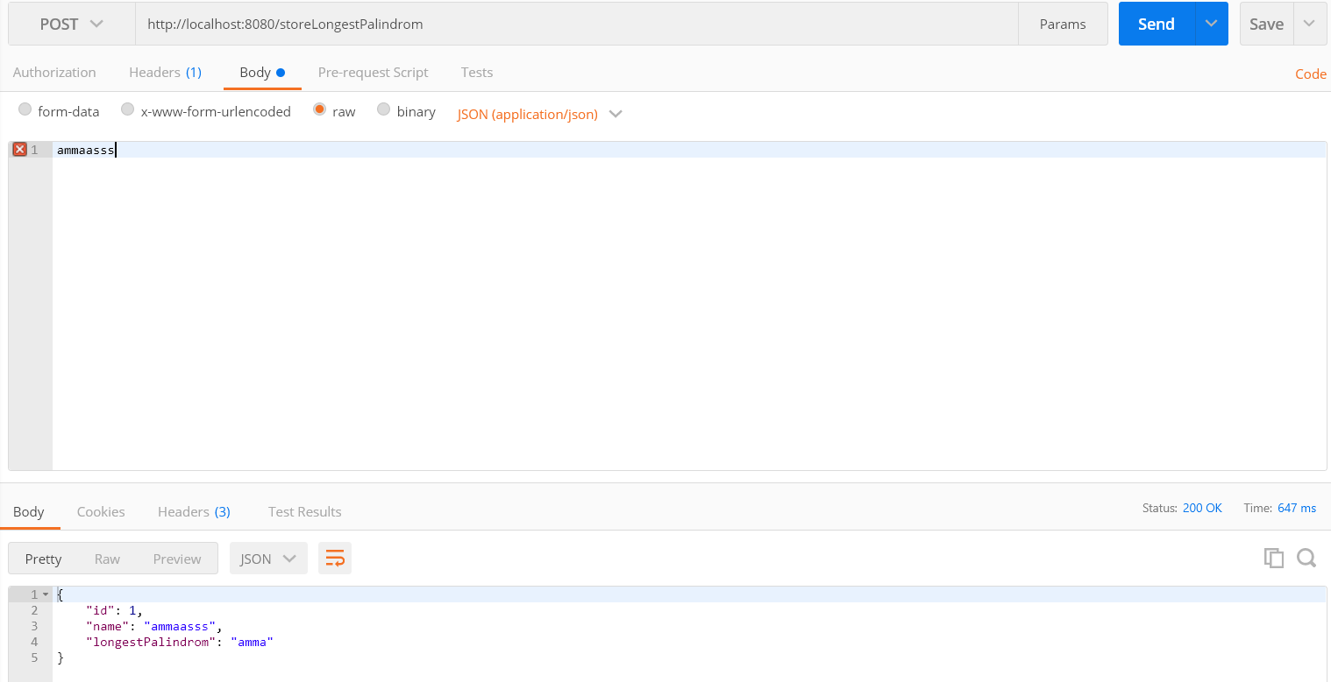

Input length is morethan 1000, we will get exception(“Invalid input string. please try with valid input”)

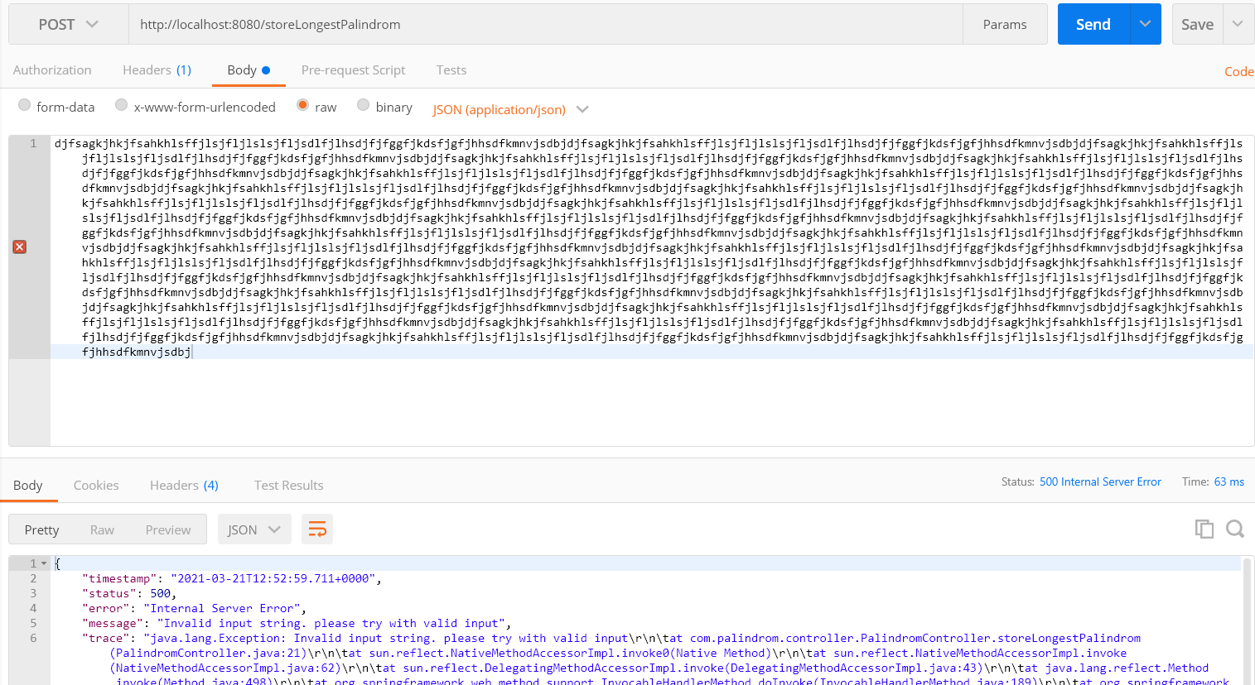

Retreive the longest palindrom value

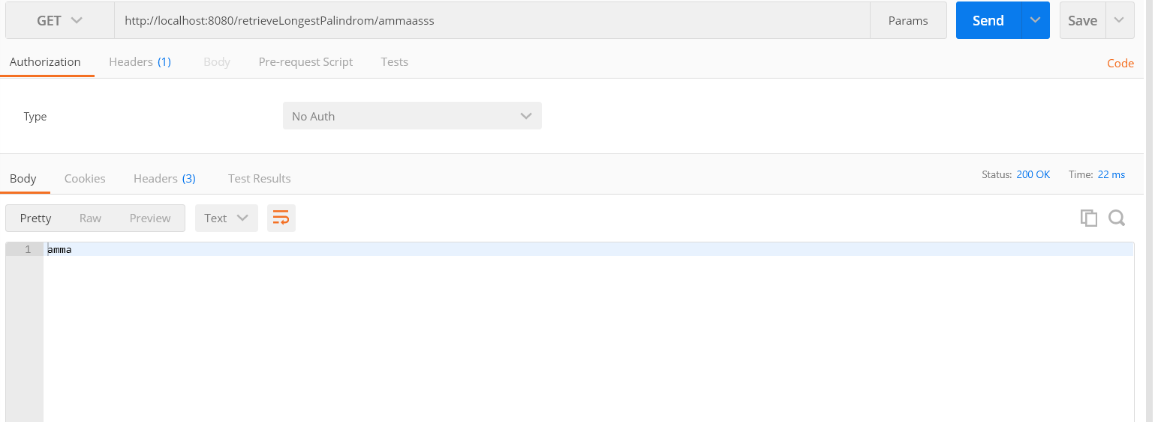

Incase of value is not available in Database

