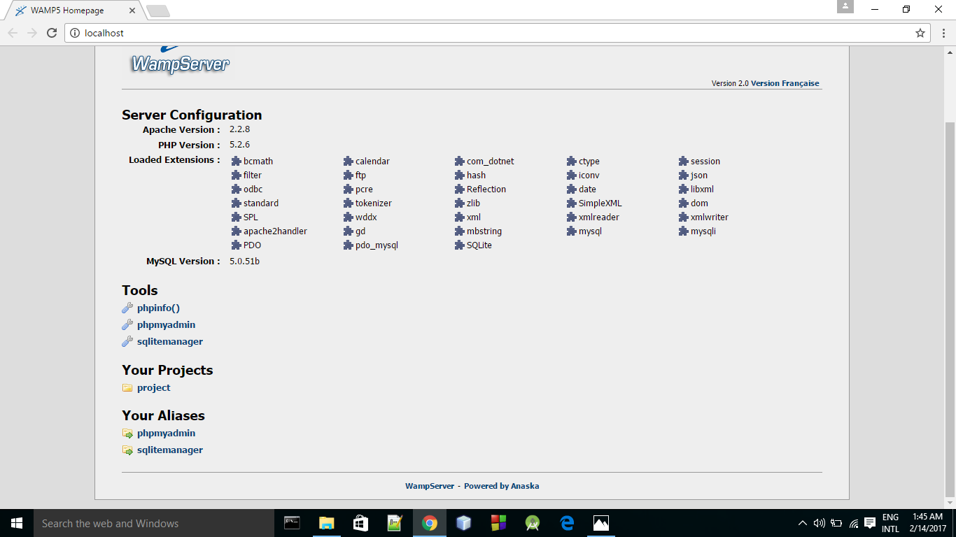

WAMP SERVER PAGE

File Name: 🡪 Project

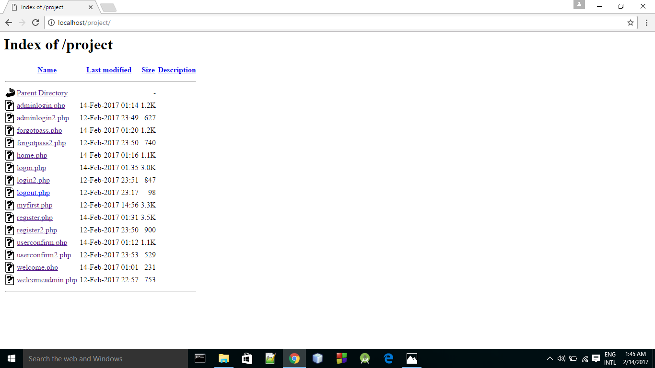list of all files<.php> created

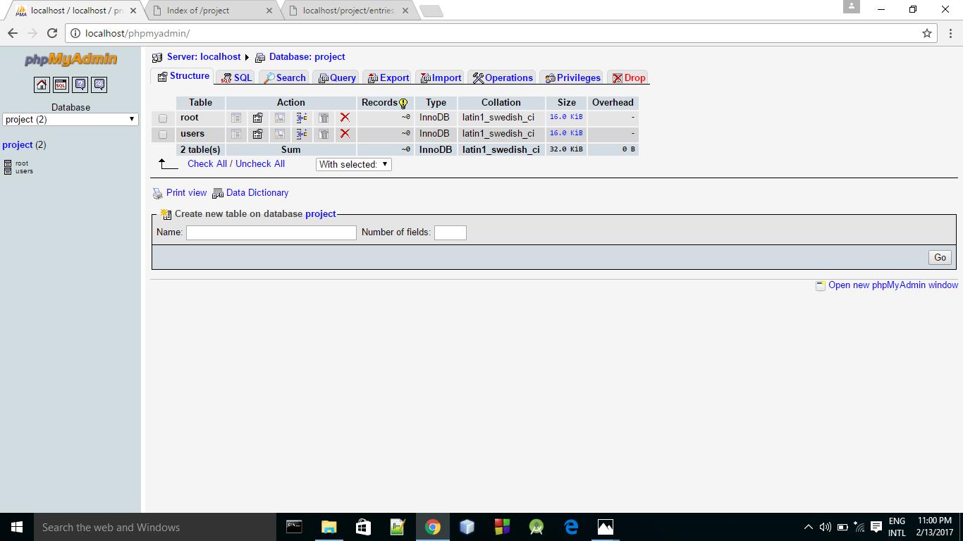

DATABASE🡪 PROJECT

2 TABLES ARE CREATED IN THIS DATA BASE

ROOT🡪 FOR ADMIN

USERS🡪 FOR ALL THE STUDENTS

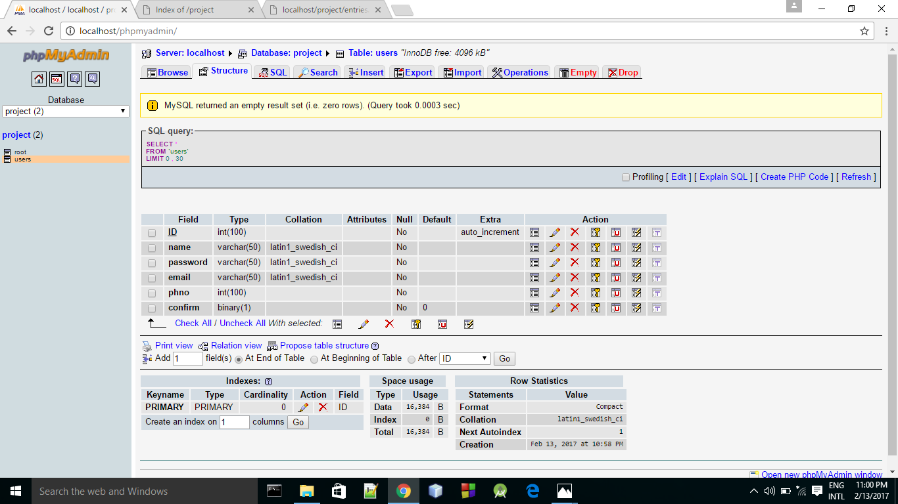

TABLE NAME🡪 USERS

6 ATTRIBUTES

* ID 🡪(NUMBER<100>) PRIMARY KEY , AUTO-INCREEMENT
* NAME🡪(VARCHAR<50>)
* PASSWORD🡪(VARCHAR<50>)
* EMAIL🡪(VARCHAR<50>), TYPE🡪EMAIL
* PHNO 🡪 (NUMBER<100>)
* CONFIRM🡪 BINARY🡪”0 ” BY DEFAULT

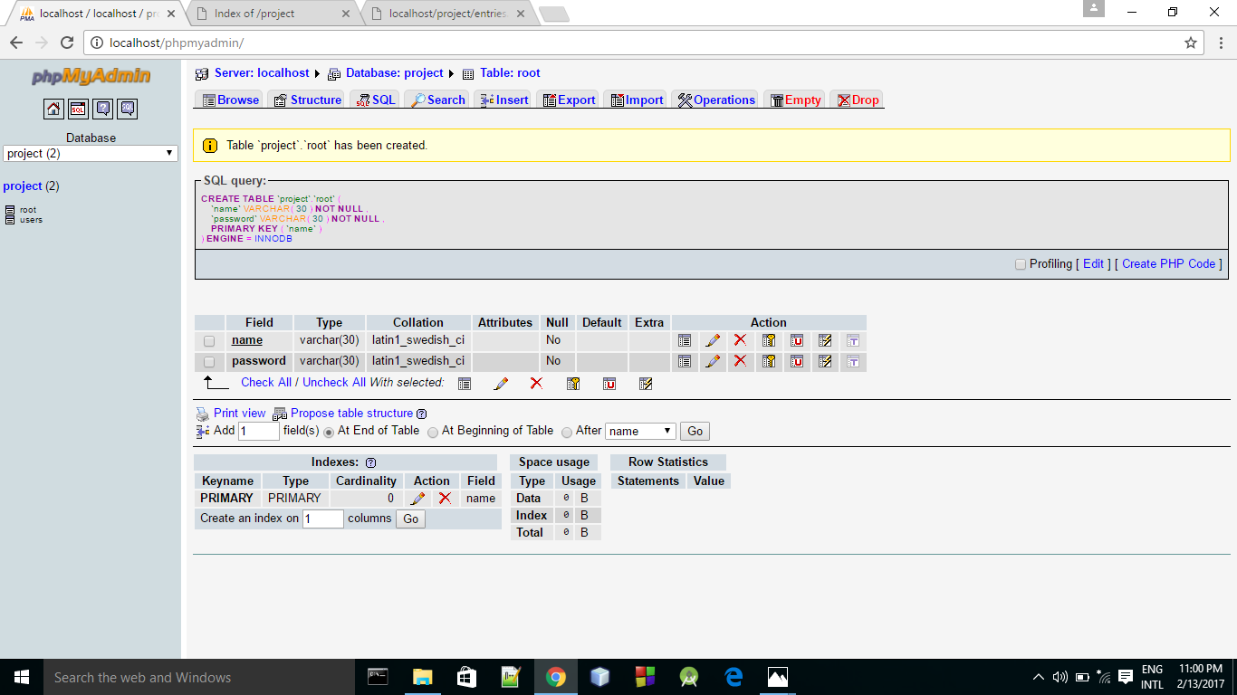

TABLE NAME🡪 ROOT

2 ATTRIBUTES

* NAME 🡪(VARCHAR<30>)🡪 PRIMARY KEY
* PASSWORD 🡪 (VARCHAR<30>)

NAME🡪 “admin”

Password🡪 “admin”

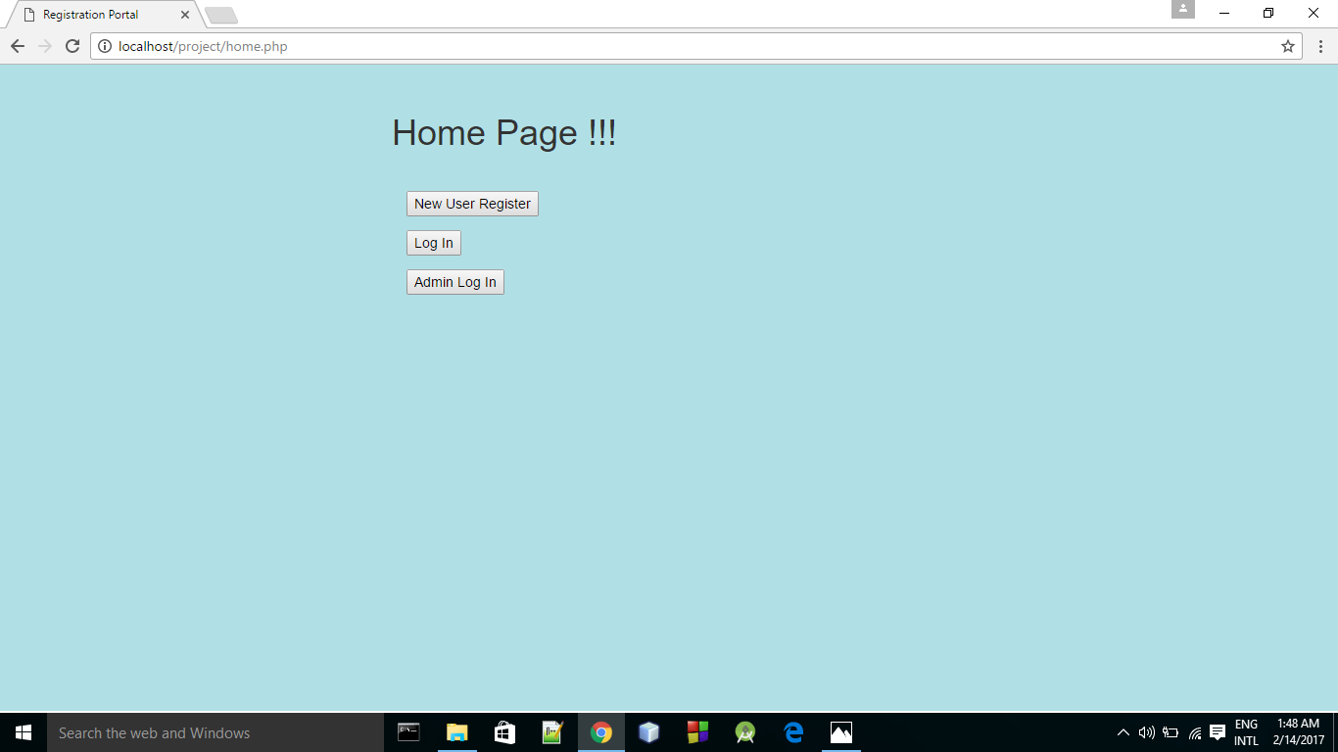

HOME PAGE OF THE INSTITUTE 🡪

3 BUTTONS

* NEW USER REGISTER
* LOG IN
* ADMIN LOG IN

HTML CODE FOR “home.php”

<html>

<head>

<title>Registration Portal</title>

<meta charset="utf-8">

<meta name="viewport" content="width=device-width, initial-scale=1">

<link rel="stylesheet" href="https://maxcdn.bootstrapcdn.com/bootstrap/3.3.7/css/bootstrap.min.css">

<script src="https://ajax.googleapis.com/ajax/libs/jquery/3.1.1/jquery.min.js"></script>

<script src="https://maxcdn.bootstrapcdn.com/bootstrap/3.3.7/js/bootstrap.min.js"></script>

</head>

<style>

.container {

width: 100%;

height: 660px;

background-color: powderblue;

padding-left:400px;

padding-top:30px

}

.container-fluid {

padding-top:30px;

color: white;

}

</style>

<body>

<div class="container">

<h1>Home Page !!!</h1>

<div class="container-fluid">

<form method = "POST" action = "register.php" style="color: black;">

<input type="submit" value="New User Register"><br>

</form>

<form method = "POST" action = "login.php" style="color: black;">

<input type="submit" value="Log In"><br>

</form>

<form method = "POST" action = "adminlogin.php" style="color: black;">

<input type="submit" value="Admin Log In"><br>

</form>

</div>

</body>

</html>

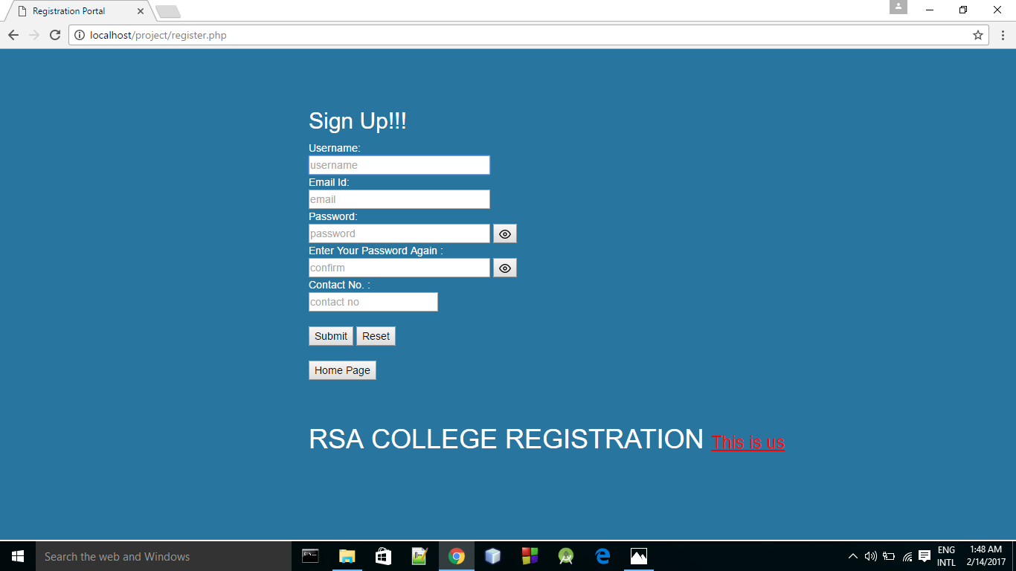PAGE🡪 register.php

SIGN UP PAGE--> RSA COLLEGE REGISTRATION

FORM PAGE:

ALL DATA TO BE FILLED

HOME PAGE BUTTON WILL TAKE US BACK TO HOME PAGE

SUBMIT TAKES US TO “register2.php” page

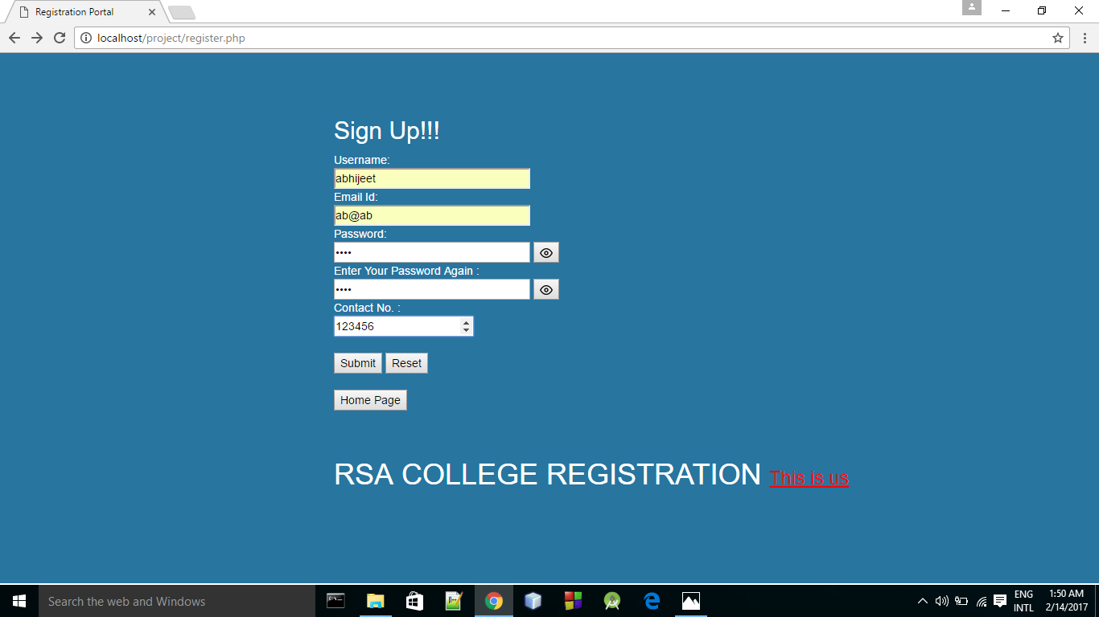On clicking the Submit button, we go to the page register2.php where a message is displayed 🡪

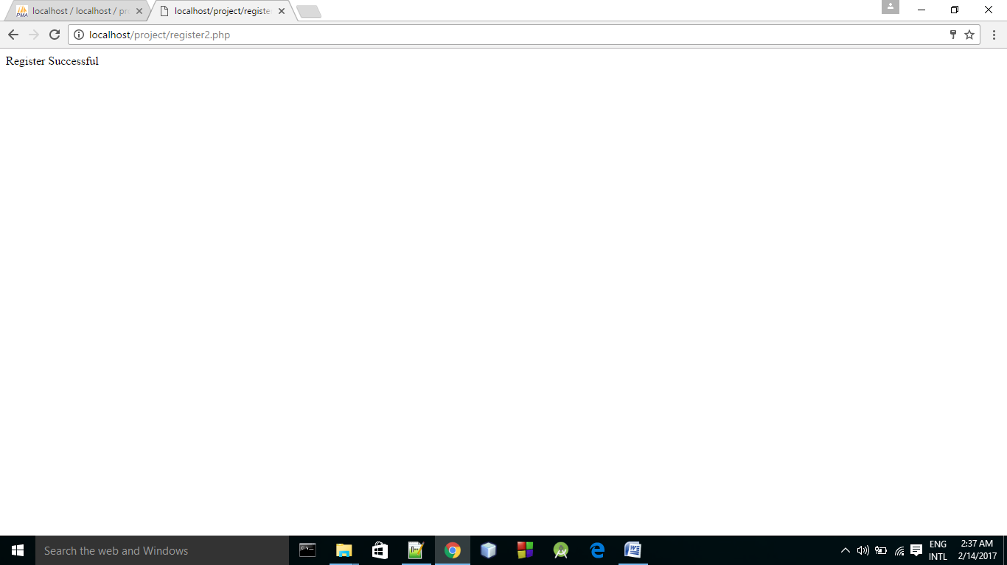“**REGISTER SUCCESSFUL**”

HTML CODE FOR “register.php”

<html lang="en">

<head>

<title>Registration Portal</title>

<meta charset="utf-8">

<meta name="viewport" content="width=device-width, initial-scale=1">

<link rel="stylesheet" href="https://maxcdn.bootstrapcdn.com/bootstrap/3.3.7/css/bootstrap.min.css">

<script src="https://ajax.googleapis.com/ajax/libs/jquery/3.1.1/jquery.min.js"></script>

<script src="https://maxcdn.bootstrapcdn.com/bootstrap/3.3.7/js/bootstrap.min.js"></script>

<style>

.tooltip .tooltiptext {

visibility: hidden;

width: 120px;

background-color: black;

color: #fff;

text-align: center;

border-radius: 6px;

padding: 5px 0;

/* Position the tooltip */

position: absolute;

z-index: 1;

}

.tooltip:hover .tooltiptext {

visibility: visible;

color: black;

}

.container {

width: 100%;

height: 660px;

background-color: #28759f;

padding-left:400px;

padding-top:30px

}

.container-fluid {

padding-top:30px;

color: white;

}

</style>

</head>

<body>

<div class="container">

<div class="container-fluid">

<h2>Sign Up!!!</h2>

<form method = POST action="register2.php" autocomplete="on">

Username: <br>

<input type="text" name="a" size="30" autofocus placeholder="username" style="color: black;" ><br>

Email Id: <br>

<input type="email" name="c" size="30" placeholder="email" style="color: black;"><br>

Password: <br>

<input type="password" placeholder="password" id="pwd" name="b" size="30" style="color: black;"/>

<button type="button" id="eye" >

<img src="https://cdn0.iconfinder.com/data/icons/feather/96/eye-16.png" alt="eye">

</button>

<br>

Enter Your Password Again : <br>

<input type="password" placeholder="confirm" id="pwd1" name="cb" size="30" style="color: black;"/>

<button type="button" id="eye1" >

<img src="https://cdn0.iconfinder.com/data/icons/feather/96/eye-16.png" alt="eye">

</button>

<br>

Contact No. : <br>

<input type="number" name="d" size="10" placeholder="contact no" style="color: black;"><br>

<br>

<input type="submit" value="Submit" style="color: black;">

<input type="reset" value="Reset" style="color: black;">

</form>

<form method = "POST" action = "home.php"><br>

<input type="submit" value="Home Page" style="color: black;"><br>

</form>

</div>

<div class="container-fluid" style="padding-top: 40px; color: white; ">

<h1> RSA COLLEGE REGISTRATION <small> <a href="myfirst.php" style="color: red;" >

<u> This is us<u></a> </small>

</h1>

</div>

</div>

<script>

function show()

{

var p = document.getElementById('pwd');

p.setAttribute('type','text');

}

function hide()

{

var p = document.getElementById('pwd');

p.setAttribute('type','password');

}

var pwShown = 0;

document.getElementById("eye").addEventListener("click", function() {

if (pwShown == 0)

{

pwShown = 1;

show();

}

else {

pwShown = 0;

hide();

}

}, false);

</script>

<script>

function show1()

{

var pp = document.getElementById('pwd1');

pp.setAttribute('type','text');

}

function hide1()

{

var pp = document.getElementById('pwd1');

pp.setAttribute('type','password');

}

var pwShown1 = 0;

document.getElementById("eye1").addEventListener("click", function() {

if (pwShown1 == 0)

{

pwShown1 = 1;

show1();

}

else {

pwShown1 = 0;

hide1();

}

}, false);

</script>

</html>

PHP CODE FOR “register2.php”

<?php

$name = $_POST['a'];

$pass = $_POST['b'];

$mail = $_POST['c'];

$phn = $_POST['d'];

$cpass = $_POST['cb'];

if($name=="" || $pass=="" || $mail=="" || $phn=="")

{

echo "Fill All<br>";

echo "<a href='register.php'>Back</a><br>";

echo "<a href='home.php'>Home Page</a>";

}

else if($pass!=$cpass)

{

echo "Passwords Do Not Match<br>";

echo "<a href='register.php'>Back</a><br>";

echo "<a href='home.php'>Home Page</a>";

}

else{

mysql_connect("localhost","root","");

mysql_select_db("project");

$query = "SELECT * FROM users WHERE name = '$name' ";

$result = mysql_query($query);

$count = mysql_num_rows($result);

if($count ==0)

{

$q = "INSERT INTO users(name,password,email,phno) VALUES ('$name','$pass','$mail','$phn')";

mysql_query($q);

echo "Register Successful";

}

else{

echo "User Already Exists";

}

}

?>

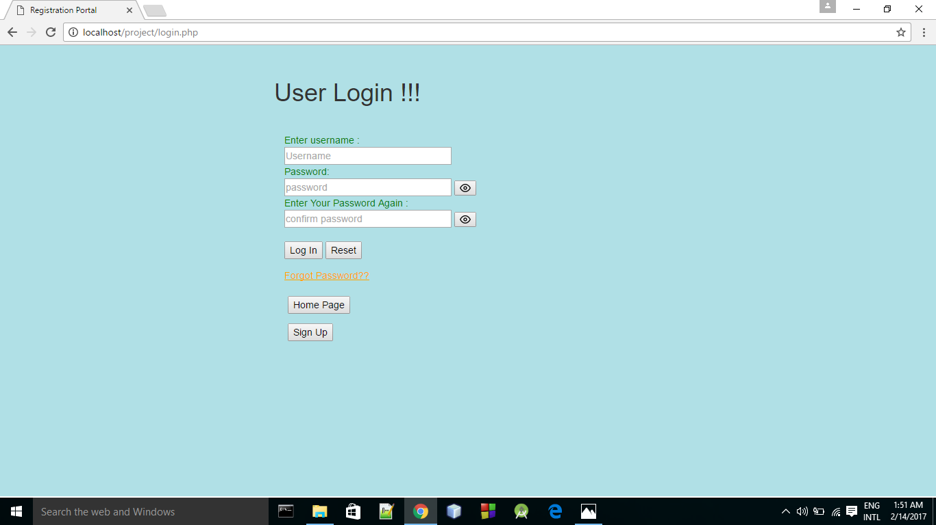

PAGE🡪 login.php

HOME PAGE BUTTON WILL TAKE BACK TO HOME PAGE

SUBMIT TAKES US TO “login2.php” page

FORGOT PASSWORD IS A LINK WHICH TAKES TO RESET PASSWORD PAGE 🡪 forgotpas.php

SIGN UP BUTTON TAKES US TO SIGN UP PAGE

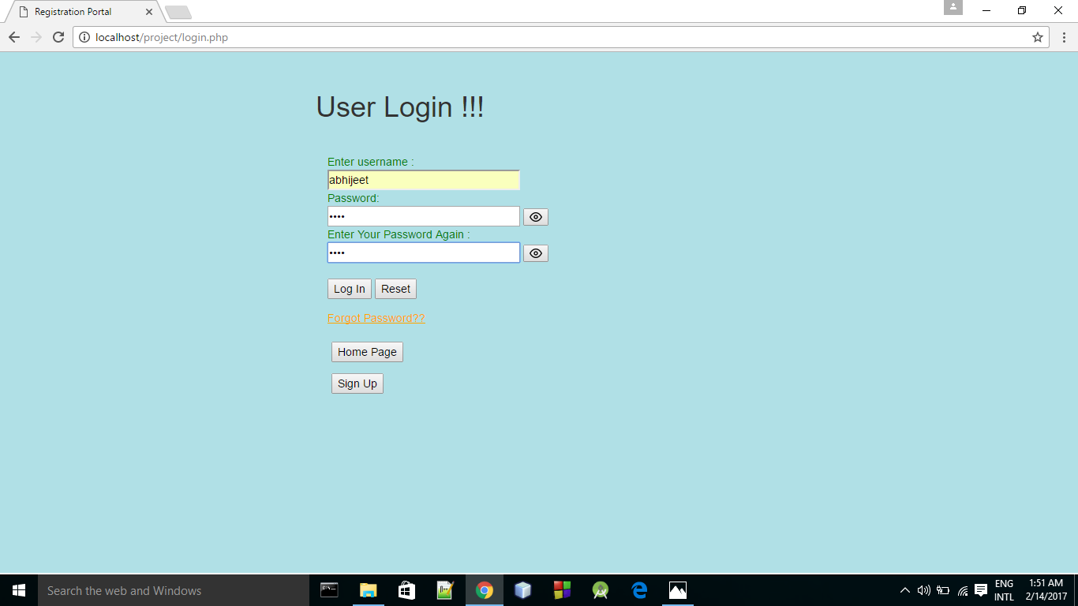Logging in takes us to login2.php where a message is displayed “you are not confirmed yet”

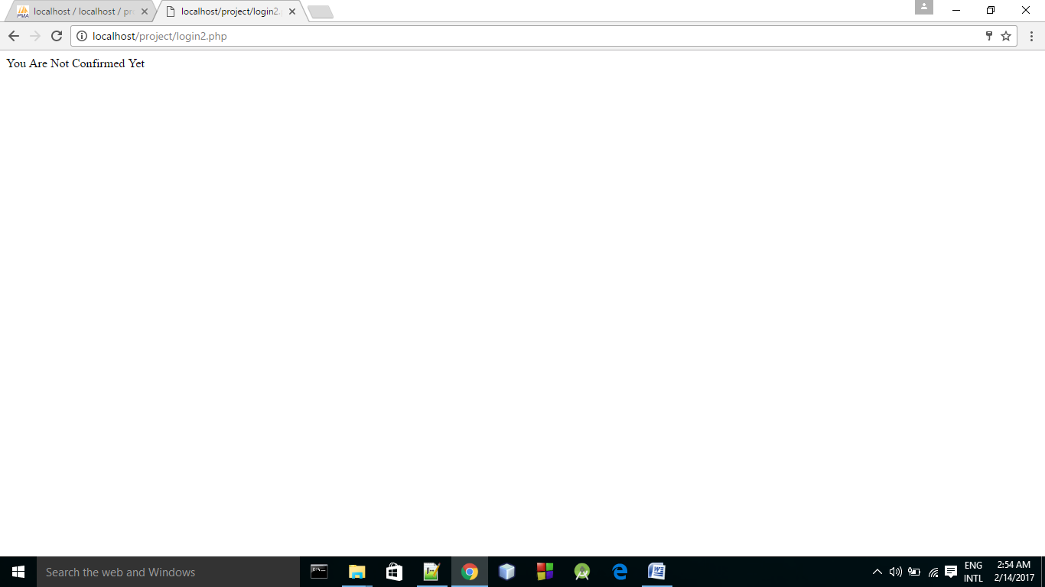Admin can only confirm a student. Once the student is confirmed, logging in again will display a message “you are confirmed”

HTML CODE FOR “login.php”

<html>

<head>

<title>Registration Portal</title>

<meta charset="utf-8">

<meta name="viewport" content="width=device-width, initial-scale=1">

<link rel="stylesheet" href="https://maxcdn.bootstrapcdn.com/bootstrap/3.3.7/css/bootstrap.min.css">

<script src="https://ajax.googleapis.com/ajax/libs/jquery/3.1.1/jquery.min.js"></script>

<script src="https://maxcdn.bootstrapcdn.com/bootstrap/3.3.7/js/bootstrap.min.js"></script>

</head>

<style>

.container {

width: 100%;

height: 660px;

background-color: powderblue;

padding-left:400px;

padding-top:30px

}

.container-fluid {

padding-top:30px;

color: green;

}

.container2 {

color: white;

padding-left: 20px;

}

</style>

<body>

<div class="container">

<h1> User Login !!!</h1>

<div class="container-fluid">

<form method=POST action=login2.php>

Enter username :<br>

<input type = "text" placeholder="Username" name = "a" size = "30" style="color: black;"><br>

Password: <br>

<input type="password" placeholder="password" id="pwd" name="b" size="30" autocomplete="off" style="color: black;"/>

<button type="button" id="eye" >

<img src="https://cdn0.iconfinder.com/data/icons/feather/96/eye-16.png" alt="eye">

</button>

<br>

Enter Your Password Again : <br>

<input type="password" placeholder="confirm password" id="pwd1" name="cb" size="30" autocomplete="off" style="color: black;"/>

<button type="button" id="eye1" >

<img src="https://cdn0.iconfinder.com/data/icons/feather/96/eye-16.png" alt="eye">

</button>

<br>

<br>

<input type = "submit" value = "Log In" style="color: black;">

<input type = "reset" value = "Reset" style="color: black;"><br>

</form>

<a href='forgotpass.php' style="color: orange;"><u>Forgot Password??</u></a>

</div>

<div class="container2" >

<form method = "POST" action = "home.php" ><br>

<input type="submit" value="Home Page" style="color: black;">

</form>

<form method = "POST" action = "register.php" >

<input type="submit" value="Sign Up" style="color: black;">

</form>

</div>

</div>

</body>

<script>

function show()

{

var p = document.getElementById('pwd');

p.setAttribute('type','text');

}

function hide()

{

var p = document.getElementById('pwd');

p.setAttribute('type','password');

}

var pwShown = 0;

document.getElementById("eye").addEventListener("click", function() {

if (pwShown == 0)

{

pwShown = 1;

show();

}

else {

pwShown = 0;

hide();

}

}, false);

</script>

<script>

function show1()

{

var pp = document.getElementById('pwd1');

pp.setAttribute('type','text');

}

function hide1()

{

var pp = document.getElementById('pwd1');

pp.setAttribute('type','password');

}

var pwShown1 = 0;

document.getElementById("eye1").addEventListener("click", function() {

if (pwShown1 == 0)

{

pwShown1 = 1;

show1();

}

else {

pwShown1 = 0;

hide1();

}

}, false);

</script>

</html>

PHP CODE FOR “login.php”

<?php

session_start();

$name = $_POST['a'];

$pass = $_POST['b'];

if($name == "" || $pass == "")

{

echo "Fill All<br>";

echo "<a href='login.php'>Back</a><br>";

echo "<a href='home.php'>Home Page</a>";

}

else

{

mysql_connect("localhost","root","");

mysql_select_db("project");

$query = "SELECT * FROM users WHERE name = '$name' AND password='$pass' ";

$res = mysql_query($query);

$count = mysql_num_rows($res);

if($count==0)

{

echo "Username And Password Do Not Match";

}

else

{

$qq = "SELECT * FROM users WHERE name = '$name' AND confirm='1'";

$q = mysql_query($qq);

$c = mysql_num_rows($q);

if($c==0)

{

echo "You Are Not Confirmed Yet";

}

else

{

$_SESSION['name']=$name;

header('location:welcome.php');

}

}

}

?>

_ _ _ _ _ _ _ _ _ _ _ _ _ _ _ _ _ _ _ _ _ _ _ _ _ _ _ _ _ _ _ _

Once Login is done, a session gets started .

This prevents getting logged in from other browsers.

The session ends only when one logs out of the page.

Theres no need to log in again in the same browser until the session ends.

The sessions page for users is in the page🡪

Welcome.php

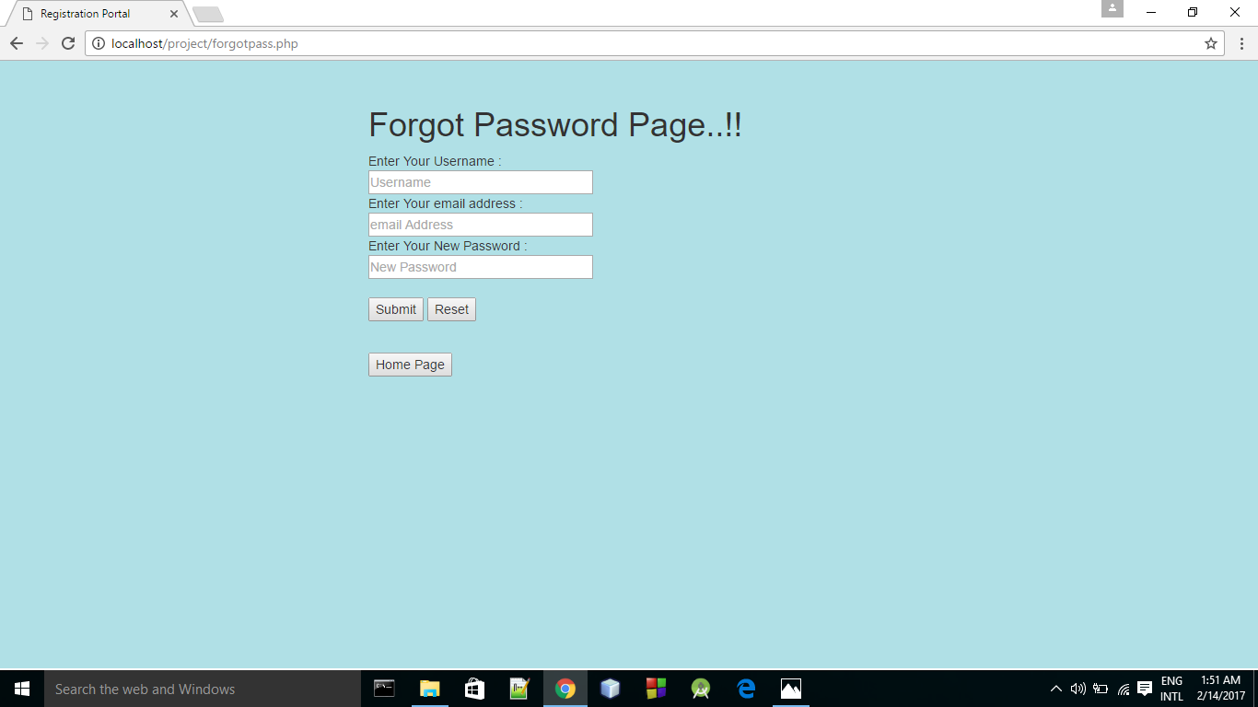Forgot Password Page 🡪 forgotpass.php

Code For Html Page🡪 forgotpass.php

<html>

<head>

<title>Registration Portal</title>

<meta charset="utf-8">

<meta name="viewport" content="width=device-width, initial-scale=1">

<link rel="stylesheet" href="https://maxcdn.bootstrapcdn.com/bootstrap/3.3.7/css/bootstrap.min.css">

<script src="https://ajax.googleapis.com/ajax/libs/jquery/3.1.1/jquery.min.js"></script>

<script src="https://maxcdn.bootstrapcdn.com/bootstrap/3.3.7/js/bootstrap.min.js"></script>

</head>

<style>

.container {

width: 100%;

height: 660px;

background-color: powderblue;

}

</style>

<body>

<div class="container">

<h1>Forgot Password Page..!!</h1>

<form method=POST action=forgotpass2.php>

Enter Your Username :<br>

<input type="text" placeholder="Username" name="a" size="30"><br>

Enter Your email address : <br>

<input type="email" placeholder="email Address" name="b" size="30"><br>

Enter Your New Password : <br>

<input type="password" placeholder="New Password" name="c" size="30"><br>

<br>

<input type="submit" value="Submit">

<input type="reset" value="Reset">

</form>

<form method = "POST" action = "home.php">

<br><input type="submit" value="Home Page"><br>

</form>

</div>

</html>

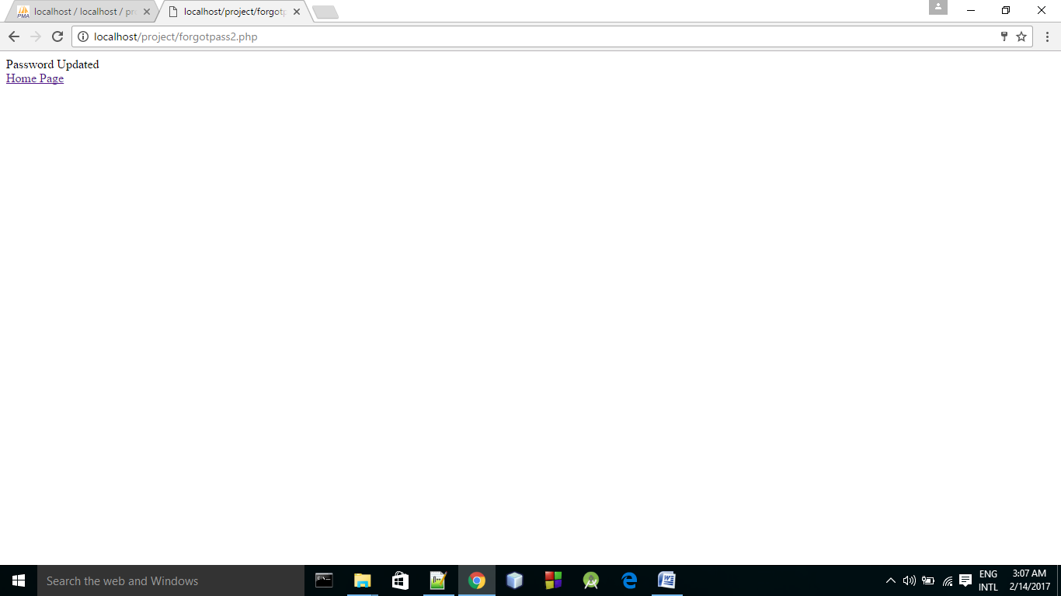PHP Page for🡪 forgotpass2.php

Code🡪

<?php

$name = $_POST['a'];

$pass = $_POST['c'];

$mail = $_POST['b'];

if($name=="" || $pass=="" || $mail=="" )

{

echo "Fill All<br>";

echo "<a href='forgotpass.php'>Back</a><br>";

echo "<a href='home.php'>Home Page</a>";

}

else{

mysql_connect("localhost","root","");

mysql_select_db("project");

$query = "SELECT * FROM users WHERE name = '$name' And email = '$mail' ";

$result = mysql_query($query);

$count = mysql_num_rows($result);

if($count !=0)

{

$q = "UPDATE users SET password = '$pass' WHERE name = '$name' ";

mysql_query($q);

echo "Password Updated<br>";

echo "<a href='home.php'>Home Page</a>";

}

else{

echo "Username And email does not match";

}

}

?>

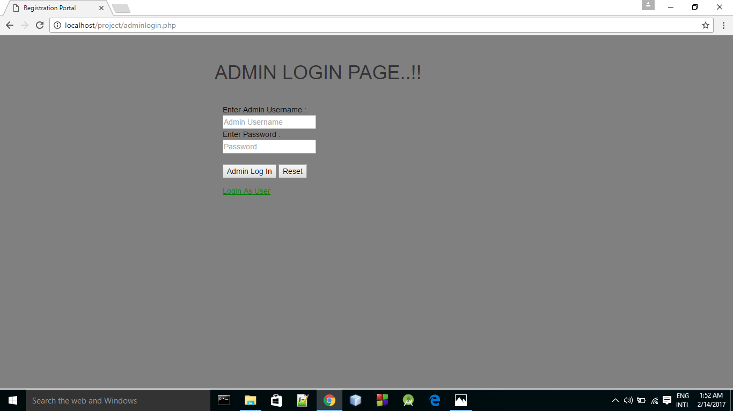

Admin Login Page HTML🡪 adminlogin.php

Username🡪 admin Password🡪 admin

The admin logs in and confirms the registration of students.

On clicking the adminlogin button, php page adminlogin2.php displayes the data of all the students who have been registered.

On confirmation, the “confirm” attribute displays 1.

Session is started when admin logs in and ends on logging out.

CODE FOR HTML PAGE🡪adminlogin.php

<html>

<head>

<title>Registration Portal</title>

<meta charset="utf-8">

<meta name="viewport" content="width=device-width, initial-scale=1">

<link rel="stylesheet" href="https://maxcdn.bootstrapcdn.com/bootstrap/3.3.7/css/bootstrap.min.css">

<script src="https://ajax.googleapis.com/ajax/libs/jquery/3.1.1/jquery.min.js"></script>

<script src="https://maxcdn.bootstrapcdn.com/bootstrap/3.3.7/js/bootstrap.min.js"></script>

</head>

<style>

.container {

width: 100%;

height: 660px;

background-color: gray;

padding-left:400px;

padding-top:30px

}

.container-fluid {

padding-top:30px;

color: black;

}

</style>

<body>

<div class="container">

<h1> ADMIN LOGIN PAGE..!!</h1>

<div class="container-fluid" >

<form method = "POST" action = "adminlogin2.php">

Enter Admin Username :<br>

<input type="text" placeholder="Admin Username" name="a" ><br>

Enter Password :<br>

<input type="password" placeholder="Password" name="b" ><br>

<br>

<input type="submit" value="Admin Log In">

<input type="reset" value="Reset">

</form>

<a href='login.php' style="color: green;"><u>Login As User</u></a>

</div>

</div>

</body>

</html>

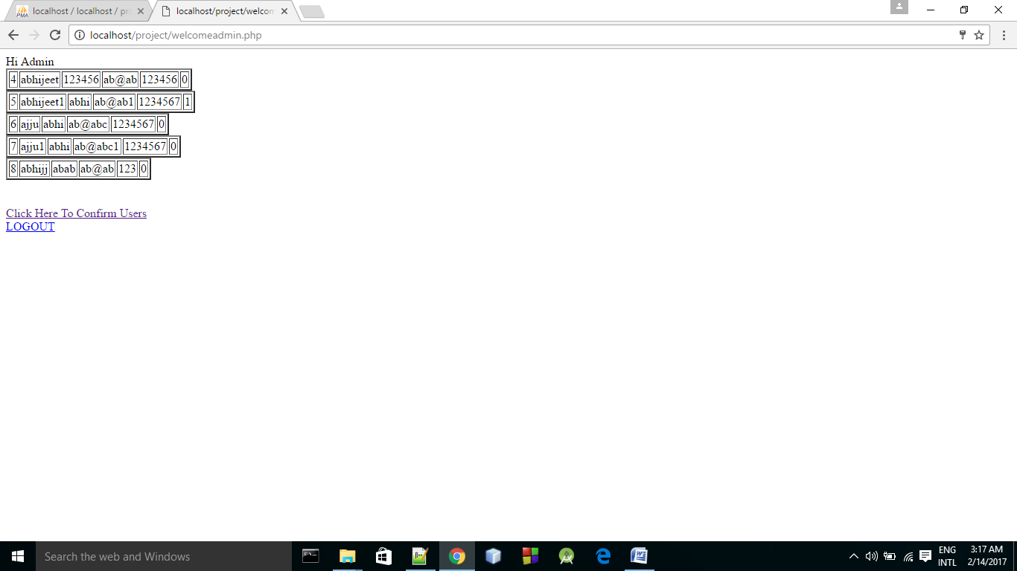

PHP CODE FOR 🡪 adminlogin2.php

<?php

session_start();

$name=$_POST['a'];

$pass=$_POST['b'];

if($name == "" || $pass == "")

{

echo "Please Fill All<br>";

echo "<a href='adminlogin.php'>Back</a><br>";

echo "<a href='home.php'>Home Page</a>";

}

else

{

mysql_connect("localhost","root","");

mysql_select_db("project");

$query = "SELECT * FROM root WHERE name = '$name' AND password = '$pass'";

$res = mysql_query($query);

$count = mysql_num_rows($res);

if($count == 0)

{

echo "Username And Password Do Not Match";

}

else

{

$_SESSION['name']=$name;

header('location:welcomeadmin.php');

}

}

?>

The admin confirms the user by submitting its name in the “userconfirm.php” page. The php page “userconfirm2.php” displays the message user confimed if the username is valid, else it displays a message

“no such user exists”

Session Login page for Admin:🡪 welcomeadmin.php

Code for🡪 welcomeadmin.php

<?php

session_start();

if(isset($_SESSION['name']))

{

echo "Hi Admin <br>";

mysql_connect("localhost","root","");

mysql_select_db("project");

$query = "SELECT * FROM users";

$res = mysql_query($query);

while($row=mysql_fetch_array($res))

{

echo"<table border='2'>";

echo"<tr>";

echo"<td>".$row[0]."</td>";

echo"<td>".$row[1]."</td>";

echo"<td>".$row[2]."</td>";

echo"<td>".$row[3]."</td>";

echo"<td>".$row[4]."</td>";

echo"<td>".$row[5]."</td>";

echo"</tr>";

echo"</table>";

}

echo "<br><br>";

echo "<a href='userconfirm.php'>Click Here To Confirm Users</a><br>";

echo "<a href='logout.php'>LOGOUT</a>";

}

else

{

header('location:adminlogin2.php');

}

?>

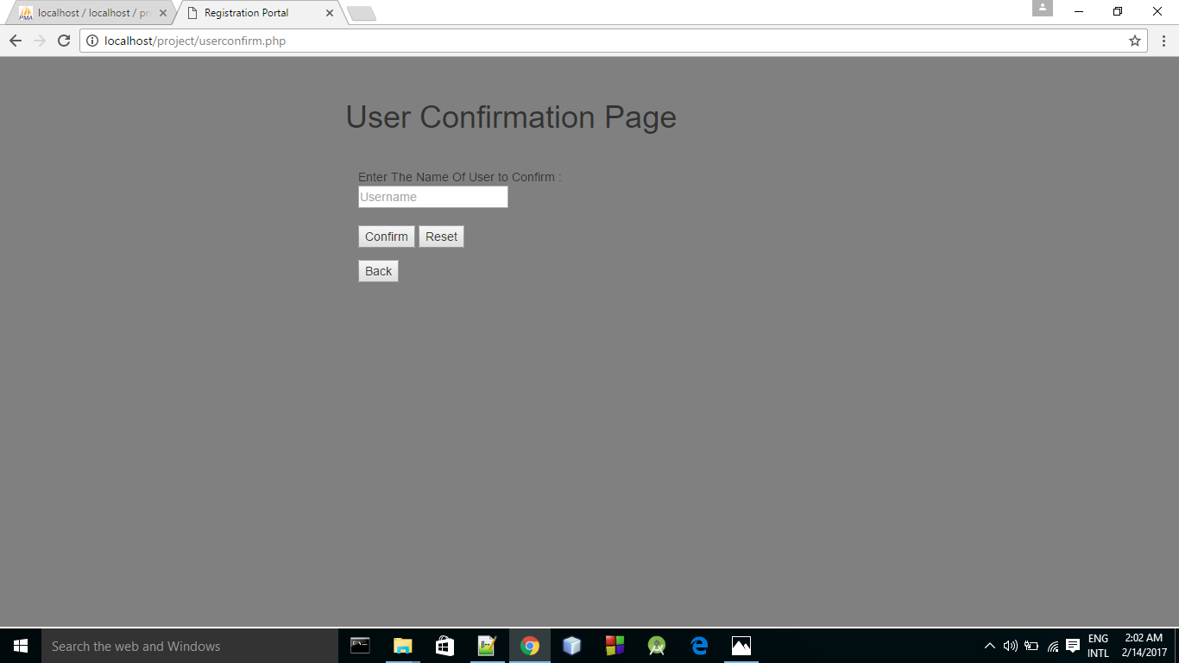HTML CODE FOR🡪 userconfirm.php

<html>

<head>

<title>Registration Portal</title>

<meta charset="utf-8">

<meta name="viewport" content="width=device-width, initial-scale=1">

<link rel="stylesheet" href="https://maxcdn.bootstrapcdn.com/bootstrap/3.3.7/css/bootstrap.min.css">

<script src="https://ajax.googleapis.com/ajax/libs/jquery/3.1.1/jquery.min.js"></script>

<script src="https://maxcdn.bootstrapcdn.com/bootstrap/3.3.7/js/bootstrap.min.js"></script>

</head>

<style>

.container {

width: 100%;

height: 660px;

background-color: gray;

padding-left:400px;

padding-top:30px

}

</style>

<body>

<div class="container">

<h1>User Confirmation Page</h1>

<div class="container-fluid" style=" padding-top:30px;">

<form method = "POST" action = "userconfirm2.php">

Enter The Name Of User to Confirm :<br>

<input type="text" placeholder="Username" name="a" ><br>

<br>

<input type="submit" value="Confirm">

<input type="reset" value="Reset">

</form>

<form method = "POST" action = "welcomeadmin.php">

<input type="submit" value="Back"><br>

</form>

</div>

</div>

</body>

</html>

PHP CODE FOR 🡪 userconfirm2.php

<?php

$name = $_POST['a'];

if($name == "")

{

echo "Fill All<br>";

echo "<a href='userconfirm.php'>Back</a><br>";

}

else

{

mysql_connect("localhost","root","");

mysql_select_db("project");

$query = "SELECT * FROM users WHERE name = '$name'";

$res = mysql_query($query);

$count = mysql_num_rows($res);

if($count == 0)

echo "No Such User";

else

{

$q = "UPDATE users SET confirm = '1' WHERE name = '$name'";

mysql_query($q);

header('location:welcomeadmin.php');

}

}

?>

Session end page for admin and user.

Page🡪 logout.php

Code for logout.php

<?php

session_start();

session_unset();

session_destroy();

header("location:home.php");

?>