Internship Project Report
Project Title
Restaurant Data Analysis Using Python

Internship
Cognifyz Technologies – Data Analysis Internship

Submitted By
Abhinav Kadam
Bachelor of Science in Data Science
2026

CERTIFICATE

COGNIFYZ TECHNOLOGIES
Data Analysis Internship

CERTIFICATE OF PROJECT COMPLETION
This is to certify that the project report entitled "Restaurant Data Analysis Using Python" is a bonafide work carried out by Mr. Abhinav Kadam, a student of Bachelor of Science in Data Science, in partial fulfillment of the requirements of the Data Analysis Internship offered by Cognifyz Technologies.
The project has been developed using Python and various data analysis libraries including Pandas, NumPy, Matplotlib, Seaborn, Plotly, Folium, and Scikit-learn. It involves data cleaning, exploratory data analysis, visualization, geographic analysis, sentiment analysis, clustering, and business insight generation based on restaurant data.
The work presented in this report was completed during the internship period and demonstrates the practical application of data analytics techniques to solve real-world business problems. The project successfully fulfills the internship tasks and objectives specified by Cognifyz Technologies.
We appreciate the sincere efforts, dedication, and technical skills demonstrated during the successful completion of this project and wish the student success in future academic and professional endeavors.

Project Details
Particular | Details
Project Title | Restaurant Data Analysis Using Python
Internship | Cognifyz Technologies – Data Analysis Internship
Student Name | Abhinav Kadam
Course | Bachelor of Science in Data Science
Academic Year | 2025–2026
Repository | Restaurant-Data-Analysis

Project Guide / Mentor | Candidate Signature
__________________________ | Abhinav Kadam
Signature | Signature
Date: 14/07/2026
Place: Latur

ACKNOWLEDGEMENT

I would like to express my sincere gratitude to Cognifyz Technologies for providing me with the opportunity to undertake the Data Analysis Internship. This internship has provided valuable practical exposure to real-world data analysis techniques and strengthened my understanding of Python-based data analytics.
I am deeply thankful to the entire team at Cognifyz Technologies for designing an industry-oriented internship program that encouraged me to apply theoretical concepts to practical business problems. The internship tasks helped me enhance my skills in data cleaning, exploratory data analysis, data visualization, geographic analysis, machine learning, and sentiment analysis using Python.
I would also like to express my heartfelt gratitude to my faculty members and the Department of Data Science for their continuous guidance, encouragement, and support throughout the completion of this project. Their valuable suggestions and motivation greatly contributed to the successful execution of this work.
I extend my sincere thanks to my family and friends for their constant encouragement, patience, and moral support during the internship and report preparation.
Finally, I would like to acknowledge the developers and maintainers of the open-source Python libraries—Pandas, NumPy, Matplotlib, Seaborn, Plotly, Folium, Scikit-learn, and NLTK—whose tools made the successful completion of this project possible.
I consider this internship a significant milestone in my academic journey, as it has strengthened both my technical knowledge and practical problem-solving abilities in the field of data analysis.

Abhinav Kadam
Bachelor of Science in Data Science
Data Analysis Intern
Cognifyz Technologies
Academic Year: 2025–2026

INDEX
Chapter | Title | Page No.
 | Certificate | i
 | Acknowledgement | ii
 | Abstract | iii
 | Table of Contents | iv
 | List of Figures | v
 | List of Tables | vi
Chapter 1 | Introduction | 1
1.1 | Introduction | 2
1.2 | Company Overview (Cognifyz Technologies) | 3
1.3 | Problem Statement | 4
1.4 | Objectives | 5
1.5 | Scope of the Project | 6
1.6 | Tools and Technologies | 7
1.7 | Project Workflow | 8
1.8 | Expected Outcomes | 9
Chapter 2 | Literature Review | 10
2.1 | Introduction | 11
2.2 | Restaurant Data Analytics | 12
2.3 | Exploratory Data Analysis (EDA) | 13
2.4 | Importance of Data Visualization | 14
2.5 | Geographic Analysis | 15
2.6 | Customer Rating Analysis | 16
2.7 | Cuisine Analysis | 17
2.8 | Restaurant Chain Analysis | 18
2.9 | Sentiment Analysis | 19
2.10 | K-Means Clustering | 20
2.11 | Research Gap | 21
2.12 | Chapter Summary | 22
Chapter 3 | Project Planning and Methodology | 23
3.1 | Introduction | 24
3.2 | Project Overview | 25
3.3 | Project Objectives | 26
3.4 | Development Methodology | 27
3.5 | Project Architecture | 28
3.6 | Software Requirements | 29
3.7 | Hardware Requirements | 30
3.8 | Python Libraries Used | 31
3.9 | Project Folder Structure | 32
3.10 | Internship Task Mapping | 33
3.11 | Project Workflow Description | 34
3.12 | Deliverables | 35
3.13 | Chapter Summary | 36
Chapter 4 | Dataset Description and Data Preprocessing | 37
4.1 | Introduction | 38
4.2 | Dataset Overview | 39
4.3 | Data Dictionary | 40
4.4 | Data Cleaning Objectives | 41
4.5 | Data Cleaning Process | 42
4.6 | Missing Value Analysis | 43
4.7 | Duplicate Record Analysis | 44
4.8 | Data Type Verification | 45
4.9 | Column Standardization | 46
4.10 | Processed Dataset | 47
4.11 | Data Analysis Pipeline | 48
4.12 | Importance of Data Preprocessing | 49
4.13 | Output of Data Cleaning | 50
4.14 | Chapter Summary | 51
Chapter 5 | Exploratory Data Analysis (Level 1) | 52
5.1 | Introduction | 53
5.2 | Top Cuisines Analysis | 54
5.3 | City-wise Restaurant Analysis | 56
5.4 | Price Range Distribution | 58
5.5 | Online Delivery Analysis | 61
5.6 | Key Findings of Level 1 Analysis | 64
5.7 | Chapter Summary | 65
Chapter 6 | Advanced Data Analysis (Level 2) | 66
6.1 | Introduction | 67
6.2 | Restaurant Ratings Analysis | 68
6.3 | Customer Votes Analysis | 70
6.4 | Cuisine Combination Analysis | 71
6.5 | Geographic Analysis | 73
6.6 | K-Means Clustering | 75
6.7 | Restaurant Chain Analysis | 77
6.8 | Summary of Level 2 Analysis | 79
6.9 | Business Recommendations | 80
6.10 | Chapter Summary | 81
Chapter 7 | Advanced Analysis (Level 3) | 82
7.1 | Introduction | 83
7.2 | Restaurant Reviews (Sentiment Analysis) | 84
7.3 | Votes Analysis | 87
7.4 | Correlation Analysis | 90
7.5 | Price Range vs. Online Delivery and Table Booking | 91
7.6 | Overall Findings | 94
7.7 | Business Recommendations | 95
7.8 | Chapter Summary | 96
Chapter 8 | Results, Business Insights, Conclusion and Future Scope | 97
8.1 | Introduction | 98
8.2 | Overall Results | 99
8.3 | Summary of Key Findings | 101
8.4 | Business Insights | 104
8.5 | Internship Learning Outcomes | 106
8.6 | Project Limitations | 108
8.7 | Future Scope | 109
8.8 | Conclusion | 111
 | References | 113
 | Appendix A – Dataset Overview | 115
 | Appendix B – Important Python Code | 117
 | Appendix C – Notebook Screenshots | 120
 | Appendix D – Project Visualizations | 123
 | Appendix E – GitHub Repository Structure | 126

Abstract (Draft)

This project presents a comprehensive analysis of restaurant data using Python and widely adopted data analysis libraries. The objective is to extract meaningful insights related to restaurant ratings, cuisines, pricing, online delivery services, table booking facilities, customer votes, and geographical distribution.
The project follows a structured workflow comprising data collection, preprocessing, exploratory data analysis, visualization, geographic analysis, clustering, and business insight generation. Libraries including Pandas, NumPy, Matplotlib, Seaborn, Plotly, Folium, and Scikit-learn are used to analyze the dataset and present results through informative visualizations.
The analysis addresses the internship tasks defined by Cognifyz Technologies, such as identifying popular cuisines, city-wise restaurant distribution, price range analysis, online delivery trends, restaurant ratings, cuisine combinations, restaurant chains, geographical visualization, sentiment analysis, and customer voting behavior.
The findings demonstrate how data analytics can support informed decision-making in the restaurant industry by identifying customer preferences, market trends, and operational opportunities.
Keywords: Data Analysis, Python, Pandas, NumPy, Matplotlib, Seaborn, Plotly, Folium, Scikit-learn, Restaurant Analytics, Exploratory Data Analysis.

1.1 Introduction
The restaurant industry generates large volumes of operational and customer-related data through online food delivery platforms, reservation systems, and customer reviews. Transforming this data into meaningful insights enables restaurant owners, business analysts, and decision-makers to improve service quality, understand customer preferences, optimize pricing strategies, and identify growth opportunities.
Data analysis plays a vital role in discovering hidden patterns, relationships, and trends from raw datasets. Using Python and modern data analysis libraries, complex datasets can be cleaned, processed, visualized, and interpreted to support informed business decisions.
This internship project, completed under Cognifyz Technologies, focuses on analyzing a restaurant dataset containing information about restaurant names, cities, cuisines, price ranges, aggregate ratings, customer votes, online delivery services, table booking facilities, and geographical coordinates. The project follows a structured workflow involving data cleaning, exploratory data analysis, visualization, geographic analysis, clustering, and sentiment analysis to generate actionable business insights.

1.2 Company Overview
Cognifyz Technologies is a technology-focused organization that provides internship opportunities in Data Analysis, Data Science, Machine Learning, Artificial Intelligence, and Software Development. The internship emphasizes practical problem-solving using real-world datasets and industry-standard tools.
During this internship, the project was organized into three progressive levels of analysis:
- Level 1: Fundamental exploratory analysis
- Level 2: Advanced analysis and geographic visualization
- Level 3: Customer behavior analysis and business insights

1.3 Problem Statement
Restaurants generate large amounts of customer and operational data, but without systematic analysis it is difficult to identify trends in customer preferences, pricing strategies, restaurant performance, cuisine popularity, and service quality.
The objective of this project is to analyze restaurant data using Python and extract meaningful insights that can support business decision-making through statistical analysis and data visualization.

1.4 Objectives
The primary objectives of this project are to:
- Perform comprehensive data cleaning and preprocessing.
- Analyze restaurant ratings and customer behavior.
- Identify the most popular cuisines.
- Study restaurant distribution across cities.
- Analyze price range distribution.
- Evaluate online delivery and table booking services.
- Identify restaurant chains and their performance.
- Perform geographic visualization of restaurant locations.
- Apply clustering techniques to identify geographic patterns.
- Conduct sentiment analysis using restaurant rating text.
- Generate actionable business insights from the analysis.

1.5 Scope of the Project
The scope of this project includes:
- Data preprocessing
- Exploratory Data Analysis (EDA)
- Statistical analysis
- Business intelligence
- Geographic visualization
- Customer behavior analysis
- Restaurant chain analysis
- Sentiment analysis
- Data visualization using Python
The project demonstrates how analytical techniques can be used to support business decisions in the restaurant industry.

1.6 Tools and Technologies
Programming Language
- Python
Development Environment
- Jupyter Notebook
Python Libraries
- Pandas
- NumPy
- Matplotlib
- Seaborn
- Plotly
- Folium
- Scikit-learn
- NLTK
- WordCloud
These libraries are listed in the project's dependency file and are used throughout the analysis.

1.7 Project Workflow
The project follows the workflow below:
Restaurant Dataset
│
▼
Data Collection
│
▼
Data Cleaning
│
▼
Exploratory Data Analysis
│
▼
Level 1 Analysis
│
▼
Level 2 Analysis
│
▼
Level 3 Analysis
│
▼
Business Insights
│
▼
Conclusion

1.8 Expected Outcomes
The project aims to:
- Discover customer dining preferences.
- Identify the most popular cuisines.
- Evaluate restaurant performance.
- Analyze pricing patterns.
- Study customer ratings and votes.
- Understand the adoption of online delivery and table booking.
- Support data-driven business decisions through visual and statistical analysis.

Literature Review
2.1 Introduction
The restaurant industry is one of the fastest-growing sectors worldwide, generating vast amounts of structured and unstructured data through customer orders, online reviews, ratings, delivery platforms, reservation systems, and social media interactions. This data provides valuable insights into customer preferences, restaurant performance, pricing strategies, and service quality. Data analysis techniques enable businesses to transform raw information into meaningful knowledge that supports informed decision-making.
Recent advancements in Python-based data analytics have made it possible to efficiently clean, process, visualize, and analyze large datasets using open-source libraries such as Pandas, NumPy, Matplotlib, Seaborn, Plotly, and Scikit-learn. These tools are widely adopted in academia and industry due to their flexibility, scalability, and ease of use.

2.2 Restaurant Data Analytics
Restaurant data analytics involves collecting, processing, and interpreting operational and customer-related information to improve business performance. Restaurants generate diverse datasets, including customer ratings, cuisine preferences, pricing information, delivery options, reservation details, and geographic locations.
Analyzing these datasets helps organizations:
- Understand customer behavior.
- Identify popular cuisines.
- Optimize menu offerings.
- Improve pricing strategies.
- Enhance customer satisfaction.
- Support expansion into high-demand locations.
- Increase operational efficiency.
Restaurant analytics has become increasingly important due to the rapid growth of online food delivery platforms and digital restaurant management systems.

2.3 Exploratory Data Analysis (EDA)
Exploratory Data Analysis (EDA) is the initial stage of any data analysis project. It involves examining datasets to understand their structure, identify missing values, detect anomalies, and uncover relationships among variables.
Common EDA techniques include:
- Summary statistics
- Frequency analysis
- Distribution analysis
- Correlation analysis
- Outlier detection
- Data visualization
Visualizations such as histograms, bar charts, scatter plots, pie charts, and box plots simplify complex datasets and enable analysts to identify hidden trends more effectively.
In this project, EDA forms the foundation for analyzing restaurant ratings, cuisines, cities, pricing categories, online delivery services, restaurant chains, and customer engagement. The project's visual outputs demonstrate these analyses across multiple tasks.

2.4 Importance of Data Visualization
Data visualization converts numerical information into graphical representations that are easier to interpret and communicate.
Effective visualizations help stakeholders:
- Detect trends quickly.
- Compare business performance.
- Identify customer preferences.
- Discover anomalies.
- Make informed business decisions.
Python libraries such as Matplotlib, Seaborn, Plotly, and Folium provide powerful visualization capabilities. In this project, these libraries are used to generate bar charts, pie charts, histograms, scatter plots, geographic maps, and clustering visualizations.

2.5 Geographic Analysis
Location is one of the most significant factors affecting restaurant success. Geographic analysis identifies spatial patterns in restaurant distribution using latitude and longitude coordinates.
Benefits include:
- Identifying restaurant density.
- Detecting underserved markets.
- Supporting expansion planning.
- Understanding regional customer behavior.
- Visualizing restaurant clusters.
Interactive mapping tools such as Folium enable users to explore restaurant locations and geographic trends, while clustering algorithms group nearby restaurants based on spatial similarity.

2.6 Customer Rating Analysis
Customer ratings provide direct feedback regarding restaurant quality and service performance. Rating analysis enables businesses to evaluate customer satisfaction and compare restaurants objectively.
Key rating metrics include:
- Average rating
- Rating distribution
- Rating categories
- City-wise average ratings
- Cuisine-wise ratings
Higher ratings generally indicate better customer experiences and stronger business performance. Rating analysis also helps identify areas requiring operational improvement.

2.7 Cuisine Analysis
Cuisine analysis identifies the popularity and performance of different food categories. Understanding cuisine preferences enables restaurants to design menus that align with market demand.
Cuisine analysis commonly involves:
- Most common cuisines
- Cuisine combinations
- Highest-rated cuisines
- Regional cuisine preferences
This project examines both individual cuisines and cuisine combinations to identify customer preferences and highly rated food offerings.

2.8 Restaurant Chain Analysis
Restaurant chains represent businesses operating multiple outlets under the same brand. Analyzing chain performance provides insights into brand recognition, customer loyalty, and operational consistency.
Chain analysis focuses on:
- Number of outlets
- Average ratings
- Customer votes
- Brand popularity
These metrics help evaluate market leaders and compare chain performance across locations.

2.9 Sentiment Analysis
Sentiment analysis is a Natural Language Processing (NLP) technique used to classify customer opinions as positive, negative, or neutral. It helps organizations measure public perception of their products and services.
In this project, customer rating text is categorized into sentiment classes, enabling an assessment of overall customer satisfaction alongside numerical ratings. The resulting sentiment distribution complements the quantitative analysis.

2.10 K-Means Clustering
K-Means is an unsupervised machine learning algorithm that partitions data into clusters based on similarity.
Applications include:
- Customer segmentation
- Geographic clustering
- Market analysis
- Pattern recognition
In this project, K-Means clustering groups restaurants according to their geographic coordinates, allowing spatial patterns and regional concentrations to be visualized. The cluster visualization is included among the project outputs.

2.11 Research Gap
Many restaurant studies focus only on customer ratings or sales analysis. However, business decisions require a broader understanding of customer preferences, cuisine combinations, pricing, online services, geographic distribution, restaurant chains, and customer sentiment.
This project addresses these aspects by integrating data cleaning, exploratory analysis, geographic visualization, clustering, and sentiment analysis into a single workflow.

Project Planning and Methodology
3.1 Introduction
A systematic project methodology ensures that data analysis is accurate, reproducible, and capable of generating meaningful business insights. This project follows a structured workflow beginning with data acquisition and ending with business recommendations. The workflow includes data cleaning, exploratory data analysis (EDA), visualization, geographic analysis, clustering, and sentiment analysis. The project is organized into four Jupyter notebooks corresponding to the internship tasks: data cleaning, Level 1 analysis, Level 2 analysis, and Level 3 analysis.

3.2 Project Overview
Project Title:
Restaurant Data Analysis Using Python
Internship:
Cognifyz Technologies – Data Analysis Internship
Project Type:
Python-Based Exploratory Data Analysis
Domain:
Data Analytics
Programming Language:
Python
Development Environment:
Jupyter Notebook

3.3 Project Objectives
The project was designed to achieve the following objectives:
- Clean and preprocess the restaurant dataset.
- Perform exploratory data analysis.
- Analyze cuisines and restaurant distribution.
- Study customer ratings and voting behavior.
- Examine online delivery and table booking services.
- Analyze restaurant chains.
- Visualize restaurant locations geographically.
- Apply K-Means clustering for spatial analysis.
- Perform sentiment analysis using restaurant rating text.
- Generate business insights to support decision-making.

3.4 Development Methodology
The project follows a sequential data analytics workflow:
Data Collection
│
▼
Data Cleaning
│
▼
Data Preprocessing
│
▼
Exploratory Data Analysis
│
▼
Visualization
│
▼
Geographic Analysis
│
▼
Machine Learning (K-Means)
│
▼
Sentiment Analysis
│
▼
Business Insights
│
▼
Conclusion
This workflow ensures that the dataset is prepared before analytical and visualization tasks are performed.

3.5 Project Architecture
Restaurant Dataset
│
▼
Data Cleaning
(Removing Duplicates
Handling Missing Values
Standardizing Columns)
│
▼
Processed Dataset
│
├───────────────┐
▼ ▼
Level 1 Level 2
Analysis Analysis
│ │
└───────┬───────┘
▼
Level 3 Analysis
│
▼
Business Insights
│
▼
Project Report

3.6 Software Requirements
Software | Purpose
Python | Programming Language
Jupyter Notebook | Development Environment
Git & GitHub | Version Control
VS Code | Code Editor
Microsoft Word | Report Writing

3.7 Hardware Requirements
Component | Specification
Processor | Intel Core i5 or Higher
RAM | Minimum 8 GB
Storage | 10 GB Free Space
Operating System | Windows 10/11

3.8 Python Libraries Used
The project uses several open-source Python libraries for data analysis, visualization, mapping, machine learning, and natural language processing. These dependencies are documented in the project's requirements.txt.
Library | Purpose
Pandas | Data manipulation
NumPy | Numerical computation
Matplotlib | Basic plotting
Seaborn | Statistical visualization
Plotly | Interactive charts
Folium | Interactive maps
Scikit-learn | K-Means clustering
NLTK | Sentiment analysis
WordCloud | Text visualization
OpenPyXL | Excel file handling

3.9 Project Folder Structure
The repository follows a well-organized structure separating datasets, notebooks, visualizations, reports, and outputs.
Restaurant-Data-Analysis/
│
├── data/
│ ├── raw/
│ └── processed/
│
├── notebooks/
│ ├── 01_Data_Cleaning.ipynb
│ ├── 02_Level_1_Analysis.ipynb
│ ├── 03_Level_2_Analysis.ipynb
│ └── 04_Level_3_Analysis.ipynb
│
├── visuals/
│
├── outputs/
│
├── reports/
│
├── README.md
├── requirements.txt
├── LICENSE
└── .gitignore

3.10 Internship Task Mapping
The project is structured to satisfy the Cognifyz Technologies internship requirements by dividing the analysis into three levels.
Internship Level | Tasks Completed
Data Cleaning | Missing values, duplicates, data type verification, preprocessing
Level 1 | Top cuisines, city analysis, price range distribution, online delivery analysis
Level 2 | Ratings analysis, cuisine combinations, geographic analysis, restaurant chain analysis
Level 3 | Sentiment analysis, votes analysis, price range vs. services analysis

3.11 Project Workflow Description
Step 1 – Data Collection
The restaurant dataset was loaded into Python using Pandas for further processing.
Step 2 – Data Cleaning
The dataset was cleaned by:
- Removing duplicate records
- Handling missing values
- Standardizing column names
- Verifying data types
- Creating a processed dataset
Step 3 – Exploratory Data Analysis
EDA was performed to understand:
- Rating distribution
- Restaurant distribution
- Cuisine popularity
- Price ranges
- Customer behavior
Step 4 – Visualization
Multiple visualizations were created, including:
- Bar charts
- Pie charts
- Histograms
- Scatter plots
- Geographic maps
- Cluster plots
Representative outputs include online delivery availability, price category distributions, top cuisines, restaurant chains, rating distributions, cuisine combinations, geographic clusters, and sentiment distributions.
Step 5 – Machine Learning
K-Means clustering was applied to latitude and longitude data to identify geographic clusters of restaurants.
Step 6 – Sentiment Analysis
Restaurant rating text was classified into sentiment categories (Positive, Neutral, and Negative) to summarize customer opinions.
Step 7 – Business Insights
The analytical results were interpreted to produce recommendations for restaurant owners and decision-makers.

3.12 Deliverables
The project produced:
- Cleaned dataset
- Python notebooks
- Visualizations
- Geographic maps
- Cluster analysis
- Sentiment analysis
- Business insights
- GitHub repository
- Internship report

Dataset Description and Data Preprocessing

4.1 Introduction
Data preprocessing is one of the most important phases of any data analysis project. Real-world datasets often contain missing values, inconsistent formats, duplicate records, and data quality issues that can affect the accuracy of analysis. Before performing exploratory data analysis (EDA), the restaurant dataset was cleaned, validated, and transformed into a structured format suitable for further analysis.
The preprocessing stage ensures that the dataset is complete, reliable, and consistent, thereby improving the quality of visualizations, statistical analysis, and business insights generated throughout the project.

4.2 Dataset Overview
The project utilizes a restaurant dataset containing information about restaurants, customer ratings, cuisines, pricing, online services, geographic coordinates, and customer engagement.
The dataset includes information such as:
- Restaurant Name
- Country
- City
- Address
- Locality
- Latitude
- Longitude
- Cuisines
- Average Cost for Two
- Currency
- Has Table Booking
- Has Online Delivery
- Price Range
- Aggregate Rating
- Rating Color
- Rating Text
- Votes
These attributes provide sufficient information for performing business analytics and customer behavior analysis.

4.3 Data Dictionary
Attribute | Description
Restaurant Name | Name of the restaurant
Country Code | Country identifier
City | Restaurant location
Address | Complete address
Locality | Area where restaurant is located
Latitude | Geographic latitude
Longitude | Geographic longitude
Cuisines | Cuisine served by restaurant
Average Cost for Two | Estimated dining cost
Currency | Local currency
Has Table Booking | Table booking availability
Has Online Delivery | Online delivery availability
Price Range | Price category (1–4)
Aggregate Rating | Customer rating
Rating Color | Color associated with rating
Rating Text | Rating description
Votes | Customer votes received

4.4 Data Cleaning Objectives
The preprocessing stage was designed to achieve the following objectives:
- Improve data quality
- Remove duplicate records
- Handle missing values
- Standardize column names
- Verify data types
- Prepare a processed dataset
- Ensure consistency for visualization and statistical analysis

4.5 Data Cleaning Process
The cleaning process followed a systematic sequence.
Step 1: Import Required Libraries
The dataset was processed using Python libraries such as:
- Pandas
- NumPy
These libraries provided efficient functions for data loading, manipulation, and validation.

Step 2: Load Dataset
The restaurant dataset was imported into a Pandas DataFrame.
Initial inspection included:
- Dataset dimensions
- Column names
- Preview of records
- Data types

Step 3: Dataset Inspection
The dataset was examined to determine:
- Number of rows
- Number of columns
- Missing values
- Duplicate records
- Data types
- Statistical summary
This initial assessment helped identify preprocessing requirements before analysis.

4.6 Missing Value Analysis
Missing values can reduce the reliability of analytical results.
The dataset was checked for null values in every column.
Appropriate preprocessing techniques were applied where necessary to ensure data completeness before analysis.
Benefits include:
- Improved accuracy
- Better visualization
- Reliable statistical calculations
- Reduced analytical bias

4.7 Duplicate Record Analysis
Duplicate observations can distort statistical results by overrepresenting certain records.
The dataset was examined for duplicate entries.
Duplicate records were removed (if present) to ensure that every restaurant was represented only once in the processed dataset.

4.8 Data Type Verification
Correct data types are essential for numerical calculations and visualization.
Each column was validated to ensure it had an appropriate type.
Examples include:
Data Type | Examples
Integer | Votes, Price Range
Float | Aggregate Rating, Latitude, Longitude
Object | Restaurant Name, City, Cuisines
Boolean / Categorical | Online Delivery, Table Booking
This verification ensured compatibility with statistical analysis and machine learning algorithms.

4.9 Column Standardization
To improve code readability and maintain consistency, column names were standardized during preprocessing.
Typical preprocessing steps included:
- Removing extra spaces
- Converting names to lowercase
- Replacing spaces with underscores
- Maintaining consistent naming conventions
Standardized column names simplify subsequent analysis and visualization.

4.10 Processed Dataset
After preprocessing, the dataset was ready for exploratory data analysis.
The processed dataset satisfied the following quality requirements:
- Clean records
- Consistent formatting
- Standardized attributes
- Verified data types
- Reliable numerical values
This dataset served as the input for all Level 1, Level 2, and Level 3 internship analyses.

4.11 Data Analysis Pipeline
The preprocessing pipeline can be summarized as follows:
Raw Dataset
│
▼
Load Dataset
│
▼
Dataset Inspection
│
▼
Missing Value Analysis
│
▼
Duplicate Detection
│
▼
Column Standardization
│
▼
Data Type Verification
│
▼
Processed Dataset

4.12 Importance of Data Preprocessing
Effective preprocessing provides several benefits:
- Improves data quality
- Enhances model performance
- Produces accurate visualizations
- Prevents computational errors
- Supports reliable business insights
- Simplifies exploratory data analysis
Without proper preprocessing, subsequent analyses may produce misleading conclusions.

4.13 Output of Data Cleaning
The outcome of the preprocessing stage was a cleaned and validated dataset suitable for:
- Exploratory Data Analysis
- Statistical Analysis
- Data Visualization
- Geographic Mapping
- K-Means Clustering
- Sentiment Analysis
- Business Intelligence Reporting
This cleaned dataset became the foundation for all subsequent internship tasks.

Exploratory Data Analysis (Level 1)

5.1 Introduction
Exploratory Data Analysis (EDA) is a crucial phase in the data analytics lifecycle, enabling analysts to understand data distributions, identify trends, detect anomalies, and derive meaningful business insights before applying advanced analytical techniques.
As part of the Cognifyz Technologies Data Analysis Internship, the Level 1 analysis focused on four primary tasks:
- Top Cuisines Analysis
- City-wise Restaurant Analysis
- Price Range Distribution
- Online Delivery Analysis
These analyses provide a comprehensive understanding of customer preferences, restaurant distribution, pricing strategies, and service availability. The results are supported by visualizations generated during the project.

5.2 Task 1 – Top Cuisines Analysis
Objective
To identify the most popular cuisines served by restaurants and understand customer food preferences.

Methodology
The cuisine information was extracted from the dataset and separated into individual cuisine types. Frequency analysis was then performed to determine the most common cuisines.
Python libraries used:
- Pandas
- Matplotlib
- Seaborn

Visualization
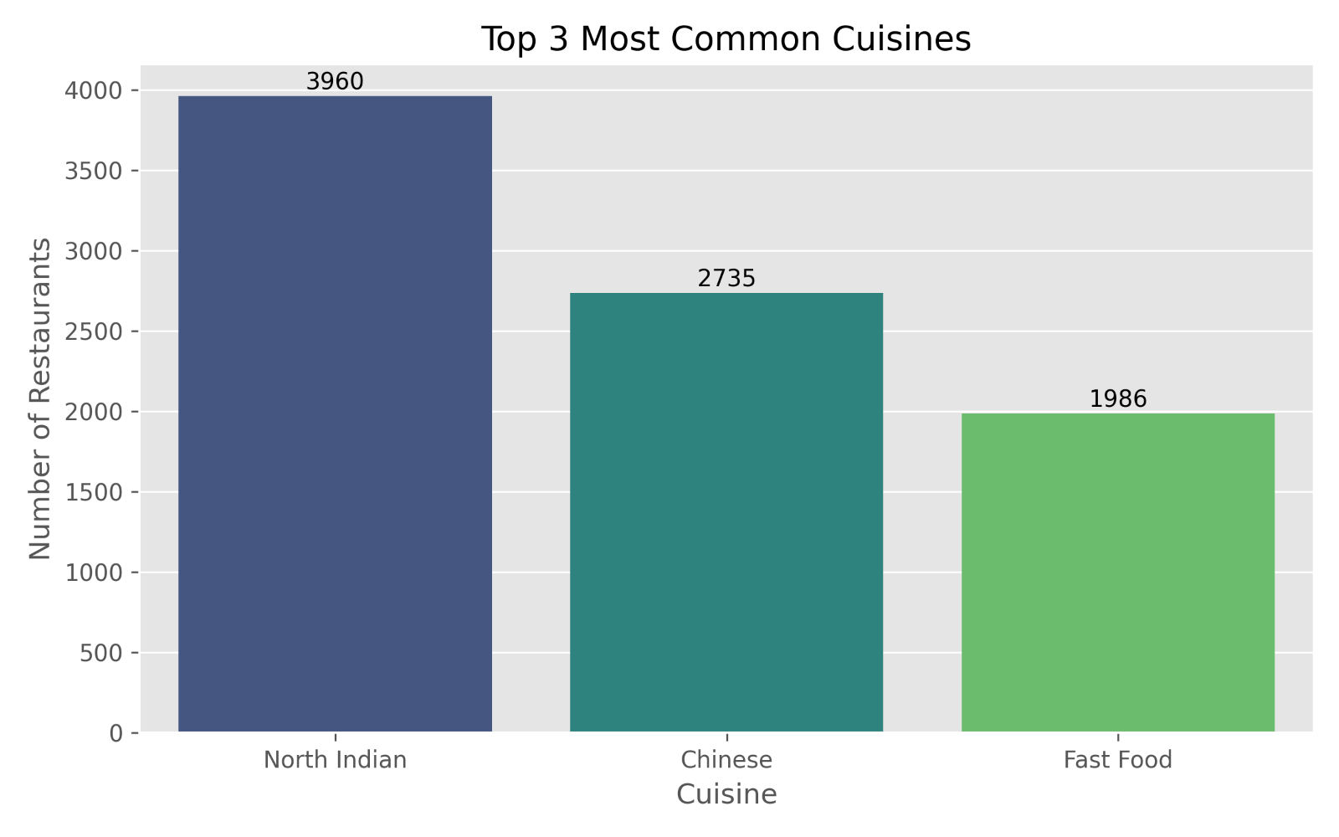
Figure 5.1: Top Three Most Common Cuisines
According to the generated visualization:
- North Indian – 3960 restaurants
- Chinese – 2735 restaurants
- Fast Food – 1986 restaurants
The corresponding chart is included in the project visuals.

Interpretation
The results indicate that North Indian cuisine dominates the dataset, followed by Chinese and Fast Food. This reflects strong customer demand for these cuisine categories and suggests that restaurants specializing in these offerings have a significant market presence.

Business Insight
Restaurant owners planning new outlets may consider including North Indian or Chinese dishes in their menus to align with prevailing customer preferences. Businesses can also combine these popular cuisines to appeal to a wider customer base.

5.3 Task 2 – City-wise Restaurant Analysis
Objective
To analyze the distribution of restaurants across different cities and identify locations with the highest restaurant density.

Methodology
Restaurants were grouped by city and counted to determine the number of establishments in each location.
Additionally, city-wise average ratings were examined to compare restaurant performance.

Visualization
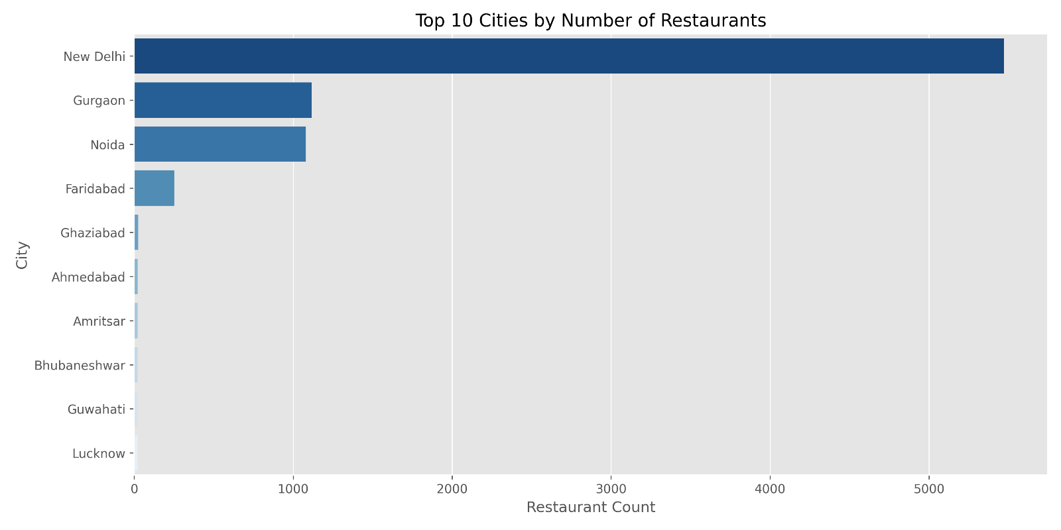
Figure 5.2: Top 10 Cities by Number of Restaurants
The analysis shows that New Delhi has the highest number of restaurants, followed by Gurgaon, Noida, and Faridabad.

Interpretation
The concentration of restaurants in metropolitan areas reflects higher population density, stronger consumer demand, and more developed food service markets.

Business Insight
Restaurant businesses seeking expansion should evaluate high-density urban markets while also identifying underserved regions that present opportunities for growth.

5.4 Task 3 – Price Range Distribution
Objective
To study the distribution of restaurants across different pricing categories.

Methodology
Restaurants were categorized into four price ranges:
- Low Cost
- Moderate
- Expensive
- Luxury
Frequency counts and percentage distributions were calculated and visualized.

Visualization 1
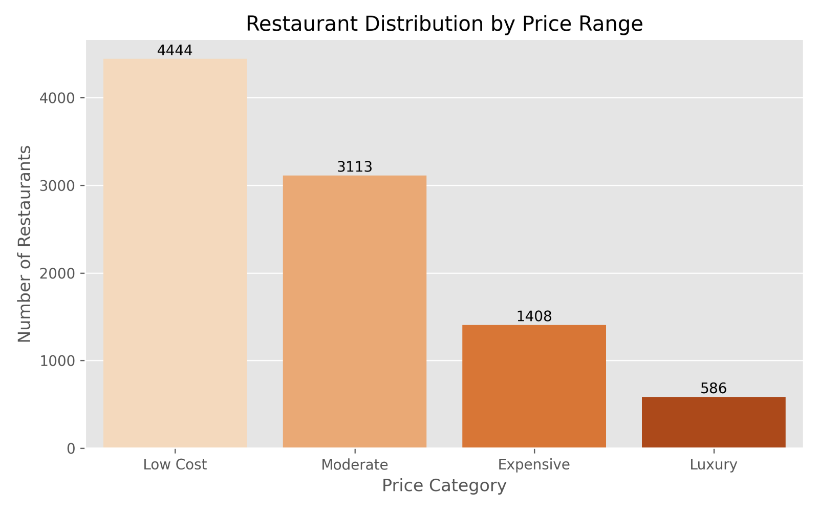
Figure 5.3: Restaurant Distribution by Price Range
The project results show:
Price Category | Restaurants
Low Cost | 4444
Moderate | 3113
Expensive | 1408
Luxury | 586
These values are shown in the project visualization.

Visualization 2
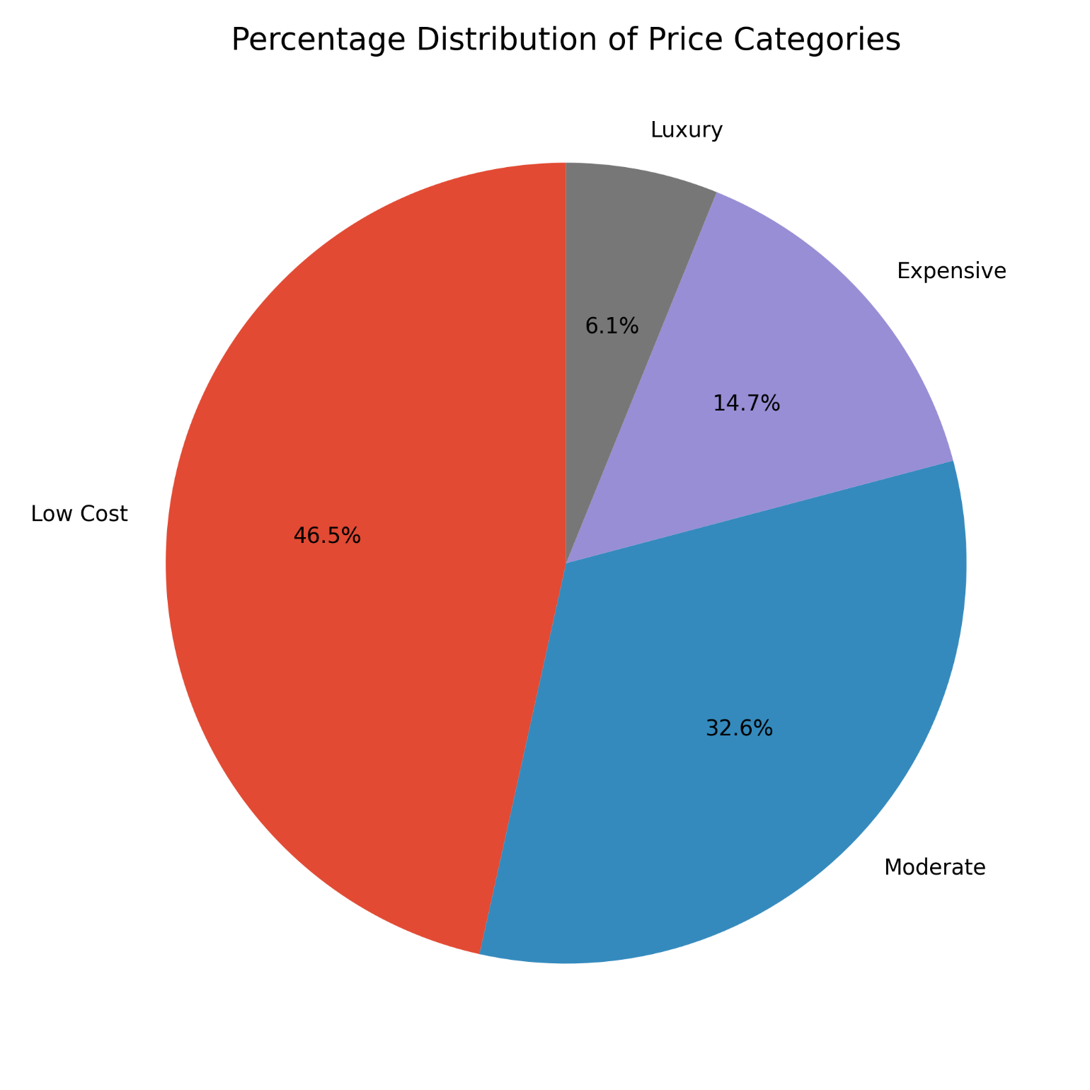
Figure 5.4: Percentage Distribution of Price Categories
The corresponding pie chart indicates:
- Low Cost – 46.5%
- Moderate – 32.6%
- Expensive – 14.7%
- Luxury – 6.1%

Interpretation
Most restaurants belong to the low-cost and moderate price categories. Luxury restaurants constitute only a small proportion of the dataset.

Business Insight
The market is primarily driven by affordable dining options, suggesting that restaurants targeting budget-conscious customers have a larger potential customer base.

5.5 Task 4 – Online Delivery Analysis
Objective
To evaluate the availability of online delivery services and compare customer ratings between restaurants offering and not offering online delivery.

Methodology
Restaurants were classified based on the availability of online delivery services.
The analysis included:
- Frequency distribution
- Percentage distribution
- Average rating comparison

Visualization 1
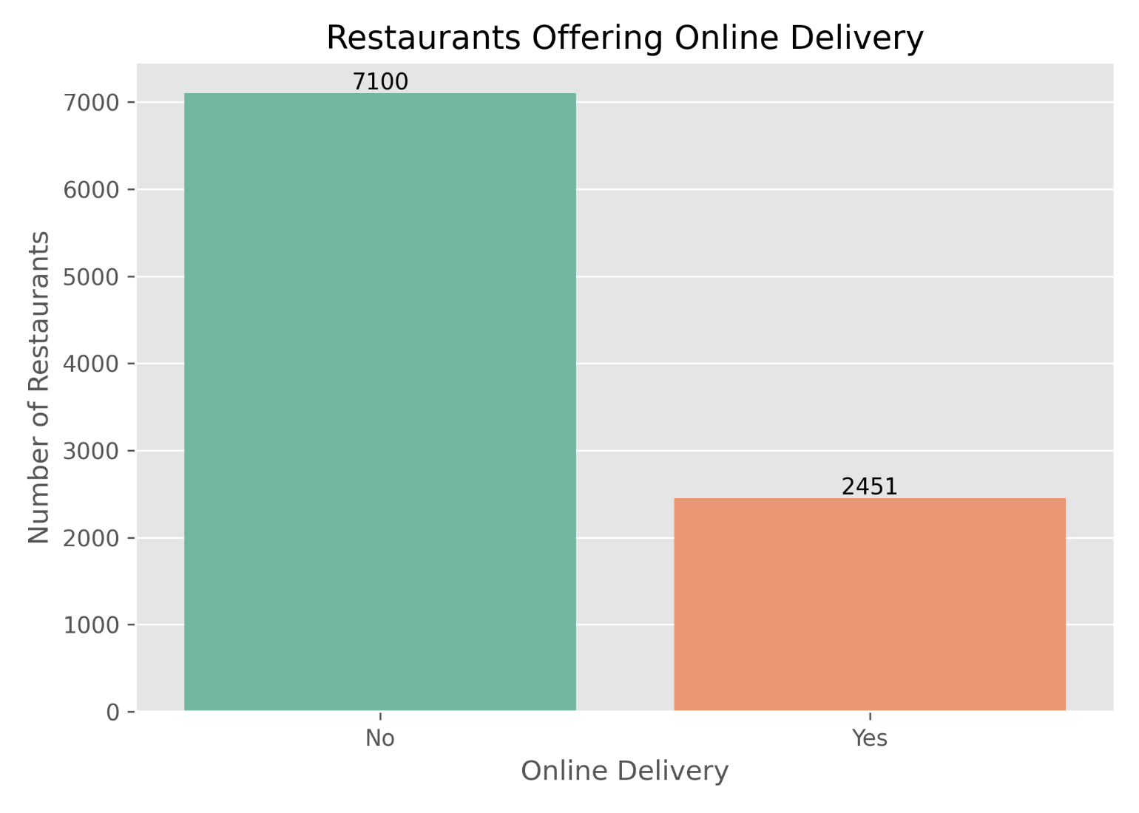
Figure 5.5: Restaurants Offering Online Delivery
The project results indicate:
- No Online Delivery – 7100 restaurants
- Online Delivery Available – 2451 restaurants

Visualization 2
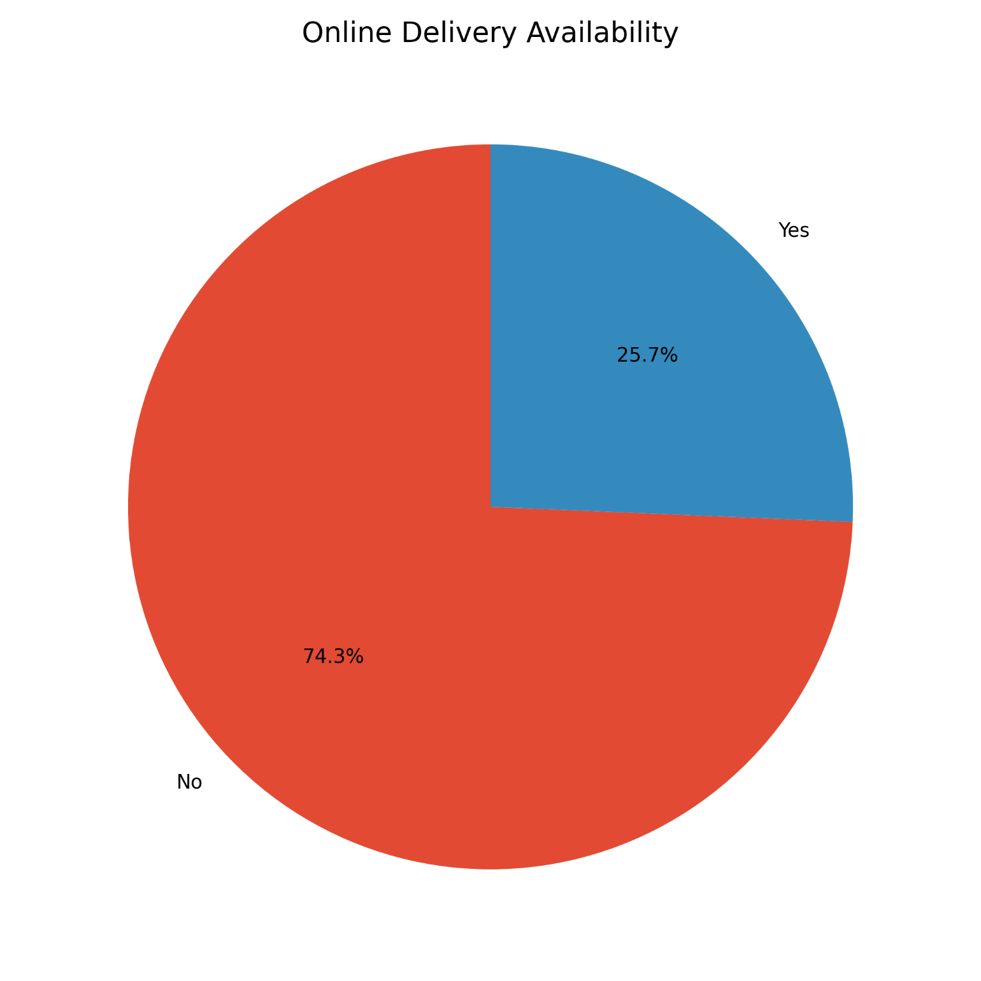
Figure 5.6: Online Delivery Availability
The percentage distribution is:
- No – 74.3%
- Yes – 25.7%

Visualization 3
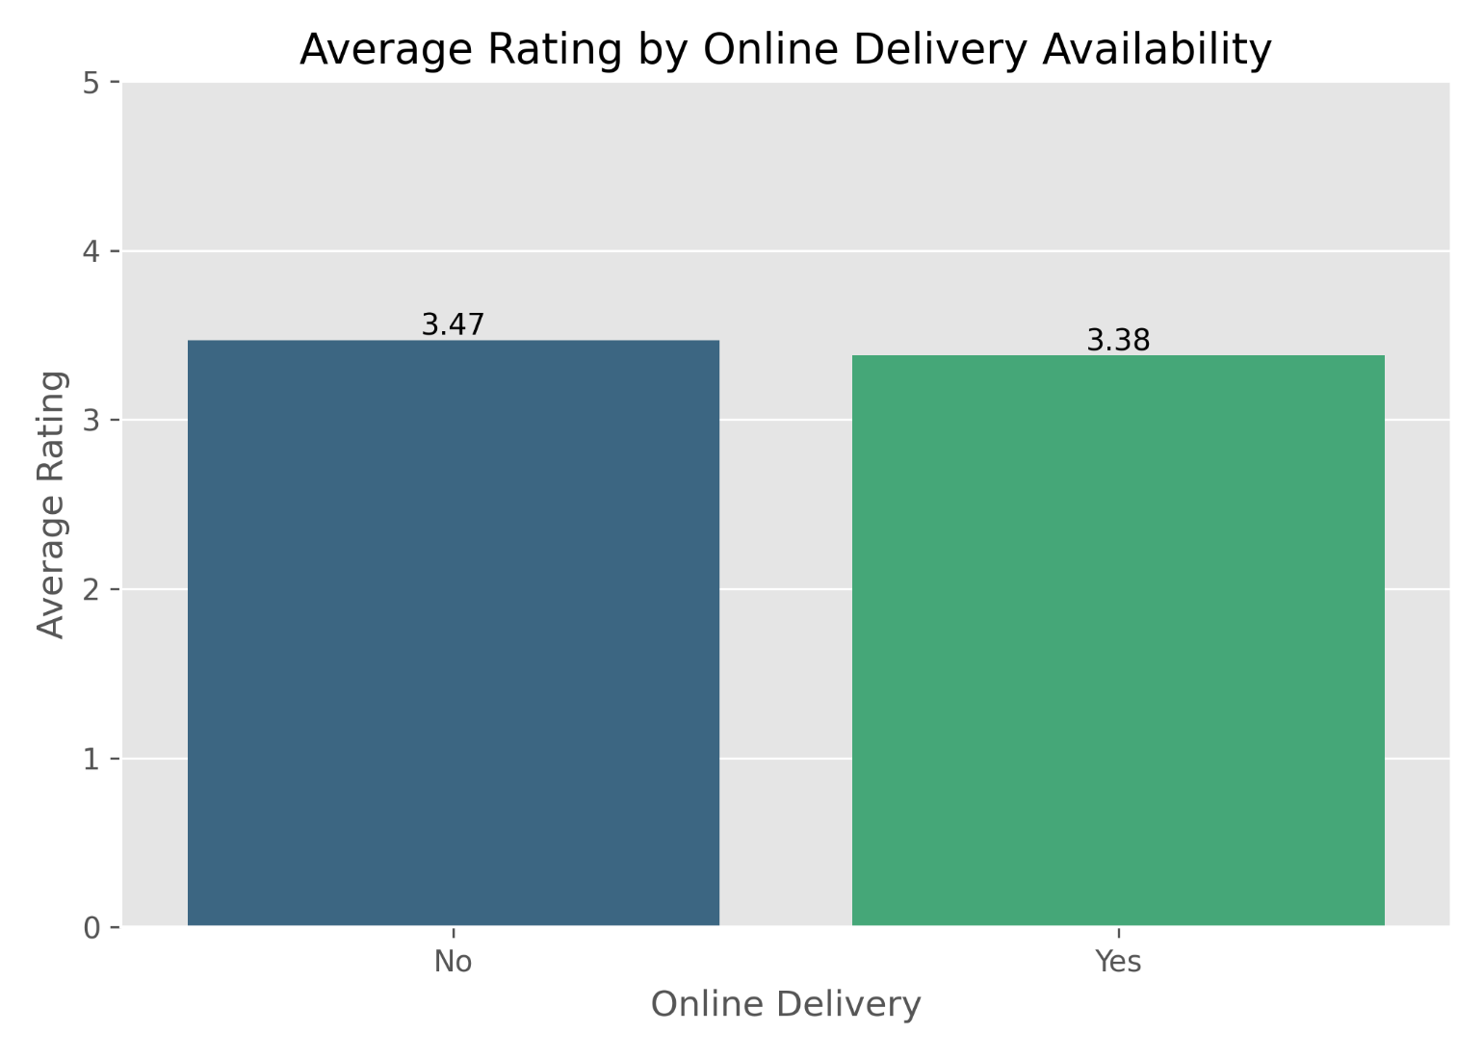
Figure 5.7: Average Rating by Online Delivery Availability
The comparison shows:
Online Delivery | Average Rating
No | 3.47
Yes | 3.38
These averages are shown in the project visualization.

Interpretation
Although online delivery services are becoming increasingly popular, only about one-quarter of the restaurants in the dataset provide this facility. Restaurants without online delivery exhibit a slightly higher average rating, though the difference is relatively small.

Business Insight
Restaurants should not rely solely on online delivery as a competitive advantage. Service quality, food quality, and customer experience remain key factors influencing customer ratings.

5.6 Key Findings of Level 1 Analysis
The Level 1 analysis produced several important findings:
- North Indian cuisine is the most common cuisine in the dataset.
- New Delhi has the highest concentration of restaurants.
- Nearly half of all restaurants belong to the low-cost category.
- Approximately one-quarter of restaurants provide online delivery.
- Average ratings are similar regardless of online delivery availability, indicating that delivery alone does not determine customer satisfaction.

Advanced Data Analysis (Level 2)

6.1 Introduction
After completing the Level 1 exploratory analysis, the project progressed to advanced analytical tasks that provide deeper insights into restaurant performance, customer preferences, and geographic distribution. Level 2 focuses on restaurant ratings, cuisine combinations, geographic visualization, and restaurant chain analysis.
These analyses extend beyond descriptive statistics by examining relationships between variables and presenting spatial and comparative patterns that support strategic business decision-making. The results are supported by the visualizations generated during the project.

6.2 Task 1 – Restaurant Ratings Analysis
Objective
To analyze the distribution of restaurant ratings and understand customer satisfaction across the dataset.

Methodology
The Aggregate Rating attribute was analyzed to determine:
- Rating distribution
- Most common rating ranges
- Average customer votes
- Overall customer satisfaction
Python libraries used:
- Pandas
- Matplotlib
- Seaborn

Visualization
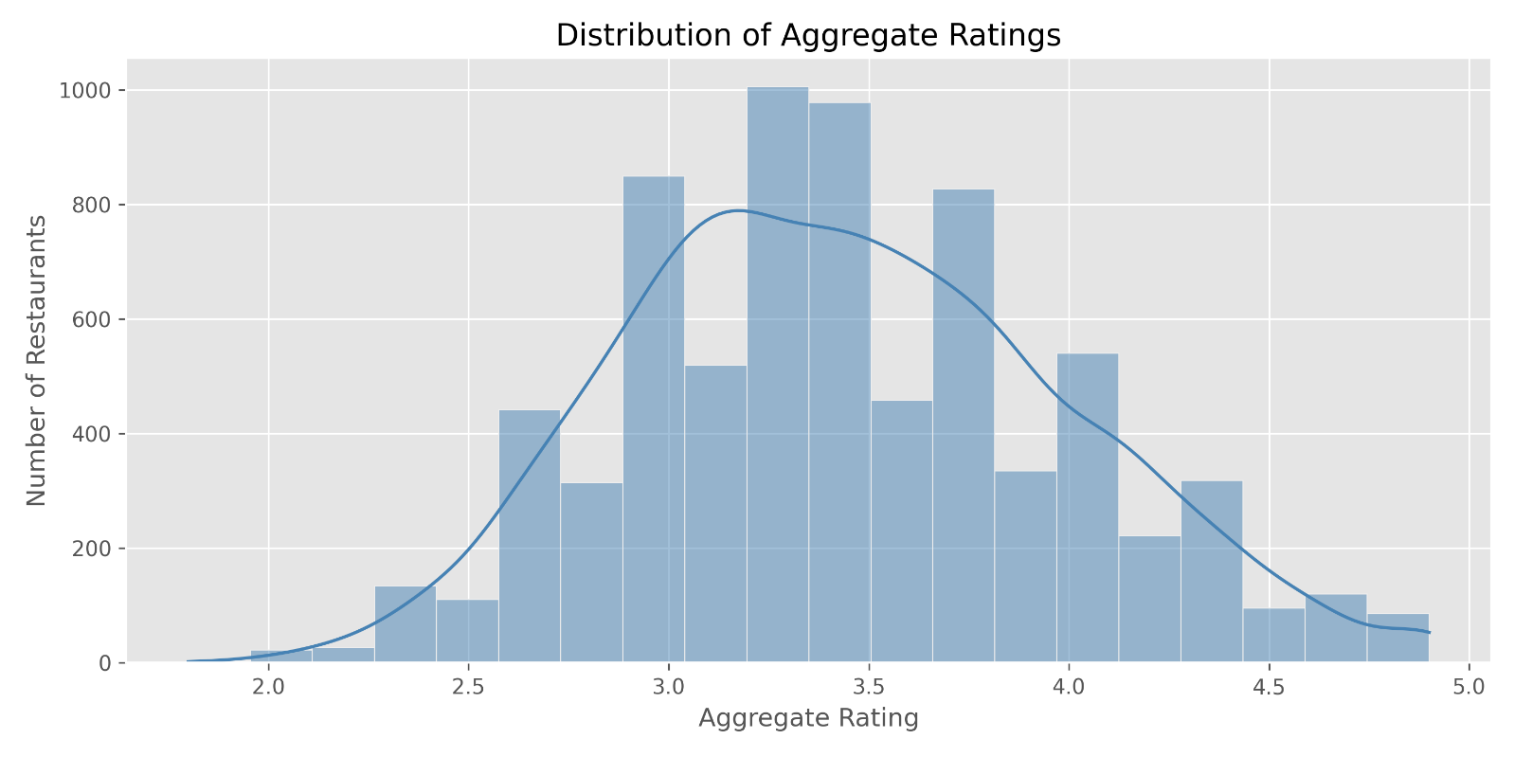
Figure 6.1: Distribution of Aggregate Ratings
The histogram illustrates how restaurant ratings are distributed across the dataset, highlighting the most common rating intervals.

Interpretation
The majority of restaurants have ratings within the 3.0–4.5 range, indicating that most establishments receive moderately positive customer feedback. Extremely low and exceptionally high ratings occur less frequently.

Business Insight
Restaurants with ratings below the common range should investigate customer feedback to identify opportunities for improving service quality, food quality, and overall customer experience.

6.3 Customer Votes Analysis (Level 2 Overview)
Customer votes serve as an indicator of restaurant popularity and customer engagement.
The analysis includes:
- Average customer votes
- Vote distribution
- Relationship between votes and ratings
Restaurants with higher ratings generally attract greater customer engagement, although popularity is also influenced by brand recognition and location.

6.4 Task 2 – Cuisine Combination Analysis
Objective
To identify frequently occurring cuisine combinations and determine whether certain combinations are associated with higher customer ratings.

Methodology
Restaurants offering multiple cuisines were grouped according to cuisine combinations.
The analysis involved:
- Frequency analysis
- Average rating comparison
- Ranking of cuisine combinations

Visualization
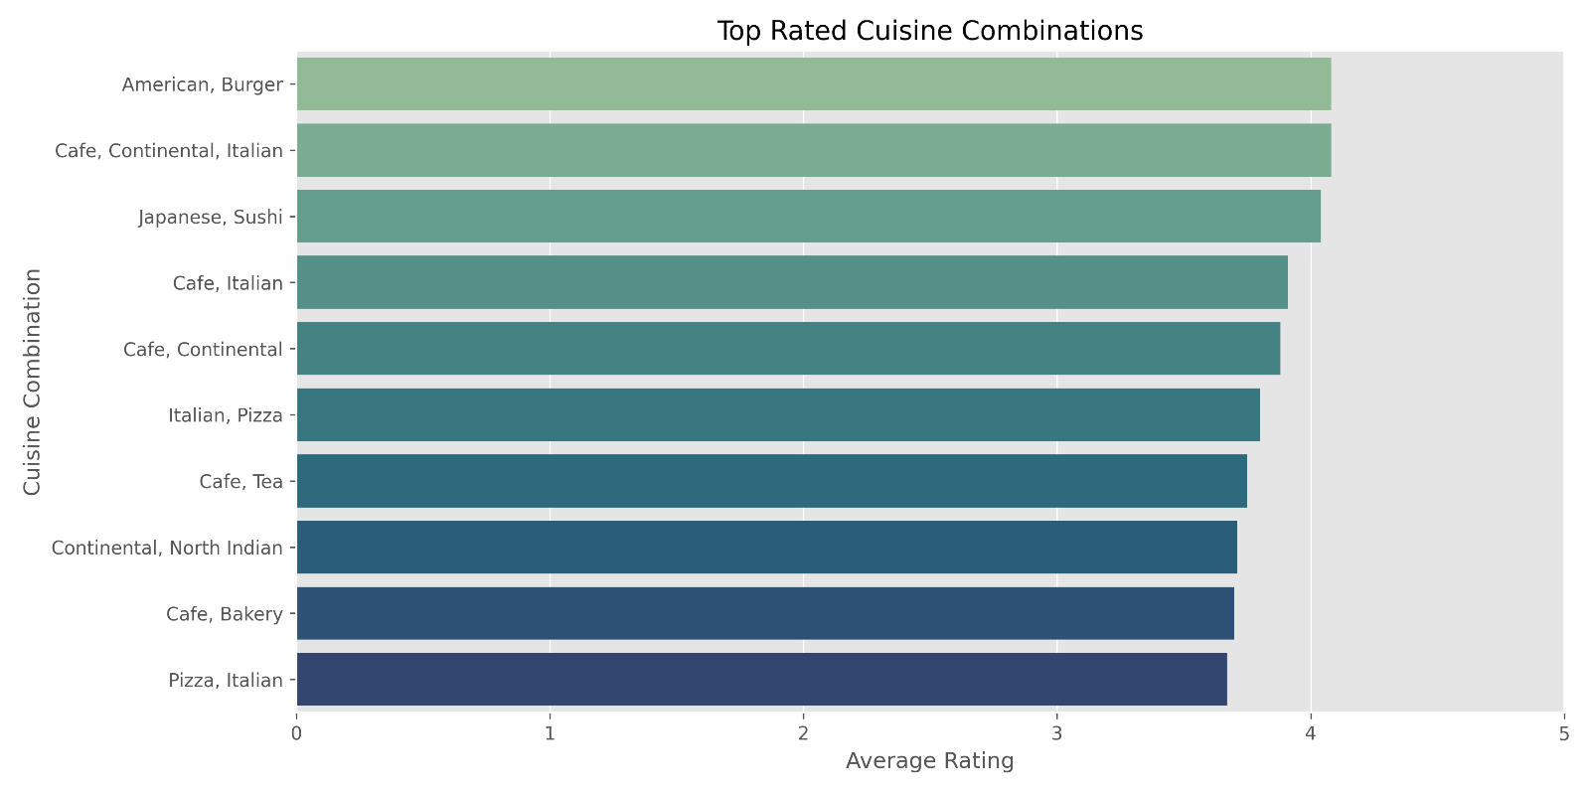
Figure 6.2: Most Common Cuisine Combinations

The visualization highlights the combinations of cuisines most frequently offered by restaurants in the dataset.

Interpretation
Restaurants frequently combine complementary cuisines to attract a broader customer base. Certain combinations also exhibit higher average ratings, suggesting positive customer reception.

Business Insight
Restaurant owners can use these findings when designing menus or expanding their offerings. Combining popular cuisines may improve customer appeal while maintaining operational efficiency.

6.5 Task 3 – Geographic Analysis
Objective
To visualize restaurant locations using geographic coordinates and identify spatial patterns in restaurant distribution.

Methodology
Latitude and longitude attributes were used to plot restaurant locations on an interactive map using Folium.
The analysis included:
- Geographic mapping
- Spatial visualization
- Restaurant density identification

Visualization

Figure 6.3: Geographic Distribution of Restaurants
The interactive map displays restaurant locations and reveals concentrations in metropolitan regions.

Interpretation
Restaurants are heavily concentrated in densely populated urban areas. Geographic clustering reflects higher consumer demand and established commercial activity.

Business Insight
Businesses planning expansion can use geographic analysis to identify underserved locations where customer demand may not yet be fully met.

6.6 K-Means Clustering
Objective
To group restaurants into geographic clusters based on latitude and longitude coordinates.

Methodology
The K-Means clustering algorithm from Scikit-learn was applied to geographic coordinates.
The clustering process involved:
- Feature selection
- Data scaling (if required)
- Cluster assignment
- Cluster visualization

Visualization
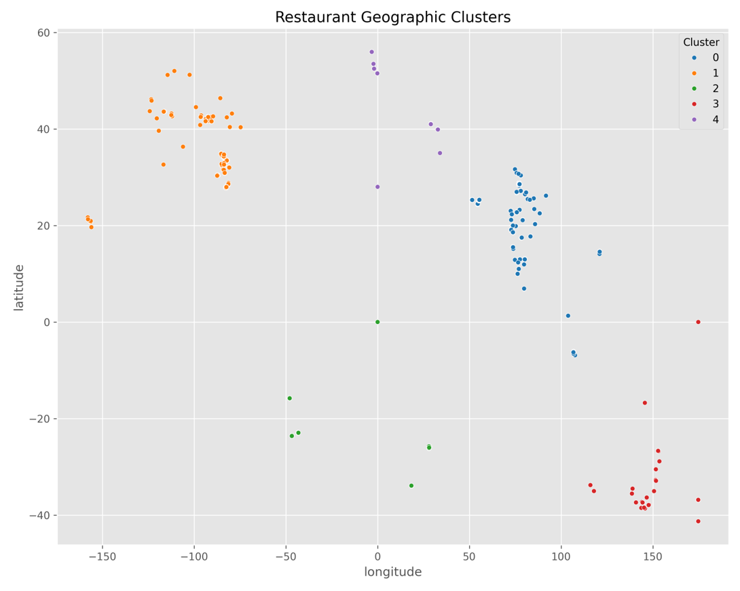
Figure 6.4: Restaurant Geographic Clusters
The cluster visualization groups restaurants into distinct geographic regions, simplifying spatial analysis.

Interpretation
The identified clusters correspond to areas with high restaurant density. Such segmentation assists in understanding regional market concentration and supports location-based decision-making.

Business Insight
Cluster analysis can guide marketing campaigns, delivery zone planning, and decisions regarding future restaurant locations.

6.7 Task 4 – Restaurant Chain Analysis
Objective
To identify restaurant chains within the dataset and evaluate their popularity and customer satisfaction.

Methodology
Restaurants sharing the same brand name were grouped into chains.
The analysis included:
- Number of outlets
- Average ratings
- Customer votes
- Chain popularity

Visualization
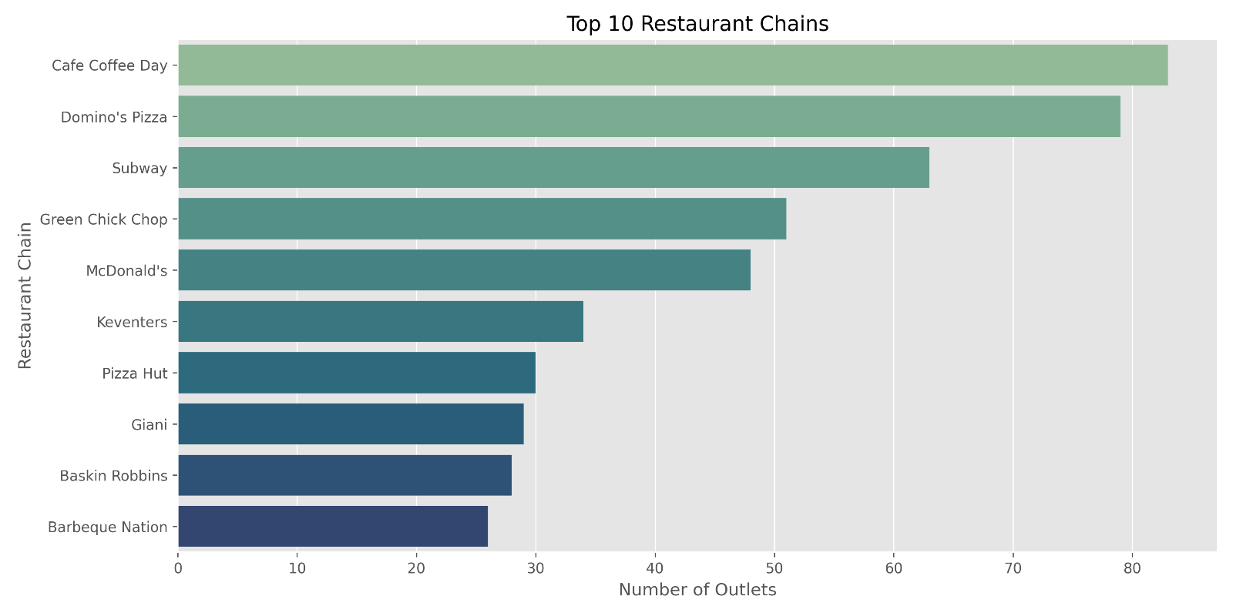
Figure 6.5: Top Restaurant Chains
The visualization presents the restaurant chains with the highest number of outlets in the dataset.

Interpretation
Well-established restaurant chains maintain a significant market presence through multiple outlets. However, chain size does not always correspond to higher customer ratings, indicating that service quality remains a critical factor.

Business Insight
Restaurant chains should focus on maintaining consistent quality across all branches to strengthen customer satisfaction and brand reputation.

6.8 Summary of Level 2 Analysis
The advanced analysis provided several important findings:
- Most restaurants receive ratings between 3.0 and 4.5.
- Customer votes generally increase with restaurant popularity.
- Certain cuisine combinations are more common and receive favorable ratings.
- Restaurants are geographically concentrated in major urban areas.
- Geographic clustering highlights regional restaurant density.
- Restaurant chains vary considerably in both popularity and customer satisfaction.

6.9 Business Recommendations
Based on the Level 2 analysis, the following recommendations are proposed:
- Maintain consistent service quality to improve customer ratings.
- Offer popular cuisine combinations to attract diverse customer segments.
- Use geographic clustering to identify expansion opportunities.
- Monitor customer feedback alongside ratings to improve satisfaction.
- Ensure quality consistency across all outlets within restaurant chains.
- Utilize interactive geographic analysis for delivery planning and market expansion.

Advanced Analysis (Level 3)

7.1 Introduction
Level 3 represents the final stage of the Restaurant Data Analysis project. This phase extends the analysis by focusing on customer opinions, restaurant popularity, voting behavior, and the relationship between restaurant pricing and service availability.
The analyses conducted in this chapter provide business-oriented insights that help restaurant owners understand customer engagement, evaluate service strategies, and identify factors influencing restaurant popularity. These tasks correspond directly to the Level 3 internship requirements.

7.2 Task 1 – Restaurant Reviews (Sentiment Analysis)
Objective
To analyze customer review sentiment using the Rating Text attribute and identify the overall distribution of customer opinions.

Methodology
Instead of analyzing full review text, the project utilizes the Rating Text field available in the dataset. Each restaurant is categorized into sentiment classes such as:
- Excellent
- Very Good
- Good
- Average
- Poor
- Not Rated
These categories were grouped to evaluate customer sentiment across restaurants.
Python libraries used:
- Pandas
- Matplotlib
- Seaborn
- NLTK
- WordCloud
These libraries are included in the project's dependency list.

Visualization
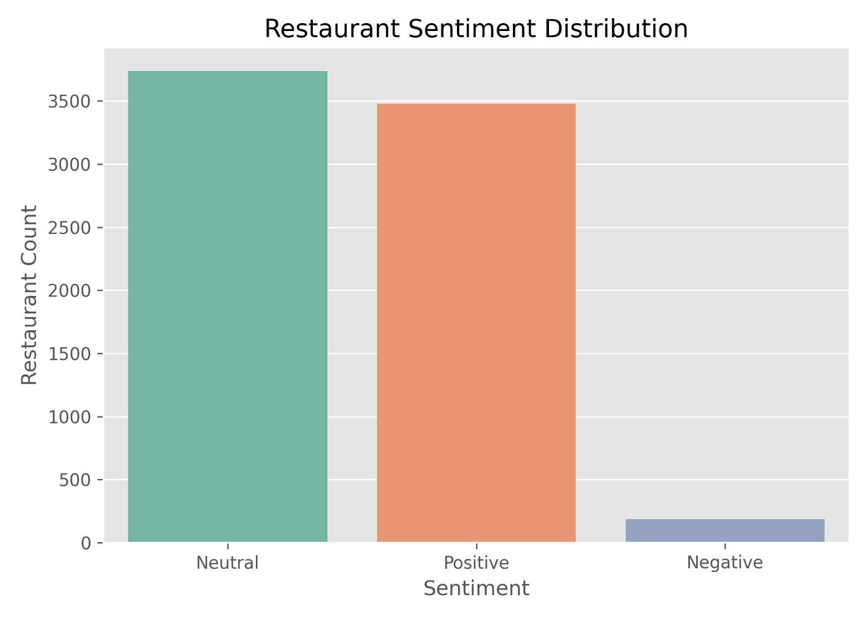
Figure 7.1: Customer Sentiment Distribution
The sentiment chart illustrates the proportion of restaurants belonging to different rating categories and highlights the overall customer perception of restaurant quality.

Interpretation
The analysis indicates that most restaurants fall within positive sentiment categories such as Good, Very Good, and Excellent, while relatively few restaurants receive poor ratings. This suggests that the majority of restaurants in the dataset provide satisfactory customer experiences.

Business Insight
Restaurants receiving negative sentiment should focus on improving service quality, food consistency, and customer support. Monitoring sentiment trends can help businesses respond proactively to customer expectations.

7.3 Task 2 – Votes Analysis
Objective
To identify restaurants with the highest and lowest customer votes and examine the relationship between customer votes and restaurant ratings.

Methodology
The analysis involved:
- Sorting restaurants based on vote count
- Identifying highly popular restaurants
- Identifying restaurants with minimal customer engagement
- Comparing votes with aggregate ratings
- Performing correlation analysis

Visualization
Figure 7.4: Votes vs Aggregate Rating
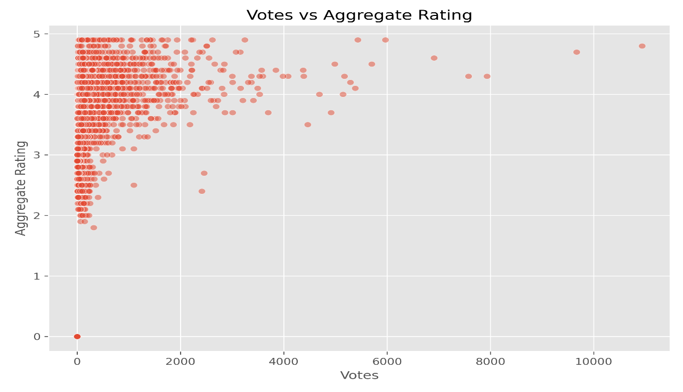
These visualizations are included in the project outputs.

Interpretation
The scatter plot suggests a positive relationship between customer votes and aggregate ratings. Restaurants receiving higher ratings generally attract greater customer engagement, although some exceptions exist due to factors such as brand recognition and location.

Business Insight
High customer engagement often reflects strong brand visibility and customer satisfaction. Restaurants with low vote counts should consider improving digital presence, customer interaction, and marketing efforts to increase visibility.

7.4 Correlation Analysis
Correlation analysis was performed to examine the relationship between customer votes and restaurant ratings.
Observation
- Higher ratings are generally associated with a greater number of customer votes.
- The relationship is positive but not perfectly linear, indicating that additional factors influence customer engagement.
Examples of influencing factors include:
- Restaurant location
- Brand reputation
- Cuisine popularity
- Online delivery availability
- Marketing efforts

7.5 Task 3 – Price Range vs Online Delivery and Table Booking
Objective
To determine whether restaurant pricing influences the availability of online delivery and table booking services.

Methodology
Restaurants were grouped according to Price Range and compared against:
- Online Delivery availability
- Table Booking availability
Cross-tabulation and visualization techniques were used to examine these relationships.

Visualization
Figure 7.5: Price Range vs Online Delivery
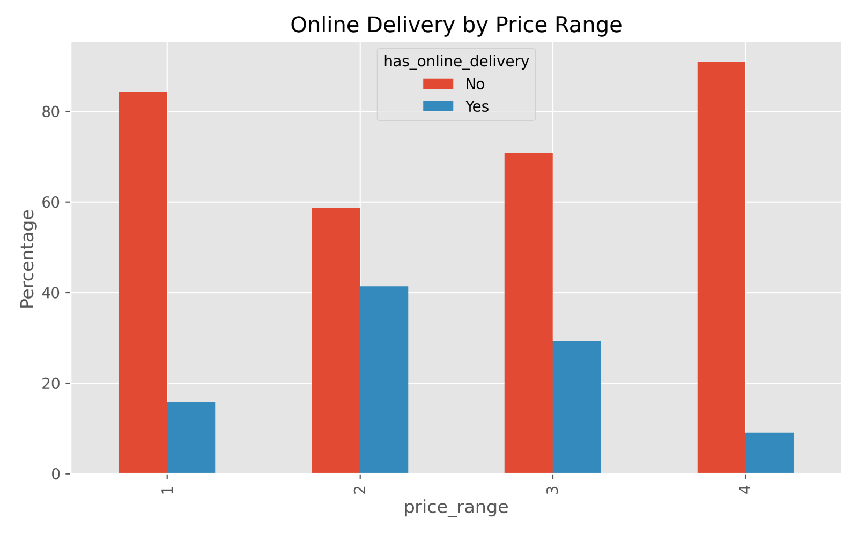
Figure 7.6: Price Range vs Table Booking
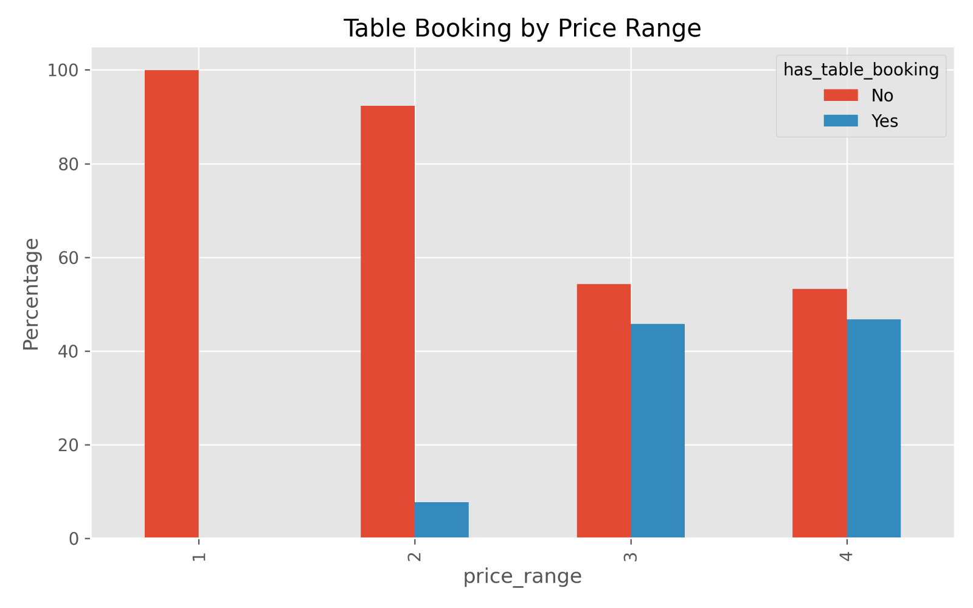
The corresponding charts are included among the project visualizations.

Interpretation
The analysis indicates that:
- Lower-priced restaurants are less likely to provide table booking facilities.
- Higher-priced restaurants are more likely to offer premium services such as table booking.
- Online delivery is available across multiple price categories, although adoption varies.

Business Insight
Premium restaurants differentiate themselves through enhanced customer services, while budget restaurants focus on affordability and accessibility. Businesses should align service offerings with their target market and pricing strategy.

7.6 Overall Findings from Level 3
The Level 3 analysis produced several important observations:
- Most restaurants receive positive customer sentiment.
- Restaurants with higher ratings tend to attract more customer votes.
- Customer engagement is influenced by both quality and visibility.
- Premium restaurants are more likely to provide table booking.
- Online delivery is widely adopted but is not limited to a single pricing category.
- Service availability is closely linked to restaurant positioning and pricing.

7.7 Business Recommendations
Based on the findings, the following recommendations are proposed:
- Improve service quality to enhance customer ratings and positive sentiment.
- Encourage customer reviews and ratings to increase engagement.
- Strengthen online visibility through digital marketing and food delivery platforms.
- Introduce premium services such as table booking where appropriate.
- Use customer sentiment analysis as part of continuous service improvement.
- Develop pricing strategies that match customer expectations and service offerings.

Results, Business Insights, Conclusion, and Future Scope

8.1 Introduction
This chapter summarizes the findings obtained throughout the Restaurant Data Analysis project. The analyses performed during the internship provided valuable insights into customer preferences, restaurant performance, pricing strategies, geographic distribution, and service availability. By integrating data cleaning, exploratory data analysis, visualization, geographic mapping, clustering, and sentiment analysis, the project demonstrates how data analytics can support strategic decision-making in the restaurant industry.

8.2 Overall Results
The project successfully completed all planned analyses and produced meaningful insights from the restaurant dataset.
Project Outcomes
- Dataset successfully cleaned and preprocessed.
- Missing values and duplicate records addressed.
- Comprehensive exploratory data analysis completed.
- Popular cuisines identified.
- City-wise restaurant distribution analyzed.
- Price range distribution evaluated.
- Online delivery services assessed.
- Customer ratings analyzed.
- Cuisine combinations examined.
- Geographic restaurant locations visualized.
- Restaurant chains identified and analyzed.
- Sentiment analysis performed.
- Customer voting behavior evaluated.
- Relationship between pricing and service availability investigated.
These outcomes align with the internship objectives and demonstrate the use of Python-based analytical techniques.

8.3 Summary of Key Findings
Cuisine Analysis
- North Indian cuisine emerged as the most frequently served cuisine.
- Chinese and Fast Food were also highly represented.
- Popular cuisine combinations attracted higher customer engagement.

City Analysis
- Major metropolitan cities contained the highest concentration of restaurants.
- Urban areas exhibited greater restaurant diversity and customer activity.

Price Range Analysis
- Most restaurants belonged to the low-cost and moderate pricing categories.
- Luxury restaurants represented a relatively small segment of the market.

Online Delivery
- A significant proportion of restaurants did not provide online delivery.
- Customer ratings were broadly similar regardless of delivery availability.

Customer Ratings
- Most restaurants received ratings between 3.0 and 4.5.
- Extremely high and extremely low ratings were comparatively rare.

Restaurant Chains
- Several restaurant chains maintained multiple outlets.
- Popularity varied across chains.
- Higher outlet counts did not always correspond to higher customer ratings.

Geographic Analysis
- Restaurants were concentrated in urban regions.
- Geographic clustering highlighted areas of high restaurant density.

Sentiment Analysis
- Positive customer sentiment predominated.
- Only a small proportion of restaurants exhibited negative sentiment.

Customer Votes
- Restaurants with higher ratings generally attracted more customer votes.
- Brand recognition and location also influenced customer engagement.

Service Analysis
- Premium restaurants were more likely to offer table booking facilities.
- Online delivery services were available across multiple pricing categories.

8.4 Business Insights
The project generated several practical insights that can assist restaurant owners and managers.
Customer Preferences
Customers demonstrated a strong preference for popular cuisines such as North Indian and Chinese.
Pricing Strategy
Affordable restaurants dominate the market, indicating sustained demand for budget-friendly dining options.
Service Quality
Customer satisfaction depends primarily on food quality and service rather than solely on online delivery availability.
Restaurant Expansion
Geographic analysis suggests that expansion decisions should consider restaurant density and local demand.
Digital Presence
Increasing online visibility and encouraging customer reviews may improve customer engagement and restaurant popularity.
Premium Services
Higher-priced restaurants should continue offering premium services such as table booking to maintain their market positioning.

8.5 Internship Learning Outcomes
During the Cognifyz Technologies Data Analysis Internship, the following technical skills were developed:
Programming
- Python
Data Manipulation
- Pandas
- NumPy
Data Visualization
- Matplotlib
- Seaborn
- Plotly
Geographic Analysis
- Folium
Machine Learning
- K-Means Clustering
- Scikit-learn
Natural Language Processing
- NLTK
- WordCloud
Development Tools
- Jupyter Notebook
- Git
- GitHub
The technologies used throughout the project correspond to those listed in the project documentation and dependency file.

8.6 Project Limitations
Although the project achieved its objectives, several limitations were identified:
- The dataset represents a specific snapshot and may not reflect current restaurant trends.
- Customer reviews were represented by rating categories rather than detailed review text.
- Sales, revenue, and operational cost information were unavailable.
- Geographic analysis was limited to the available latitude and longitude data.
- Advanced predictive models were outside the scope of the internship.

8.7 Future Scope
The project can be extended in several ways:
- Develop restaurant recommendation systems using machine learning.
- Build predictive models for restaurant ratings.
- Forecast customer demand using time-series analysis.
- Create interactive business dashboards using Power BI or Tableau.
- Integrate live restaurant data using APIs.
- Perform advanced NLP on detailed customer reviews.
- Deploy the project as a web application using Flask or Streamlit.
- Develop an AI-powered restaurant recommendation platform.

8.8 Conclusion
The Restaurant Data Analysis project successfully demonstrated the application of Python-based data analytics techniques to solve practical business problems within the restaurant industry. The project involved data preprocessing, exploratory data analysis, visualization, geographic mapping, clustering, sentiment analysis, and business intelligence.
The analyses provided valuable insights into customer preferences, restaurant performance, pricing strategies, service availability, and geographic distribution. By completing all internship tasks across Level 1, Level 2, and Level 3, the project met the objectives of the Cognifyz Technologies Data Analysis Internship while strengthening practical skills in data analysis, visualization, and business interpretation.

References
Use APA 7th edition formatting in your report.
- Python Software Foundation. Python Documentation.
- Pandas Development Team. Pandas Documentation.
- NumPy Developers. NumPy Documentation.
- Matplotlib Development Team. Matplotlib Documentation.
- Seaborn Documentation.
- Plotly Documentation.
- Folium Documentation.
- Scikit-learn Documentation.
- NLTK Documentation.
- Cognifyz Technologies – Internship Guidelines.
- Project README and Repository Documentation.

Appendix
Include the following in the appendix:
Appendix A
- Dataset overview
- Column descriptions
Appendix B
- Important Python code snippets
Appendix C
- Screenshots from:
  - Data Cleaning Notebook
  - Level 1 Analysis
  - Level 2 Analysis
  - Level 3 Analysis
Appendix D
- Project visualizations (bar charts, pie charts, histograms, scatter plots, maps, and clustering outputs).
Appendix E
- GitHub repository structure
- README overview
- Requirements file
- Installation instructions.

