Supervised Learning Competition Report

- Course Details
  - Course Name: Data Analytics
  - Course ID: CISC-839
  - Course Instructor: Hazem Abbas

- Group Members
  - Karthik Ranga Swamy: 20188884
  - Abhishek Awasthi: 20143052
  - Dhanush Reddy Nandyala: 20134832

- Project Topic
- Predict patients readmission to the hospital

- Tools and Software Version
- The entire project was created and developed in Windows 10 operating system.
- Programming Language : Python (3.7)
- Python IDE : Spider

Additional main libraries used:
- Pandas: Python has long been great for data managing and preparation, but less so for data analysis and modeling. Pandas is an open source library helps fill this gap, enabling you to carry out your entire data analysis workflow in Python.
- To install type the following in Anaconda prompt (terminal):
$ conda install pandas

- scikit-learn: Scikit-learn is a library in Python that provides many unsupervised and supervised learning algorithms. It’s built upon some of the technology you might already be familiar with, like NumPy, pandas, and Matplotlib.
- To install type the following in Anaconda prompt (terminal):
$ conda install scikit-learn

- imbalanced-learn: It is a python package offering a number of re-sampling techniques commonly used in datasets showing strong between-class imbalance. It is compatible with scikit-learn .
- To install type the following in Anaconda prompt (terminal):
$ conda install imbalanced-learn

- Description of Analytics process
- Most of the changes below has been referred from Strack Beata et al.[1]
- We have removed all the columns with missing values of more than 40% in their Data.
- We are considering only Primary diagnosis and have removed secondary and additional secondary diagnosis columns.
- There are a certain column from which there is no gain of information as they all have the same value for all like ‘examide’ and ‘citoglipton’ has the only value ‘No’ and glimepiride-pioglitazone', 'metformin-rosiglitazone' proved to have 99.9% of the same value after further row operations so they are not contributing anything.
- Further for all medication we have classified it as 0 for ‘No’ and ‘1’ for ‘up’, ‘down’ and ‘Steady’ to simplify the data.
- Values of the primary diagnosis (ICD9 codes) in the final dataset have been mapped to their respective group Names.
Group Name ICD9 Codes
Circulatory 390–459, 785
Respiratory 460–519, 786
Digestive 520–579, 787
Diabetes 250.xx
Injury 800–999
Musculoskeletal 710–739
Genitourinary 580–629, 788
Neoplasms 140–239
Other 780, 781, 784, 790–799
- Referring table from Strack Beata et al.[1] we have categories the columns like discharge deposition, admission source, and others.
- Then we have implemented the one-hot encoding to the categorical variables
- Some numerical variables were heavily skewed towards the right so applied log transformation the standardized the all the numeric variables and removed the outliers.
- In the end we ended up with a train data frame with dimensions 55719,70
- Now our Data is ready to train so we have split it into 80:20 for train and validation purpose.
- We used SMOTE to over sample the minority class and trained it using a Random Forrest Classifier among 10folds
- Hyper parameters was done by trial and error.
- To run the code install the above mentioned libraries and run the Competition.py file.

- Other Approaches Explored:
- Initially we have trained our model using logistic regression with 10 fold cross-validation but the model performed very poor.
- Later then we implement a decision tree Classifier but that did not also improve the results as the classes were highly imbalanced

- Later on we tried different oversampling techniques like ADASYN but conclude that SMOTE works best for this data set.
- We tried to create new features so that the model does not under fit but couldn’t due to the lack of knowledge on medical data.

- Evaluation:
- Below is the confusion matrix on validation set.
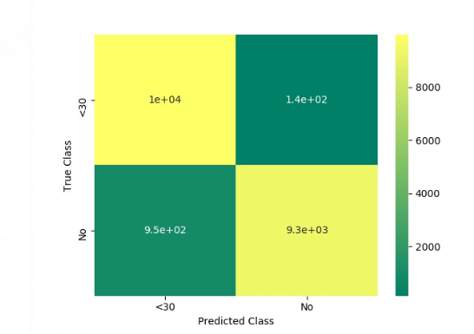
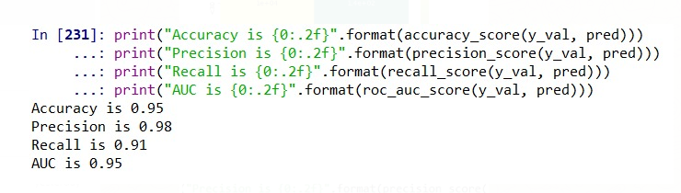

- Below is the confusion matrix for Multi Class classifications on validation set.
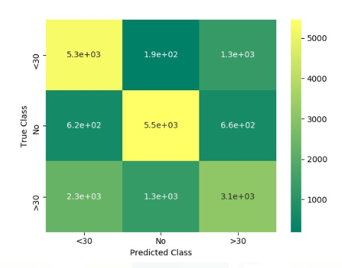

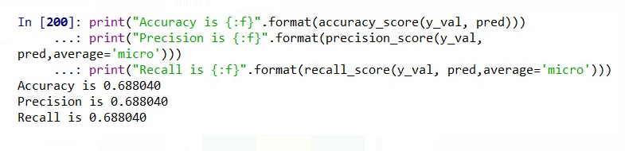

From above Analyses it’s clear that Model Predicts better results while classifying data into Binary classes.

1). Beata Strack, Jonathan P. DeShazo, Chris Gennings, et al., “Impact of HbA1c Measurement on Hospital Readmission Rates: Analysis of 70,000 Clinical Database Patient Records,” BioMed Research International, vol. 2014, Article ID 781670, 11 pages, 2014. https://doi.org/10.1155/2014/781670.

