## WEB222 Assignment 4 – DOM Manipulation

## Objective

Practise DOM/JavaScript coding, dynamically adding text heading, populating HTML table using DOM and generating images using DOM (rather than innerHTML property).

## Specifications

To begin, download **assign4-template.zip** file from **My.Seneca/Blackboard** and unpack the zip file. In this assignment, you’ll build up a front-end web app which queries data from a given array of Country objects, named **countries,** and show the results on a web page using HTML DOM API. The array of Country objects is provided in the **country-data.js** file. And your tasks are to update JavaScript code in the **myscript.js** file according to the instructions below.

**BASIC REQUIREMENTS**

1. You must not change the given files **assignment4.html**, and **country-data.js**. The **myscript.js** is the only file that you are allowed to update. Note: you should create event handler for window.onload . The level 2 heading (h2) will be generated in the **heading2** div. The text for this heading is “Country List”. The table with two columns including table header will be generated inside **table** div. Again you are only allowed to modify inside the myscript.js file. The table header for column one is “Country” and the table header for column two is “Capital”. The table data must be read from the country-data.js in order to generate the rows. Again you are only allowed to modify inside the myscript.js file. You must use DOM’s createElement method.
2. You **must not** use the DOM/Node innerHTML property to populate HTML tables and creating the heading for “Country List”.
3. The table data (rows with two columns) must be generated in a loop.
4. Using DOM property add a border style to **table** div. Again you are only allowed to modify inside the myscript.js file.
5. Next, you need to use **onclick** event listener to sense the click on the **Flag Images** link. Once, the **Flag Images** link is clicked, you need to create the flag images using DOM’s createElement method in the ‘flags’ div. Again you are only allowed to modify inside the myscript.js file. Note that the flag images are located inside the **flags** folder. The images are of .png extension and they start with the country name, then hyphen and then the text **flag**. This pattern needs to be used when setting the **src** attribute of the images. An example could be something like this

var img1 = document.createElement("img");

var str= './flags/'+ countries[j].Name+ '-flag.png';

img1.setAttribute('src', str);

The images must be generated in a loop. Set the alt attribute to some text. Set the width and height to 200px for each image.

1. Once, the **Flag Images** is clicked and flags are generated/displayed, use DOM’s removeChild method to remove the **Flag Images** link from the page.
2. When running your web app on a browser, no errors should occur on the browser web console.

**SAMPLE OUTPUT**

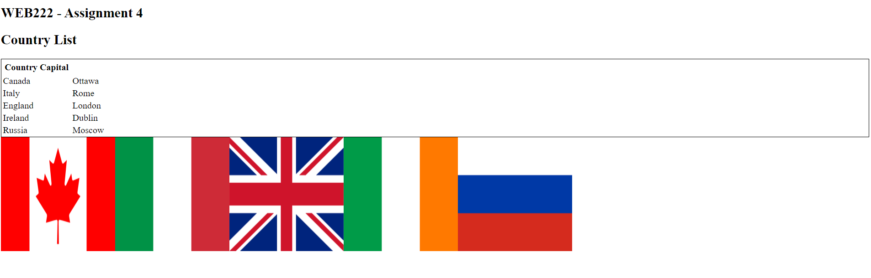

## Assignment submission

* Compact all your files including all directory structures into a zip file named **assignment4.zip**. Submit the **zip** file to the Blackboard (My.Seneca) before the due date.

## Important note

* You are to only write code inside the myscript.js file. No other file requires any modification.
* Using the DOM/Node innerHTML property anywhere in the assignment will result in 100% penalty for the grade of your assignment.
* NO LATE SUBMISSIONS for assignments. Late assignment submissions will not be accepted and will receive a grade of zero (0).
* After the end (11:30pm) of the due date, the assignment submission link on the Blackboard will no longer available.
* Do not be late – there are processing/queuing/transmission delay from your machine to blackboard server.