ELF = executable and linkable format

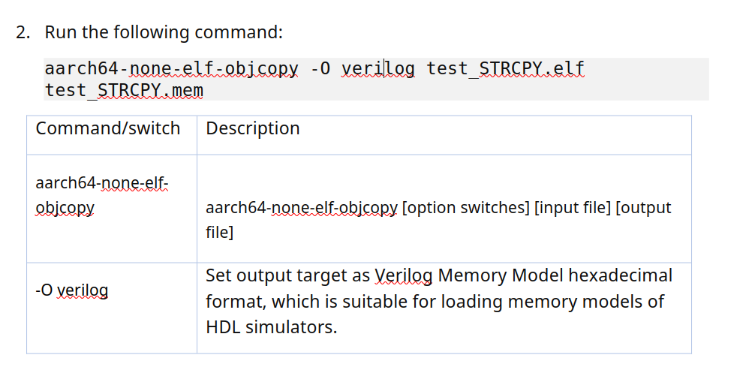
df

aarc64-none-elf is the gnu toolchain for the 64bit arm8A architecture

objcopy manipulate an executable (elf) and changes it into another kind of file, in our case a verilog file

difference between LDR and LDUR (or STR and STUR) is that the ones with U allows for unaligned offsets (any offset that isn’t 4 for 32 bit ld/str or 8 for 64 bit ld/str). STR and LDR NEED aligned offsets (4 for 32 bit ld/str, 8 for 64bit ld/str).

