***Computer Architecture Course***

**LAB 5**

**Forwarding Paths**

**Issue 1.0**

Contents

1 Introduction 1

1.1 Lab overview 1

2 Requirements 1

3 Recap: Limitation of the simple pipeline 2

4 Theory: Forwarding paths 3

5 Implementing forwarding paths in Arm Education Core 5

5.1 Task: Code modifications 7

6 Exercise: Verify and analyze forwarding paths 11

7 Summary 15

# Introduction

|  |
| --- |
| Lab overview At the end of this lab, you will be able to:   * Outline the limitations of a simple pipeline for Read-After-Write (RAW) data hazards. * Describe the purpose and operation of forwarding paths. * Identify the pipeline registers and signals that require forwarding paths. * Modify the Arm Education Core to implement forwarding paths. * Verify the functionality of the forwarding path implemented. * Summarize the advantage and limitations of forwarding paths. |

# Requirements

Before attempting this lab, ensure that you have already completed the installation instructions in the *Getting Started Guide* provided with this course.

The prerequisites for this lab are:

* Familiarity with Arm assembly
* Verilog
* Arm Education Core with simple pipeline—completed Lab 4

Lab 5 is provided with Lab5_forwarding_pipeline.zip. This zip file contains supplementary files used in the exercises of this lab and contains the Arm Education Core with a simple pipeline, which was done in Lab 4.

# Recap: Limitation of the simple pipeline

In our previous labs (Lab 4), we have implemented a simple pipeline and observed limitations whereby:

* The simple pipeline could not cope with Read-After-Write (RAW) data hazards. It was only able to output the correct results if NOPs were inserted in between the instructions with dependencies, which can decrease the throughput at a given time period. See Figure 1.
* NOPs were also used so that the program would not halt prematurely when the YIELD instruction was processed.

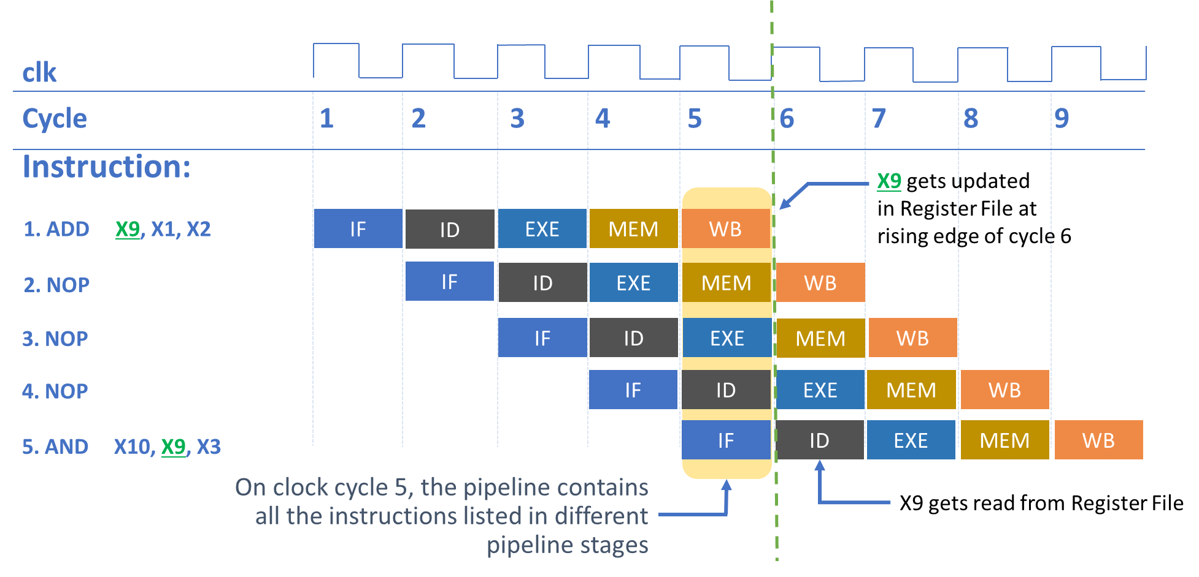

Figure 1: RAW data hazard in the pipeline being resolved with NOPs in the previous lab

There are other types of hazards such as the Write After Read (WAR), Write After Write (WAW), and Control Hazards. For the WAR and WAW hazards, the instruction sequence must be ensured to be in the right order, which the compiler can ensure for this to happen (Arm Education Core is an in-order core, so these hazards cannot happen). Control hazards are also known as branch hazards, where the processor does not know which instruction to fetch next because the branch decision has not been made in the time available to fetch the next instruction.

In this lab, we will explore a hardware architecture technique that can help resolve some RAW data hazards, which are called forwarding paths.

# Theory: Forwarding paths

One method to solve the RAW data hazard issue is by forwarding the result of an instruction to a certain pipeline stage of the next dependent instruction, as shown in Figure 2.

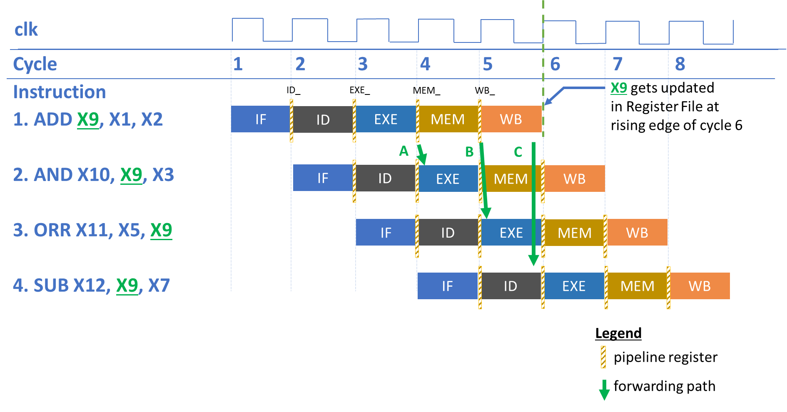

Figure 2: Forwarding paths in the pipeline

1. At the rising edge of the start of clock cycle 4, the EXE results for the ADD instruction is registered in the MEM pipeline register. The result in the MEM pipeline register is forwarded to the EXE stage of the AND instruction (see green arrow **A**). Forwarding path **A** (MEM_ -> EXE) bypasses the AND instruction having to wait for the ADD instruction to finish the WB stage in order to obtain the updated value of X9.
2. At the rising edge of the start of clock cycle 5, the result for the ADD instruction is now in the WB pipeline register. The result in the MEM pipeline now belongs to the result of the AND instruction instead. The ORR instruction is dependent on the ADD instruction. Therefore, the result in the WB pipeline register is forwarded to the EXE stage of the ORR instruction (see green arrow **B**). Forwarding path **B** (WB_ -> EXE) bypasses the ORR instruction having to wait for the ADD instruction to finish the WB stage.
3. During clock cycle 5, the result for the ADD instruction is to be written back to register X9—let’s call the result to be written *write_reg_value*. The SUB instruction is still in the ID stage reading the old value of X9 because X9 will only be updated at the rising edge of cycle 6. (Do recall that in the case of Arm Education Core, the Register File has asynchronous reads and synchronous writes. Registers are read from ports N, M, and A in the ID stage). Therefore, *write_reg_value* needs to be forwarded to the register read value in the ID stage (see forwarding path **C**, write_reg_value -> read_reg_value).

Now, consider the following load-store scenario:

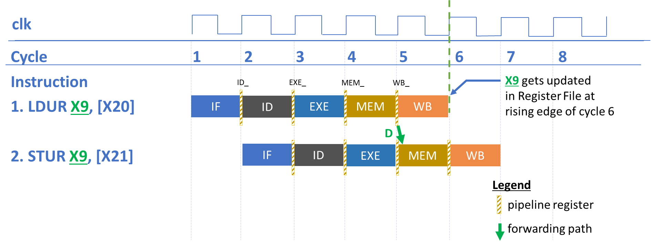

Figure 3: Forwarding path for load-store dependency scenario

1. At the rising edge of the start of clock cycle 5, the value loaded in the MEM (LDUR instruction) is now in the WB pipeline register. The STUR instruction is dependent on the LDUR instruction and stores data in the memory in the MEM stage. Therefore, the result in the WB pipeline register is forwarded to the MEM stage of the STUR instruction (see green arrow **D**). Forwarding path **D** (WB_ -> MEM) bypasses the STUR instruction having to wait for the LDUR instruction to finish the WB stage.

# Implementing forwarding paths in Arm Education Core

In the previous labs, we have learned that Arm Education Core’s Register File has three read ports N, M, and A, from which there are individual data paths for each port:

* Port N is usually for the register of the first operand. This feeds into the datapath leading to exec_n.
* Port M is the register of the second operand. This feeds into the datapath leading to exec_m.
* Port A is usually for the register that contains the value to be stored in a store instruction. This feeds into the datapath leading to exec_a.

Therefore, we need to:

1. Implement forwarding path combinatorial logic to pass the appropriate MEM/WB pipeline register to the exec_n, exec_m, exec_a values—see Figure 4.
2. Ensure that if a read address and write address for the Register File are equal, then the read value takes the value to be written (path C in Figure 2).

Notice that in Figure 4, the **EX_exec_n** pipeline register is now replaced with **EX_fexec_n**. **EX_fexec_n** feeds into the forwarding path logic, which will then select whether **EX_exec_n** should be from the EX pipeline register (**EX_fexec_n**) or from the MEM and WB pipeline registers, likewise for **EX_exec_a** and **EX_exec_m**.

To implement forwarding paths in Arm Education Core, we will use Lab5_forwarding_pipeline.zip provided with Lab 5. In this zip folder, the following files differ from the simple pipeline Arm Education Core RTL code from Lab 4:

* Educore.v
* InstructionDecoder.v
* RegisterFile.v

These differences will be described in the next task.

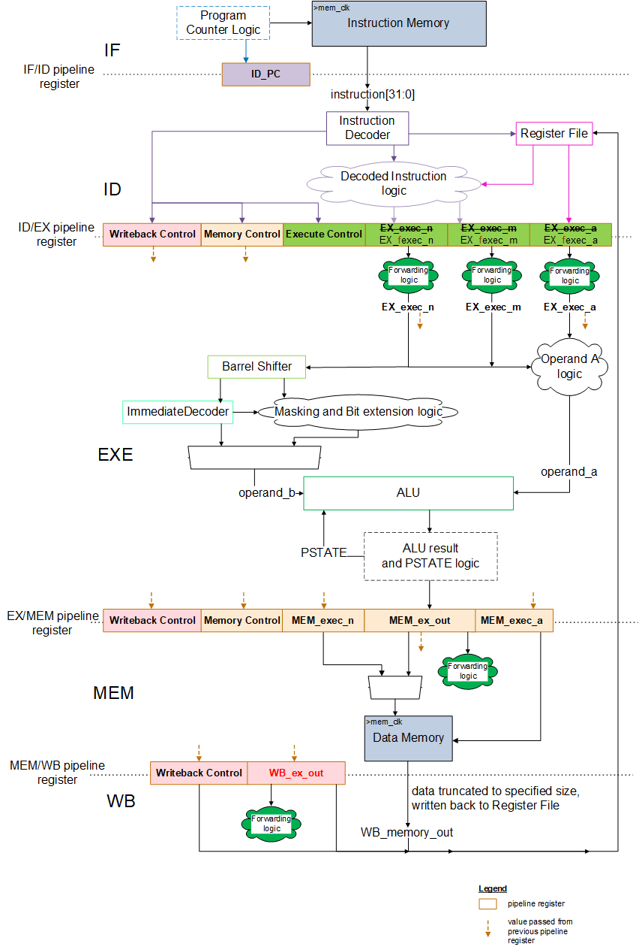

Figure 4: Pipelined Arm Education Core with forwarding path

## Task: Code modifications

To do the code modifications for forwarding path implementation in Arm Education Core, follow these instructions:

1. Create a working directory folder called Lab_5.
2. Unzip the provided Lab5_forwarding_pipeline.zip in your working directory Lab_5 folder.
3. Open the src\RegisterFile.v file and take notice of the following changes compared to the previous lab:

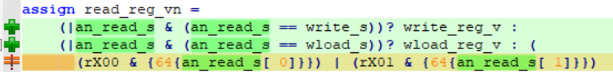

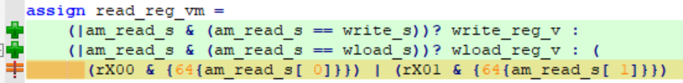

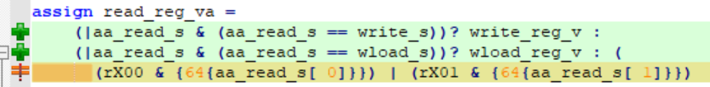

These changes are to implement forwarding path **C** in Figure 2, whereby if a read address and write address for the Register File are similar, then the read value takes the value to be written. This is applicable for ports N, M, and A. Do recall that there are two write ports, one for write register and the other for writeback due to load instructions.

1. Open the src\InstructionDecoder.v file and take notice that the Instruction Decoder now has the following additional outputs:

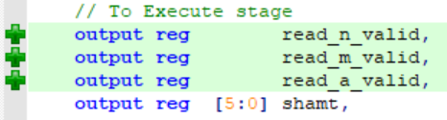

These additional ports are merely active-HIGH signals, which indicate that the instruction has valid register operands. For example, for an instruction ADD X1, X2, X3, register X1 is the destination register, so we don’t need to forward register X1 value to the later pipeline stages (as part of the forwarding paths), and thus the read_a_valid is LOW.

1. Open the src\Educore.v file and take notice of the following changes:
   1. Since the Instruction Decoder module has additional outputs, the following wires are defined:

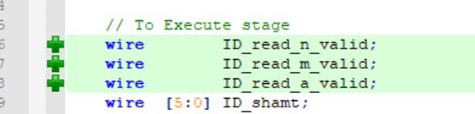

and are connected to the Instruction Decoder Module:

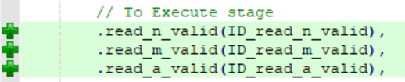

* 1. We have also declared registers **EX_fexec_<n/m/a>** and **EX_exec_<n/m/a>** so that it is similar to what is shown in Figure 4.

1. Modify Educore.v so that register indexes and register valid signals from the Instruction Decoder are pipelined into the EX registers in the next clock cycle by adding the following code:
   1. Declare the following EX registers in the //Register declaration section of Educore.v, as shown in the green section below:

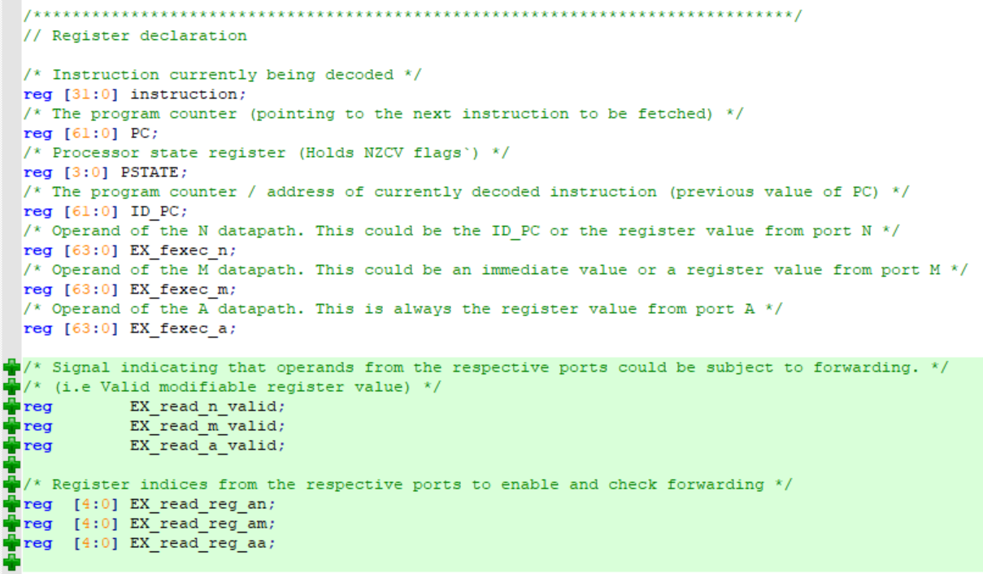

* 1. Now connect these newly declared pipeline registers to the corresponding value from the ID stage at the positive edge of the core clock, as shown in the green section below:

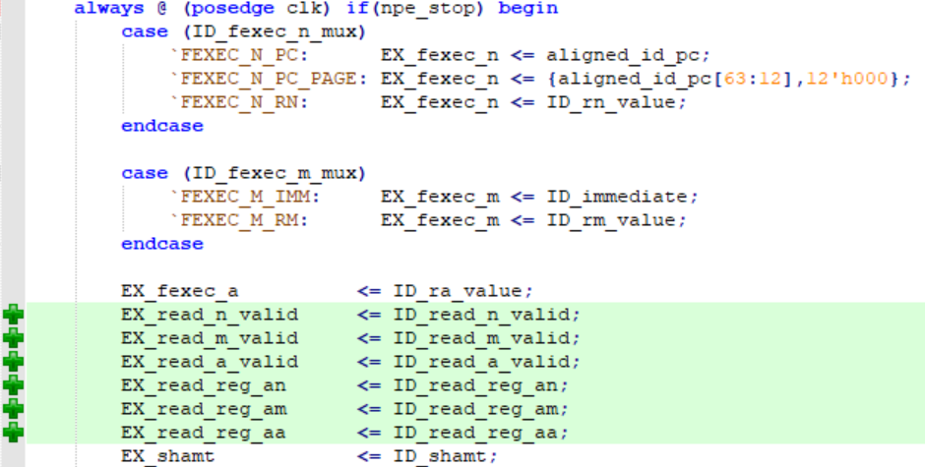

1. Modify the Execute stage in Educore.v so that it is as shown below:

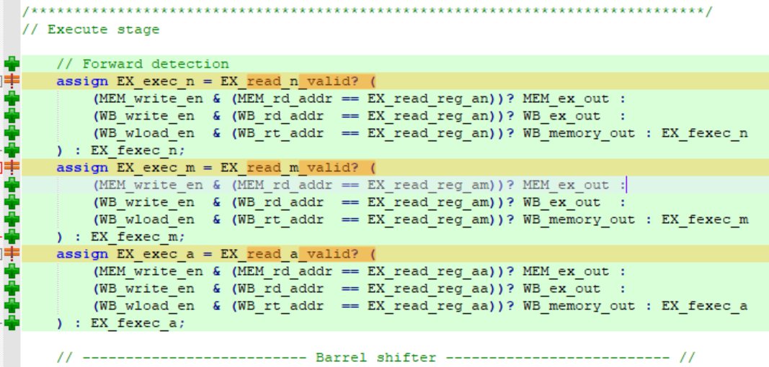

These changes are to implement forwarding paths **A** and **B** in Figure 2. This modification implements multiplexes so that **EX_exec_<n/m/a>** can get forwarded the appropriate values from either the MEM stage (MEM_ex_out, i.e., result of EXE) or the WB stage (WB_ex_out/WB_memory_out, i.e., results of MEM stage, depending on whether it is a data processing instruction or load/store instruction). The conditions for these multiplexes include:

* If the register indexes are valid for each N, M, A port (EX_read_<n/m/a>_valid)
* If there is data dependency, i.e., the destination register address (rd_addr) or target register address (rt_addr for load) in the MEM and WB stages match the current register index at EXE stage in any of the N, M, A ports (e.g., MEM_rd_addr == EX_read_reg_aa)
* If the instruction will update/write to the Register File (write_en or wload signals).

1. To account for load-store dependency scenarios, modify the Memory stage in Educore.v so that it is as shown below:

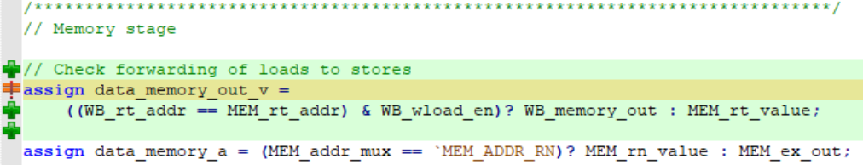

These changes are to implement forwarding path **D** in Figure 2.

data_memory_out_v is the value to be written to the data memory, typically from a store instruction. If the instruction before is a load instruction (WB_load_en) and there is register data dependence, then the stored value is from the previous instruction.

1. Save the modified files.

# Exercise: Verify and analyze forwarding paths

In this exercise, we will take a closer look at the behavior of the forwarding paths implemented in the pipelined Arm Education Core. We will achieve this by simulating Arm Education Core with test_Lab5_forwardingpaths.S, which has the following code:

.global _start

.text

_start:

//place move instructions here

MOVZ X0, #0x0100

MOVZ X1, #0x0101

MOVZ X5, #0x1

MOVZ X6, #0x2

MOVZ X7, #0x3

MOVZ X8, #0x4

MOVZ X9, #0x5

// store values in memory

STURB W5, [X0]

STURB W6, [X0, #1]

STURB W7, [X0, #2]

STURB W8, [X0, #3]

// test load-store dependency

LDURB W10, [X0]

STURB W10, [X0, #4]

// test data dependency

ADD X10, X9, #0

AND X11, X10, X7

ORR X12, X8, X10

SUB X13, X10, X5

// test load-use dependency

LDURB W10, [X1]

NOP

AND X11, X10, X7

ORR X12, X8, X10

SUB X13, X10, X5

// test Branch

B _test

ADD X11, X10, #100 // this shouldn't execute

ADD X11, X10, #200 // this shouldn't execute

ADD X11, X10, #300 // this shouldn't execute

_test:

ADD X11, X10, #5

NOP

NOP

NOP

NOP

YIELD

Run the provided testcase in Lab5_forwarding_pipeline.zip using the bash script, by following these steps:

1. Open a Windows terminal and change directory to the folder.

cd Lab5_forwarding_pipeline

1. Run the run_tests.sh file by entering the following command:

bash run_tests.sh

1. Use the following command to inspect the generated waveforms:

cd sim_dump/

gtkwave test_Lab5_forwardingpaths.mem.lx2 ../GTKW/debug.gtkw

1. Inspect the waveforms and check if they match the expected results of the Assembly code.

**Observations:**

The following diagram shows a snapshot of the simulated waveforms:

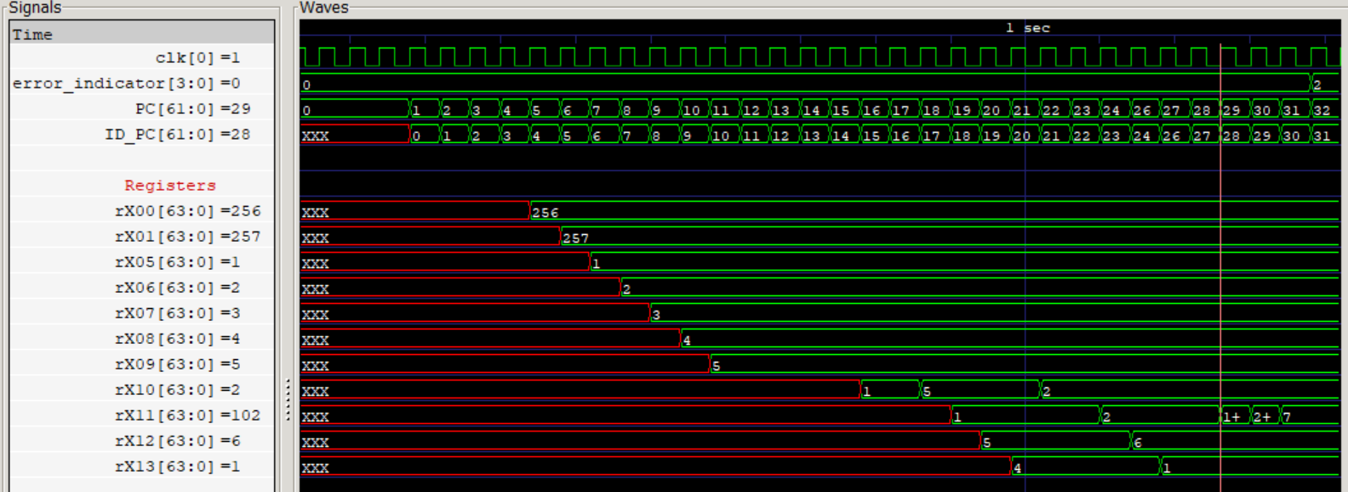Figure 5: Waveforms from test_Lab5_forwardingpath1.mem.lx2

The load-store dependency problem is also resolved, as shown in Figure 6.

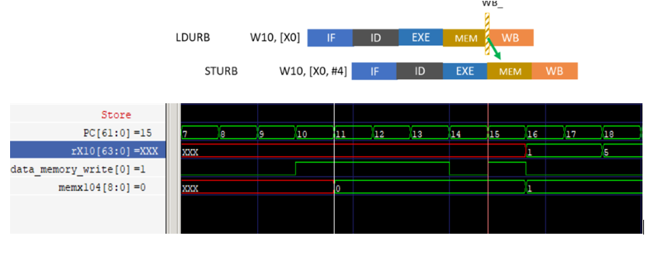

Figure 6: Load-store dependency resolved with the forwarding path

Answer the following questions:

1. What is the purpose of the following NOP instruction in the code:

// test load-use dependency

LDURB W10, [X1]

NOP

AND X11, X10, X7

ORR X12, X8, X10

SUB X13, X10, X5

Modify the testcase and remove the NOP between the LDURB instruction and AND instruction. Resimulate and observe the waveforms. (**Hint**: Look specifically at the contents of register X11). What happens? Explain your answer.

1. For the branch instruction, why are the 2 ADD instructions after B _test being executed when it should have branched immediately to ADD X11, X10, #5? Why isn’t the ADD X11, X10, #300 being executed?
2. Name 1 advantage and 2 limitations that are not solved by the forwarding paths.

# Summary

In this lab, we have implemented forwarding paths in Arm Education Core and demonstrated how it can increase the throughput in a given time if there are data hazards. However, there are still some limitations, and we will address these in the next lab.